JLab tech note JLab-TN-17-010 August 2017, minor revisions August 2019

Extrapolation of Asymmetry Data to Determine A_{o}

Marcy L. Stutzman, Timothy J. Gay, Daniel Moser, Douglas W. Higinbotham

A. Extrapolation Functions
The ultimate goal of a Mott asymmetry measurement is to provide an absolute value of the incident electron polarization, P_{e}. This is obtained by knowing the theoretical Sherman function S: P_{e} = A_{o}/S. Since S is calculated assuming elastic single-collision conditions, A_{o} must correspond to a Mott asymmetry for these conditions. In principle, this requires that elastic scattering be guaranteed by energy filtering, and that a vanishingly thin target be used to eliminate the possibility of plural scattering. In practice one extrapolates measured asymmetries to zero target thickness, while providing the best possible energy discrimination against inelastically-scattered electrons [1]. At incident electron energies below ~200 keV, “retarding field” Mott polarimeters allow the precise extrapolation of asymmetries to zero energy loss in conjunction with target thickness extrapolations [2]. (Energy extrapolation alone is not sufficient to guarantee single-scattering conditions; see reference [3], Figure 9.) At MeV energies such as ours, where semiconductor or scintillator-based electron detection is used, energy discrimination becomes more. In this section, we describe the target thickness extrapolation method used to determine A_{o} from a series of asymmetry measurements with finite thickness foils.
We measure Mott asymmetries, A(t), as a function of Au target foil thickness, t, ranging from 0.050 μm to 1μm. At 5 MeV in this foil thickness range, A(t) is a monotonically decreasing function of t, losing about 20% of its value as t increases from 0 μm (A_{o}) to 1 μm. The function A(t) has a weak curvature with a positive second derivative. Historically, and because of the lack of any compelling theoretical guidance, a variety of functional forms have been used to fit A(t), and thus determine A_{o} [3,4, 4.1,4.2,4.3]. These have all been of the form
$A^{q}\left(t\right)=A_{o}(1-at)$, (i)
$A\left(t\right)=A_{o}\frac{(1-at)}{\left(1+bt\right)} ,$ (ii)
or $A\left(t\right)=a+be^{-ct},$ (iii)

where q = 1, -1, or -2, and a, b, c, and A_{o} are fitting parameters. In form (iii), a+b = A_{o} or, if b is set to zero, A_{o} = a.
As we will see below, the precision with which A_{o} can be determined is limited primarily by the uncertainty in the target thicknesses. These uncertainties are typically 5-8% of the t values themselves. An attractive alternative to thickness extrapolations is to consider A vs. the count rate summed from both detectors, R(t). Uncertainties in the count rates are due mostly to drift between stability runs, believed to be due to instability in the measured beam current, to which the rates must be normalized. These uncertainties are typically much smaller on a percentage basis than the uncertainties in t. In this work, we will thus also consider R -dependent extrapolation functions.
The GEANT4 simulations discussed in JLab-TN- give us some confidence that a fitting form of type (ii) is the most appropriate function with which to extrapolate our A(t) data to A_{o}. Having said this, we prefer the conservative approach espoused in reference [4], in which the A(t) data were fit to four functions of types (i) and (ii). It was shown that the spread in the (correlated) fit values of A_{o} was somewhat larger than the statistical uncertainty in the A_{o} values given by a specific fitting form. As a result, the uncertainty in the weighted mean of the four intercepts (their quoted final value of A_{o}) was assigned to be such that ±2σ error bars encompassed all four intercepts.
To this end, we have applied a more general procedure to assess the precision of our final A_{o} values: the method of Padé approximates [5]. Padé approximates (PAs) are a class of rational fractions which are typically well-behaved and converge more rapidly than Taylor series approximations to a set of data for extrapolation. The PAs, A_{n,m}, take the form
$A_{n,m}\left(t\right)=\frac{P_{m}(t)}{Q_{n}(t)}=\frac{A_{o}(a_{n}t^{n}+a_{n-1}t^{n-1}+…+a_{2}t^{2}+a_{1}t+a_{0})}{(b_{m}t^{m}+b_{m-1}t^{m-1}+…+{ b}_{2}t^{2}+b_{1}t+b_{0})}$ (iv)
for m ≥ 0 and n ≥ 1. The form of Eq. (i) thus corresponds to A_{1,0} for q = 1, A_{0,1} for q = -1, and A_{0,2} for q = -2; equations (ii) correspond to A_{1,1}. Finally, equation (iii) is essentially a PA of arbitrarily high order s of the form A_{s,0}.

Asymmetry vs. Thickness
This following analysis is the final for the data presented June 1, 2017. It includes the standard time of flight and energy cuts, but not additional uncertainties due to systematics in the choice of dA or dR.

We begin our analysis by using the A_{1,0} form to fit a given A(t) data set, and then increase both n and m until application of an F test indicates that higher orders of n and/or m are not justified [6]. As we will show below, the only PA forms that were not excluded using F-tests for the A(t) data were the A_{1,0}, A_{0,1}, A_{1,1}, and A_{2,0} forms. All fits that passed the F-test were then also subjected to a reduced chi-squared analysis as well [6]. The χ2 values over 2 for the A_{1,0} indicate that, for the 9 degrees of freedom for that fit, the A_{1,0} has less than a 2% chance of accurately representing the data, and therefore will be removed from the set of fits used to extrapolate the data to find A(0).

Tables 1 and 2 shows the results of the Pade analysis for the fits of the A(t) data for Runs 1 and 2. The values in red indicate either a failed F test or Pvalue low enough to exclude the fit. The allowed Pade orders are highlighted in green.

Table 1
Run 1 Asymmetry vs. Thickness
PadeOrder | Intercept | dIntercept | Ftest | Reduced χ2 | Pvalue
Pade10 | 43.88 | 0.14 | n/a | 2.50 | 0.01
Pade20 | 44.08 | 0.13 | 7.34 | 1.40 | 0.20
Pade30 | 44.25 | 0.23 | -2.12 | 2.52 | 0.02
Pade01 | 44.06 | 0.10 | 8.76 | 1.20 | 0.30
Pade11 | 44.12 | 0.14 | 8.56 | 1.29 | 0.25
Pade21 | 44.44 | 1.76 | -2.40 | 2.50 | 0.02
Pade02 | 44.12 | 0.14 | 0.40 | 1.29 | 0.25
Pade12 | 44.61 | 5.31 | 1.25 | 1.24 | 0.28

Table 2
Run 2 Aymmetry vs. Thickness
PadeOrder | Intercept | dIntercept | Ftest | Reduced χ2 | Pvalue
Pade10 | 43.86 | 0.15 | n/a | 2.51 | 0.01
Pade20 | 44.10 | 0.14 | 7.89 | 1.35 | 0.22
Pade30 | 44.12 | 0.41 | -4.42 | 5.98 | 0.00
Pade01 | 44.06 | 0.11 | 8.97 | 1.19 | 0.30
Pade11 | 44.16 | 0.15 | 9.32 | 1.23 | 0.28
Pade21 | 44.31 | 0.79 | -2.12 | 2.23 | 0.04
Pade02 | 44.15 | 0.15 | 0.65 | 1.24 | 0.28
Pade12 | 44.57 | 2.89 | 1.08 | 1.22 | 0.29

The allowed Pade orders (technically the fits not excluded by statistical tests) for Run 1 and Run 2 are the A_{0,1}, A_{1,1}, and A_{2,0}, with the graphs of the data shown in Figures 1 and 2, and summaries of the fit parameters and extrapolated Ao shown in Tables 3 and 4.
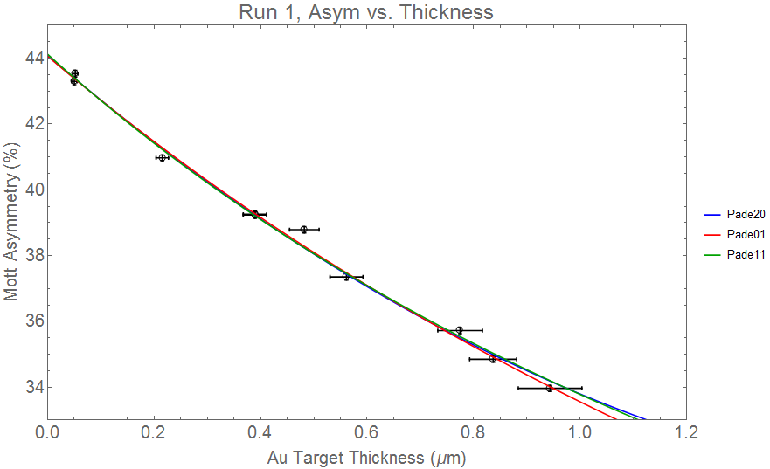
Figure 1

Table 3
Fit, A(t) Run1 | Parameters | Reduced χ2 | ChiSquarePValue
Pade01 | $$\frac{44.06(10)}{1+0.31(01)x}$$ | 1.2 | 0.30
Pade20 | $$44.08(13)-13.8(1.0)x+3.5(1.2)x^{2}$$ | 1.4 | 0.20
Pade11 | $$\frac{44.12(14)+3.8(5.7)x}{1+0.41(16)x}$$ | 1.29 | 0.25
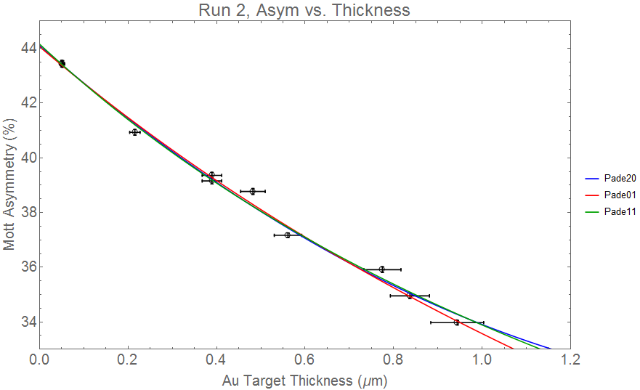
Figure 2

Table 4
Fit, A(t) Run2 | Parameters | Reduced χ2 | ChiSquarePValue
Pade01 | $$\frac{44.06(11)}{1+0.31(01)x}$$ | 1.19 | 0.30
Pade20 | $$44.10(14)-14.0(1.0)x+3.9(1.2)x^{2}$$ | 1.35 | 0.22
Pade11 | $$\frac{44.16(15)+5.7(5.9)x}{1+0.47(16)x}$$ | 1.23 | 0.28

Figure 3 shows the values of Ao for three different PA forms that are not excluded, as well as the A10 form which has been rejected due to a poor reduce χ2 value and outlier value compared to the other PAs. Run 1 is shown on top and run 2 below the center line, with the average value shown in a solid vertical line, and the extents of the uncertainty in the dotted vertical lines.

Asymmetry vs. Rate
Similarly, analysis of PAs was carried out for the asymmetry vs. rate data, where the theory and simulation does not provide guidance regarding a preferred functional form. In this case, the A_{0,2}, A_{1,1}, and A_{2,0} forms were not excluded by the F-test, with the higher order PAs failing the F-test. The A_{2,0}, A_{1,0} and A_{0,1} were then rejected due to poor reduced χ2 and P-values values. Results of the A(R) PA analysis are shown in Table 6 and Table 7, and the summary of the PAs not rejected are in Table 8.
Table 5 shows the results of the Pade analysis for the fits of the A(R) data for Runs 1 and 2. The values in red indicate either a failed F test or Pvalue low enough to exclude the fit. The allowed Pade orders are highlighted in green.

Table 6
Asymmetry vs. Rate Run 1
PadeOrder | Intercept | dIntercept | Ftest | Reduced χ2 | Pvalue
Pade10 | 43.28 | 0.29 | n/a | 22.43 | 1.37E-34
Pade20 | 43.93 | 0.13 | 62.98 | 2.56 | 0.01
Pade30 | 44.08 | 0.12 | 4.37 | 1.73 | 0.11
Pade01 | 43.63 | 0.20 | 12.41 | 8.79 | 4.27E-12
Pade11 | 44.09 | 0.11 | 127.00 | 1.34 | 0.23
Pade21 | 44.21 | 0.16 | 0.59 | 1.42 | 0.20
Pade02 | 44.04 | 0.11 | 36.65 | 1.61 | 0.13
Pade12 | 44.00 | 0.15 | -0.64 | 1.75 | 0.11

Table 7
Asymmetry vs. Rate Run 2
PadeOrder | Intercept | dIntercept | Ftest | Reduced χ2 | Pvalue
Pade10 | 43.19 | 0.32 | n/a | 22.21 | 3.21E-34
Pade20 | 43.95 | 0.15 | 58.06 | 2.73 | 0.01
Pade30 | 44.15 | 0.15 | 4.86 | 1.76 | 0.10
Pade01 | 43.58 | 0.23 | 11.08 | 9.31 | 6.24E-13
Pade11 | 44.14 | 0.13 | 122.01 | 1.38 | 0.21
Pade21 | 44.25 | 0.20 | -0.22 | 1.67 | 0.12
Pade02 | 44.07 | 0.13 | 37.08 | 1.69 | 0.11
Pade12 | 44.00 | 0.18 | -0.95 | 1.91 | 0.08

Table 8
Fit, A(R) Run1 | Parameters | Reduced χ2 | ChiSquarePValue
Pade11 | $$\frac{44.09(11)+0.10(02)x}{1+4.54(47)×{10}^{-3}x}$$ | 1.34 | 0.23
Pade02 | $$\frac{44.03(11)}{1+2.14(08)×{10}^{-3}x-3.03(47)×{10}^{-6}x^{2}}$$ | 1.61 | 0.13

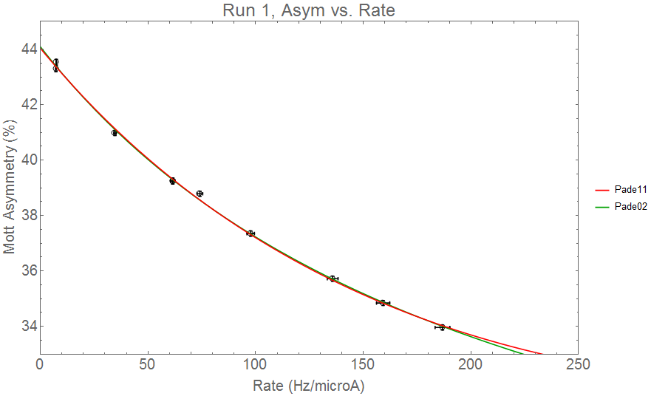
Figure 4

Table 9:
Fit, A(R) Run2 | Parameters | Reduced χ2 | ChiSquarePValue
Pade11 | $$\frac{44.14(13)+0.12(02)x}{1+5.03(55)×{10}^{-3}x}$$ | 1.38 | 0.21
Pade02 | $$\frac{44.07(13)}{1+2.26(10)×{10}^{-3}x-3.48(53)×{10}^{-6}x^{2}}$$ | 1.69 | 0.11

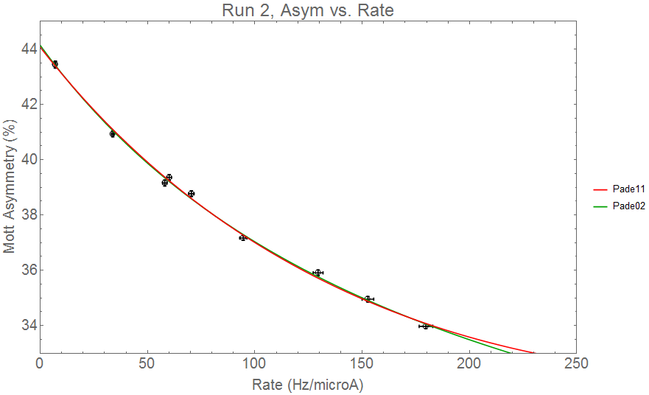
Figure 5

Figure 6 shows the intercepts from the fits not statistically rejected, the mean intercept for each run, and an uncertainty in this mean that is defined by the range of the uncertainties in each point, that is the maximum and minimum extents of the uncertainties for the individual data points.

Figure 6 shows the values of Ao for the two PA forms that are not excluded by F-testing or χ2 criteria for the Rate vs. thickness data. Run 1 is shown on top and run 2 below the center line, with the average value shown in a solid vertical line, and the extents of the uncertainty in the dotted vertical lines.
.

Rate vs. thickness
The series of Pade approximants was used to again fit the R(t) data sets for runs 1 and 2, with all forms excluded on the basis of the Pvalue or the Ftest except the A_{2,0} and A_{1,1}, with results shown in Table 10 and Table 11. GEANT simulations used a model with single and double scattering effects based on the calculations of Wegener [], which yield a quadratic dependence of rate on thickness, or the A_{2,0} Pade approximant. This is among the forms allowed by the purely statistical analysis through PAs.
Table 10 shows the results of the Pade analysis for the fits of the R(t) data for Run 1 (top) and Run 2 (bottom) to the various forms A_{n,m}. The intercepts for all fits are forced through the point R(0)=0. For each PA, the F-test result, the reduced χ2 value and the P-value probability are shown.

Rate vs. Thickness Run 1
Pade  Order | Intercept | dIntercept | Ftest | Reduced χ2 | Pvalue | a1 | da1 | a2 | da2 | a3 | da3 | b1 | db1 | b2 |  | db2
Pade10 | 0.00 | 5.31 | n/a | 2.51 | 0.01 | 168.09 | 5.31
Pade20 | 0.00 | 4.57 | 50.14 | 0.39 | 0.07 | 141.37 | 4.57 | 51.42 | 8.76
Pade30 | 0.00 | 7.59 | -0.72 | 0.49 | 0.16 | 148.80 | 7.59 | 7.41 | 32.94 | 45.34 | 31.17
Pade11 | 0.00 | 3.62 | 59.07 | 0.34 | 0.05 | 143.42 | 3.62 | 0.00 | 0.00 | 0.00 | 0.00 | -0.27 | 0.04
Pade21 | 0.00 | 4.62 | 1.54 | 0.32 | 0.05 | 146.47 | 4.62 | -50.55 | 72.51 | 0.00 | 0.00 | -0.53 | 0.38
Pade12 | 0.00 | 6.18 | 1.72 | 0.31 | 0.05 | 147.49 | 6.18 | 0.00 | 0.00 | 0.00 | 0.00 | -0.13 | 0.18 | -0.14 |  | 0.18

Table 11
Rate vs. Thickness Run 2
Pade  Order | Intercept | dIntercept | Ftest | Reduced χ2 | Pvalue | a1 | da1 | a2 | da2 | a3 | da3 | b1 | db1 | b2 | db2
Pade10 | 0.00 | 5.14 | n/a | 2.54 | 0.01 | 161.74 | 5.14
Pade20 | 0.00 | 5.24 | 33.57 | 0.55 | 0.18 | 136.91 | 5.24 | 47.54 | 9.98
Pade30 | 0.00 | 9.03 | -1.17 | 0.75 | 0.37 | 144.88 | 9.03 | 0.72 | 38.67 | 48.02 | 36.23
Pade11 | 0.00 | 4.27 | 38.02 | 0.50 | 0.14 | 138.70 | 4.27 | 0.00 | 0.00 | 0.00 | 0.00 | -0.26 | 0.04
Pade21 | 0.00 | 5.35 | 0.99 | 0.50 | 0.16 | 141.52 | 5.35 | -43.01 | 103.53 | 0.00 | 0.00 | -0.48 | 0.58
Pade12 | 0.00 | 7.34 | 1.56 | 0.46 | 0.14 | 143.24 | 7.34 | 0.00 | 0.00 | 0.00 | 0.00 | -0.10 | 0.22 | -0.16 | 0.22

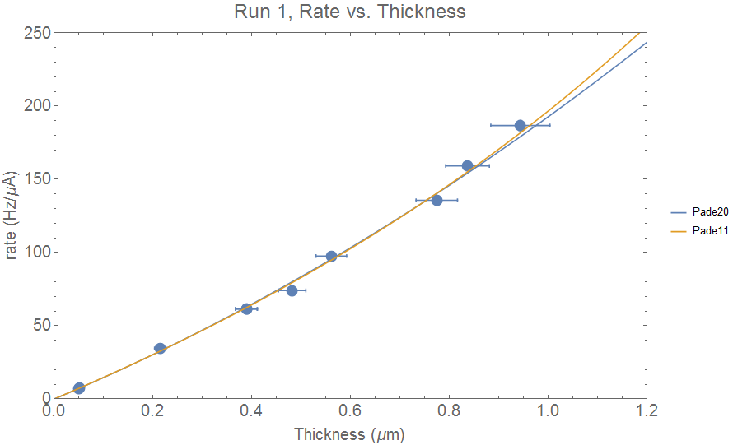
Figure 7
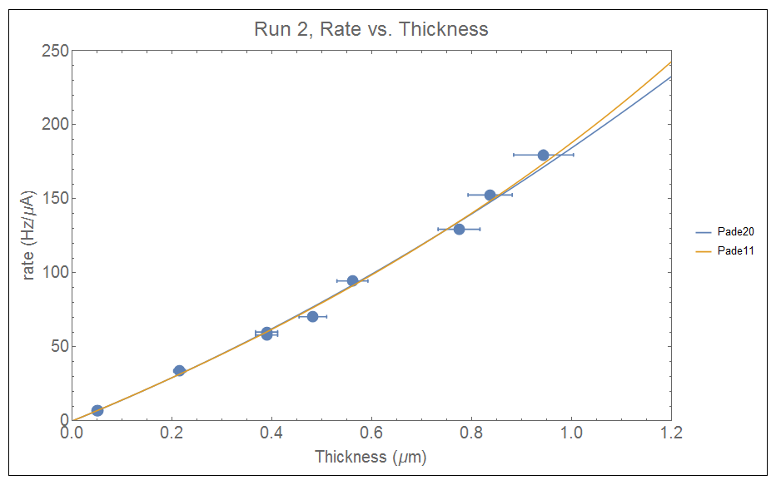
Figure 8

Conclusions
This analysis of the Mott asymmetries and extrapolation to the value of A(0) is a statistical exercise intended to assist in determining the value of A(0) and its uncertainty without using physical models of the electron scattering. The Pade Approximant method uses a series of rational fractions, then uses the F-test to determine if adding terms to the fitting function is statistically valid, and uses P-value and Chi-squared testing to ensure that the resulting functions are valid.
The conclusions to draw from this analysis are the following: lacking physical justification to choose one function over another, the uncertainty for the extrapolated A(0) value should include a term that captures the uncertainty that arises from being able to extrapolate with several different functions. This additional uncertainty on the functional form can be seen, for example, in the Run 2 A(R) data. The two functional forms that are not disallowed are the A_{1,1} with A(0)=44.14(13) and A_{0,2} with A(0)=44.07(13). We could choose either of these functions to be the one we use, through historical context or intuition, but without physical guidance for this data set, the most conservative approach is to average the A(0) values of the two functions, and treat the uncertainties conservatively by taking the full range of the uncertainties of the two functions, yielding A(0)=44.11(16) for Run 2 A(R).
For the A(t) and R(t) data where GEANT simulations for single and double scattered electrons find preferred functional forms for the fit to the data, the PAs that are not consistent with the physical process can either be ignored, using only the Wegener suggested form, or they can be kept by averaging the extrapolated values of A(0) and expanding the uncertainty in A(0) to include the uncertainty in the functional form.
Final data table:
 | Average of allowed PAs | For Wegener suggested A11
A(t) Run 1 | A(0)=44.09(16) | A(0) =44.12(14)
A(R) Run 1 | A(0)=44.06(13)
A(t) Run 2 | A(0)=44.11(18) | A(0)=44.16(15)
A(R) Run 2 | A(0)=44.11(16)

References
1. T.J. Gay and F.B. Dunning, “Mott Electron Polarimetry,” Rev. Sci. Instrum. 63, 1635 (1992).
2. Hodge et al. RSI 1979.
3. T.J. Gay, J.A. Brand, J.E. Furst, M.A. Khakoo, W.V. Meyer, W.M.K.P. Wijayaratna, and F.B. Dunning, “Extrapolation Procedures in Mott Electron Polarimetry,” Rev. Sci. Instrum. 63, 114 (1992).
4. G.D. Fletcher, T.J. Gay, and M.S. Lubell, “New Insights Into Mott–Scattering Electron Polarimetry,” Phys. Rev. A 34, 911 (1986).
4.1 J. Sromicki et al., "Polarization in Mott Scattering of Multi-MeV Electrons from Heavy Nuclei", Phys. Rev. Lett. 82, 57 (1999)
4.2 V. Tioukine, K. Aulenbacher and E. Riehn, "A Mott polarimeter operating at MeV electron beam energies", Rev. Sci. Instrum. 82, 033303 (2011)
4.3. H. Wegener, "Mott-Streuung an Streufolien endlicher Dicke", Zeitschrift für Physik A Hadrons and Nuclei 151, 252 ( also reference Steigerwald conference proceedings)
4.4 M. Steigerwald, "MeV Mott Polarimetry at Jefferson Lab", AIP Conf. Proc. 570, 935 (2001)
5. J.Kallrath ”Rational Function Techniques and Padé Approximants”, in: Hagel, J. (Ed.), Nonlinear Perturbation Methods with Emphasis to Celestial Mechanics pp 97-107, Madeira University Press, Madeira, Portugal
6. P.Bevington, Data Reduction and Error Analysis for the Physical Sciences, 2nd ed. (McGraw-Hill, New York, 1969), appendix C-4.
7. Ladish?
8. Measurements made using a Hitachi s-4700 FESEM with 15.0 kV electron energy.
9. Lebow Company, 5960 Mandarin Ave., Goleta, CA 93117, USA, lebowcompany.com
10. Brun, R. & Rademakers, F. (1996). ROOT - An Object Oriented Data Analysis Framework. AIHENP'96 Workshop, Lausane (p./pp. 81--86), .

W-1 H. Wegener, Mott-Streuung an Streufolien endlicher Dicke, Zeitschrift f. Physik A 151, 252 (1958)

