fa
 | Operational Safety Procedure Form  (See ES&H Manual Chapter 3310 Appendix T1 Operational Safety Procedure (OSP) and Temporary OSP Procedure for instructions.) | Click  For Word Doc

Title: | QCM Operation at the Upgraded Injector Test Facility (UITF)
Location: |  | Upgraded Injector Test Facility (UITF) located in the Test Lab High Bay Area, rooms 1127-1129 |  |  |  |  | Type: | OSP  X  TOSP
Risk Classification  (per Task Hazard Analysis attached)  (See ESH&Q Manual Chapter 3210 Appendix T3 Risk Code Assignment.) |  |  |  | Highest Risk Code Before Mitigation |  |  |  | 3
 |  |  |  | Highest Risk Code after  Mitigation (N, 1, or 2): |  |  |  | 1
Owning Organization: |  |  | Center for Injectors and Sources, Accel. Div. |  | Date: | February 6, 2018
Document Owner(s): |  |  | Matthew Poelker

DEFINE THE SCOPE OF WORK
- Purpose of the Procedure – Describe in detail the reason for the procedure (what is being done and why).
The purpose of this OSP is to describe in detail the procedures for safely commissioning the Quarter Cryomodule (QCM) with RF at the UITF (but not accelerating beam). There are two main concerns: prompt ionizing radiation as a result of field emission inside the QCM, and ODH conditions that result from cryogenic conditions required to operate the SRF accelerating cavities.

FSAD Rev. 7a considered the Injector Test Facility to be a Technical Area containing one or more accelerator components that did not constitute an accelerator and did not create hazards that presented an unacceptable risk (require the use of credited controls for hazard mitigation). FSAD Rev. 8, in DRAFT, considers the Upgraded Injector Test Facility (UITF) to be an accelerator, analyzes the hazards, and specifies the hazard mitigations. This OSP provides the basis for RF-commissioning of the QCM at UITF and is consistent with the requirements in FSAD Rev. 8 DRAFT.

* Final Safety Assessment Document Rev 7a: https://jlabdoc.jlab.org/docushare/dsweb/View/Collection-4440
- Scope – include all operations, people, and/or areas that the procedure will affect.
High Power RF Commissioning of the QCM (no beam acceleration)

Apply high power RF energy to the cold QCM located inside the UITF enclosure using two klystrons. One klystron drives a unique 2-cell accelerating cavity described as an rf-capture section, and the other drives a 7-cell cavity similar to those used in C100 cryomodules at CEBAF. Compare RF performance at UITF to performance previously measured at Cryomodule Test Facility (CMTF).

The cryogenic conditions related to QCM operation are different at UITF compared to conditions that were evaluated at the CMTF. Specifically, liquid nitrogen at 80K will be used for the shield line, and not helium at 35K. And the UITF enclosure is unique, and different from the CMTF enclosure.

Besides evaluating the performance of the QCM, we will be commissioning a brand new cryogenic system (the QCM connected to CTF with new controls and piping), and a new high power RF system (new high power amplifier and klystron racks). The klystrons used at UITF represent “CEBAF spares” and are expected to operate at XkW for the 2-cell cavity and YkW for the 7-cell cavity. Based on QCM performance observed at the CMTF, and based on the beam energy requirements of UITF (10 MeV maximum), the QCM is not expected to operate in a field emission regime.

The implementation of this OSP also represents the first tests of the cold and energized QCM interfaced to a new PSS system.

The affected area is the entire UITF enclosure composed of Cave 1 and Cave2, and the region above Cave1 where the electronics racks are located (See figure 1)

- Description of the Facility – include building, floor plans and layout of the experiment or operation.
The location of UITF is the High Bay Area of the Test Lab. Figure 1 shows the UITF lay out and identifies Caves 1 & 2. This OSP covers QCM commissioning with RF (no beam acceleration) which occurs in Cave 1, but also affects Cave2 because Cave1 and Cave2 form a common space. The names “Cave1” and “Cave2” are convenient designations, referencing old and new test areas, respectively. Figures 1 and 2 show the labyrinth, which is the main access to UITF. Figure 3 shows UITF with concrete shielding over the roof of Cave 1. Electronics racks are located above Cave1. In Figure 3, for illustration purposes only, the roof of Cave2 is shown removed.
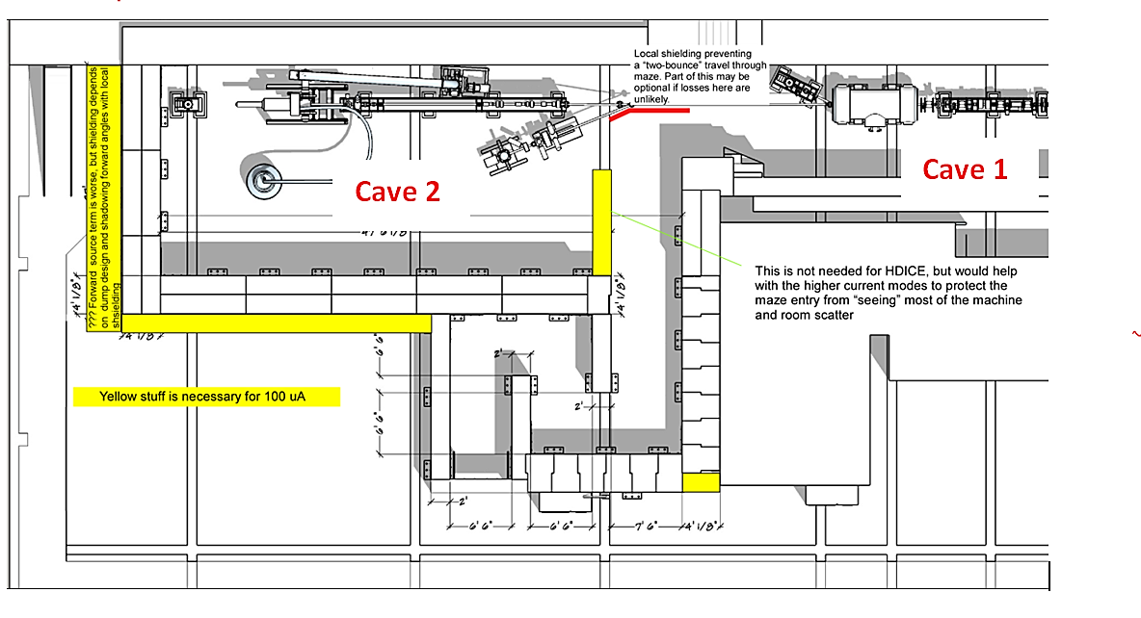
CAVE 2
Labyrinth

Figure 1 UITF beamline layout showing the two Caves. The QCM is inside Cave 1

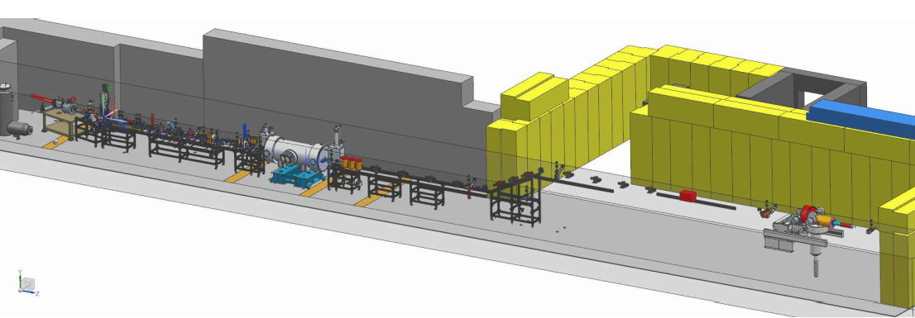
Figure 2 UITF layout showing the exit to main entrance through labyrinth towards the high bay area

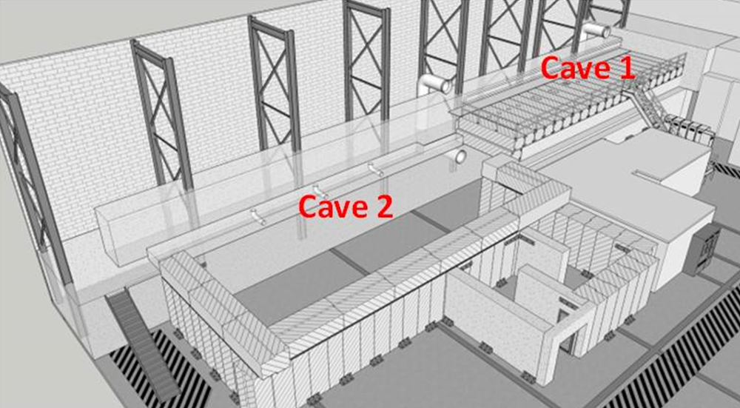

Figure 3 UITF layout showing the main entrance Labyrinth and shielded roof of Cave 1. The klystrons and RF controls are located above Cave1. Cryogens are delivered to UITF from the CTF via piping that enters at the south end of Cave1.

ANALYZE THE HAZARDS and IMPLEMENT CONTROLS
- Hazards identified on written Task Hazard Analysis
Refer to attached Task Hazard Analysis Work Sheet for details and mitigation. The following lists the hazards.
- Ionizing Radiation
- RF Non-ionizing Radiation
- Oxygen Deficiency
- Electrical
- Pressure / Vacuum
- Authority and Responsibility:
  - Who has authority to implement/terminate
Matthew Poelker, Joe Grames, Carlos Hernandez-Garcia, Chris Perry (Cryo portion), Mike Drury (SRF portion)

- Facility Manager – This responsibility is assigned by the Department head of the ISRFST department. This individual has ownership of the facility and has overall responsibility for safe configuration and operation of the facility.
- Test Coordinator – The test coordinator is assigned by either the Facility Manager or the Department head of the SRF Institute. The Test Coordinator has overall responsibility for a given test plan (such as a Cryomodule Acceptance Test). The Test Coordinator is responsible for planning and executing the test plan, ensuring that operations are carried out in a safe manner, directing the activities of system operators while they are on shift, and insuring that the facility is properly staffed. The Test Coordinator must be cognizant of the status of the facility and any device under test in the facility for the duration of the Test Plan. The TC must have a thorough understanding of the configuration and operation of the relevant systems required for the execution of the planned experiments. For most routine production testing, the Facility Manager may also serve as the Test Coordinator.

  - Who is responsible for key tasks
Matthew Poelker, Joe Grames, Carlos Hernandez-Garcia, the Cryo Group and members of the SRF Institute

- Principal Investigators (PI’s) have to demonstrate to the Test Coordinator that the test is appropriate. The PI must also ensure that the System Operator has the ability to perform the test. The PI or approved designee must be on call while the respective test is being performed.
- RF System Operators: They are to be authorized by the Facility Manager. They assist the Principal Investigators in the execution of tests and the changing of system configurations. They must have a thorough understanding of the configuration and operation of the PSS and MPS systems, as well as the configuration of the MPS and RF systems required for the execution of the planned experiments. They should also have a general understanding of the interactions of the cryogenic systems with the specific RF tests. They are responsible for safe operation of the facility and have the authority to stop any experiment if they feel that there is unnecessary potential to damage equipment or if there is an elevated level of risk of injury.
- Cryogenic System Operators: They are to be authorized by the Facility Manager. They assist the principal investigators in the execution of tests and the changing of system configurations. They must have a thorough understanding of the configuration and operation of the cryogenic systems required for the execution of the planned experiments. They should also have an understanding of the interactions of the specific RF tests with operations of the cryogenic systems. They are responsible for safe operation of the facility and have the authority to stop any experiment if they feel that there is unnecessary potential to damage equipment or if there is an elevated level of risk of injury.
- Duty Operator: The Duty Operator is the individual System Operator who has been assigned to be responsible for operations on a specific shift. The Test Coordinator assigns the Duty Operator. The Test Coordinator assumes this responsibility during unattended periods of operation such weekends or nights.
- Visiting Operators are approved by The Test Coordinator to assist PIs in the execution of tests and the changing of system configurations. When using high power RF systems, their activities are to be directed and closely monitored by the Duty Operator.
- The Radiation Control Department will provide radiation survey support as well as maintenance support of any radiation monitoring equipment that is associated with Personnel Safety.
- Industrial Hygiene shall provide RF survey assistance upon request.
- The Group Leader of the Safety Systems Group (SSG) or his designee is the owner of the Personnel Safety System (PSS).

  - Who analyzes the special or unusual hazards including elevated work, chemicals, gases, fire or sparks (See ES&H Manual Chapter 3210 Appendix T1 Work Planning, Control, and Authorization Procedure)
Task Hazard Analyses (THA’s) for any Test Plans that require operation of the facility in a manner that is outside the scope of this OSP and existing THA’s will be executed by the Facility Manager acting in concert with the relevant Subject Matter Experts (SME’s):

SME’s will include but are not limited to the following individuals or their designees:
- Chris Perry – Cryogenic Safety
- Jerry Kowal - Safety Systems Group Leader – PSS and ODH Monitoring
- Rick Nelson – RF Safety
- Vashek Vylet – RadCon
- Harry Fanning – Accelertor Division Safety Officer
- John Hansknecht – Safety Warden
- Jennifer Williams – Oxygen Deficiency

  - What are the Training Requirements (See http://www.jlab.org/div_dept/train/poc.pdf)
UITF Operators must have the following Training
- SAF 100 – ES&H Orientation
- SAF 307 – Ladder Safety
- SAF603A – Electrical Safety Awareness: Classes, Modes, etc.
- SAF 103 – Oxygen Deficiency Hazard
- SAF 104 – Lock, Tag and Try
- SAF 801– Rad worker
- SAF130AU – Pressure Systems Safety Awareness for Users
- Read and sign this OSP

- Personal and Environmental Hazard Controls Including:
  - Shielding
The accelerating cavities inside the QCM can be driven with sufficient RF power to initiate field emission, which will produce X-rays. The Radiation Control Department (RCD) has recommended and evaluated the shielding at UITF to mitigate radiation hazards.

Key Shielding Features:

The east wall of the UITF enclosure (see figure 1) is many meters thick and is an effective radiation barrier. The west wall of Cave1 is 36” thick. Cave 1 has 30” concrete shielding on the roof. There are six penetrations in the Cave1 ceiling. These penetrations serve three purposes: a) means to pass cables to connect beamline devices to the controls located in the electronics racks above, b) to pass RF waveguides from klystrons to the QCM, and c) to provide a means for helium gas to escape the UITF enclosure. All of the penetrations, except the one used for RF waveguides, have 3.5” iron shielding directly beneath (figure 4 below).

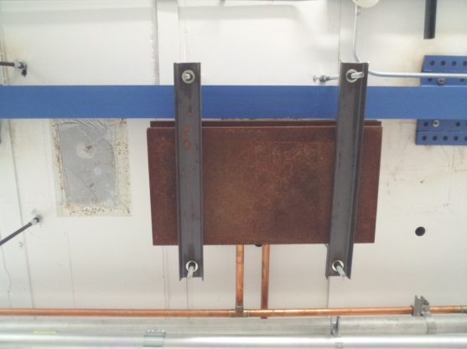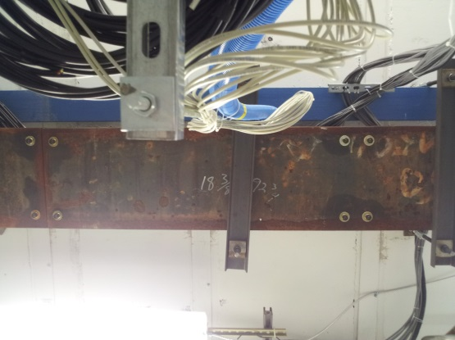

Figure 4 Steel plates covering penetrations in Cave 1. Cables pass through the penetrations linking the electronics racks and beamline elements.

A thick aluminium plate, grouted to the ceiling, with rectangular cutouts provides a pathway for RF waveguides that connect the QCM to klystrons above Cave1. This penetration is filled with sand. (Figure 5)

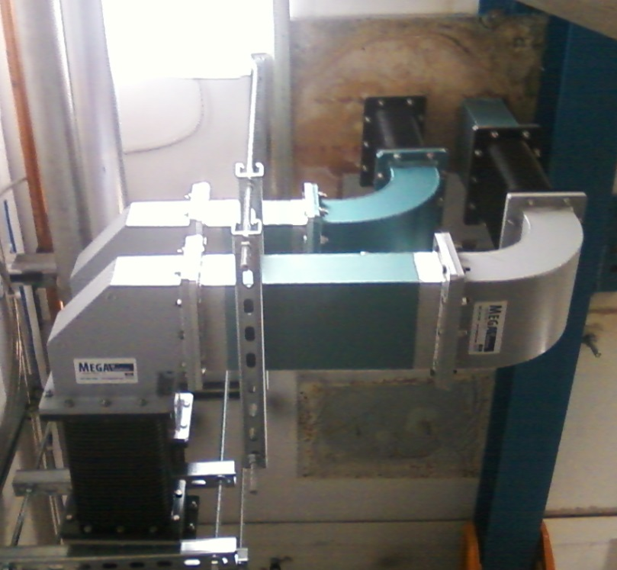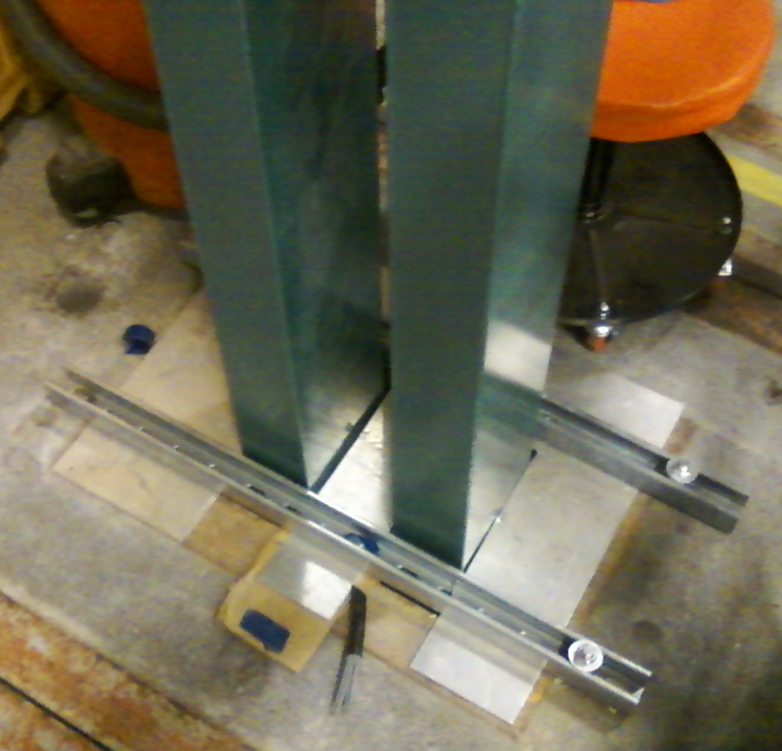

Figure 5: images of RF waveguides passing through a ceiling penetration in Cave1, connecting the QCM to klystrons. Left: view from inside the UITF enclosure, Right: view above the cave, near the klystron racks.

Two penetrations serve as helium vent holes should the Cave1 enclosure fill with helium gas. Above the cave, these penetrations have “chimney stacks” attached (more in Section 6.5 Ventilation), to direct the light helium gas safely above the heads of occupants who might be working atop the Cave1 enclosure. Packing foam fills the remaining penetrations, to block the free flow of helium gas to the electronics racks located above, where personnel might be working.

Although the QCM is located in Cave1, the entire UITF enclosure (Cave1 and 2) will be swept and made clear of personnel. The main entrance labyrinth and the south access labyrinth prevent line of sight exposure to x-ray radiation for people working in the main high bay area outside the UITF enclosure.

An assessment by the Radiation Control Department (RCD) indicates Cave1 is adequately configured with sufficient shielding to mitigate radiation hazards.

<Vashek, numbers here?>

The top of the UITF Cave1 roof is accessible during QCM operation but the area is considered a Radiologically Controlled Area, with signage provided by RCD indicating access restrictions and dosimeter requirements. Signage will be posted at the bottom of the stairs leading to the Cave1 roof (see Figure 5, left). After QCM commissioning activities are complete, access to the UITF Cave1 roof is unrestricted (See Figure 5, right).

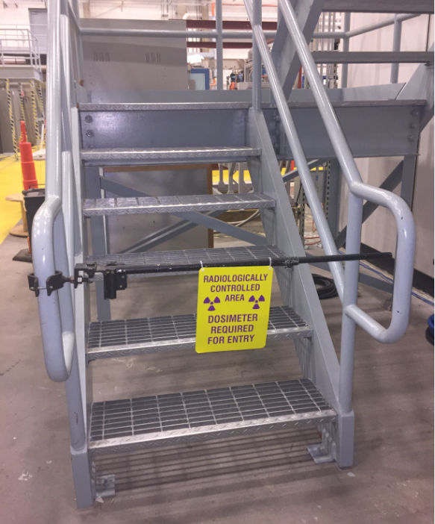
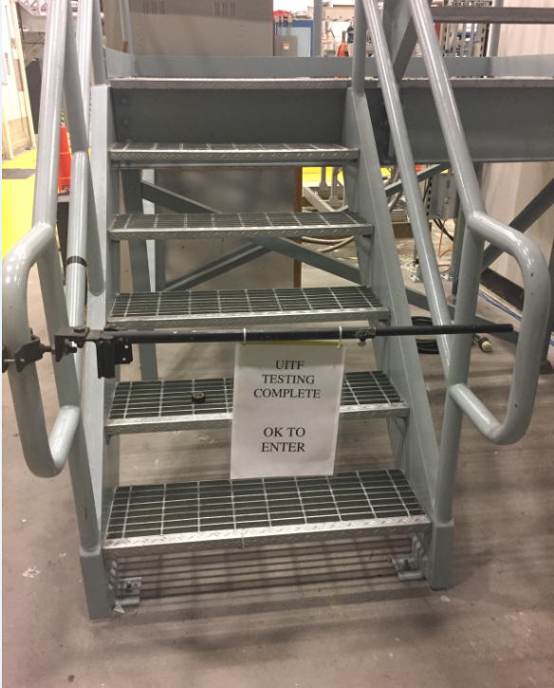

Figure 5 (left) During UITF operations, the top of UITF Cave1 roof is a Radiologically Controlled Area and dosimetry is required to access the roof. (right) access is unrestricted when UITF operations are complete.

During initial QCM commissioning, RCD will conduct radiation surveys of accessible areas outside the UITF enclosure to verify shielding effectiveness and establish final operational limits, alarm thresholds, and postings.

Activation?
High-gradient cryomodules such as C-100 and similar designs contain cavities that have shown the potential to produce radio-activation when operated at high power. Under certain conditions, the energy of the photon field produced by field emitted electrons may exceed the threshold for giant resonance photo-nuclear interactions. These interactions result in the emission of neutrons and the production of residual radioactivity. This phenomenon is difficult to predict. However, the onset of the condition is easily detectable by means of neutron radiation monitoring in the vicinity of the cryomodule.

  - Barriers (magnetic, hearing, elevated or crane work, etc.)
The QCM is under vacuum, and for this test, the valves to the adjoining beamline are closed, with epics control of the valves disabled. Because the valves are closed, there is no possibility of injecting and accelerating a beam through the QCM.

The doors to UITF represent barriers, these are described below in Section 6.3 Interlocks

  - Interlocks
The UITF’s Personnel Safety System (PSS) ensures that personnel cannot access the UITF enclosure when prompt radiation hazards are possible. And the PSS will turn OFF radiation sources when unacceptable radiation levels are detected by CARMS located outside the enclosure. Radiation exposure is prevented through both administrative (sweep procedures, locked gates, postings) and engineered means (interlocks, radiation monitoring, etc.). UITF (see Figure 5) is a completely enclosed area. No one is allowed inside the enclosure during beam operations, or gun high voltage conditioning, or when high power RF is applied to the buncher or the QCM.

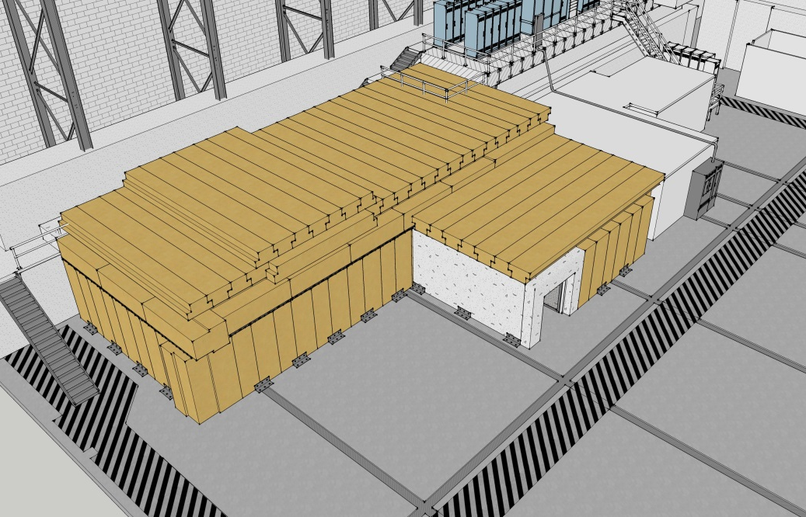
Exit
Main Entrance
Figure 5 UITF With concrete shielding in place
Figures 6 and 7 show the two entry/exit ways to and from the UITF, the run safe box, signage along with the warning beacons.

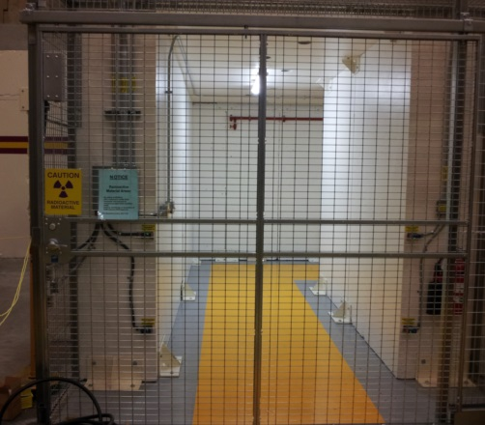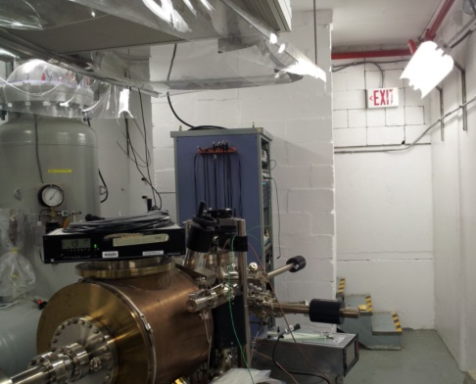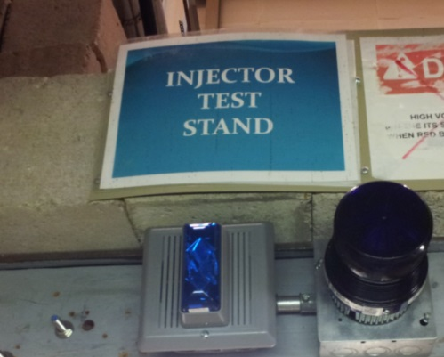
Beacons
Figure 6 (Left) Main entrance/exit from high bay area through the labyrinth of UITF (Middle), Secondary exit into the high bay from the southern-most location of the keV section. Both doors have Personnel Safety System interlocks and emergency exit switches on the nearby walls (Right). Beacons exist at both entrance/exit ways
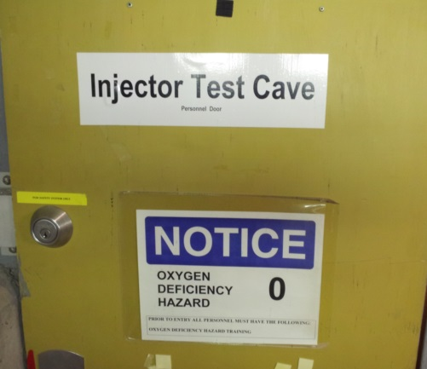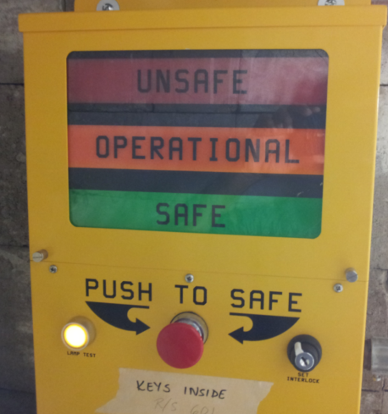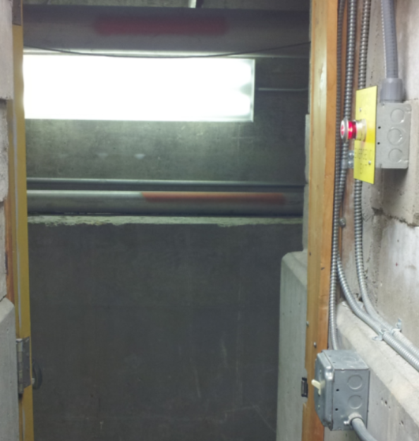
Crash Switch
Figure 7 (Left) Exit into high bay from Cave 1 near the electron gun (Middle) Run/Safe Box (Right) Crash Switch for exit. Run/Safe Boxes and Crash switches are at both the entrance/exit ways

There are four PSS states: OPEN, SWEEP, READY and RUN. READY state is the safe state, when doors are open and the UITF enclosure can be occupied by personnel. The RUN state issues “permits” to RF sources, the Gun High Voltage power supply and PSS laser shutters. “Permits” allow these devices to be energized.

There are radiation monitors – referred to as CARMs – that are interlocked to the PSS system. CARMs are primarily used to detect radiation outside the UITF enclosure but one or more CARMs may be located inside the UITF enclosure. CARM placement is determined by the RCD. When CARMs detect unacceptable levels of radiation in Run state, the PSS will drop to READY state, removing all the permits.

In OPEN state, the main entrance/exit will be in use. The secondary exit door can be used as needed, but is primarily considered an emergency exit. The main and secondary entrance/exit doors are part of the PSS, with magnetic locks that engage and prevent entry when the UITF enclosure is swept and the PSS is set to the Run state. The PSS will turn OFF radiation sources when door interlocks are breached.

Additional details related to the PSS interlocks:

There are signals warning about potential prompt radiation:
- a Magenta Beacon is active as soon as UITF PSS Controller is switched to SWEEP State and stays ON for all higher States
- 30s siren is turned ON, when UITF is about to switch to RUN State. This means the RUN State is delayed by 30s while the warning siren sounds
In addition, when a CARM is tripped, it drops the UITF PSS Controller from RUN State to READY (safe) and there are latched audible and visual alarm indicators in the UITF Control Room. The audible alarm can be silenced when RESET pushbutton is pressed once. If the cause of alarm is not present anymore, then the RESET pushbutton, when pressed 2nd time, will clear the visual alarm. It is not necessary to clear the latched alarms to return to RUN State as long as there is no active CARM trip. Trip of the CARMs will trigger radiation alarm (audible and visual) at the UITF Control Room independently of the PSS State.

Relevant to this OSP, the klystrons and HPA are interlocked to the PSS and can only be energized when the UITF enclosure is swept, cleared of personnel and taken to the RUN state. The PSS will turn OFF the applied RF to the QCM when UITF enclosure door interlocks are breached or when CARMs indicate excessive radiation measured outside the enclosure.

Configuration Control:
All PSS cable, conduit, and control devices are labeled. Only Safety Systems Group personnel may access these devices.
Devices that are owned by the Safety Systems Group
- AC Contactor in Control Room AC301
- AC Contactor in Test Cave AC302
- AC Contactor on Mezzanine above Test Cave AC303

Certain devices that are critical for safe CMTF operation, such as RF high power amplifier power supplies, are interfaced to the PSS but are not owned by the Safety Systems Group. The safety function of these devices still falls under PSS configuration control.
Devices not owned by the safety systems group but under PSS configuration control:
- Dual 13kW / 1497 MHz klystron power supply PSS interlock chain
- 1.3 GHz SSA’s
- Waveguide Shutter WS01
- Waveguide Shutter WS02
- Waveguide section between the 1497 MHz klystron and the waveguide shutter switches.

The devices in the listed above shall have a PSS configuration control sticker. The sticker instructs anyone that may want to disconnect the device to first contact a member of the safety systems group.
As an alternative to the automated safety interlock system, the safety systems group may maintain configuration control through the use of administrative lock and tag and the PSS jumper request system. Administrative lock and tag may only be used to render a device Off/Safe. Administrative lock and tag and jumpers used for bypassing the normal PSS configuration of a device may only be applied by a member of the safety systems group.

  - Monitoring systems
There are three monitoring systems. One is the PSS, explained above, which provides access control to the UITF and protects personnel from prompt ionizing radiation associated with UITF operation. The second is the ODH monitoring system, which alarms when the oxygen level in the UITF enclosure drops below 19.5%. There are X sensors for helium and Y sensors for nitrogen. The third monitoring system relates to the pressure within the SF6 tank that houses the Glassman gun high voltage power supply. There is a digital pressure gauge that monitors SF6 pressure, and can be configured to “alarm” when pressure falls below a User specified level. The alarm is a Yellow LED that illuminates at the SF6 tank. The alarm is also an EPICS signal. The alarm is triggered when pressure drops from 60 to 58 psi. Finally, there is an Ashcroft pressure switch that will shut off the Glassman HV power supply when SF6 pressure falls below 45psi.

Radiation Mitigation
Table 3 indicates values that result in administrative actions such as radiation area posting and access controls to minimize exposure. Location number 2 on the CMTF Roof approximately represents a maximum radiation dose rate for the roof. Administrative controls (e.g. posting as a Radiologically Controlled Area or Radiation Area) may be applied to limit access to portions of the roof until radiation monitoring proves that they are otherwise unnecessary. Additional shadow shielding will be used, if needed, to reduce the intensity of radiation oriented towards the labyrinth on the northeast end of the test area. An active area radiation monitoring system, frequent surveys, and operations log reviews will be conducted to ensure that the dose to monitored personnel is less than 250 mrem/yr and unmonitored personnel is below 10 mrem/yr. Passive integrating dosimeters at key locations will be used to provide a record of dose. If either of the administrative goals above appear to be in jeopardy of being exceeded, further controls will be established or documented justification to exceed them will be produced. The access points will be posted and controlled in accordance with the Jefferson Lab EH&S Manual and Radiation Control Manual.

Some scattered radiation (through cable trenches, penetrations, etc.) may be present outside even the thickest parts of the shielding. Consequently, the Radiation Control Department (RadCon) will evaluate the need for shielding and/or active radiation monitors outside the test area where there are trenches, joints or cracks between concrete walls, doors, etc. or other shielding discontinuities. Careful placement of shielding and/or interlocked radiation monitors will be used to prevent a "Radiation Area" condition from occurring outside the CMTF. Any removable shielding is inspected and posted as configuration controlled shielding. RadCon verifies the configuration of interlocked radiation monitors and shielding at least annually.

On-line interlocked radiation monitors (CARMs) and associated warning devices (magenta beacons) are installed at access points to the CMTF. On-line radiation monitoring is part of the operating procedures. If the radiation level outside the shielding should exceed administrative trip points, the radiation monitor will open the guard line that interrupts RF delivery to the CMTF. All radiation detectors associated with the on-line monitoring system shall be properly maintained, calibrated at least annually, and tested during each PSS certification. RadCon, in coordination with the Test Coordinator and Principal Investigator on duty, will perform these actions. Portable survey meters will be used to periodically survey areas outside of the test area. Routine and special surveys will be taken by RadCon staff or Assigned Radiation Monitors and will be coordinated with the operations staff to ensure that the surveys are appropriately coupled to operating conditions. Copies of these surveys will be made available to CMTF operations staff.

Low power operations in the cave are limited to 1 watt, in order to reduce the hazard of ionizing radiation.

CARM Alarm Response
CARM alarms will terminate radiation-producing activities in the CMTF. In the event of a CARM alarm, the Principal Investigator (PI) or Duty Operator shall notify (RadCon) through the duty phone 757-876-1743 and discuss the operational activities that preceded the alarm. The Test Coordinator should also be notified. RadCon staff may require a supplementary radiation survey as radiation producing activities recommence. An ARM, if available, may conduct the radiation survey and report the results to the Radiation Control Staff. RadCon staff will address the results of the radiation survey with the Test Coordinator, PI and/or Duty Operator and discuss the mitigating measures, if necessary, for continued operation. The Test Coordinator will then determine when operations may resume.

Neutron CARM Alert Response

One neutron radiation detector in the cave is configured to produce an “alert level” alarm in the control room. This alarm will occur if the neutron levels in the vicinity of the cryomodule exceed 0.5 mrem/hr. This alarm will NOT terminate the test. The operator may acknowledge the alarm to silence the audible annunciator. When this condition occurs, the operator shall place signage prominently at the PSS console stating “Contact RadCon at 876-1743 Survey required” and make an appropriate elog entry copied to hamlette@jlab.org and welch@jlab.org and to the Test Coordinator. Furthermore, the Operator will place identical signage on the cryomodule during the next available access. The Test Coordinator must contact RadCon prior to removal of the cryomodule from the cave so that a survey for activation can be performed. The communications should be made far enough in advance to facilitate coordination of the survey.

  - Ventilation
Cryogenic fluids are delivered to the QCM from the CTF refrigerator, liquid helium (LHe) and liquid nitrogen (LN2). The ODH assessment (preliminary, see below) is attached to this OSP and can be found at:
https://jlabdoc.jlab.org/docushare/dsweb/Get/Document-135009/UITF%20prelim_%20ODH%20assessment.pdf

The QCM will be cooled to LHe temperature only periodically at UITF. Anticipated operation of the QCM will likely not exceed three periods of operation per year, with each period lasting approximately 1 week. During the majority of time, when the QCM is not being operated, only LN2 will be used to cool the QCM.

The QCM will be connected to the CTF refrigerator using two sets of u-tubes. One set of u-tubes is located at the CTF refrigerator, and the other set is located inside Cave1 of the UITF enclosure. As described by the preliminary ODH assessment, the UITF enclosure was assigned ODH0 status EXCEPT for elevations above 9’, and when u-tubes are removed or stabbed.

There are two fans on the east wall of Cave 1 (Figure 8). In addition, there are three 0.15 m (6”) diameter vent holes on the west wall near the ceiling and two 0.3m x 0.3m (12”x12”) square vents. These square vent holes have chimneys attached to them on the ceiling. The height of the chimneys is about 7 ft. which will mitigate any hazard in the unusual event of cryogenic gas release in Cave 1. The existence of these fans is included for completeness of information, however the ODH assessment of UITF does not take credit for the existence of these fans.

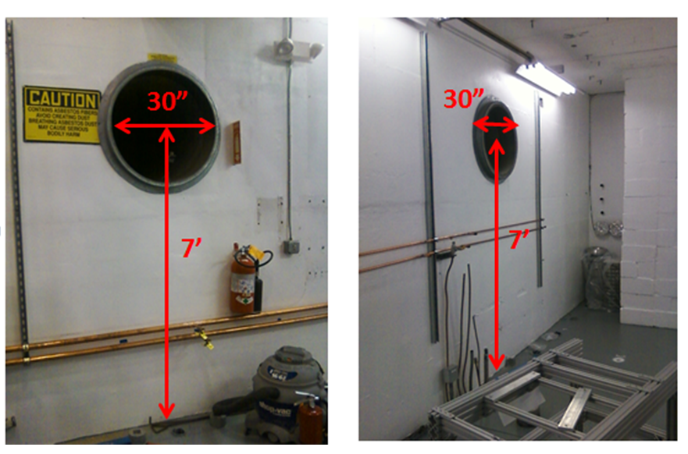
Figure 8 (Left) Fan with a capacity of 7400 CFM vents air into the high bay area, (middle) fan with a capacity of 4400 CFM vents air to outside the test lab

As mentioned above in the section related to Shielding, two penetrations serve as vent holes should the Cave1 enclosure fill with helium gas. Above the cave, these penetrations have “chimney stacks” attached, to direct the light helium gas safely above the heads of occupants who might be working atop the Cave1 enclosure. Packing foam fills the remaining penetrations, to block the free flow of helium gas to the electronics racks located above, where personnel might be working.

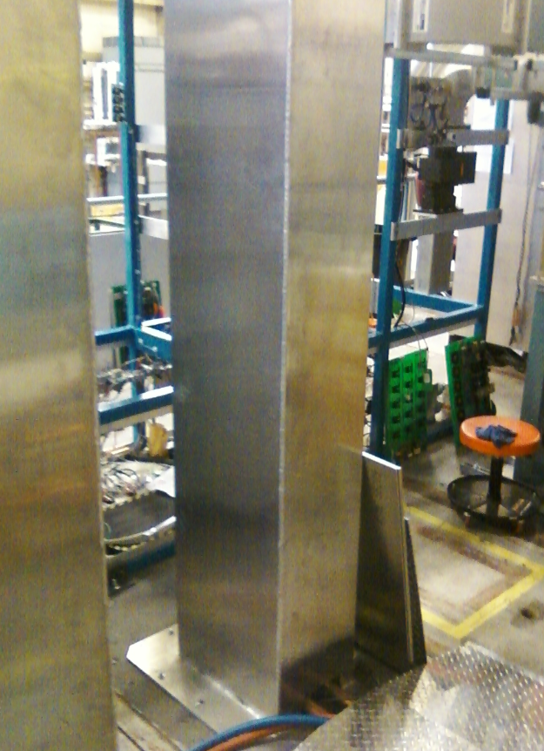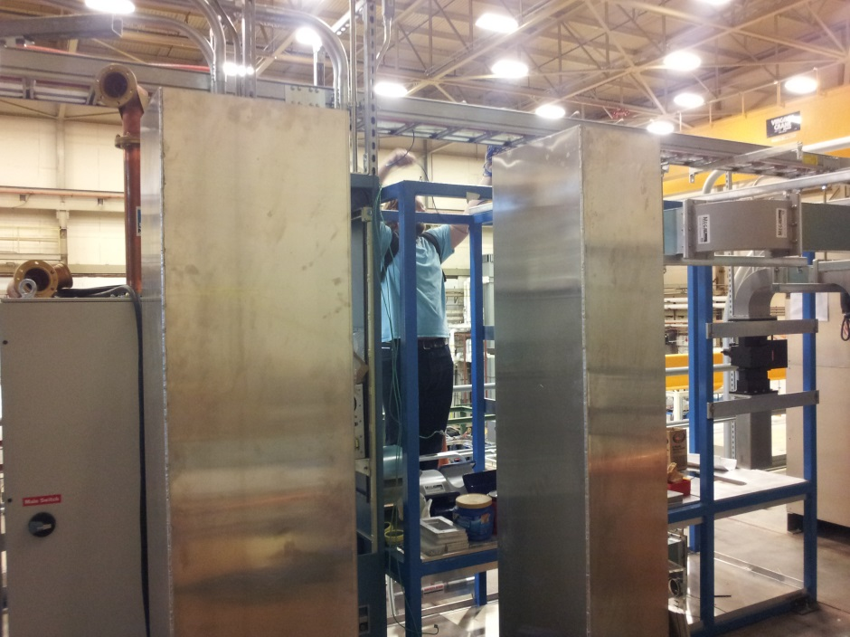
Figure 8, right two chimneys attached to square vent holes in the ceiling of Cave 1 will direct helium gas above the heads of staff members working near the electronics racks above Cave1

There is a passive 5.6 m² vent beneath the raised roof of Cave 2 (Figure 9) to vent lighter than air cryogens into the high bay area in the unlikely event of an equipment failure of experimental targets (e.g. HD-Ice).
.

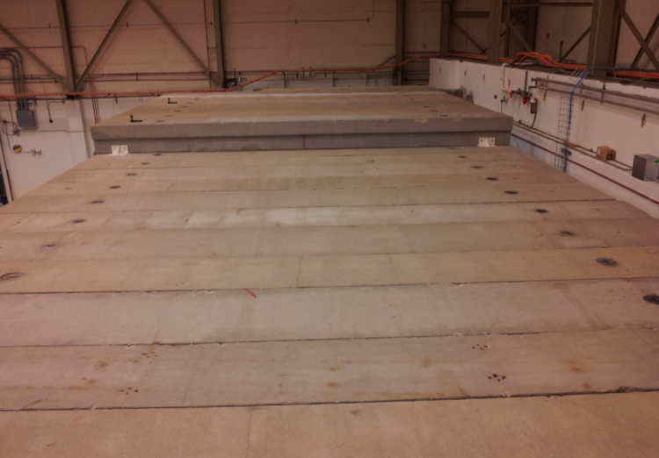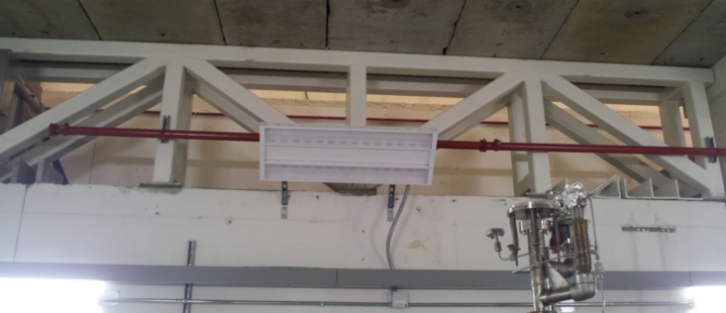
Figure 9 (Left) Shielded elevated-roof section of Cave 2, which will be used for experimental targets, including cryogenic targets. (Right) 5.6 m² Vent area beneath the elevated roof section of Cave2, for lighter than air cryogenic gases to escape.

There are three main vent pathways by which helium gas can escape from the QCM, and each vent pathway is located on the QCM vent stack: a) circle seal relief which Opens at 17 psi, b) a parallel plate relief valve which Opens at 43 psi and c) a burst disk which Opens at 51 psi. See Figure 10, below.

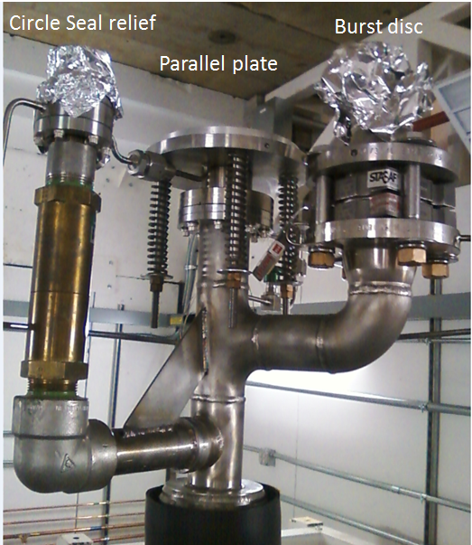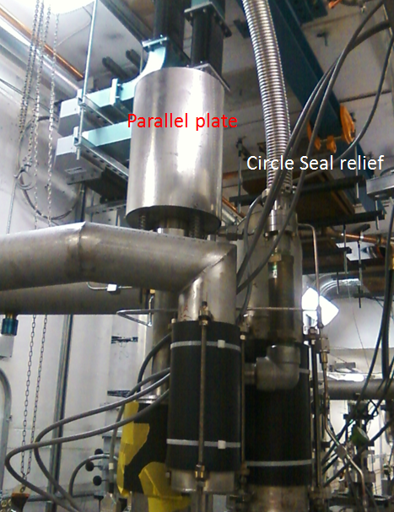
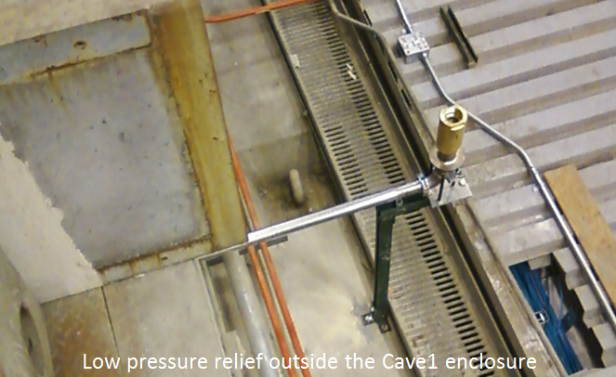
Figure X: top left shows the three relief ports on the CQM vent stack. Top right shows the deflector sheet metal attached to the parallel-plate relief which would direct gasesous hlium upward and not toward occupants inside the UITF enclosure. This figure also shows piping attached to the exhaust port of the circle seal relief which would direct vented gas out of the UITF enclosure, bottom photo. The extra circle seal relief valve attached to this piping leading outside the UITF enclosure permits evacuation of the line as required for 2K operations, but OPENS at just 0.5 psi in case there is a vent incident.

If a vent incident should occur, the circle seal relief would OPEN first. For this reason, the exhaust of the circle seal relief is piped outside of the UITF enclosure. Sheet metal wrapped around the parallel-plate relief serves to direct gaseous helium upward, and not toward personnel walking near the QCM.
  - Pressure / Vacuum
The evacuated QCM is considered a Category 1 vacuum system, per Part 7 of the Pressure Safety Supplement, because there cryogenic fluids are used. A pressure vessel assessment of the QCM has been conducted and….

  - Other (Electrical, ODH, Trip, Ladder) (Attach related Temporary Work Permits or Safety Reviews as appropriate.)
See above, Ventilation section. The ODH assessment for the UITF is attached. It is deemed “preliminary” until ….. This assessment can be found at:
https://jlabdoc.jlab.org/docushare/dsweb/Get/Document-135009/UITF%20prelim_%20ODH%20assessment.pdf

The potential hazards associated with the UITF operations include electrical/electrocution, non-ionizing radiation (RF), ionizing radiation, vacuum, ODH, and material handling concerns. These hazards and their mitigation are covered in the attached Task Hazard Analysis.

- List of Safety Equipment:
  - List of Safety Equipment:
- Safety glasses when performing mechanical work, as needed
- Gloves depending on mechanical or shielding work
- Hard hats and/or steel toed boots depending on materials handling needs
- Laser safety goggles, as required by LOSP (ACC-17-64784-LOSP)
  - Special Tools:
n/a
- Associated Administrative Controls
- Safety Systems Group staff is responsible for:
  - PSS administrative and engineered controls
  - Training on access controls and sweep procedures

- Radiation Control Department staff is responsible for:
  - Maintenance and calibration of fixed interlocked and hand held radiation monitors
  - Area and personnel dosimeters
  - Radiation surveys
  - Assigned Radiation Monitor Training (if needed)

- Center for Injectors and Sources (CIS) staff is responsible for:
  - Ensuring that valves on either side of QCM are forced CLOSED, with controls disabled to prevent opening of valves
  - Posting signs and barrier at Top of Cave1

*Administrative controls includes: Authority/responsibility, Procedures, Postings, and PPE

- CIS personnel are responsible for safe operation of the UITF.
- UITF’s PSS logic manages the two door switches and the Run/Safe Boxes to provide an “Area Secure” signal to the PSS logic
- The CARMs/radiation probes are interlocked to the PSS.
- High power RF (for buncher and ¼ cryomodule) is interlocked to the PSS

DEVELOP THE PROCEDURE
- Operating Guidelines
The UITF’s QCM commissioning procedure is described by this Operational Safety Procedure, which addresses hazards associated with maintenance and operation and their mitigations through engineered and administrative controls. Fault conditions in the UITF can produce only local work area impacts.

Staffing
The UITF can be operated by a single trained and authorized user (typically the personnel conducting gun and/or beam studies).

UITF Operation
PSS state for the UITF is either: Open Mode (open access), Sweep Mode, Ready Mode and Run Mode. Ready Mode is an internal (logical) mode confirming that all interlocks are ready for transition to Run Mode.

Prior to QCM commissioning, the laser bypass key must be returned to the PSS console in the Control Room in order to energize the gun high voltage power supply. In addition, the UITF must be placed in Open Mode using the Personnel Safety System (PSS) and the doors must be properly configured (i.e., closed). The sweep procedure is described in Section 11.

UITF Operator Requirements
In addition to the training listed in section 4.4, the UITF operator must:
- Read and understand this OSP that includes PSS sweep procedures,
- Receive the practical training on this OSP and on UITF operational procedures from system owner (Matthew Poelker or designee)
- Perform walkthrough of the following areas: UITF control room and Cave 1 roof where the electronics racks are located.
- Notification of Affected Personnel (who, how, and when include building manager, safety warden, and area coordinator)
Safety: UITF Safety Warden, John Hansknecht 269-7097
UITF system owner: Matthew Poelker, office 269-7357, cell. 757-897-9408
- List the Steps Required to Execute the Procedure: from start to finish.

QCM in position at Cave1

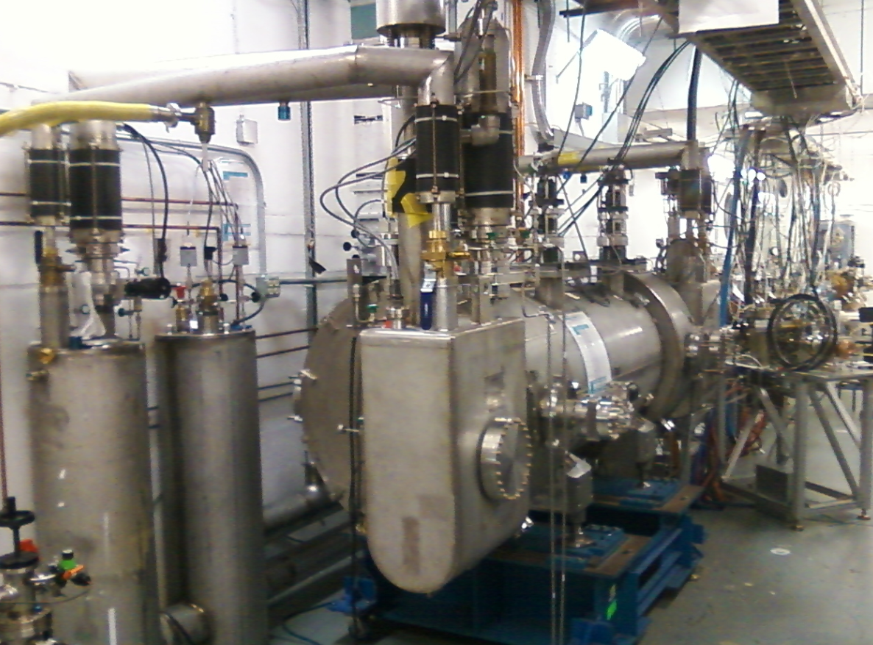

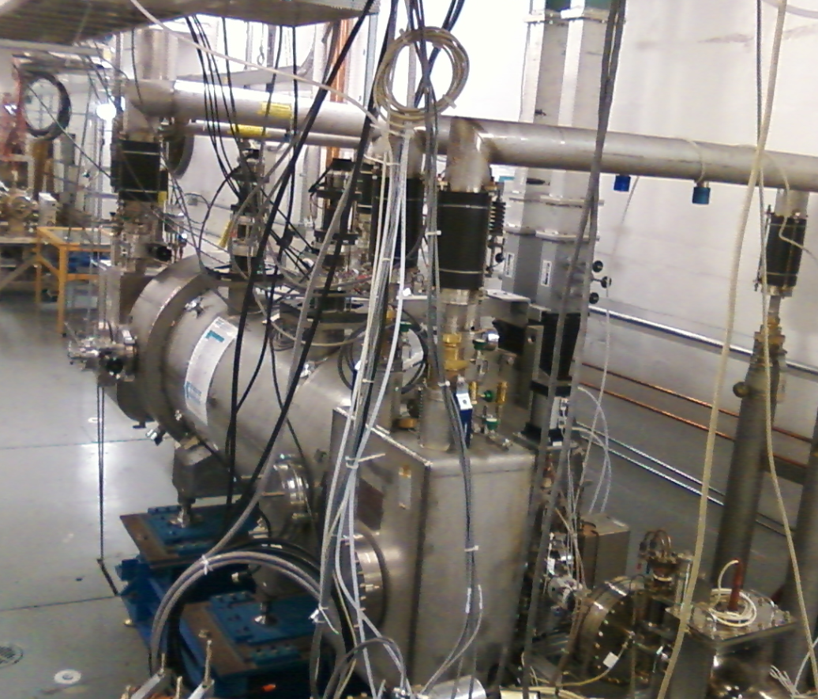
Figure 10 The QCM in position at Cave1 of the UITF, with u-tubes “stabbed” and waveguides connected.

General

Operating Protocol

The following are general operating guidelines to be followed when using the test area for radiation producing experiments. Refer to the Conduct of Operations document for details.
One qualified System Operator, normally the Duty Operator, must be present in the facility during all high power RF operations. Their names are displayed on the control desk and entered in the CMTF electronic logbook.
- Only authorized personnel shall be permitted to enter the test area to make changes in the apparatus. Authorization must be obtained from the Duty Operator, Principal Investigator or Test Coordinator.
- The Duty Operator is responsible for ensuring safe operation in accordance with the OSP during attended high power RF operations. All personnel entering any Radiologically Controlled Areas shall carry Personal Dosimetry.
- Any staff member has the responsibility to report to the Principal Investigator or the Duty Operator on issues of safety. If there is no Duty Operator assigned at the time of the event, the staff member shall contact the Test Coordinator, Facility Manager or their designee. An on-call list is posted in the control room to address off-hour conditions. If the issue cannot be resolved at this level, operation shall cease until such time as the issue is resolved.
- Response to any emergency, accident condition, or injury shall be coordinated with the site security, phone extension 5822.
- The control room must be attended when high power RF is on. High voltage operations may be left unattended for brief break periods. (See Table 5 for Staffing Requirements.)
- One-person operation of the cryomodule test facility is permitted from the control room or in the cave when the cave ODH status is ODH 0.
- The Test Coordinator or his designee must be on call for emergencies.

Cryomodule test cave waveguide shutter WR650 (1497 MHz) waveguide switch

- The waveguide shutter switches located in the test cave provides a second level of assurance that high power RF is not routed to an open waveguide located beyond said shutter. The WR650 waveguide shutter switches are located in the second floor area of the cryomodule test cave. They are approximately 4 feet off of the floor adjacent to the south wall. One switch removes power from cavities 1, 3, 5 and 7. The second switch removes power from cavities 2, 4, 6, and 8. Cavity 1 is on the equipment door end (west) of the cryomodule test cave. These shutters are not currently used as LOTO points. When it is necessary to work on an open waveguide, LOTO must be applied directly to the circuit breakers controlling AC power to the high power amplifier in question.

Post High Power RF testing (Shutdown):
- 1497 Klystrons
  - First, change state of Klystron Power Supply to “RF Off”, then to “High Voltage Off”.
  - Locate the AC circuit breaker panel behind the 1497 MHz racks and switch to the “Off” position and lock out with administrative lock. See Figure 3.

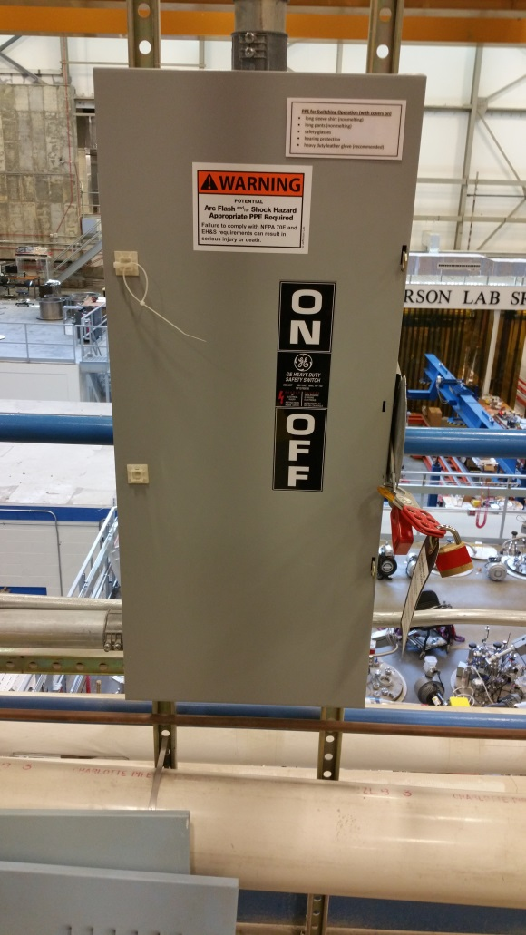
Figure 3: 1497 HPA AC Circuit Breaker

The following describes QCM commissioning procedure:

Procedure:
Inside the UITF
- Verify that valves on either side of the QCM are CLOSED and cannot be opened via EPICS (i.e., the compressed air line is NOT attached to the OPEN spigot of the valve)
- The following is an overview of the PSS sweep. Use the complete detailed sweep procedure and map attached to this OSP. A copy will also be maintained in the Control Room.
- Post the top (mezzanine) of Cave 1 as a restricted area
- Inform all occupants to leave the UITF enclosure
- Close both doors
- Go to control room and turn key to SWEEP
- Enter the enclosure through the back door, close door behind you upon entry
- Arm RunSafe Box601 in the hallway
- Sweep the enclosure, walking all the way to the north wall of Cave2
- Verify the Faraday Cup is locked in place, and the valve to the ¼ cryomodule is locked CLOSED
- Arm RunSafe Box602 near labyrinth exit
- Exit through the labyrinth closing screen gate door completely
- Return to control room, turn key to RUN to arm the Personnel Safety System

In the Control Room
- Turn ON the QCM…..

Shielding Verification: In advance of QCM commissioning, Contact the Radiation Control Group to verify shielding.

- Back Out Procedure(s) i.e. steps necessary to restore the equipment/area to a safe level.
At any time during UITF operations, the PSS can be brought to OPEN Mode Access, in case there is a need for accessing the enclosure or to conclude high voltage operations.

Returning the PSS to OPEN Mode in normal operating conditions
- Turn off the gun HVPS from the EPICS control screen
- Turn OFF the buncher RF from EPICS control screens
- Switch the key to “OPEN” mode
- De-post restricted area on mezzanine

- Special environmental control requirements:
  - List materials, chemicals, gasses that could impact the environment (ensure these are considered when choosing Subject Matter Experts) and explore EMP-04 Project/Activity/Experiment Environmental Review below
  - Environmental impacts (See EMP-04 Project/Activity/Experiment Environmental Review)
  - Abatement steps (secondary containment or special packaging requirements)
- Unusual/Emergency Procedures (e.g., loss of power, spills, fire, etc.)

Returning the PSS to OPEN Mode in case of emergency or any other abnormal conditions
At any moment the PSS Safety Crash buttons can be depressed. This action will cut off the gun high voltage power supply, turn OFF high power RF, and will close the laser shutter if those systems are operational. It will also crash the sweep and will force unlock the doors.

Since ionizing radiation is present in the enclosure only when the gun is at high voltage, depressing any of the PSS RunSafe or Control Room crash buttons will restore the area to a safe level. NOTE: the emergency exit crash switch will only release the local door lock.

The following is a list of currently installed alarms:

- ODH (blue strobe + buzzer)
- Fire (white strobe + high pitch)
- SF6 pressure sensor on Glassman high voltage power supply SF6 tank
- Potential prompt radiation (magenta strobe beacon and 30 second siren)

The expected response to any of the alarms is to evacuate the UITF enclosure immediately and proceed to the high bay area of the Test Lab

Return to normal operations occurs when alarms are cleared by the following personnel:

- ODH cleared by SSG or CIS Staff
- Fire cleared by Facilities Management
- SF6 CIS staff, SF6 custodian, UITF Safety Warden responsibility

Comments regarding SF6 hazards: The 45 lbs of SF6 that resides inside the high voltage power supply vessel would occupy 3.2 cubic meters if it were instantaneously released, compared to 207 cubic meter volume of Cave1. Since SF6 is about 5 times heavier than air, it will accumulate on the floor when released from the high voltage power supply vessel. It would reside within a layer less than 1” thick on the floor. However, if it fully mixed with air in Cave 1, the oxygen concentration would fall to ~ 20.5% which is not deemed hazardous (normal oxygen content of 21%). Accounting for the 4400 cfm exhaust fan, it will take ~ 45 minutes to remove all SF6 from the cave (assuming good mixing in the Cave). This time interval does not allow enough time for personnel to exceed the 8-hour exposure limit of 1000ppm. The estimated 8-hour average exposure concentration would be ~ 572ppm.
If the ventilation fan is not operating inside the UITF enclosure, the SF6 will remain along the floor. In this case, personnel are not allowed to work on the floor in case of known leaks.

Other emergency procedures not covered by alarms are:

- Ventilation failure. Expected Response is to evacuate area immediately and convene at muster point.

- Personnel inside UITF enclosure AND the doors are locked. NOTE: This event should never occur if proper sweep procedures are followed. Expected response is to proceed to the nearest Run/Safe Box and press the crash button. Each door has a local crash out button the will release its lock to allow exit. Opening the door will drop the PSS to OPEN mode.

- Electrical Power failure and in case of personnel trapped inside UITF enclosure. Personnel Entrapment should never occur if proper sweep procedures are followed. PSS system will unlock the doors (Electrical power maintains the locks, loss of power unlocks – fail/safe mode)

Notifications:
UITF Safety Warden, John Hansknecht 269-7097
UITF system owner: Matthew Poelker, office 269-7357, cell. 757-897-9408
ODH, Fire: Guard gate 269-5822
Other Emergencies: Guard gate 269-5822

- Instrument Calibration Requirements (e.g., safety system/device recertification, RF probe calibration)
- Inspection Schedules
PSS certification will happen twice per year, scheduled by SSG
- References/Associated/Relevant Documentation
Task Hazard Analysis
UITF ODH assessment – preliminary
Pressure vessel assessment of QCM?
- List of Records Generated (Include Location / Review and Approved procedure)
Operations logbook (electronic)

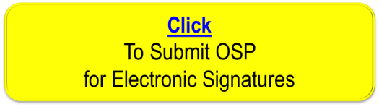
Distribution: Copies to Affected Area, Authors, Division Safety Officer
Expiration: Forward to ESH&Q Document Control

Form Revision Summary
Revision 1.4 – 06/20/16 – Repositioned “Scope of Work” to clarify processes
Qualifying Periodic Review – 02/19/14 – No substantive changes required
Revision 1.3 – 11/27/13 – Added “Owning Organization” to more accurately reflect laboratory operations.
Revision 1.2 – 09/15/12 – Update form to conform to electronic review.
Revision 1.1 – 04/03/12 – Risk Code 0 switched to N to be consistent with 3210 T3 Risk Code Assignment.
Revision 1.0 – 12/01/11 – Added reasoning for OSP to aid in appropriate review determination.
Revision 0.0 – 10/05/09 – Updated to reflect current laboratory operations
ISSUING AUTHORITY | FORM TECHNICAL POINT-OF-CONTACT | APPROVAL DATE | REVIEW DATE | REV.
ESH&Q Division | Harry Fanning | 06/20/16 | 06/20/19 | 1.4
This document is controlled as an on line file. It may be printed but the print copy is not a controlled document. It is the user’s responsibility to ensure that the document is the same revision as the current on line file. This copy was printed on 2/7/2018.

