- Generation and Characterization of Magnetized Bunched Electron Beam from a DC Photogun for JLEIC Cooler
Principal Investigators: Riad Suleiman and Matt Poelker

Project Status
During the first half of FY18, we made significant progress characterizing relatively low bunch charge magnetized beam. We measured beam magnetization as a function of gun solenoid current and developed particle tracking code simulations that predict measured values with reasonable accuracy, but only after improving our magnetic field model along the beamline and the electrostatic field map of the photogun cathode/anode gap. See figure below
We installed a green-light laser with rf-pulse structure that is powerful enough to generate many tens of millimapers of magnetized beam, and based on a gain-switched master oscillator. The laser is very reliable, operating stably for the last six months without intervention.
We completed the design of a TE₀₁₁ RF cavity that we hope is sensitive to beam magnetization, providing a non-invasive monitor of the beam’s orbital angular momentum. Cavity drawings were sent to an outside machine shop for fabrication. Machined parts will be returned to Jefferson Lab for brazing.
We encountered a significant setback resulting in a ~ three-month long delay to the project. After more than 1400 hours of reliable operation at 300 kV, the photogun insulator suffered a high voltage arc that punctured the insulator and necessitated complete replacement. The insulator was replaced and the photogun is presently being baked to achieve acceptable vacuum conditions.
Because of the photogun insulator failure and associated three-month delay, we cannot complete all of the tasks outlined in our original plan within the time remaining. Specifically, there is not enough time to study round-to-flat-beam transformations.

Project Plan
In the time remaining, we will focus on the following tasks:
- Restore photogun operation and measure beam emittance and magnetization versus gun solenoid magnetic field for different laser beam sizes at photocathode. Verify that magnetization scales with laser beam size. Compare measured and predicted values using simulations codes developed previously.
- Demonstrate magnetized beam production at very high average current (32mA) and bunch charge approaching 0.5 nC. Compare measurements to simulation.
- Use a regenerative laser amplifier to characterize the effect of space charge (bunch charge up to 3 nC) on beam magnetization. Again, compare measurements to simulation.
- Demonstrate that beam magnetization can be measured non-invasively using a TE₀₁₁ RF cavity.
These tasks represent the majority of the promised deliverables of this three-year LDRD project, with the most important being the production of magnetized beam at high average current and high bunch charge.

Budget
Before the photogun insulator failure, spending went largely per plan, with most of the budget devoted to scientific staff making beam based measurements. After the insulator failure, scientific staff continued to analyze the beam-size and magnetization/rotation data acquired before the insulator failure. Budget was assigned to staff of the SRF Institute to design the TE₀₁₁ RF magnetometer cavity. Procurements were submitted for a new ceramic insulator (to replace the damaged one), laser components to build the regenerative amplifier for nanoCoulomb demonstrations, and for copper to build the RF cavity beam magnetometer. See attached spending report for first half of FY18.

Publications
Three in progress: 1) 300kV DC High Voltage Photogun with Inverted Insulator Geometry, 2) Magnetized Beam from DC High Voltage Photogun, 3) Green Light RF-Pulsed Laser with Gain-Switched Diode Master Oscillator

Workshops/Conferences
M. Poelker, P. Adderley, J. Benesch, B. Bullard, J. Grames, F. Hannon, J. Hansknecht, C. Hernandez-Garcia, R. Kazimi, G. Krafft, M. A. Mamun, R. Suleiman, M. Tiefenback, S. Zhang, Y. Wang, S. Wijiethunga and J. Yoskovitz, Magnetized Electron Beam for JLEIC Re-circulator Cooler Ring, Invited Talk presented at XVII International Workshop on Polarized Sources, Targets & Polarimetry, Kaist, South Korea October 10 – 20, 2017.

Md Abdullah A Mamun, Philip Adderley, Jay Benesch, Don Bullard, Jean Roger Delayen, Joseph Michael Grames, Jiquan Guo, Fay Elizabeth Hannon, John Hansknecht, Carlos Hernandez-Garcia, Reza Kazimi, Geoffrey Arthur Krafft, Matt Poelker, Riad Suleiman, Michael George Tiefenback, Yan Wang, Shukui Zhang (JLab, Newport News, Virginia), Sajini Anushika Kumari Wijethunga (ODU, Norfolk, Virginia), Production of Magnetized Electron Beam from a DC High Voltage Photogun, Poster to be presented at IPAC’18, Vancouver, Ca, April 29 – May 4, 2018.

Yan Wang, Carlos Hernandez-Garcia, Md Abdullah A Mamun, Matt Poelker, Riad Suleiman, Michael George Tiefenback, Shukui Zhang (JLab, Newport News, Virginia), Geoffrey Arthur Krafft (JLab, Newport News, Virginia; ODU, Norfolk, Virginia), 300 kV DC high voltage photogun with Inverted Insulator Geometry and CsxKySb, Poster to be presented at IPAC’18, Vancouver, Ca, April 29 – May 4, 2018.

Sajini Anushika Kumari Wijethunga, Jean Roger Delayen (ODU, Norfolk, Virginia), Jay Benesch, Fay Elizabeth Hannon, Md Abdullah A Mamun, Matt Poelker, Riad Suleiman (JLab, Newport News, Virginia), Geoffrey Arthur Krafft (JLab, Newport News, Virginia; ODU, Norfolk, Virginia), Simulation Study of Magnetized Electron Beam, Poster to be presented at IPAC’18, Vancouver, Ca, April 29 – May 4, 2018.

Jiquan Guo, Gary Guangfeng Cheng, Fredrik Fors, James Henry, Matt Poelker, Robert Rimmer, Riad Suleiman, Haipeng Wang (JLab, Newport News, Virginia), A Non-Invasive Magnetic Momentum Monitor Using a TE011 Cavity, Poster to be presented at IPAC’18, Vancouver, Ca, April 29 – May 4, 2018.

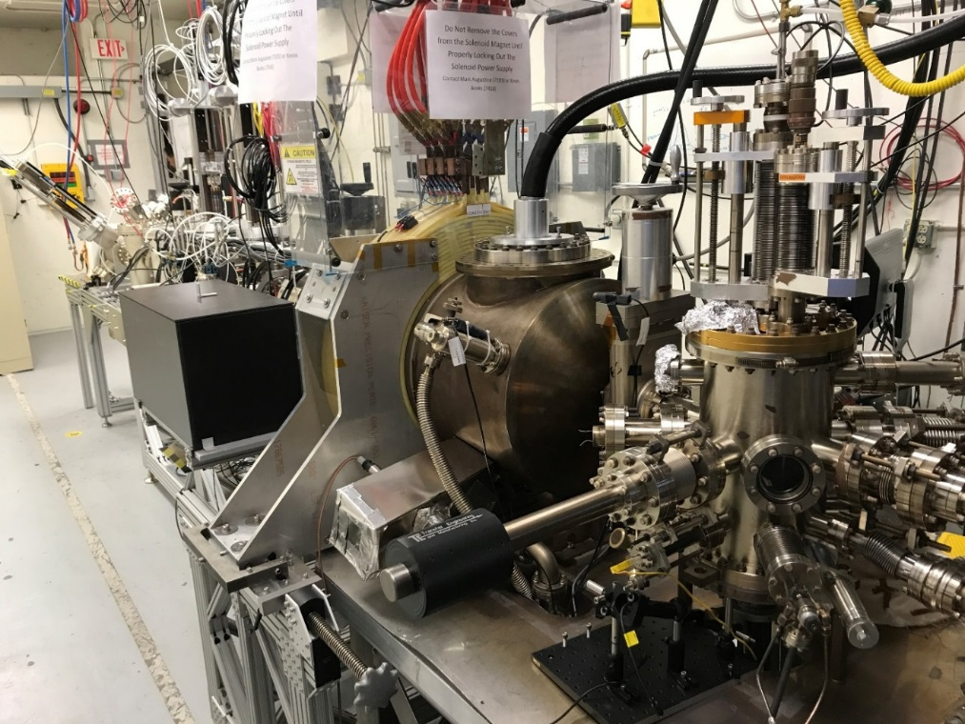
Magnetized photogun and beamline at the GTS

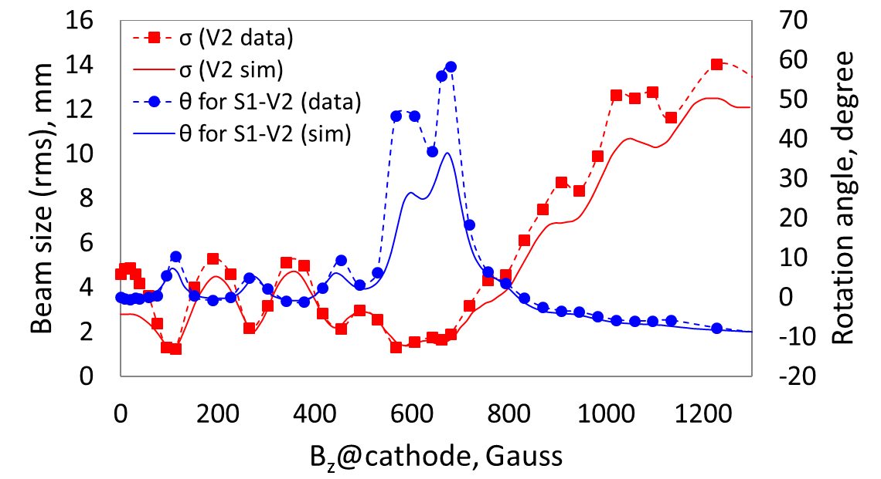
Experimental measurements of beam size at second viewer (red) as a function of magnetic field at photocathode compared to ASTRA simulation (solid line). The discrepancy at zero Gauss is due to inadequate 3D electrostatic field map. Blue: Rotation angle measured with slit and viewer compared to simulation.

