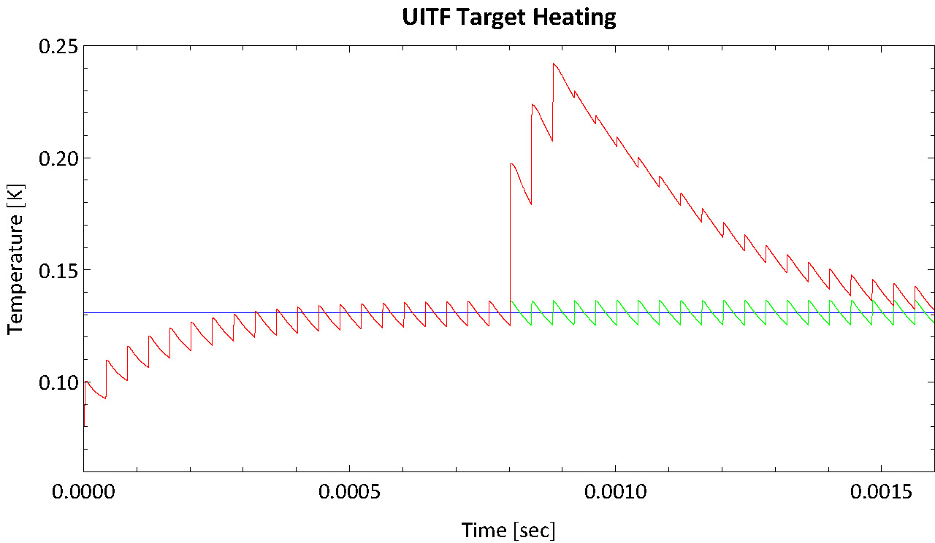

It has been suggested that the UTIF beam could be periodically (60Hz) enhanced (x10) for a short period of time (100 usec) in order to make the beam visible to the available BPM’s. The interaction of the HD target, its raster and the beam is a complicated question which we can only approximately calculate. The blue line (0.131 K) in the plot above is the calculated temperature at the far end of our current target design (19mm dia., 12.5mm len., 25.5mm offset, 1080 wires, 3mil dia.) when subjected to a constant 1 nA beam uniformly distributed over the front face, assuming a temperature of 0.080 K at the mixing chamber(0.5 mW).
Of course, what we actually have is a 25 KHz raster that sweeps a small beam spot (2mm dia assumed) over the target every 40 usec. Thus any particular column through the target will see a pulse every 40 usec, causing a quick rise in temperature followed by a relaxation back down. This results in a sawtooth oscillation (green line) around the equilibrium (blue line). Note that the numerical solution to the differential equations has been started with no beam, everything at the mixing chamber temperature, so that 0.5 msec or so is required for the temperature to build up to equilibrium with these small pulses.
The proposal of a 100 usec enhancement period corresponds to 2.5 raster periods so half the target will see 3 enhanced pulse while the rest only 2. The red curve shows the effect of 3 pulses enhanced by a factor of 10 after 20 normal pulses. Note that the effect of 2enhanced ones is easily interpolated from the plot. Roughly the effect of the pulses is to raise the temperature by 70 to100 mK for 0.3 to 0.5 msec. At 60 Hz repetition rate, this represents 2 to 3% of the time.
We do not have any direct measurement on the temperature dependence of the depolarization process but we believe it is linearly dependent on the number of wrong spin electrons on the atomic hydrogen created by the beam. The increase in the number of these wrong spin electrons is a factor of 66.5 in going from 0.131 K to 0.240 K. Assuming that exists for 3% of the time results in triple the rate of decay or a reduction in the lifetime by a factor of 3.
There is an important caveat to this, however. Up till now we have assumed all the energy deposited by the beam immediately appears as thermal heating. In our previous tests with electron beams we observed that heat continued to appear for many minutes after the beam was removed, only slowly decaying away. We have interpreted this as due to the dissociation of HD molecules, creating a population of atomic H and D that only re-associated on a time scale of many minutes. It appears that 70 to 90% of the energy deposited goes into this stored chemical potential energy, so that beam current fluctuations are heavily filtered.
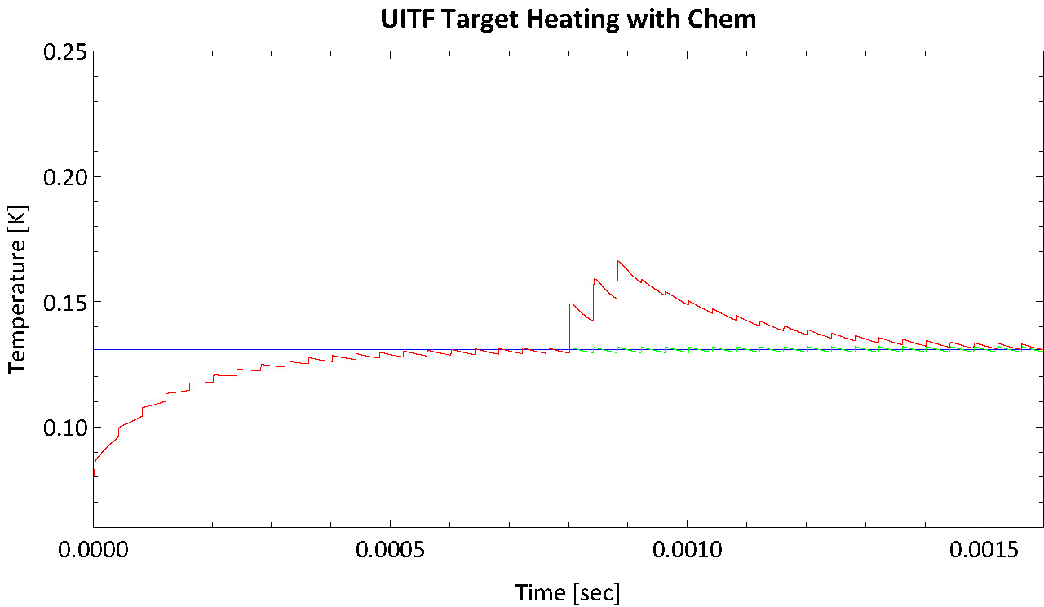
This plot shows the heating when we assume only 20% of the beam energy goes into prompt heating and the rest is released at a constant rate. Now the enhanced pulses lead to only a 40 mK rise and the wrong spin population only rises by a factor of 8.4. If present for 3% of the time, this means an increase in the rate of de-polarization by 25% and a lifetime 80% of that without the enhanced pulses.

