I/Q Demodulator Performance: 09/06/16
The receiver below was developed to measure a 2495 MHz signal coupled from the ring coupled cavity polarimeter, and compare it to the accelerators 499 MHz sinusoidal clock. To measure the receivers pre-experimental performance, a 2495 MHz sinusoidal source was phase modulated 180 degrees at 1 kHz, 500 Hz, and 30 Hz and then attenuated before entering the receiver’s input.

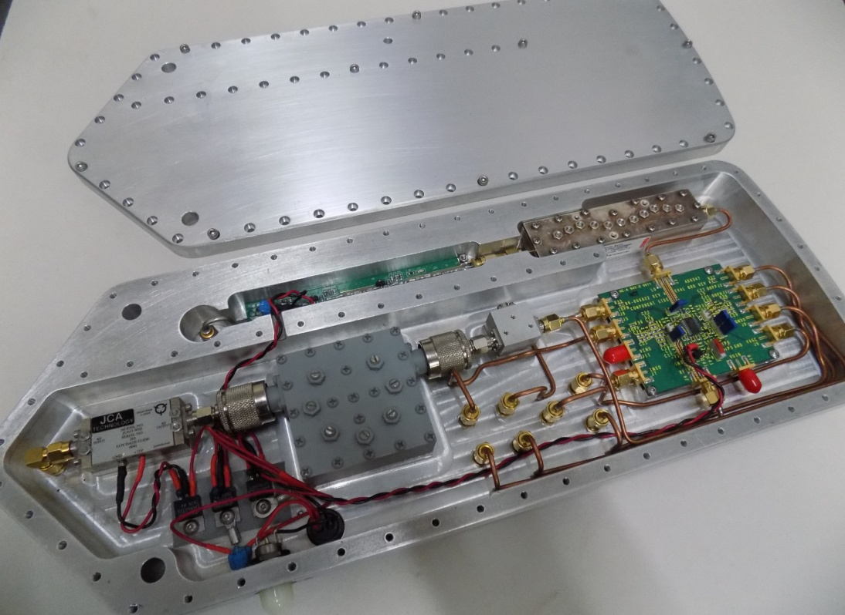
180 degree phase modulation @ 1 kHz :
The four plots below show the measured phase while the input is phase modulated 180 degrees at 1kHz and attenuated to -100 dbm, -110 dbm, -120 dbm and -130 dbm. The yellow trace is the received signal strength indicator (RSSI) that is AC coupled. A measurement of RF power can be made using the offset level of the RSSI, the number in the lower left (yellow) box on the oscilloscopes screen. As can be seen that the receiver is able to make phase measurements even as the RSSI voltage bottoms out at about -110 dbm.
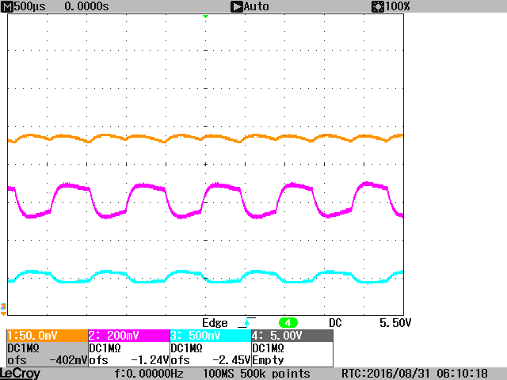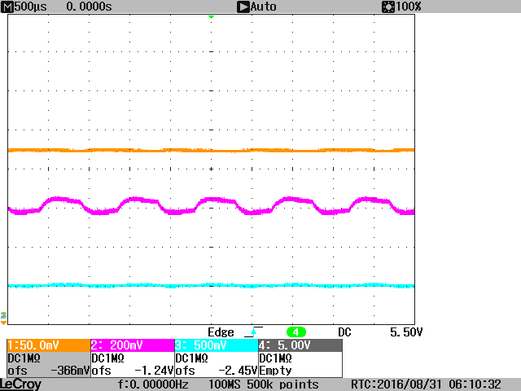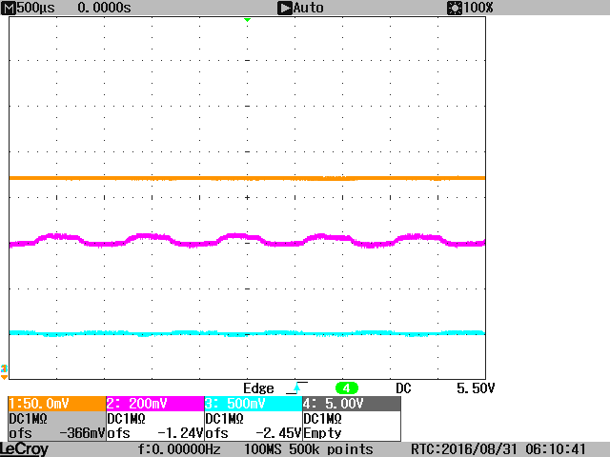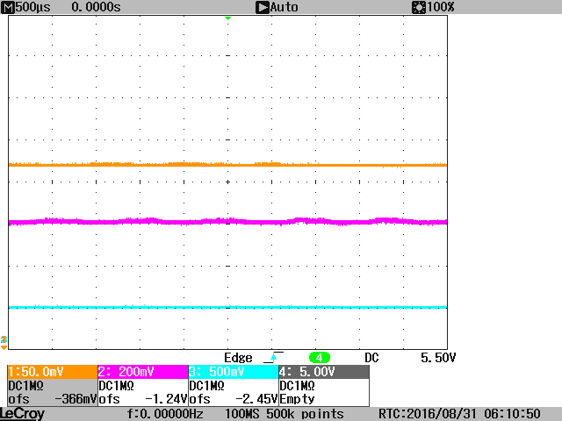
180 degree phase modulation @ 500 Hz (-100 dbm, -110 dbm, -120 dbm and -130 dbm):
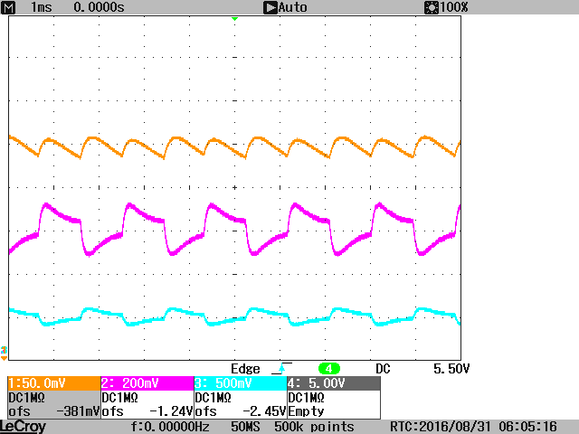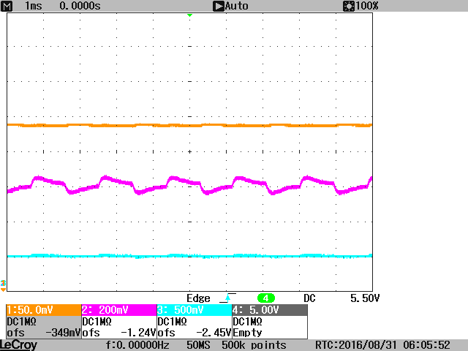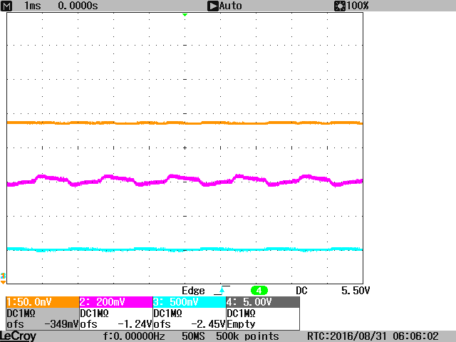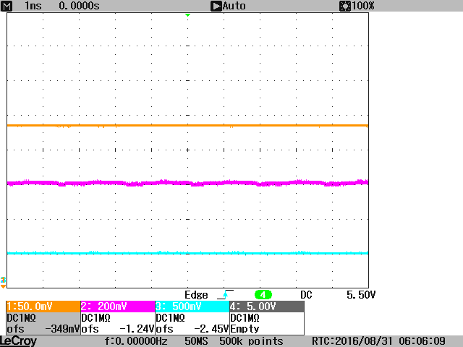

180 degree phase modulation @ 30 Hz (-100 dbm, -110 dbm, -120 dbm and -130 dbm):
