Booster Cryomodule Microphonics in the UITF
Tom Powers, Peter Owen
Data taken Dec. 2021
Summary
Background microphonics were taken continuously for 8 hours on 7 Dec. 2021 and for 3 hours on 9 Dec. 2021. On the second day two accelerometers were placed on the cryomodule one on the JT valve assembly and one on the cavity 2 tuner motor. These were used to try to correlate transient microphonics with operation of said devices. The detune phase DETA2 was measured for each cavity and was sampled at 3 kS/s. The data files were one hour each and there was a break of a few hundred milliseconds between data files.
The background microphonics where larger than nominally expected for cavity 1. However, due to the low operating gradient and the low loaded-Q the cavity should operate well with the planned 600 W RF source. Cavity 2 had very good average microphonics which should not cause problems in CEBAF. It is expected that both cavities will have reduced microphonics when installed in CEBAF as compared to the UITF. There was an anomalous measured cavity detuning (difference between RF drive phase and field probe phase) on cavity 2 which occurred every 5 to 10 minutes. It was large enough that it would easily lead to a cavity trip. The source of this signal is not understood. For a certain fraction of the events the cavity did show some indications of residual vibrations after the event. The initial transient was very fast and large. Typically, they were several hundred Hertz and from time to time exceeded 1 kHz of frequency shift in time scales less than 300 us. This type of event has not been seen in CEBAF, the CMTF or in the FEL. If it is real and cannot be mitigated the cavity will trip every time such an event occurs.
Cavity 1 had transient microphonics that were correlated to JT valve operation as indicated by the signal from an accelerometer that was placed on the JT valve. These microphonic frequency shifts often exceeded 100 Hz. Cavity 2 did respond to its tuner being operated but the increase in microphonics was minimal.
Typical RMS and peak microphonics, excluding the anomalous transient in cavity 2 and the two tuning events on cavity 1 are shown in table 1.
Cavity | RMS Microphonics  No Transients | Peak Microphonics  No Transients | Peak with Transient Microphonics | Anomalous  Transient
1 | 15.5 Hz | 50 Hz | >125 Hz | NA
2 | 6.2 Hz | 27 Hz | >35 Hz | >1100 Hz
Table 1. Summary of microphonics measured on 7 and 9 Dec. 2021.
Cavity | RMS DETA2 | Peak DETA2 with Transients | DETA2  Anomalous Transient
1 | 8° | 39°
2 | 4.9° | 23.4° | 170°
Table 2. Summary of detune phase DETA2 measured on 7 and 9 Dec. 2021.
Background microphonics were taken in GDR mode by recording the detune angle (DETA2) which is available on the front of the field control chassis (FCC). DETA2 is the difference between the phase of the RF drive signal (CRFPP) minus the phase of the probe signal (PMES) minus an offset (TDOFF), The offset is chosen such DETA2 is zero when the cavity is at the machine reference frequency. This can be converted to detune frequency. DETA2 is converted to frequency shift using the following equation.
$$deltaF=\frac{f_{0}}{{2Q}_{L}}Tan\left(DETA2\right)$$
where deltaF is the frequency shift from the reference frequency, $f_{o}$ is the reference frequency of the cavity and $Q_{L}$ is the loaded-Q of the cavity which is typically measured using the decay time of the reflected power after the RF has been turned off or the 3 dB bandwidth of S21 from the fundamental power coupler to the field probe. While the frequency of the cavity is easy to know to a fraction of a percent the loaded-Q is subject to errors that can easily be ±25% due to standing waves causing constructive or destructive interference at the reference plane of the cavity. This is explained in detail in reference [1] A better approach which will be used the next time that data is taken is to operate the system in SEL mode in which case the frequency shift is independent loaded, RF power, etc. and is given by.
$$f_{i+1}=\frac{1}{2π\left(Q_{i}^{2}+I_{i}^{2}\right)}\left(Q_{i}\frac{I_{i+1}-I_{i}}{∆t}-I_{i}\frac{Q_{i+1}-Q_{i}}{∆t}\right)$$
Another measure of the effects of the combination of loaded-Q and is the magnitude of DETA2 with no beam loading as the RF power is given by:
$$P_{RF}=\frac{\left(β+1\right)L}{{4βQ}_{L}\left(r/Q\right)}{\left(E+Q_{L}\left(r/Q\right)I_{0}\right)}^{2}{+\left(E Tan(DETA2)\right)}^{2}$$
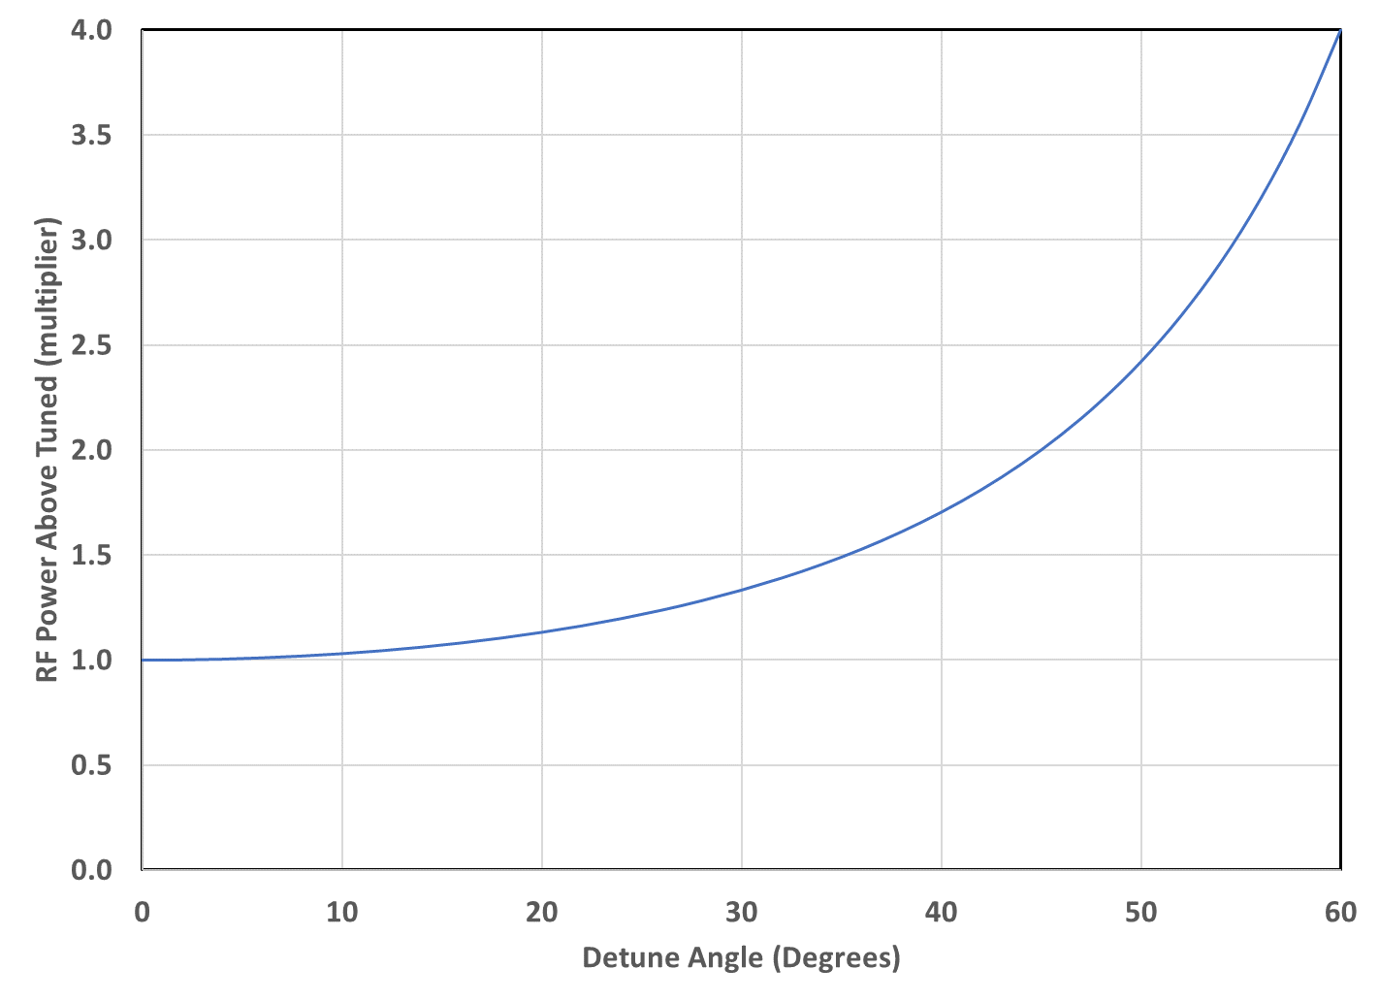
Figure 1. Additional RF power as a function of DETA2 with no beam loading.
The amount of additional power is shown in Figure 1. This additional power (in Watts) is constant depending on the loaded-Q and measured loaded-Q.
RF Power requirements.
In addition to microphonics there are two uncontrolled parameters that will affect the RF power required to operate the cavity. The first is the dead band in the tuner algorithm which for the old style RF systems is 10° and for the digital LLRF systems is 5°. The other parameter that is “uncontrolled” is the error in properly setting TDOFF. On a good day this parameter is within 5° of the proper phase offset. It is not unusual for it to exceed 10°. Figure 2 is a plot of the RF power required by the cavity for 200 uA of beam current and the peak microphonics that were measured in the UITF. The design value for the RF system is 600 W. Approximately 70 W of that power is lost in the waveguide and circulators another 30 W is a controls margin. At the design value of 2.2 MV/m 200 W of RF power will be required at the cavity coupler. If future optics required it the cavity could probably be operated at 3.5 MV/m with 200 uA of beam loading.
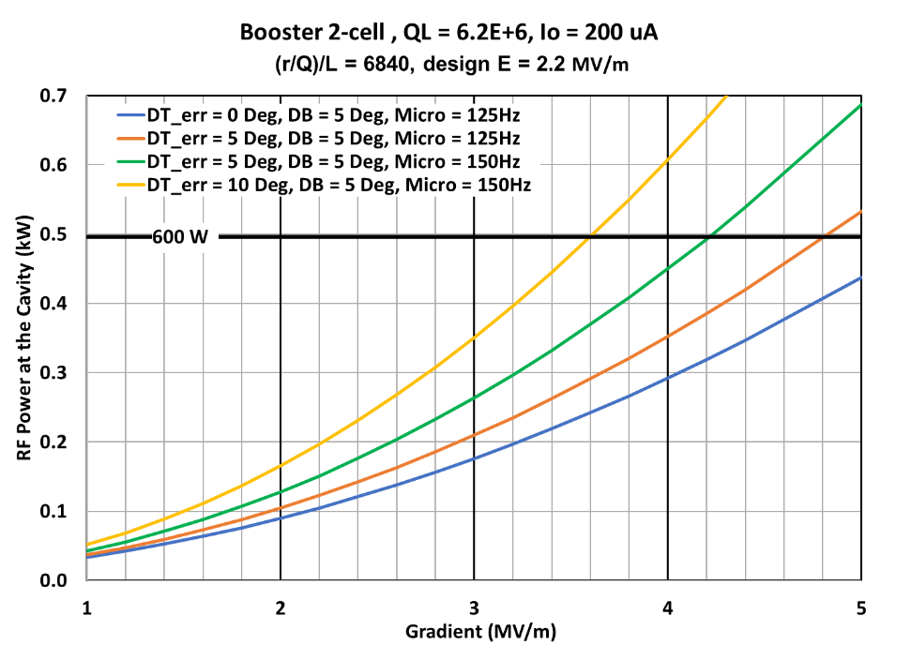
Figure 2. Calculated RF power required by the 2-cell cavity with 200 uA of beam current with various combinations of microphonics and detune errors.
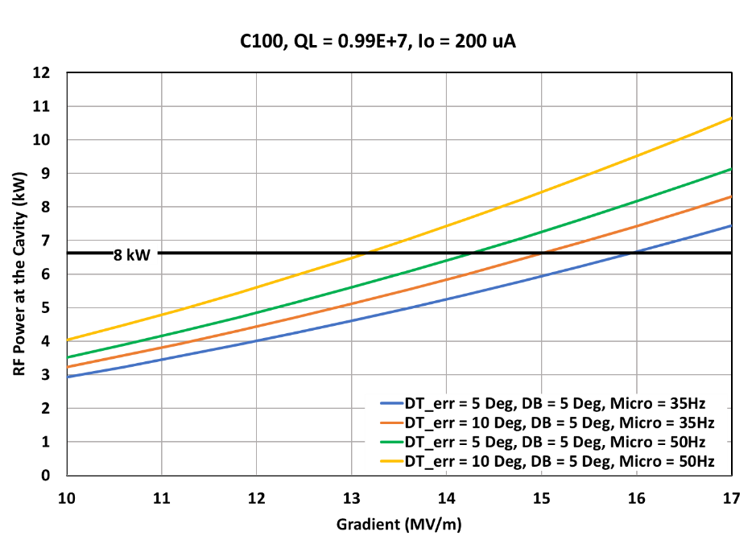
Figure 3 Required RF power as a function of gradient for cavity 2. The expected microphonics is 35 Hz. This assumes that we understand the transient signal that appears to be microphonics and if it is microphonics that we apply appropriate mitigations.
If the microphonics remain below 35 Hz peak when the cryounit is moved into the tunnel and the poorly understood transient events are resolved the cavity should be able to operate at a gradient between 14 MV/m and 15 MV/m when the zone is upgraded to an 8 kW klystron.
Data
The data was post processed to convert the DETA2 phase to cavity frequency shift. Also the one hour files were split into one-second intervals and the maximum excursion from zero was determined for each of the signals. Figures 4 and 5 show the peak values of DETA2 and deltaF respectively, for an hour beginning at 12:26 PM on 7 Dec. 2021. Figure 6 shows the peak accelerometer signals for each one second interval for 10 minutes starting at 13:54 on 9 Dec. 2021.
Two things can be learned from Figure 7. First is that the transient microphonics in cavity 1 are correlated with operation of the JT valve which was on the cavity 1 end of the cryomodule. Second it shows that the once every 5 minute transient on cavity 2 is not correlated with motion of the JT valve or the cavity 2 tuner. Figure 8 shows the finer structure of the JT valve vibration and the correlated frequency shift in cavity 1 with a slight increase in the high frequency content in the cavity 2 microphonics. Figure 9 shows the minimal impact that operation of the tuner on cavity 2 had on either cavity. Figures 10 demonstrates that the anomalous transient is not correlated to operation of the tuner on cavity 2 or the JT valve. Figures 11 through 12 show the fine structure of the transient events that are not well understood which will require further investigation. Figure 13 shows the frequency content of the background microphonics for the two cavities as well as that of the two accelerometers that were mounted on the JT valve and tuner motor respectively.
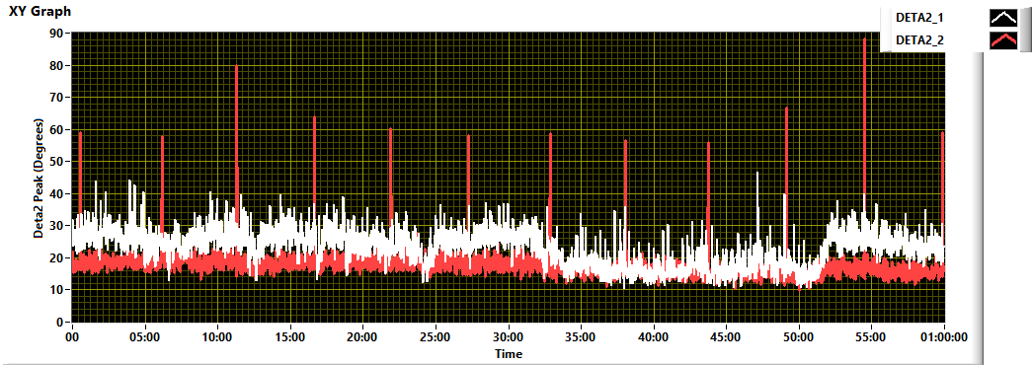
Figure 4. Typical Peak to peak DETA2 data for one second intervals for cavities 1 (white) and 2 (red).over a 1 hour period.
Figure 5. The same data converted to deltaF. Note that the point at 49 minutes has a value of 2300 Hz.
Figure 6. Peak to Peak accelerometer readings JT-Valve in the beam line direction (orange) and Tuner motor in the direction transverse to the beam line (blue). Data recorded once per second in one hour intervals. Plot shows 10 minutes of data.

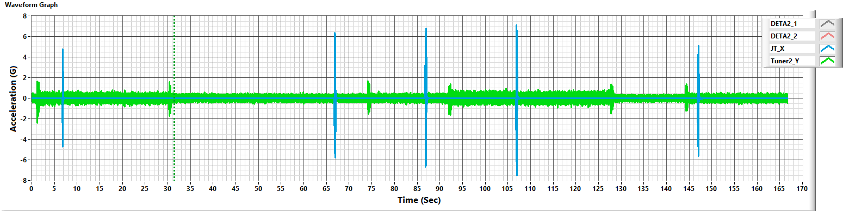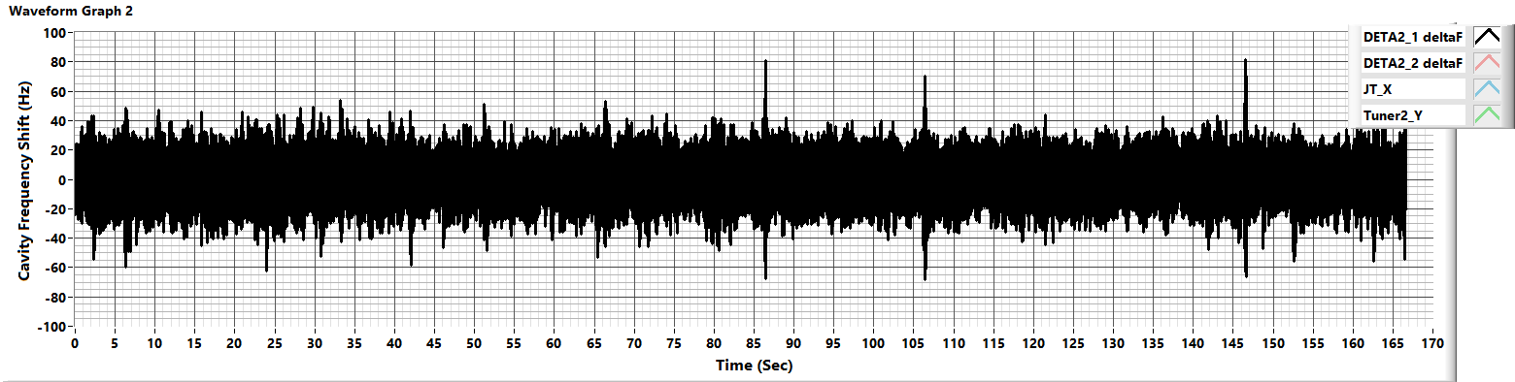
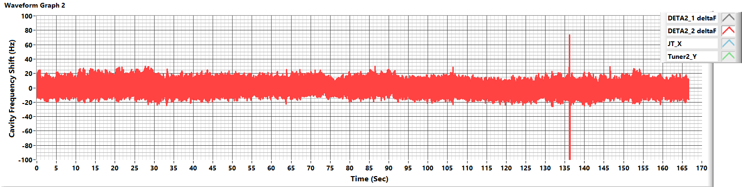
Figure 7. Upper plot blue is accelerometer attached to JT valve, green is an accelerometer attached to the tuner on cavity 2. The next plot is the frequency shift data for cavity 1 (black). Below that is the frequency shift data for cavity 2. Note correlation between the detune peaks on cavity 1 and the fact that the large transient on cavity 2 is not correlated with either of the accelerometer signals.

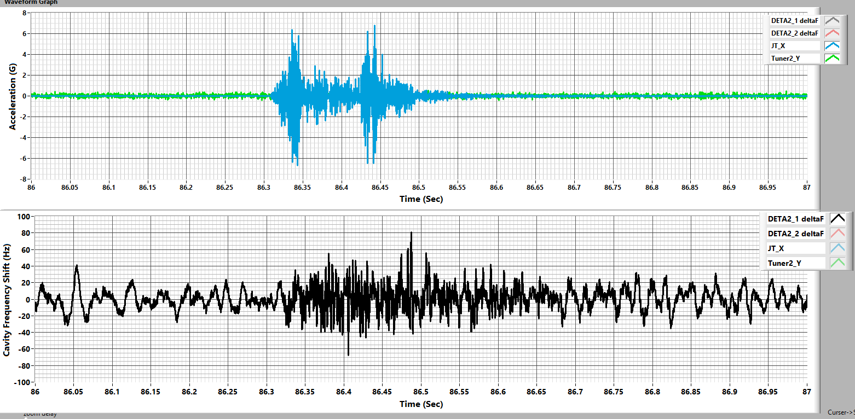
Figure 8. Same plot colors as the previous figure. Note the microphonic noise on cavity 1 the minor amount of noise on cavity 2 when the JT valve operates.
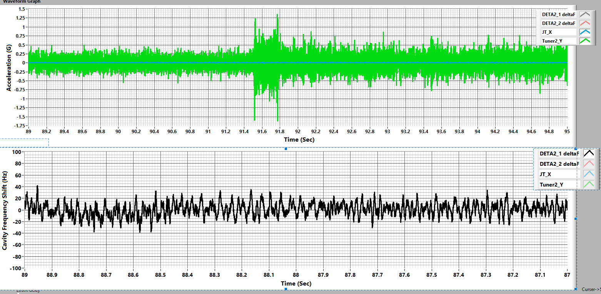
Figure 9. Same plot colors as previously. Note that Tuner operation did not introduce microphonics into either cavity.
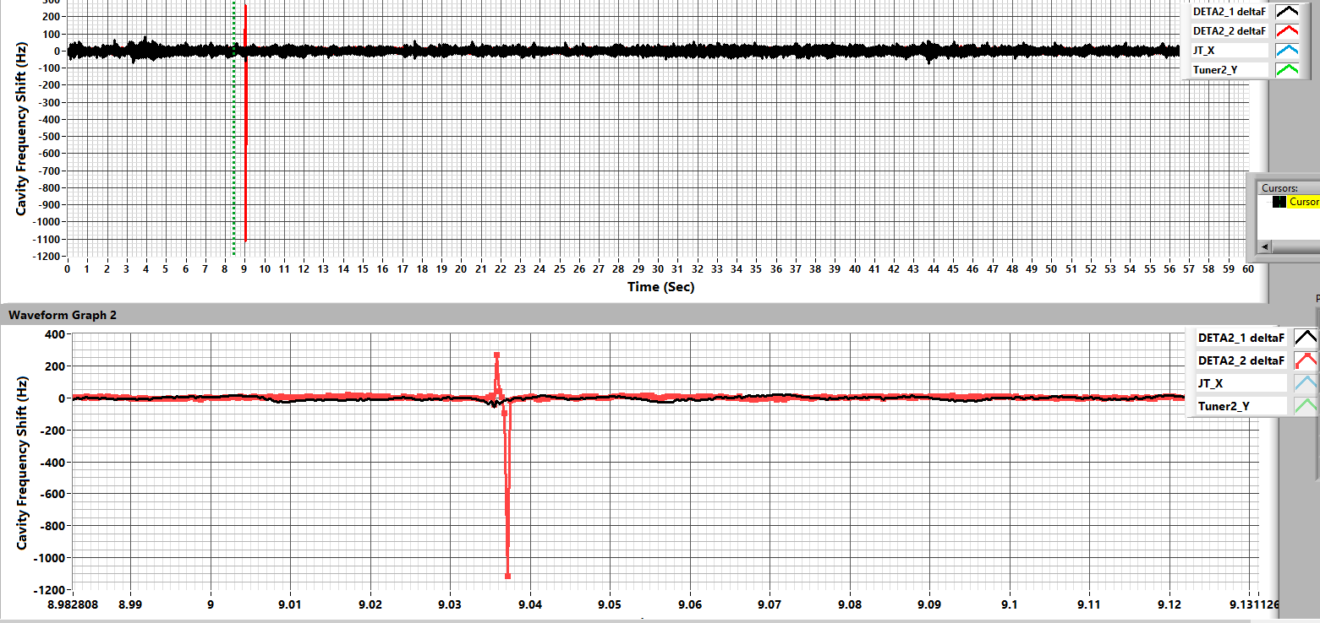
Figure 10. Example of type 1 of the excessive “frequency shift” on cavity 2 which is not correlated with tuner or JT valve operation. This type had a very quick transient (300 us per sample point) with very little if any oscillation after the event. Note the upper plots show the vibrations of the JT valve and the cavity 2 tuner which are not correlated with the transient in the second plot. The latter two plots are the same data with increased time resolution.

Figure 11. Example of type 2 of the excessive “frequency shift” on cavity 2 which is not correlated with tuner or JT valve operation. This type had a very quick transient (300 us per sample point) followed by an damped oscillation on the at about 300 Hz. The oscillation indicates that what ever caused the event perturbed the cavity sufficiently to cause it to ring down mechanically.

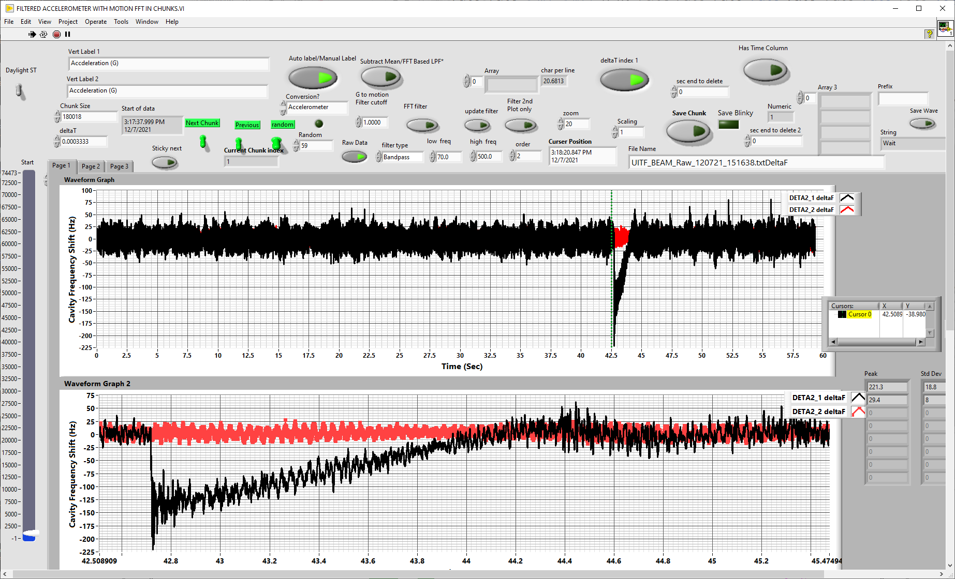
Figure 12. An odd event that occurred twice within a 10-minute period on cavity 1. The cavity shifted frequency by 225 Hz quickly and it appears that the tuners operated to bring the cavity back to tune within 2 seconds. This type of event was not observed in the rest of the 11 hours of data. Further it was only observed on cavity 1.

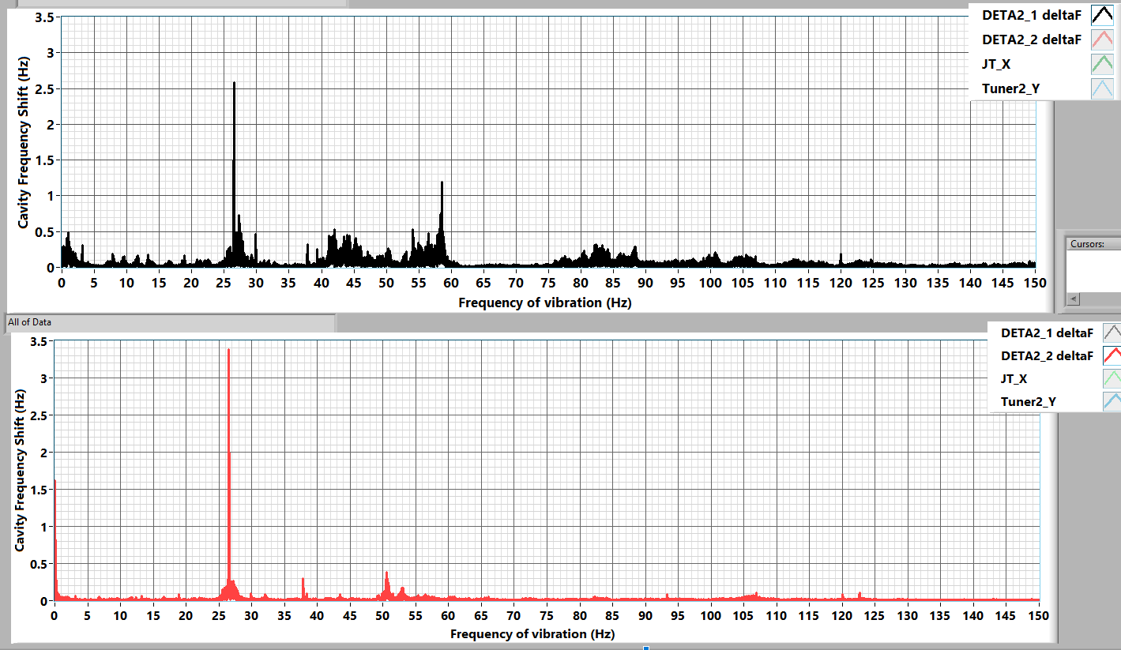
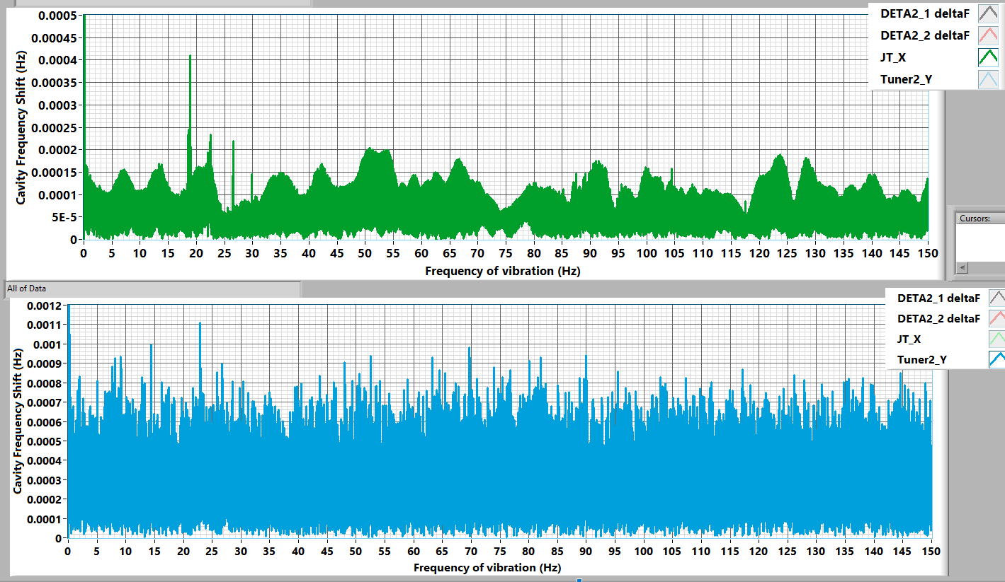
Figure 13: Frequency content on cavities 1 and 2 as well as the accelerometer on the JT valve and the tuner stack. Note that the 27 Hz vibration was observed on the JT valve. It was also previously (Sept 2021) observed on the up stream beamline.

[1] J. P. Holzbauer, et. al. “Systematic uncertainties in RF-based measurements of superocnduction cavity quality factors”, arXiv:1602.02689v1, 8 Feb. 2016.

