CIS-ASY-R30-3

18” HV chamber with spherical electrode and CEBAF-type anode

ANODE assembly findings

Jan 31 2022

Carlos Hernández-Garcia

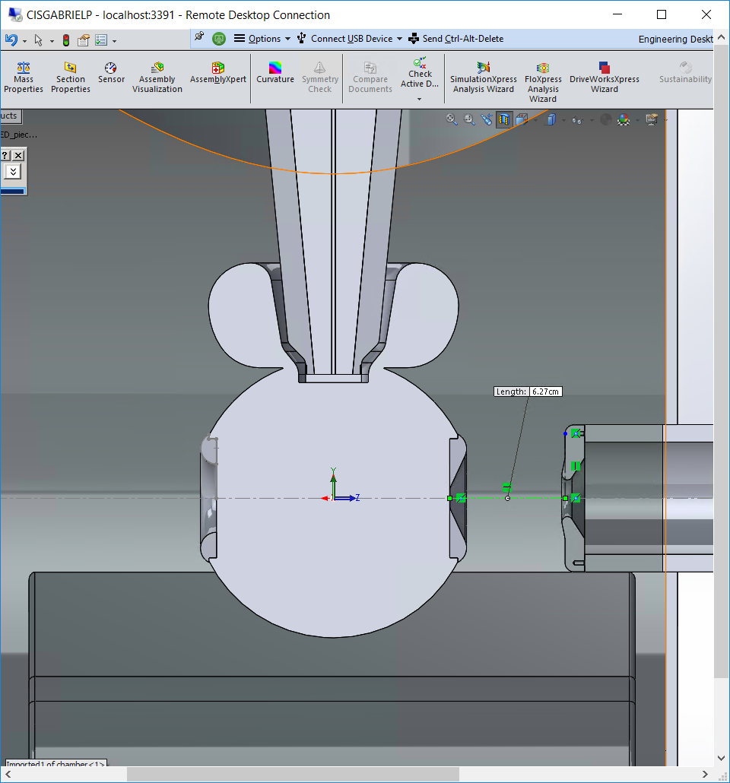 

Anode-cathode gap: is it 6.27 cm? or 2.506 in=6.36 cm?

Need to check with Shaun

The anode assembly was measured using a Vernier caliper. Then it was taken apart and inspected, and every piece thickness was measured for checking against the measured total length.

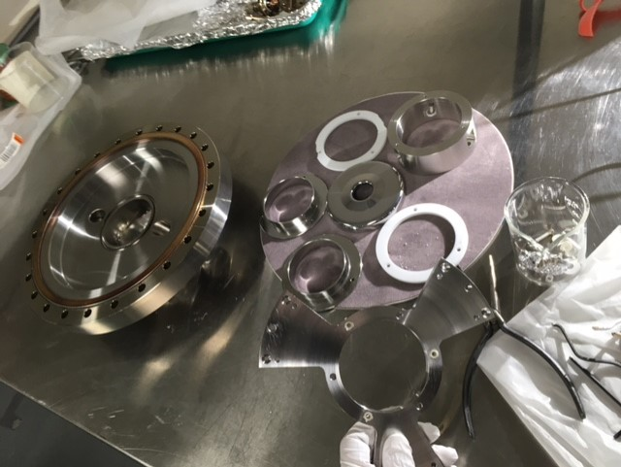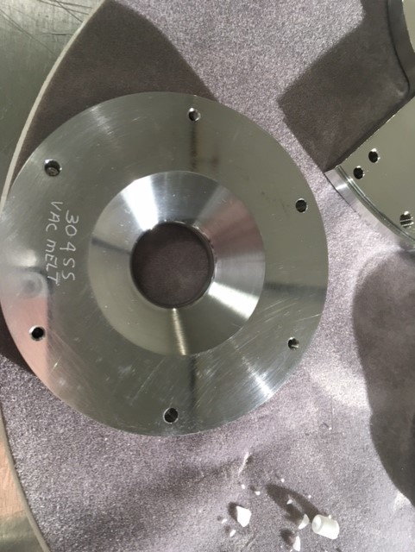

This is the back end view of the assembly before it was taken apart. Notice there is a ceramic washer missing.

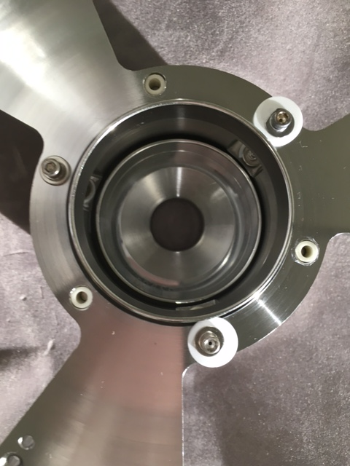

The overall length of the anode assembly was measured at 2.235”. The sum of the measured individual pieces came to 2.226”. This needs to be confirmed with assembly drawings (task for Carlos: ask Shaun for assembly drawing).

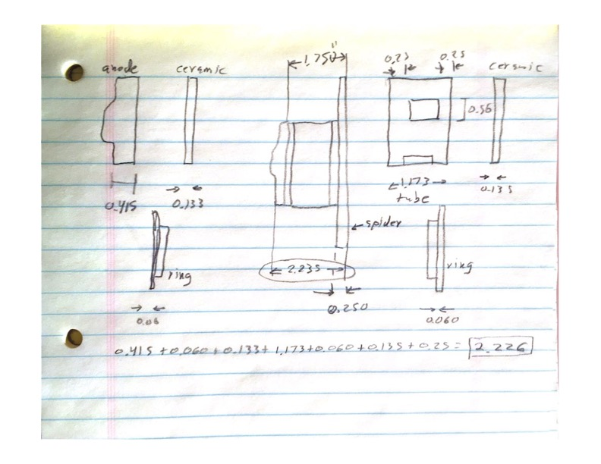 

The anode thickness measurement seems to be close to the drawing.

The anode ‘spacer’ tube measured dimensions match the drawing.



This anode has two ceramic rings that electrically isolate the anode from the tube, and the tube from the frame (spider?) at ground.

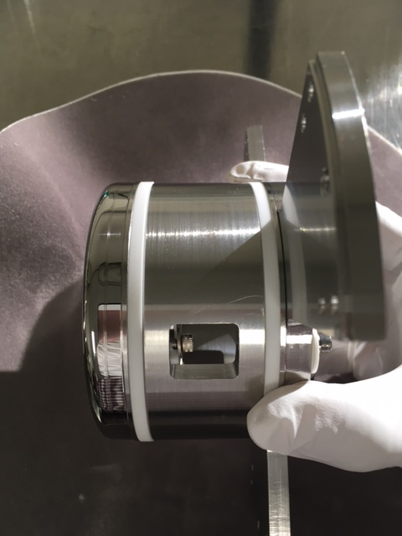

Each ceramic ring seems to be shielded from the beam line-of-sight by a thin SS short tube. One of the ceramic rings is chipped off. The other one is ok, but I do not know if there are spare ceramic rings. The ceramic bushing that isolates the screw from the anode came off in little pieces. Need to check for spares or order more.

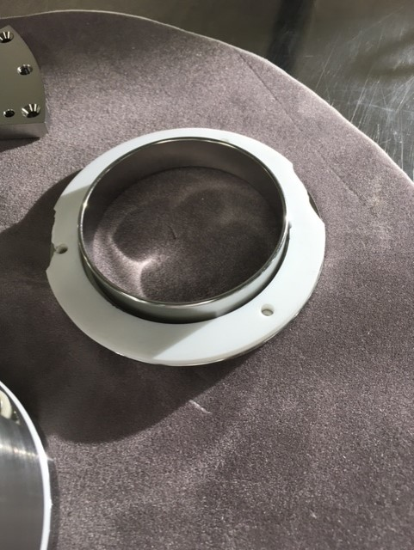 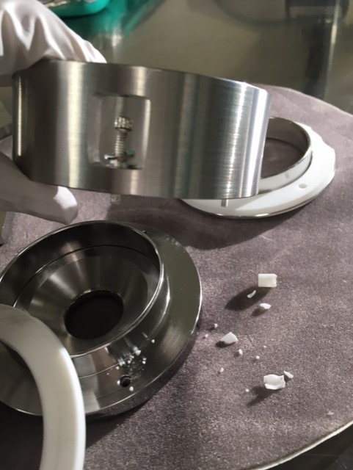

The existing screws are too long if the back ceramic ring is removed for grounding the tube.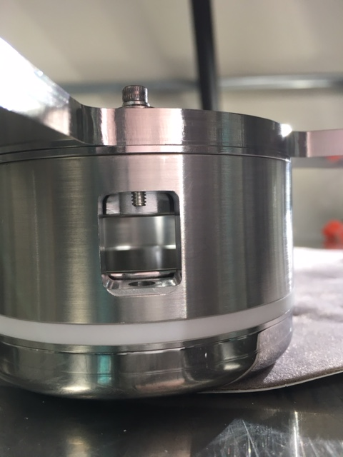

With the present anode tube ‘apertures’ is very difficult to insert the screw assembly to isolate the anode. A normal Allen wrench won’t fit to tighten the bolt.

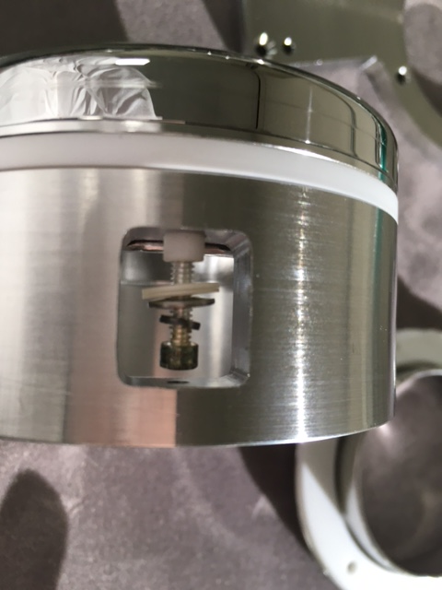 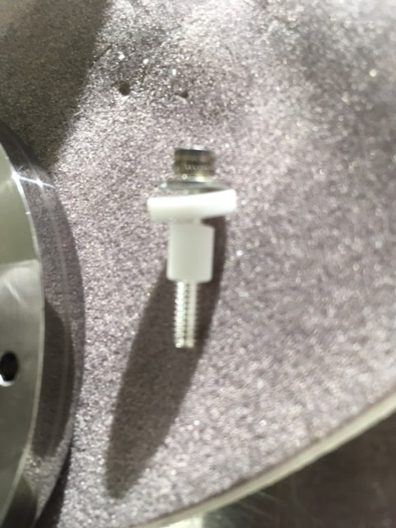

The 10” CF flange anode has two feedthroughs, one for the anode, and one for the anode tube.

