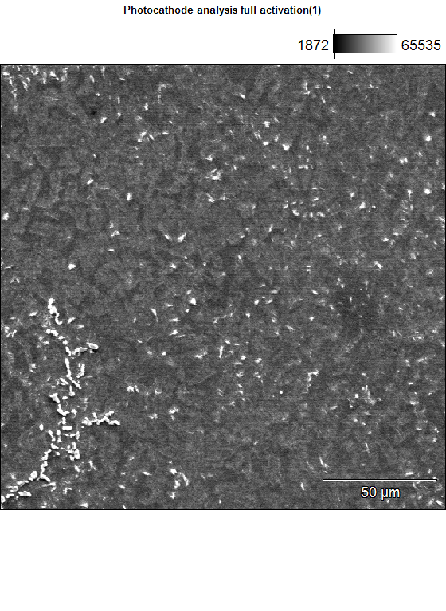

Accelerating Voltage: 15.0 kV Magnification: 500
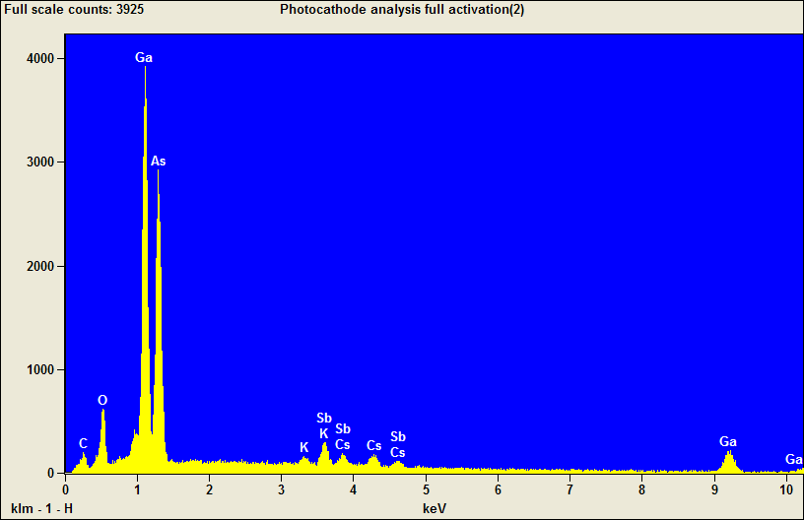

Quantitative Results Photocathode analysis full activation(2)
Element | Weight % | Weight %  Error | Norm.  Wt.% | Norm.  Wt.% Err | Atom % | Atom %  Error
C | 6.14 | +/- 0.51 | 6.14 | +/- 0.51 | 22.23 | +/- 1.84
O | 11.24 | +/- 0.28 | 11.24 | +/- 0.28 | 30.55 | +/- 0.77
K | 0.68 | +/- 0.05 | 0.68 | +/- 0.05 | 0.75 | +/- 0.06
K | --- | --- | --- | --- | --- | ---
Ga | 34.76 | +/- 1.54 | 34.76 | +/- 1.54 | 21.68 | +/- 0.96
Ga | --- | --- | --- | --- | --- | ---
As | --- | --- | --- | --- | --- | ---
As | 36.22 | +/- 0.42 | 36.22 | +/- 0.42 | 21.02 | +/- 0.24
Sb | 6.33 | +/- 0.19 | 6.33 | +/- 0.19 | 2.26 | +/- 0.07
Sb | --- | --- | --- | --- | --- | ---
Cs | 4.63 | +/- 0.55 | 4.63 | +/- 0.55 | 1.52 | +/- 0.18
Cs | --- | --- | --- | --- | --- | ---
Total | 100.00 |  | 100.00 |  | 100.00

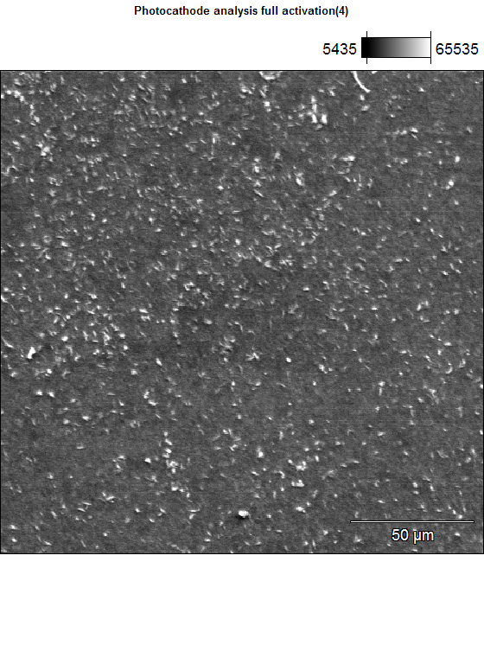

Accelerating Voltage: 15.0 kV Magnification: 500
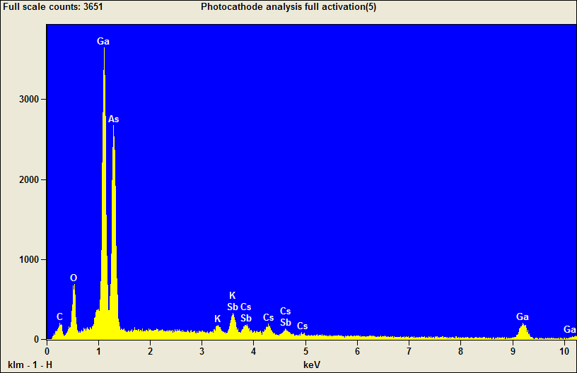

Quantitative Results Photocathode analysis full activation(5)
Element | Weight % | Weight %  Error | Norm.  Wt.% | Norm.  Wt.% Err | Atom % | Atom %  Error
C | 6.45 | +/- 0.51 | 6.45 | +/- 0.51 | 22.67 | +/- 1.80
O | 12.34 | +/- 0.29 | 12.34 | +/- 0.29 | 32.54 | +/- 0.76
K | 1.16 | +/- 0.13 | 1.16 | +/- 0.13 | 1.25 | +/- 0.14
K | --- | --- | --- | --- | --- | ---
Ga | 32.90 | +/- 1.53 | 32.90 | +/- 1.53 | 19.91 | +/- 0.93
Ga | --- | --- | --- | --- | --- | ---
As | --- | --- | --- | --- | --- | ---
As | 34.32 | +/- 0.41 | 34.32 | +/- 0.41 | 19.33 | +/- 0.23
Sb | 7.83 | +/- 0.56 | 7.83 | +/- 0.56 | 2.71 | +/- 0.20
Sb | --- | --- | --- | --- | --- | ---
Cs | 5.00 | +/- 0.56 | 5.00 | +/- 0.56 | 1.59 | +/- 0.18
Cs | --- | --- | --- | --- | --- | ---
Total | 100.00 |  | 100.00 |  | 100.00

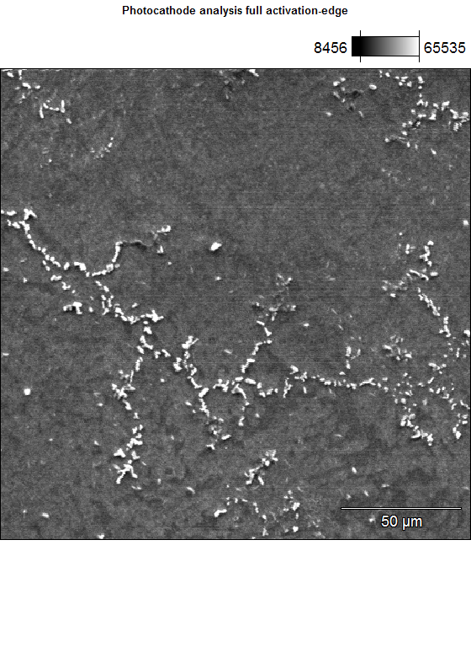

Accelerating Voltage: 15.0 kV Magnification: 500
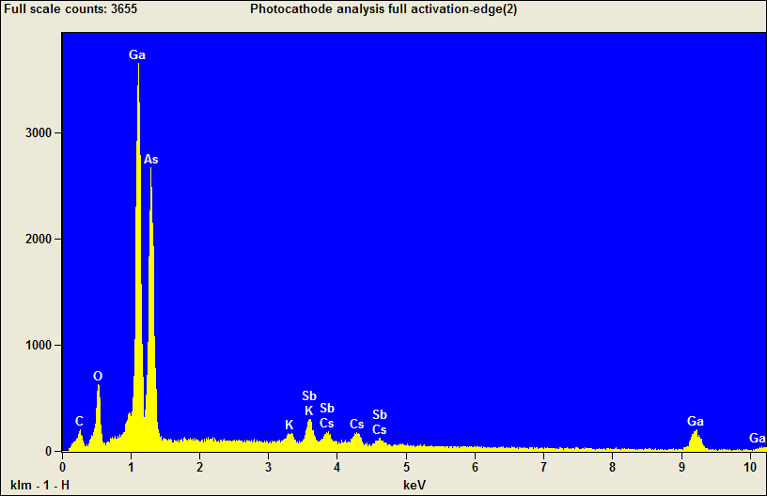

Quantitative Results Photocathode analysis full activation-edge(2)
Element | Weight % | Weight %  Error | Norm.  Wt.% | Norm.  Wt.% Err | Atom % | Atom %  Error
C | 6.44 | +/- 0.53 | 6.44 | +/- 0.53 | 23.03 | +/- 1.88
O | 11.45 | +/- 0.29 | 11.45 | +/- 0.29 | 30.75 | +/- 0.78
K | 0.91 | +/- 0.06 | 0.91 | +/- 0.06 | 1.00 | +/- 0.06
K | --- | --- | --- | --- | --- | ---
Ga | 34.32 | +/- 1.60 | 34.32 | +/- 1.60 | 21.16 | +/- 0.99
Ga | --- | --- | --- | --- | --- | ---
As | --- | --- | --- | --- | --- | ---
As | 34.75 | +/- 0.43 | 34.75 | +/- 0.43 | 19.93 | +/- 0.24
Sb | 6.78 | +/- 0.20 | 6.78 | +/- 0.20 | 2.39 | +/- 0.07
Sb | --- | --- | --- | --- | --- | ---
Cs | 5.36 | +/- 0.58 | 5.36 | +/- 0.58 | 1.73 | +/- 0.19
Cs | --- | --- | --- | --- | --- | ---
Total | 100.00 |  | 100.00 |  | 100.00

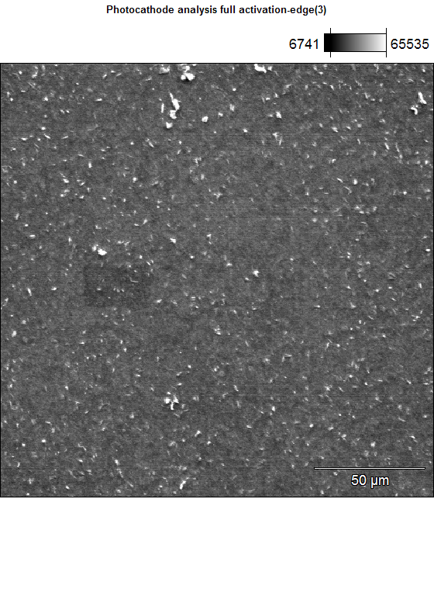

Accelerating Voltage: 15.0 kV Magnification: 500
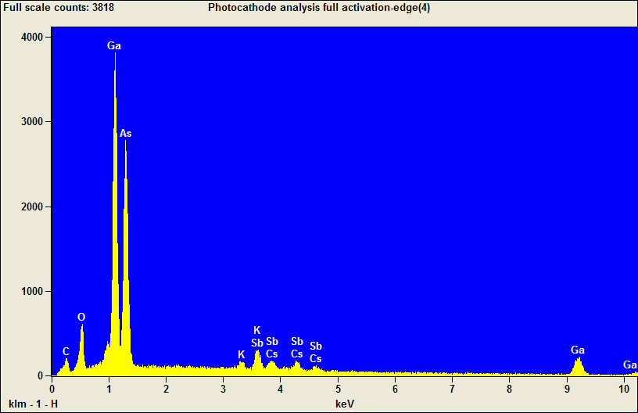

Quantitative Results Photocathode analysis full activation-edge(4)
Element | Weight % | Weight %  Error | Norm.  Wt.% | Norm.  Wt.% Err | Atom % | Atom %  Error
C | 6.11 | +/- 0.52 | 6.11 | +/- 0.52 | 22.31 | +/- 1.89
O | 10.96 | +/- 0.28 | 10.96 | +/- 0.28 | 30.03 | +/- 0.77
K | 0.78 | +/- 0.06 | 0.78 | +/- 0.06 | 0.88 | +/- 0.06
K | --- | --- | --- | --- | --- | ---
Ga | 35.35 | +/- 1.54 | 35.35 | +/- 1.54 | 22.22 | +/- 0.97
Ga | --- | --- | --- | --- | --- | ---
As | --- | --- | --- | --- | --- | ---
As | 34.86 | +/- 0.42 | 34.86 | +/- 0.42 | 20.39 | +/- 0.24
Sb | 7.84 | +/- 0.48 | 7.84 | +/- 0.48 | 2.82 | +/- 0.17
Sb | --- | --- | --- | --- | --- | ---
Cs | 4.08 | +/- 0.55 | 4.08 | +/- 0.55 | 1.35 | +/- 0.18
Cs | --- | --- | --- | --- | --- | ---
Total | 100.00 |  | 100.00 |  | 100.00

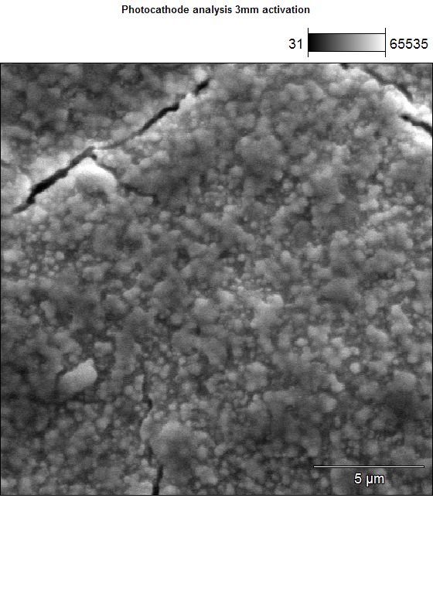

Accelerating Voltage: 15.0 kV Magnification: 5000
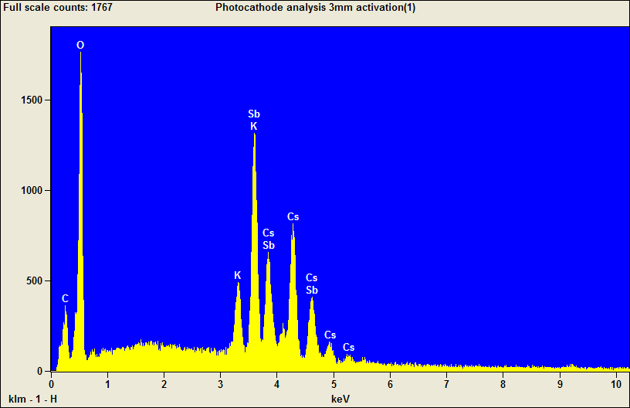

Quantitative Results Photocathode analysis 3mm activation(1)
Element | Weight % | Weight %  Error | Norm.  Wt.% | Norm.  Wt.% Err | Atom % | Atom %  Error
C | 5.91 | +/- 0.32 | 5.91 | +/- 0.32 | 18.41 | +/- 0.99
O | 25.13 | +/- 0.30 | 25.13 | +/- 0.30 | 58.75 | +/- 0.70
K | 3.72 | +/- 0.17 | 3.72 | +/- 0.17 | 3.56 | +/- 0.16
K | --- | --- | --- | --- | --- | ---
Sb | 35.68 | +/- 0.86 | 35.68 | +/- 0.86 | 10.96 | +/- 0.26
Sb | --- | --- | --- | --- | --- | ---
Cs | 29.56 | +/- 0.91 | 29.56 | +/- 0.91 | 8.32 | +/- 0.25
Cs | --- | --- | --- | --- | --- | ---
Total | 100.00 |  | 100.00 |  | 100.00

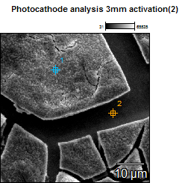

Image Name: Photocathode analysis 3mm activation(2)

Accelerating Voltage: 15.0 kV

Magnification: 1800

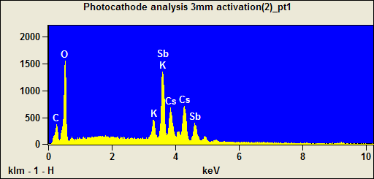

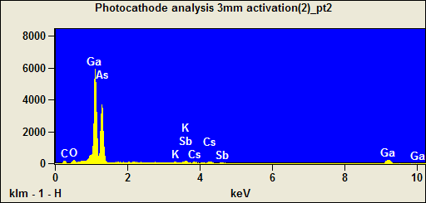

Weight %
 | C | O | K | Ga | As | Sb | Cs
Photocathode analysis 3mm activation(2)_pt1 | 6.81 | 23.54 | 3.23 |  |  | 38.81 | 27.61
Photocathode analysis 3mm activation(2)_pt2 | 8.00 | 3.03 | 0.37 | 40.27 | 43.50 | 2.58 | 2.25

Weight % Error
 | C | O | K | Ga | As | Sb | Cs
Photocathode analysis 3mm activation(2)_pt1 | +/-0.35 | +/-0.30 | +/-0.08 |  |  | +/-0.79 | +/-0.92
Photocathode analysis 3mm activation(2)_pt2 | +/-0.44 | +/-0.24 | +/-0.05 | +/-1.55 | +/-0.44 | +/-0.16 | +/-0.50

Normalized Wt. %
 | C | O | K | Ga | As | Sb | Cs
Photocathode analysis 3mm activation(2)_pt1 | 6.81 | 23.54 | 3.23 |  |  | 38.81 | 27.61
Photocathode analysis 3mm activation(2)_pt2 | 8.00 | 3.03 | 0.37 | 40.27 | 43.50 | 2.58 | 2.25

Norm. Wt. % Error
 | C | O | K | Ga | As | Sb | Cs
Photocathode analysis 3mm activation(2)_pt1 | +/-0.35 | +/-0.30 | +/-0.08 |  |  | +/-0.79 | +/-0.92
Photocathode analysis 3mm activation(2)_pt2 | +/-0.44 | +/-0.24 | +/-0.05 | +/-1.55 | +/-0.44 | +/-0.16 | +/-0.50

Atom %
 | C | O | K | Ga | As | Sb | Cs
Photocathode analysis 3mm activation(2)_pt1 | 21.41 | 55.58 | 3.12 |  |  | 12.04 | 7.85
Photocathode analysis 3mm activation(2)_pt2 | 32.33 | 9.18 | 0.46 | 28.02 | 28.17 | 1.03 | 0.82

Atom % Error
 | C | O | K | Ga | As | Sb | Cs
Photocathode analysis 3mm activation(2)_pt1 | +/-1.10 | +/-0.72 | +/-0.07 |  |  | +/-0.24 | +/-0.26
Photocathode analysis 3mm activation(2)_pt2 | +/-1.77 | +/-0.73 | +/-0.06 | +/-1.08 | +/-0.28 | +/-0.06 | +/-0.18

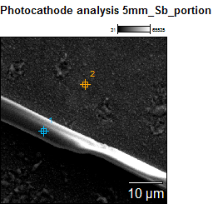

Image Name: Photocathode analysis 5mm_Sb_portion

Accelerating Voltage: 15.0 kV

Magnification: 2000

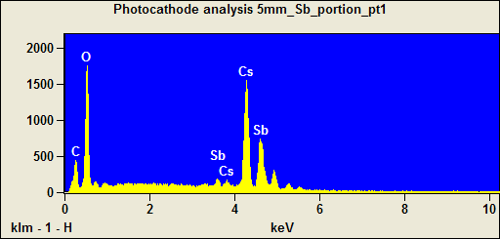

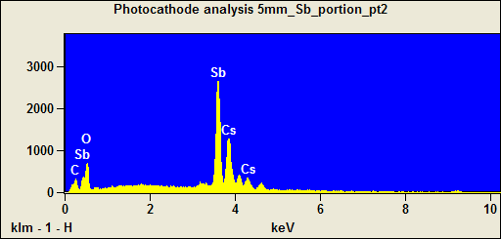

Weight %
 | C | O | Sb | Cs
Photocathode analysis 5mm_Sb_portion_pt1 | 6.45 | 23.97 | 3.35 | 66.23
Photocathode analysis 5mm_Sb_portion_pt2 | 5.96 | 11.30 | 75.40 | 7.34

Weight % Error
 | C | O | Sb | Cs
Photocathode analysis 5mm_Sb_portion_pt1 | +/-0.21 | +/-0.28 | +/-0.19 | +/-1.09
Photocathode analysis 5mm_Sb_portion_pt2 | +/-0.56 | +/-0.45 | +/-0.86 | +/-0.84

Normalized Wt. %
 | C | O | Sb | Cs
Photocathode analysis 5mm_Sb_portion_pt1 | 6.45 | 23.97 | 3.35 | 66.23
Photocathode analysis 5mm_Sb_portion_pt2 | 5.96 | 11.30 | 75.40 | 7.34

Norm. Wt. % Error
 | C | O | Sb | Cs
Photocathode analysis 5mm_Sb_portion_pt1 | +/-0.21 | +/-0.28 | +/-0.19 | +/-1.09
Photocathode analysis 5mm_Sb_portion_pt2 | +/-0.56 | +/-0.45 | +/-0.86 | +/-0.84

Atom %
 | C | O | Sb | Cs
Photocathode analysis 5mm_Sb_portion_pt1 | 20.97 | 58.50 | 1.08 | 19.46
Photocathode analysis 5mm_Sb_portion_pt2 | 26.44 | 37.62 | 33.00 | 2.94

Atom % Error
 | C | O | Sb | Cs
Photocathode analysis 5mm_Sb_portion_pt1 | +/-0.68 | +/-0.68 | +/-0.06 | +/-0.32
Photocathode analysis 5mm_Sb_portion_pt2 | +/-2.47 | +/-1.49 | +/-0.37 | +/-0.34

