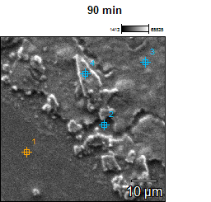

Image Name: 90 min

Accelerating Voltage: 15.0 kV

Magnification: 1500

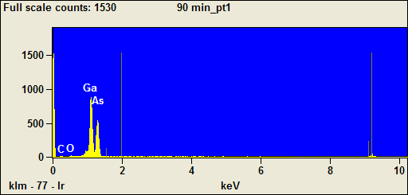

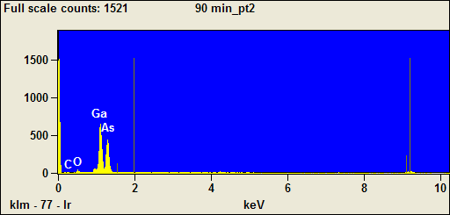

Image Name: 90 min

Accelerating Voltage: 15.0 kV

Magnification: 1500

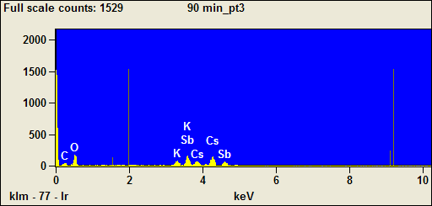

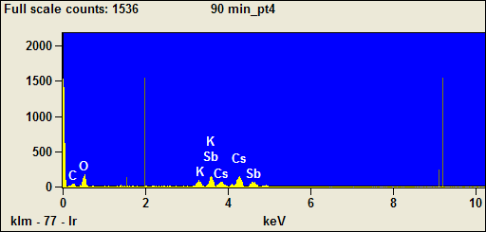

Weight %
 | C | O | K | Ga | As | Sb | Cs
90 min_pt1 | 4.97 | 2.11 |  | 43.53 | 49.40
90 min_pt2 | 8.73 | 8.89 |  | 61.98 | 20.40
90 min_pt3 | 4.75 | 19.56 | 4.55 |  |  | 32.08 | 39.06
90 min_pt4 | 6.55 | 20.46 | 5.38 |  |  | 25.76 | 41.85

Weight % Error
 | C | O | K | Ga | As | Sb | Cs
90 min_pt1 | +/-0.80 | +/-0.37 |  | +/-4.25 | +/-9.07
90 min_pt2 | +/-1.24 | +/-0.95 |  | +/-7.42 | +/-8.16
90 min_pt3 | +/-0.58 | +/-0.72 | +/-0.50 |  |  | +/-2.32 | +/-2.67
90 min_pt4 | +/-0.76 | +/-0.51 | +/-0.50 |  |  | +/-2.24 | +/-2.71

Normalized Wt. %
 | C | O | K | Ga | As | Sb | Cs
90 min_pt1 | 4.97 | 2.11 |  | 43.53 | 49.40
90 min_pt2 | 8.73 | 8.89 |  | 61.98 | 20.40
90 min_pt3 | 4.75 | 19.56 | 4.55 |  |  | 32.08 | 39.06
90 min_pt4 | 6.55 | 20.46 | 5.38 |  |  | 25.76 | 41.85

Norm. Wt. % Error
 | C | O | K | Ga | As | Sb | Cs
90 min_pt1 | +/-0.80 | +/-0.37 |  | +/-4.25 | +/-9.07
90 min_pt2 | +/-1.24 | +/-0.95 |  | +/-7.42 | +/-8.16
90 min_pt3 | +/-0.58 | +/-0.72 | +/-0.50 |  |  | +/-2.32 | +/-2.67
90 min_pt4 | +/-0.76 | +/-0.51 | +/-0.50 |  |  | +/-2.24 | +/-2.71

Atom %
 | C | O | K | Ga | As | Sb | Cs
90 min_pt1 | 22.61 | 7.20 |  | 34.14 | 36.05
90 min_pt2 | 29.75 | 22.74 |  | 36.37 | 11.14
90 min_pt3 | 17.25 | 53.35 | 5.08 |  |  | 11.50 | 12.82
90 min_pt4 | 21.91 | 51.40 | 5.53 |  |  | 8.51 | 12.66

Atom % Error
 | C | O | K | Ga | As | Sb | Cs
90 min_pt1 | +/-3.63 | +/-1.27 |  | +/-3.33 | +/-6.62
90 min_pt2 | +/-4.21 | +/-2.44 |  | +/-4.36 | +/-4.46
90 min_pt3 | +/-2.12 | +/-1.96 | +/-0.56 |  |  | +/-0.83 | +/-0.88
90 min_pt4 | +/-2.55 | +/-1.29 | +/-0.51 |  |  | +/-0.74 | +/-0.82

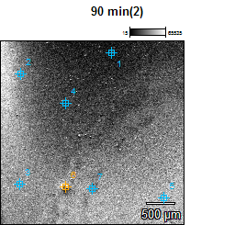

Image Name: 90 min(2)

Accelerating Voltage: 15.0 kV

Magnification: 30

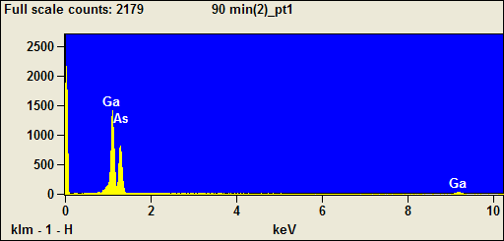

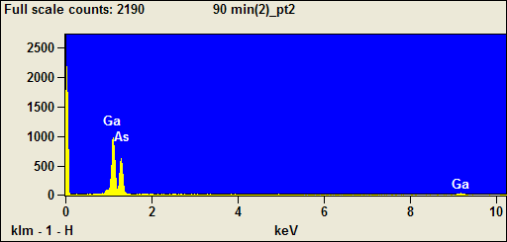

Image Name: 90 min(2)

Accelerating Voltage: 15.0 kV

Magnification: 30

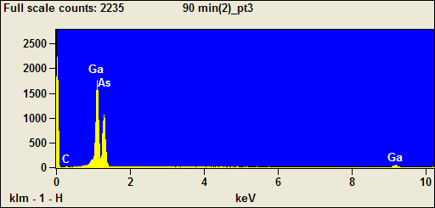

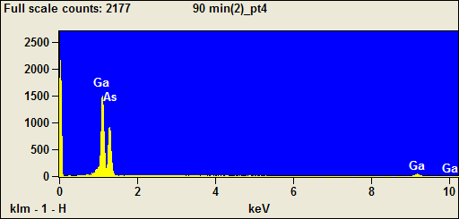

Image Name: 90 min(2)

Accelerating Voltage: 15.0 kV

Magnification: 30

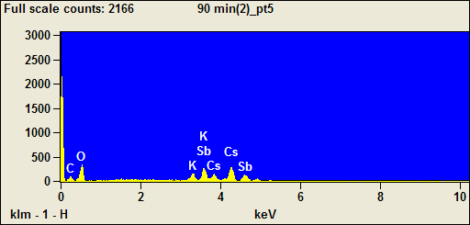

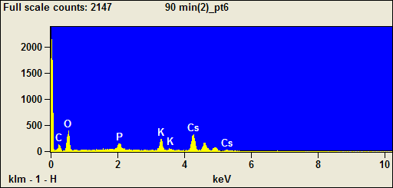

Image Name: 90 min(2)

Accelerating Voltage: 15.0 kV

Magnification: 30

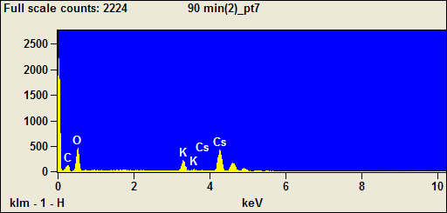

Weight %
 | C | O | P | K | Ga | As | Sb | Cs
90 min(2)_pt1 |  |  |  |  | 80.77 | 19.23
90 min(2)_pt2 |  |  |  |  | 84.85 | 15.15
90 min(2)_pt3 | 4.37 |  |  |  | 51.32 | 44.31
90 min(2)_pt4 |  |  |  |  | 78.65 | 21.35
90 min(2)_pt5 | 5.75 | 19.73 |  | 4.56 |  |  | 26.30 | 43.66
90 min(2)_pt6 | 7.61 | 27.25 | 3.30 | 8.05 |  |  |  | 53.78
90 min(2)_pt7 | 6.63 | 25.81 |  | 6.54 |  |  |  | 61.02

Weight % Error
 | C | O | P | K | Ga | As | Sb | Cs
90 min(2)_pt1 |  |  |  |  | +/-7.03 | +/-8.45
90 min(2)_pt2 |  |  |  |  | +/-7.95 | +/-8.77
90 min(2)_pt3 | +/-0.74 |  |  |  | +/-4.16 | +/-8.54
90 min(2)_pt4 |  |  |  |  | +/-7.38 | +/-8.54
90 min(2)_pt5 | +/-0.58 | +/-0.52 |  | +/-0.36 |  |  | +/-1.61 | +/-0.84
90 min(2)_pt6 | +/-0.47 | +/-0.62 | +/-0.20 | +/-0.31 |  |  |  | +/-2.02
90 min(2)_pt7 | +/-0.37 | +/-0.54 |  | +/-0.27 |  |  |  | +/-1.93

Normalized Wt. %
 | C | O | P | K | Ga | As | Sb | Cs
90 min(2)_pt1 |  |  |  |  | 80.77 | 19.23
90 min(2)_pt2 |  |  |  |  | 84.85 | 15.15
90 min(2)_pt3 | 4.37 |  |  |  | 51.32 | 44.31
90 min(2)_pt4 |  |  |  |  | 78.65 | 21.35
90 min(2)_pt5 | 5.75 | 19.73 |  | 4.56 |  |  | 26.30 | 43.66
90 min(2)_pt6 | 7.61 | 27.25 | 3.30 | 8.05 |  |  |  | 53.78
90 min(2)_pt7 | 6.63 | 25.81 |  | 6.54 |  |  |  | 61.02

Norm. Wt. % Error
 | C | O | P | K | Ga | As | Sb | Cs
90 min(2)_pt1 |  |  |  |  | +/-7.03 | +/-8.45
90 min(2)_pt2 |  |  |  |  | +/-7.95 | +/-8.77
90 min(2)_pt3 | +/-0.74 |  |  |  | +/-4.16 | +/-8.54
90 min(2)_pt4 |  |  |  |  | +/-7.38 | +/-8.54
90 min(2)_pt5 | +/-0.58 | +/-0.52 |  | +/-0.36 |  |  | +/-1.61 | +/-0.84
90 min(2)_pt6 | +/-0.47 | +/-0.62 | +/-0.20 | +/-0.31 |  |  |  | +/-2.02
90 min(2)_pt7 | +/-0.37 | +/-0.54 |  | +/-0.27 |  |  |  | +/-1.93

Atom %
 | C | O | P | K | Ga | As | Sb | Cs
90 min(2)_pt1 |  |  |  |  | 81.87 | 18.13
90 min(2)_pt2 |  |  |  |  | 85.75 | 14.25
90 min(2)_pt3 | 21.51 |  |  |  | 43.52 | 34.97
90 min(2)_pt4 |  |  |  |  | 79.83 | 20.17
90 min(2)_pt5 | 20.18 | 51.97 |  | 4.91 |  |  | 9.10 | 13.84
90 min(2)_pt6 | 20.76 | 55.77 | 3.49 | 6.74 |  |  |  | 13.25
90 min(2)_pt7 | 19.77 | 57.79 |  | 5.99 |  |  |  | 16.45

Atom % Error
 | C | O | P | K | Ga | As | Sb | Cs
90 min(2)_pt1 |  |  |  |  | +/-7.13 | +/-7.97
90 min(2)_pt2 |  |  |  |  | +/-8.03 | +/-8.25
90 min(2)_pt3 | +/-3.66 |  |  |  | +/-3.53 | +/-6.74
90 min(2)_pt4 |  |  |  |  | +/-7.49 | +/-8.07
90 min(2)_pt5 | +/-2.04 | +/-1.37 |  | +/-0.38 |  |  | +/-0.56 | +/-0.26
90 min(2)_pt6 | +/-1.28 | +/-1.27 | +/-0.22 | +/-0.26 |  |  |  | +/-0.50
90 min(2)_pt7 | +/-1.12 | +/-1.22 |  | +/-0.25 |  |  |  | +/-0.52

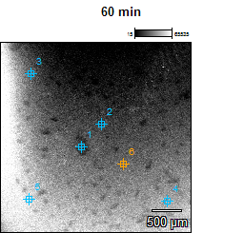

Image Name: 60 min

Accelerating Voltage: 15.0 kV

Magnification: 30

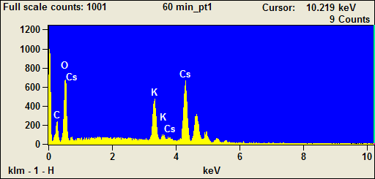

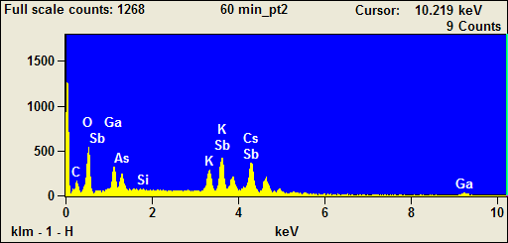

Image Name: 60 min

Accelerating Voltage: 15.0 kV

Magnification: 30

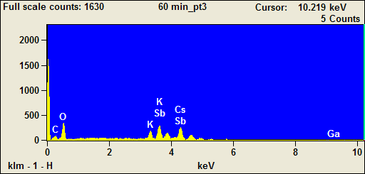

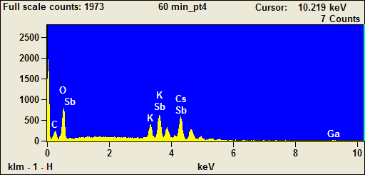

Image Name: 60 min

Accelerating Voltage: 15.0 kV

Magnification: 30

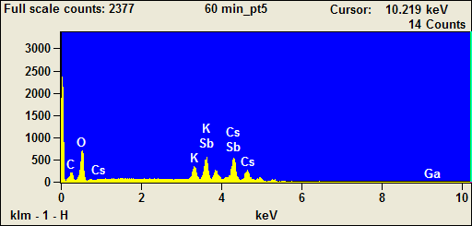

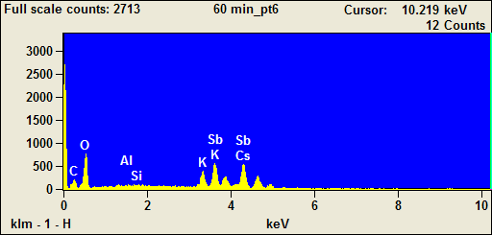

Weight %
 | C | O | Al | Si | K | Ga | As | Sb | Cs
60 min_pt1 | 6.28 | 26.24 |  |  | 9.25 |  |  |  | 58.22
60 min_pt2 | 7.02 | 18.88 |  | 0.14 | 4.28 | 10.48 | 9.16 | 21.86 | 28.18
60 min_pt3 | 5.98 | 22.25 |  |  | 4.98 | 6.28 |  | 29.16 | 31.34
60 min_pt4 | 7.61 | 22.37 |  |  | 4.38 | 5.90 |  | 25.72 | 34.01
60 min_pt5 | 7.19 | 21.47 |  |  | 5.23 | 4.53 |  | 25.67 | 35.90
60 min_pt6 | 7.40 | 23.98 | 0.13 | 0.13 | 5.30 |  |  | 25.76 | 37.29

Weight % Error
 | C | O | Al | Si | K | Ga | As | Sb | Cs
60 min_pt1 | +/-0.27 | +/-0.44 |  |  | +/-0.22 |  |  |  | +/-1.32
60 min_pt2 | +/-0.51 | +/-0.39 |  | +/-0.05 | +/-0.22 | +/-1.01 | +/-2.02 | +/-1.02 | +/-1.13
60 min_pt3 | +/-0.64 | +/-0.52 |  |  | +/-0.28 | +/-1.14 |  | +/-1.31 | +/-1.63
60 min_pt4 | +/-0.41 | +/-0.36 |  |  | +/-0.10 | +/-0.80 |  | +/-0.81 | +/-1.10
60 min_pt5 | +/-0.42 | +/-0.39 |  |  | +/-0.21 | +/-0.86 |  | +/-0.93 | +/-1.20
60 min_pt6 | +/-0.41 | +/-0.40 | +/-0.06 | +/-0.06 | +/-0.11 |  |  | +/-0.40 | +/-1.26

Normalized Wt. %
 | C | O | Al | Si | K | Ga | As | Sb | Cs
60 min_pt1 | 6.28 | 26.24 |  |  | 9.25 |  |  |  | 58.22
60 min_pt2 | 7.02 | 18.88 |  | 0.14 | 4.28 | 10.48 | 9.16 | 21.86 | 28.18
60 min_pt3 | 5.98 | 22.25 |  |  | 4.98 | 6.28 |  | 29.16 | 31.34
60 min_pt4 | 7.61 | 22.37 |  |  | 4.38 | 5.90 |  | 25.72 | 34.01
60 min_pt5 | 7.19 | 21.47 |  |  | 5.23 | 4.53 |  | 25.67 | 35.90
60 min_pt6 | 7.40 | 23.98 | 0.13 | 0.13 | 5.30 |  |  | 25.76 | 37.29

Norm. Wt. % Error
 | C | O | Al | Si | K | Ga | As | Sb | Cs
60 min_pt1 | +/-0.27 | +/-0.44 |  |  | +/-0.22 |  |  |  | +/-1.32
60 min_pt2 | +/-0.51 | +/-0.39 |  | +/-0.05 | +/-0.22 | +/-1.01 | +/-2.02 | +/-1.02 | +/-1.13
60 min_pt3 | +/-0.64 | +/-0.52 |  |  | +/-0.28 | +/-1.14 |  | +/-1.31 | +/-1.63
60 min_pt4 | +/-0.41 | +/-0.36 |  |  | +/-0.10 | +/-0.80 |  | +/-0.81 | +/-1.10
60 min_pt5 | +/-0.42 | +/-0.39 |  |  | +/-0.21 | +/-0.86 |  | +/-0.93 | +/-1.20
60 min_pt6 | +/-0.41 | +/-0.40 | +/-0.06 | +/-0.06 | +/-0.11 |  |  | +/-0.40 | +/-1.26

Atom %
 | C | O | Al | Si | K | Ga | As | Sb | Cs
60 min_pt1 | 18.44 | 57.79 |  |  | 8.34 |  |  |  | 15.44
60 min_pt2 | 22.99 | 46.40 |  | 0.19 | 4.31 | 5.91 | 4.81 | 7.06 | 8.34
60 min_pt3 | 19.30 | 53.87 |  |  | 4.93 | 3.49 |  | 9.28 | 9.13
60 min_pt4 | 23.50 | 51.87 |  |  | 4.16 | 3.14 |  | 7.84 | 9.49
60 min_pt5 | 22.84 | 51.22 |  |  | 5.10 | 2.48 |  | 8.05 | 10.31
60 min_pt6 | 22.39 | 54.46 | 0.18 | 0.17 | 4.92 |  |  | 7.69 | 10.19

Atom % Error
 | C | O | Al | Si | K | Ga | As | Sb | Cs
60 min_pt1 | +/-0.80 | +/-0.96 |  |  | +/-0.20 |  |  |  | +/-0.35
60 min_pt2 | +/-1.68 | +/-0.95 |  | +/-0.07 | +/-0.22 | +/-0.57 | +/-1.06 | +/-0.33 | +/-0.33
60 min_pt3 | +/-2.07 | +/-1.26 |  |  | +/-0.28 | +/-0.63 |  | +/-0.42 | +/-0.48
60 min_pt4 | +/-1.28 | +/-0.84 |  |  | +/-0.09 | +/-0.42 |  | +/-0.25 | +/-0.31
60 min_pt5 | +/-1.35 | +/-0.92 |  |  | +/-0.20 | +/-0.47 |  | +/-0.29 | +/-0.35
60 min_pt6 | +/-1.24 | +/-0.91 | +/-0.08 | +/-0.07 | +/-0.10 |  |  | +/-0.12 | +/-0.34

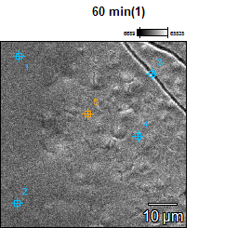

Image Name: 60 min(1)

Accelerating Voltage: 15.0 kV

Magnification: 1500

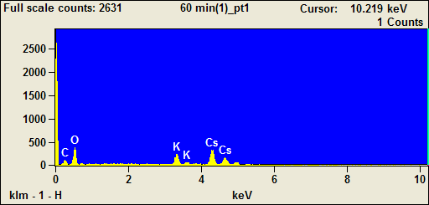

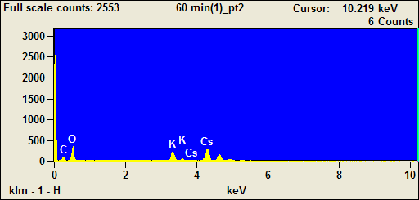

Image Name: 60 min(1)

Accelerating Voltage: 15.0 kV

Magnification: 1500

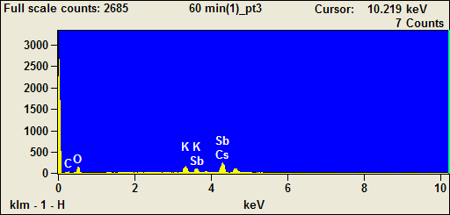

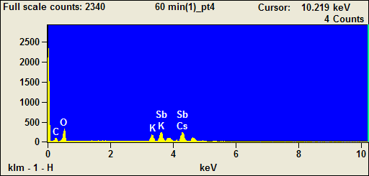

Image Name: 60 min(1)

Accelerating Voltage: 15.0 kV

Magnification: 1500

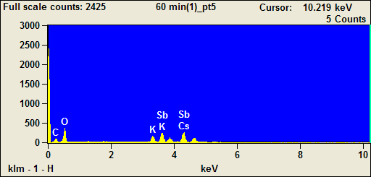

Weight %
 | C | O | K | Sb | Cs
60 min(1)_pt1 | 7.22 | 25.49 | 8.72 |  | 58.57
60 min(1)_pt2 | 6.41 | 26.43 | 9.13 |  | 58.03
60 min(1)_pt3 | 4.15 | 17.63 | 8.53 | 14.34 | 55.34
60 min(1)_pt4 | 7.65 | 21.54 | 6.10 | 28.62 | 36.09
60 min(1)_pt5 | 7.84 | 22.24 | 5.31 | 26.32 | 38.30

Weight % Error
 | C | O | K | Sb | Cs
60 min(1)_pt1 | +/-0.38 | +/-0.61 | +/-0.30 |  | +/-1.88
60 min(1)_pt2 | +/-0.38 | +/-0.62 | +/-0.33 |  | +/-1.99
60 min(1)_pt3 | +/-0.38 | +/-0.56 | +/-0.24 | +/-0.66 | +/-2.53
60 min(1)_pt4 | +/-0.44 | +/-0.41 | +/-0.33 | +/-1.59 | +/-1.89
60 min(1)_pt5 | +/-0.63 | +/-0.42 | +/-0.17 | +/-0.59 | +/-1.88

Normalized Wt. %
 | C | O | K | Sb | Cs
60 min(1)_pt1 | 7.22 | 25.49 | 8.72 |  | 58.57
60 min(1)_pt2 | 6.41 | 26.43 | 9.13 |  | 58.03
60 min(1)_pt3 | 4.15 | 17.63 | 8.53 | 14.34 | 55.34
60 min(1)_pt4 | 7.65 | 21.54 | 6.10 | 28.62 | 36.09
60 min(1)_pt5 | 7.84 | 22.24 | 5.31 | 26.32 | 38.30

Norm. Wt. % Error
 | C | O | K | Sb | Cs
60 min(1)_pt1 | +/-0.38 | +/-0.61 | +/-0.30 |  | +/-1.88
60 min(1)_pt2 | +/-0.38 | +/-0.62 | +/-0.33 |  | +/-1.99
60 min(1)_pt3 | +/-0.38 | +/-0.56 | +/-0.24 | +/-0.66 | +/-2.53
60 min(1)_pt4 | +/-0.44 | +/-0.41 | +/-0.33 | +/-1.59 | +/-1.89
60 min(1)_pt5 | +/-0.63 | +/-0.42 | +/-0.17 | +/-0.59 | +/-1.88

Atom %
 | C | O | K | Sb | Cs
60 min(1)_pt1 | 21.03 | 55.75 | 7.81 |  | 15.42
60 min(1)_pt2 | 18.68 | 57.85 | 8.17 |  | 15.29
60 min(1)_pt3 | 15.70 | 50.10 | 9.92 | 5.35 | 18.93
60 min(1)_pt4 | 24.07 | 50.88 | 5.90 | 8.89 | 10.27
60 min(1)_pt5 | 24.32 | 51.82 | 5.06 | 8.06 | 10.74

Atom % Error
 | C | O | K | Sb | Cs
60 min(1)_pt1 | +/-1.12 | +/-1.33 | +/-0.27 |  | +/-0.49
60 min(1)_pt2 | +/-1.11 | +/-1.37 | +/-0.29 |  | +/-0.52
60 min(1)_pt3 | +/-1.42 | +/-1.59 | +/-0.28 | +/-0.25 | +/-0.87
60 min(1)_pt4 | +/-1.38 | +/-0.97 | +/-0.32 | +/-0.49 | +/-0.54
60 min(1)_pt5 | +/-1.95 | +/-0.98 | +/-0.16 | +/-0.18 | +/-0.53

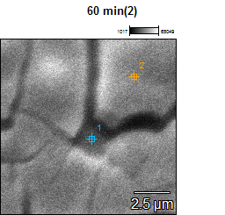

Image Name: 60 min(2)

Accelerating Voltage: 15.0 kV

Magnification: 8000

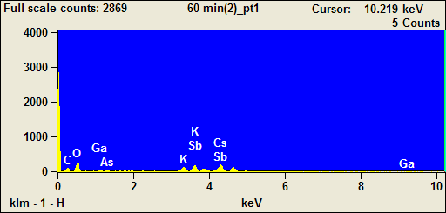

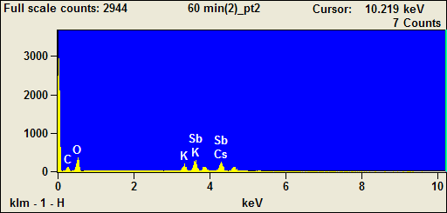

Weight %
 | C | O | K | Ga | As | Sb | Cs
60 min(2)_pt1 | 8.90 | 21.99 | 4.71 | 6.65 | 0.00 | 22.14 | 35.60
60 min(2)_pt2 | 8.92 | 23.98 | 5.26 |  |  | 26.29 | 35.55

Weight % Error
 | C | O | K | Ga | As | Sb | Cs
60 min(2)_pt1 | +/-0.48 | +/-0.59 | +/-0.16 | +/-1.35 | +/-0.00 | +/-1.36 | +/-1.83
60 min(2)_pt2 | +/-0.63 | +/-0.59 | +/-0.16 |  |  | +/-0.57 | +/-1.77

Normalized Wt. %
 | C | O | K | Ga | As | Sb | Cs
60 min(2)_pt1 | 8.90 | 21.99 | 4.71 | 6.65 | 0.00 | 22.14 | 35.60
60 min(2)_pt2 | 8.92 | 23.98 | 5.26 |  |  | 26.29 | 35.55

Norm. Wt. % Error
 | C | O | K | Ga | As | Sb | Cs
60 min(2)_pt1 | +/-0.48 | +/-0.59 | +/-0.16 | +/-1.35 | --- | +/-1.36 | +/-1.83
60 min(2)_pt2 | +/-0.63 | +/-0.59 | +/-0.16 |  |  | +/-0.57 | +/-1.77

Atom %
 | C | O | K | Ga | As | Sb | Cs
60 min(2)_pt1 | 26.64 | 49.42 | 4.34 | 3.43 | 0.00 | 6.54 | 9.63
60 min(2)_pt2 | 25.98 | 52.41 | 4.70 |  |  | 7.55 | 9.35

Atom % Error
 | C | O | K | Ga | As | Sb | Cs
60 min(2)_pt1 | +/-1.45 | +/-1.32 | +/-0.14 | +/-0.70 | +/-0.00 | +/-0.40 | +/-0.49
60 min(2)_pt2 | +/-1.83 | +/-1.29 | +/-0.14 |  |  | +/-0.16 | +/-0.47

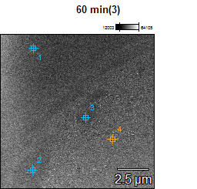

Image Name: 60 min(3)

Accelerating Voltage: 15.0 kV

Magnification: 8000

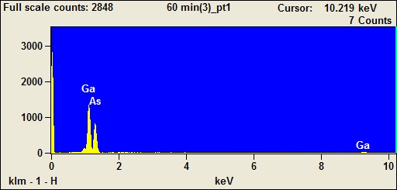

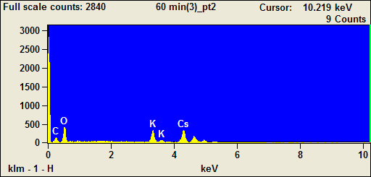

Image Name: 60 min(3)

Accelerating Voltage: 15.0 kV

Magnification: 8000

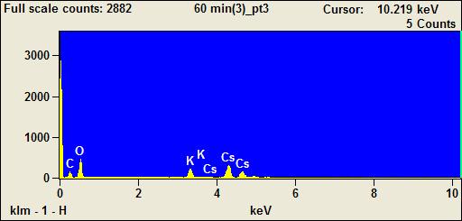

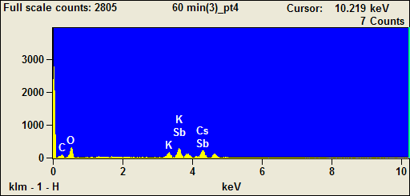

Weight %
 | C | O | K | Ga | As | Sb | Cs
60 min(3)_pt1 |  |  |  | 43.10 | 56.90
60 min(3)_pt2 | 8.02 | 28.83 | 10.71 |  |  |  | 52.44
60 min(3)_pt3 | 8.27 | 28.83 | 8.18 |  |  |  | 54.73
60 min(3)_pt4 | 7.33 | 20.70 | 4.69 |  |  | 30.55 | 36.73

Weight % Error
 | C | O | K | Ga | As | Sb | Cs
60 min(3)_pt1 |  |  |  | +/-4.72 | +/-6.25
60 min(3)_pt2 | +/-0.38 | +/-0.63 | +/-0.31 |  |  |  | +/-1.72
60 min(3)_pt3 | +/-0.40 | +/-0.63 | +/-0.29 |  |  |  | +/-1.80
60 min(3)_pt4 | +/-0.62 | +/-0.53 | +/-0.15 |  |  | +/-1.29 | +/-1.72

Normalized Wt. %
 | C | O | K | Ga | As | Sb | Cs
60 min(3)_pt1 |  |  |  | 43.10 | 56.90
60 min(3)_pt2 | 8.02 | 28.83 | 10.71 |  |  |  | 52.44
60 min(3)_pt3 | 8.27 | 28.83 | 8.18 |  |  |  | 54.73
60 min(3)_pt4 | 7.33 | 20.70 | 4.69 |  |  | 30.55 | 36.73

Norm. Wt. % Error
 | C | O | K | Ga | As | Sb | Cs
60 min(3)_pt1 |  |  |  | +/-4.72 | +/-6.25
60 min(3)_pt2 | +/-0.38 | +/-0.63 | +/-0.31 |  |  |  | +/-1.72
60 min(3)_pt3 | +/-0.40 | +/-0.63 | +/-0.29 |  |  |  | +/-1.80
60 min(3)_pt4 | +/-0.62 | +/-0.53 | +/-0.15 |  |  | +/-1.29 | +/-1.72

Atom %
 | C | O | K | Ga | As | Sb | Cs
60 min(3)_pt1 |  |  |  | 44.87 | 55.13
60 min(3)_pt2 | 21.28 | 57.42 | 8.73 |  |  |  | 12.57
60 min(3)_pt3 | 22.12 | 57.92 | 6.72 |  |  |  | 13.24
60 min(3)_pt4 | 23.92 | 50.71 | 4.70 |  |  | 9.83 | 10.83

Atom % Error
 | C | O | K | Ga | As | Sb | Cs
60 min(3)_pt1 |  |  |  | +/-4.91 | +/-6.06
60 min(3)_pt2 | +/-1.00 | +/-1.25 | +/-0.25 |  |  |  | +/-0.41
60 min(3)_pt3 | +/-1.07 | +/-1.28 | +/-0.24 |  |  |  | +/-0.43
60 min(3)_pt4 | +/-2.03 | +/-1.31 | +/-0.15 |  |  | +/-0.41 | +/-0.51

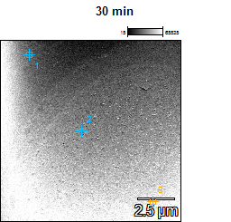

Image Name: 30 min

Accelerating Voltage: 15.0 kV

Magnification: 8000

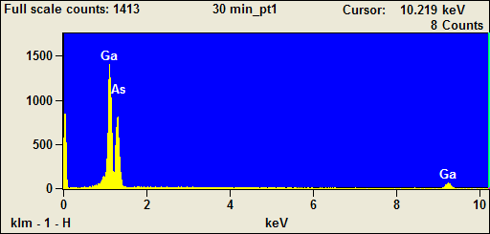

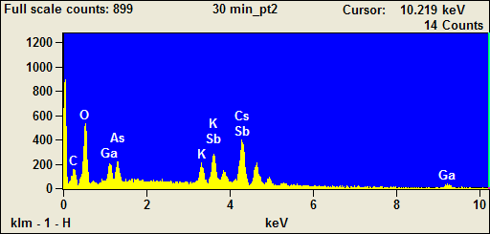

Image Name: 30 min

Accelerating Voltage: 15.0 kV

Magnification: 8000

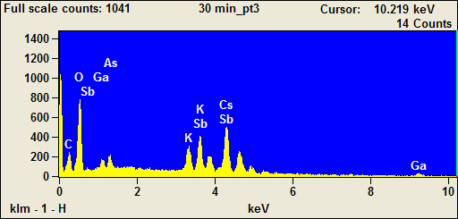

Weight %
 | C | O | K | Ga | As | Sb | Cs
30 min_pt1 |  |  |  | 52.22 | 47.78
30 min_pt2 | 7.78 | 20.94 | 2.94 | 10.12 | 10.33 | 15.11 | 32.78
30 min_pt3 | 8.21 | 24.68 | 4.46 | 6.55 | 2.42 | 18.91 | 34.77

Weight % Error
 | C | O | K | Ga | As | Sb | Cs
30 min_pt1 |  |  |  | +/-3.97 | +/-8.41
30 min_pt2 | +/-0.55 | +/-0.42 | +/-0.21 | +/-1.02 | +/-1.89 | +/-0.97 | +/-1.19
30 min_pt3 | +/-0.46 | +/-0.42 | +/-0.20 | +/-0.88 | +/-1.82 | +/-0.87 | +/-1.15

Normalized Wt. %
 | C | O | K | Ga | As | Sb | Cs
30 min_pt1 |  |  |  | 52.22 | 47.78
30 min_pt2 | 7.78 | 20.94 | 2.94 | 10.12 | 10.33 | 15.11 | 32.78
30 min_pt3 | 8.21 | 24.68 | 4.46 | 6.55 | 2.42 | 18.91 | 34.77

Norm. Wt. % Error
 | C | O | K | Ga | As | Sb | Cs
30 min_pt1 |  |  |  | +/-3.97 | +/-8.41
30 min_pt2 | +/-0.55 | +/-0.42 | +/-0.21 | +/-1.02 | +/-1.89 | +/-0.97 | +/-1.19
30 min_pt3 | +/-0.46 | +/-0.42 | +/-0.20 | +/-0.88 | +/-1.82 | +/-0.87 | +/-1.15

Atom %
 | C | O | K | Ga | As | Sb | Cs
30 min_pt1 |  |  |  | 54.01 | 45.99
30 min_pt2 | 24.12 | 48.73 | 2.80 | 5.41 | 5.13 | 4.62 | 9.19
30 min_pt3 | 23.71 | 53.49 | 3.96 | 3.26 | 1.12 | 5.39 | 9.07

Atom % Error
 | C | O | K | Ga | As | Sb | Cs
30 min_pt1 |  |  |  | +/-4.10 | +/-8.10
30 min_pt2 | +/-1.69 | +/-0.98 | +/-0.20 | +/-0.54 | +/-0.94 | +/-0.30 | +/-0.33
30 min_pt3 | +/-1.33 | +/-0.90 | +/-0.18 | +/-0.44 | +/-0.84 | +/-0.25 | +/-0.30

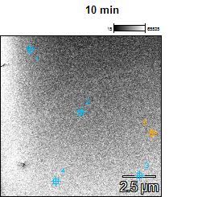

Image Name: 10 min

Accelerating Voltage: 15.0 kV

Magnification: 8000

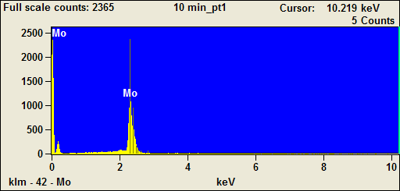

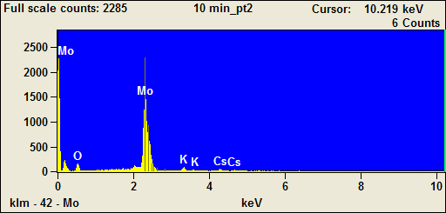

Image Name: 10 min

Accelerating Voltage: 15.0 kV

Magnification: 8000

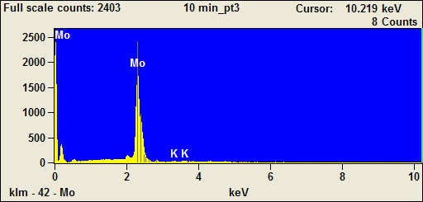

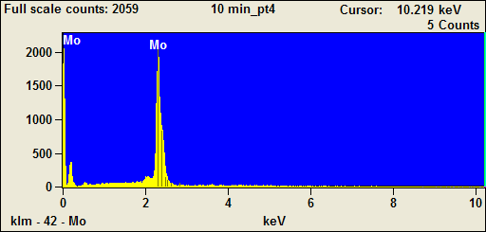

Image Name: 10 min

Accelerating Voltage: 15.0 kV

Magnification: 8000

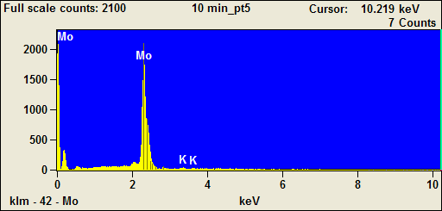

Weight %
 | O | K | Mo | Cs
10 min_pt1 |  |  | 100.00
10 min_pt2 | 21.08 | 2.47 | 70.43 | 6.02
10 min_pt3 |  | 0.79 | 99.21
10 min_pt4 |  |  | 100.00
10 min_pt5 |  | 0.84 | 99.16

Weight % Error
 | O | K | Mo | Cs
10 min_pt1 |  |  | +/-1.47
10 min_pt2 | +/-0.93 | +/-0.23 | +/-0.92 | +/-1.07
10 min_pt3 |  | +/-0.13 | +/-1.15
10 min_pt4 |  |  | +/-1.11
10 min_pt5 |  | +/-0.14 | +/-1.18

Normalized Wt. %
 | O | K | Mo | Cs
10 min_pt1 |  |  | 100.00
10 min_pt2 | 21.08 | 2.47 | 70.43 | 6.02
10 min_pt3 |  | 0.79 | 99.21
10 min_pt4 |  |  | 100.00
10 min_pt5 |  | 0.84 | 99.16

Norm. Wt. % Error
 | O | K | Mo | Cs
10 min_pt1 |  |  | +/-1.47
10 min_pt2 | +/-0.93 | +/-0.23 | +/-0.92 | +/-1.07
10 min_pt3 |  | +/-0.13 | +/-1.15
10 min_pt4 |  |  | +/-1.11
10 min_pt5 |  | +/-0.14 | +/-1.18

Atom %
 | O | K | Mo | Cs
10 min_pt1 |  |  | 100.00
10 min_pt2 | 60.99 | 2.92 | 33.99 | 2.10
10 min_pt3 |  | 1.91 | 98.09
10 min_pt4 |  |  | 100.00
10 min_pt5 |  | 2.03 | 97.97

Atom % Error
 | O | K | Mo | Cs
10 min_pt1 |  |  | +/-1.47
10 min_pt2 | +/-2.68 | +/-0.27 | +/-0.45 | +/-0.37
10 min_pt3 |  | +/-0.32 | +/-1.14
10 min_pt4 |  |  | +/-1.11
10 min_pt5 |  | +/-0.34 | +/-1.17

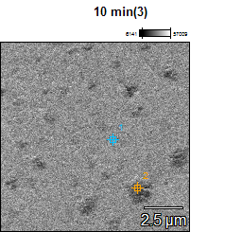

Image Name: 10 min(3)

Accelerating Voltage: 15.0 kV

Magnification: 8000

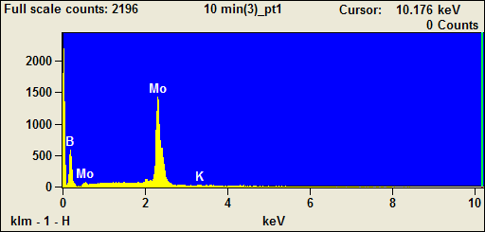

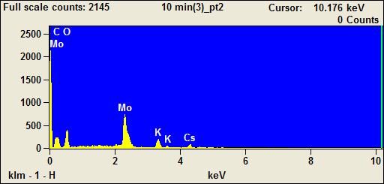

Weight %
 | B | C | O | K | Mo | Cs
10 min(3)_pt1 | 0.00 |  |  | 1.01 | 98.99
10 min(3)_pt2 |  | 10.50 | 41.50 | 6.22 | 34.10 | 7.68

Weight % Error
 | B | C | O | K | Mo | Cs
10 min(3)_pt1 | +/-0.00 |  |  | +/-0.17 | +/-1.33
10 min(3)_pt2 |  | +/-0.76 | +/-0.94 | +/-0.15 | +/-0.50 | +/-1.03

Normalized Wt. %
 | B | C | O | K | Mo | Cs
10 min(3)_pt1 | 0.00 |  |  | 1.01 | 98.99
10 min(3)_pt2 |  | 10.50 | 41.50 | 6.22 | 34.10 | 7.68

Norm. Wt. % Error
 | B | C | O | K | Mo | Cs
10 min(3)_pt1 | --- |  |  | +/-0.17 | +/-1.33
10 min(3)_pt2 |  | +/-0.76 | +/-0.94 | +/-0.15 | +/-0.50 | +/-1.03

Atom %
 | B | C | O | K | Mo | Cs
10 min(3)_pt1 | 0.00 |  |  | 2.43 | 97.57
10 min(3)_pt2 |  | 21.64 | 64.19 | 3.94 | 8.80 | 1.43

Atom % Error
 | B | C | O | K | Mo | Cs
10 min(3)_pt1 | +/-0.00 |  |  | +/-0.40 | +/-1.31
10 min(3)_pt2 |  | +/-1.56 | +/-1.46 | +/-0.09 | +/-0.13 | +/-0.19

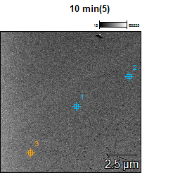

Image Name: 10 min(5)

Accelerating Voltage: 15.0 kV

Magnification: 8000

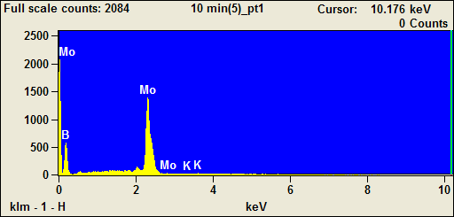

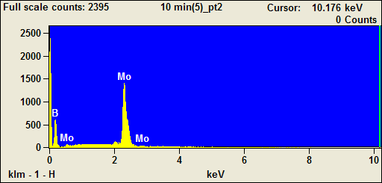

Image Name: 10 min(5)

Accelerating Voltage: 15.0 kV

Magnification: 8000

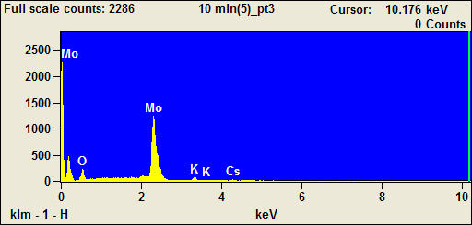

Weight %
 | B | O | K | Mo | Cs
10 min(5)_pt1 | 6.10 |  | 0.76 | 93.13
10 min(5)_pt2 | 10.32 |  |  | 89.68
10 min(5)_pt3 |  | 27.53 | 2.59 | 63.51 | 6.38

Weight % Error
 | B | O | K | Mo | Cs
10 min(5)_pt1 | +/-2.46 |  | +/-0.15 | +/-1.23
10 min(5)_pt2 | +/-2.31 |  |  | +/-1.18
10 min(5)_pt3 |  | +/-1.11 | +/-0.14 | +/-0.93 | +/-0.48

Normalized Wt. %
 | B | O | K | Mo | Cs
10 min(5)_pt1 | 6.10 |  | 0.76 | 93.13
10 min(5)_pt2 | 10.32 |  |  | 89.68
10 min(5)_pt3 |  | 27.53 | 2.59 | 63.51 | 6.38

Norm. Wt. % Error
 | B | O | K | Mo | Cs
10 min(5)_pt1 | +/-2.46 |  | +/-0.15 | +/-1.23
10 min(5)_pt2 | +/-2.31 |  |  | +/-1.18
10 min(5)_pt3 |  | +/-1.11 | +/-0.14 | +/-0.93 | +/-0.48

Atom %
 | B | O | K | Mo | Cs
10 min(5)_pt1 | 36.30 |  | 1.26 | 62.44
10 min(5)_pt2 | 50.52 |  |  | 49.48
10 min(5)_pt3 |  | 68.91 | 2.65 | 26.52 | 1.92

Atom % Error
 | B | O | K | Mo | Cs
10 min(5)_pt1 | +/-14.61 |  | +/-0.25 | +/-0.83
10 min(5)_pt2 | +/-11.33 |  |  | +/-0.65
10 min(5)_pt3 |  | +/-2.77 | +/-0.14 | +/-0.39 | +/-0.15

