May 22 2020: meeting on Wien filter GPT assessment by Gabriel

Attendees:
J. Grames, C. Hernandez-Garcia, A. Holfer, R. Kazimi, G. Palacios, and D. Turner

Summary: (refer to Gabriel’s presentation first)
- Gabriel presented E & B fields modeled by Jay Benesh to show overlap.
- Using a test “pencil-like” 200 keV beam distribution at the entrance of the Wien, he ran GPT sims and compared to the Darmstadt paper. It is also important to note that in order to make the beam propagate w/o loss, the electric field had to be multiplied by 1.21 from the Wien condition. Alicia points out they do something similar in the CEBAF injector, but with the uncertainty that the relationship between the applied voltage (knob) and the electric field is inferred from the electrode gap. Joe points out that making the change in E might violate the Wien condition. Gabriel and Carlos to check this by graphing the force through the Wien (equation 1, Figure 4 in Darmstadt paper).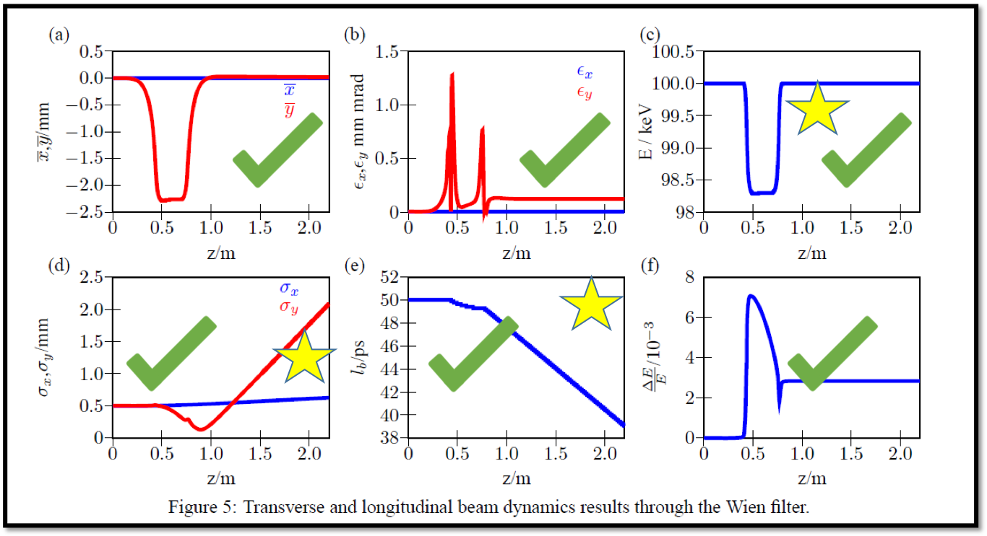
- Joe points out that the way E&B fields overlap in the Darmstadt paper is not the same as the way the fields overlap in Gabriel’s sims. Perhaps this is the cause of the discrepancy in fig a) y trajectory shape.
- Similar to #3, this could explain the difference between the Darmstadt paper and Gabriel’s sims shape in the energy curve in c). Joe points out Gabriel should do a basic sketch of the E fringe field to estimate the direction of energy gain (acceleration) and energy loss (deceleration). This could also explain the discrepancy in the bunch length behavior.
- The discrepancy in d) could be due to the use of a “pencil-like” distribution. Gabriel will simulate next using a more realistic “test” 3D distribution provided by Alicia.
- Joe mentions that Gabriel simulated correctly with the fields he was given, but Joe has the following question: Do we have the fields that accurately represent the actual Wien filter in the CEBAF injector? Carlos suggests this is a question goes beyond Gabriel’s thesis and should be addressed by our team. We need to check with Jay too and compare with magnet test measurements.
- Tasks:
  - Gabriel to repeat 130 keV sims using Alicia’s provide test 3D distribution
  - Gabriel to perform 200 keV using Alicia’s provide test 3D distribution
  - Joe points out that multiplying E by 1.21 to make the beam go through the Wien might violate the Wien condition. Gabriel and Carlos to check this by evaluation and graphing the force through the Wien (equation 1, Figure 4 in Darmstadt paper)
  - Joe, Carlos to check with Jay on modeled E & B, and on magnet test measurements to infer how close are the models to the actual Wien filter. See footnote below:

Footnote about current used by Jay in his model:

Jay Benesch
Tue 4/21/2020 8:49 AM
To:
Joe Grames;
Carlos Hernandez-Garcia
Either I erred in the current spec I provided Alicia or Joe or the BH curve of the steel is far from good.
________________________________________
From: Joe Grames <grames@jlab.org>
Sent: Tuesday, April 21, 2020 8:41 AM
To: Carlos Hernandez-Garcia; Jay Benesch
Subject: Re: Question about Wien filter B field models
I don't think it's essential to go just for this. Maybe its written down in the TN?
As far as the difference goes, I guess to say another way, if it weren't inaccuracy in the probe then the only thing it could be is the mu of the model vs. reality, eh?
________________________________
From: Carlos Hernandez-Garcia <chgarcia@jlab.org>
Sent: Tuesday, April 21, 2020 7:59 AM
To: Jay Benesch <benesch@jlab.org>
Cc: Joe Grames <grames@jlab.org>
Subject: Re: Question about Wien filter B field models
Jay,
Thank you for letting me know.
I am passing down your question to Joe.
Carlos
________________________________
From: Jay Benesch <benesch@jlab.org>
Sent: Monday, April 20, 2020 6:52 PM
To: Carlos Hernandez-Garcia <chgarcia@jlab.org>
Subject: Re: Question about Wien filter B field models
Carlos,
I can't tell you until I get back to my desk because the tunnel I'm using doesn't support Opera graphics. If time is critical, you or Joe can ask Andrei to make me essential temporarily and I'll go in and try to figure out what I did. It may be that the steel used was a lot poorer than I assumed, but at these low fields that's hard to believe.
Jay
________________________________________
From: Carlos Hernandez-Garcia <chgarcia@jlab.org>
Sent: Monday, April 20, 2020 12:01 PM
To: Jay Benesch
Subject: Question about Wien filter B field models
Hi Jay,
Joe Grames asked Gabriel and I to tally up the known Wien filter magnetic field models and measurements. I believe Gabriel got input from you and from Alicia, and I got input from Joe Meyers. We have summarized our findings in the attached presentation.
We would like to know the current you used in the models for each case, no endplates and most relevant, with Ni endplates. Please see presentation for reference, but the current used in the measurements without the endplates was 15A, and the current used for the measurements with the Ni endplates was 9.9A. As you can see, there is a small discrepancy between models and measurements.
Many thanks in advance and please let us know if we are missing anything or anything else you might like to add.
Carlos

