Summary of the Transverse Beam Characterization Measurements in the CEBAF 5 MeV Region: 2014-2015

C. Tennant, J. Grames, D. Moser, R. Suleiman, M. Tiefenback, D. Turner

Abstract

In this note we summarize the results of multiple quadrupole scan measurements in the 5 MeV region of CEBAF. During 2014 and 2015 several opportunities arose to characterize the transverse properties (emittances, Twiss parameters). The goal of this note is to document the results to date, not necessarily to explain the trends. Indeed between February and September 2015 the data suggests “something” – yet to be identified - had changed in the front end. In addition to having measurements at one location in CEBAF over a period of time, these measurements were, at times, performed as a function of momentum, which may provide further insight into the beam formation process.

Introduction

Having a good understanding of the beam dynamics in the 5 MeV region – from the exit of the capture to the entrance of cryomodule 0L03 – is vitally important. The cryounit marks the hand off of the low energy beamline, owned and modeled by the injector group using space charge codes to the relativistic, elegant-driven [1] modeling done in CASA. Additionally, the 5D line in this region successfully supported the Polarized Electrons for Polarized Positrons (PEPPo) experiment [2] and the Bubble Chamber experiment [3] – both of which require an accurate characterization of the beam properties.

Measurements

A schematic of a portion of the 5 MeV region is depicted in Figure 1. With a harp at 0L03 it remains to find what upstream quadrupole is best suited for scanning. The quadrupoles at 0L03 and 0L03A are too close to the harp, while simulations show the best performance is achieved using quadrupole MQJ0L02. Until the last set of measurements in September 2015, MQJ0L02 was scanned with downstream quadrupoles turned off which amounts to a simple quad-drift scan with a drift length of 6.629806 m from the exit of MQJ0L02 to the harp (IHA0L03). Furthermore, both planes were scanned simultaneously. However for the measurements made in support of the Bubble Chamber experiment in early September 2015, the nominal scan range of MQJ0L02 failed to produce a beam waist in either plane. Because we were utilizing the zig-zag method of data acquisition [4] each plane is scanned separately and new scan ranges were implemented. Additionally we found it necessary to keep the quadrupole at MQJ0L02A (downstream of the scanning quad) on at a set field during the measurement.

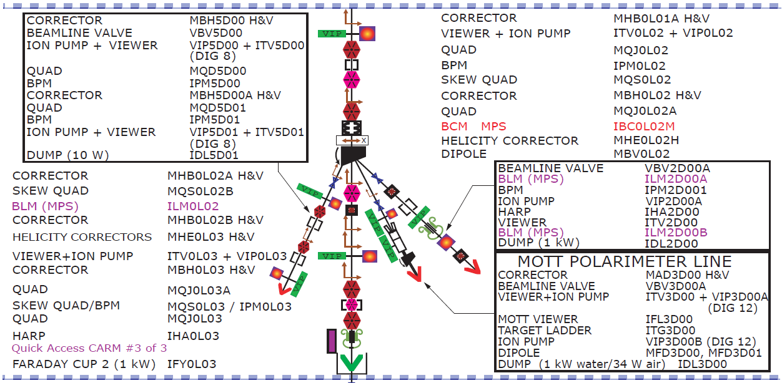

Figure 1: Schematic of the 5 MeV region showing the location of the scanning quadrupole (MQJ0L02) and harp (IHA0L03).

A summary of the dates and measurements is given below with a detailed table of results shown in Table 1.

February 19, 2014
- quadrupole scan at 5.5 MeV/c [5]

April 3, 2014
- quadrupole scan at 6.3 MeV/c

April 18, 2014
- quadrupole scan at 6.3 MeV/c
- data was not analyzed since a more comprehensive set of measurements were taken the following day

April 19, 2014
- quadrupole scans at (3.1,4.0,6.3,7.2) MeV/c in support of PEPPo experiment [6]
- to achieve each energy setpoint, gradients were changed in both cavities in the quarter cryounit (for details see Appendix A)

February 9, 2015
- quadrupole scan at 6.3 MeV/c

September 3, 2015
- quadrupole scan at (6.7,7.7,8.3) MeV/c in support of Bubble Chamber experiment
- these measurements mark the first time using the zig-zag technique to acquire data in the 5 MeV region
- immediately it was clear that something in the front end had changed since the usual scanning range of the quadrupole used in all the previous measurements failed to produce a minimum beam spot size in either transverse plane
- rather than a quad-drift configuration, in order to get sufficiently good data we needed to have a quadrupole (QJ0L02A) on at a set field between the scanning quad and the wire scanner
- whereas previous data had been analyzed off-line, due to the quad-drift-quad-drift configuration of the measurement, qsUtility was used to analyze this set of data
- for each energy setpoint the first cavity was held fixed while the gradient was changed in the second (verifying that the beam was on-crest for each iteration)

Table 1: Summary of normalized emittances and Twiss parameters in the 5 MeV region over the course of 17 months.

Date | p  {MeV/c} | ε_{x}  {mm-mrad} | ε_{y}  {mm-mrad} | β_{x}  {m} | α_{x} | β_{y}  {m} | α_{y}
February 19, 2014 | 5.50 | 0.39 | 0.26 | 6.38 | −1.02 | 2.34 | −0.02
April 3, 2014 | 6.30 | 0.35 | 0.35 | 26.98 | −3.58 | 24.73 | −0.93
April 19, 2014 | 3.10 | 0.42 | 0.16 | 22.79 | −7.42 | 10.20 | −0.67
 | 4.00 | 0.43 | 0.18 | 22.91 | −6.52 | 19.37 | −1.42
 | 6.30 | 0.42 | 0.30 | 9.11 | −2.53 | 30.13 | −8.34
 | 7.20 | 0.47 | 0.33 | 8.68 | −2.41 | 35.13 | −9.53
February 9, 2015 | 6.30 | 0.34 | 0.13 | 16.10 | −1.17 | 4.13 | −0.17
September 3, 2015 | 6.74 | 0.76 | 1.22 | 5.57 | −2.58 | 25.21 | −5.72
 | 7.71 | 0.65 | 1.17 | 6.40 | −2.44 | 16.09 | −3.78
 | 8.32 | 0.68 | 1.15 | 7.94 | −2.66 | 12.48 | −3.03

Summary

By way of summary, we offer a few comments and suggestions:

- The measurements for the Bubble Chamber experiment (September 3, 2015) were valuable inputs to the elegant model used to tune the optics of the 5D line. Because data was taken at several energy setpoints, we were able to get an idea of how Twiss parameters evolve as a function of energy (see Appendix B). Figure 2 illustrates an example of how the measurements provided the required input to the model which then provided guidance for tuning the 5D line [7]. Though quantitative comparison was not possible at the time, the elegant model tracked the observed beam behavior (i.e. spot sizes at various viewers) quite well.

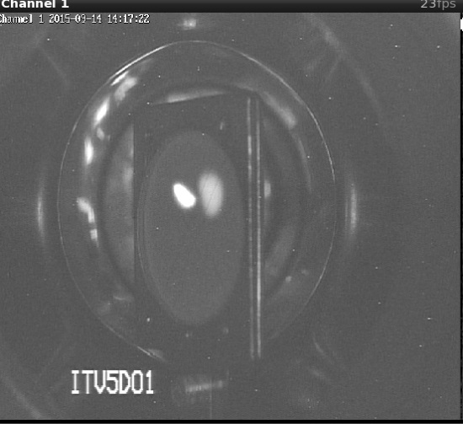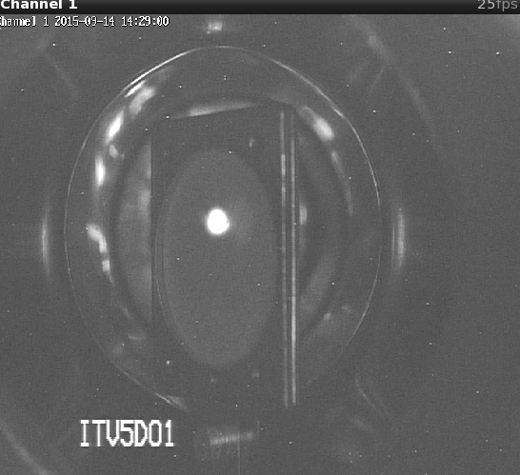

Figure 2: Beam image at ITV5D01 before (left) and after (right) model-driven changes to transverse focusing. (Note, the less intense spot on the viewer in the left image is from persistence).

- Although the momentum differs by the ~0.5 MeV/c, the comparison between the February 9 and September 3, 2015 measurements will be interesting to some and troubling to others. The horizontal emittance grows by a factor of ~2 and the vertical emittance grows by an order of magnitude. What changes in the front end occurred during that time period? Is this a new kind of injector setup? Is this related to the drive laser?
- A good understanding of the quarter cryounit, namely how it affects the beam dynamics, remains elusive. It is well known that trapped fields in cavity end groups can cause focusing (quadrupole and skew quadrupole) and steering (dipole) effects [8]. For instance the measurements from April 19, 2014 show that between 4.0 and 6.3 MeV/c the beam properties change in a significant way; the vertical emittance grows by a factor of ~2 while the horizontal beta function decreases by a factor of ~2, the beam becomes less (more) divergent horizontally (vertically). The choice of cavity gradients used for each energy setpoint will have a significant impact on the beam dynamics by changing the RF focusing and the strength of other (undesirable) fields. Having a model-driven understanding to reliably predict those results should be the goal.
- While ultimately a detailed 3D model of the quarter cryounit would be desirable, another way to gain insight into its behavior is to compare emittances and Twiss parameters at the entrance and exit. A novel technique to characterize the beam upstream of the cryounit has been exercised in a proof-of-principle measurement by J. Grames [9]. Though this may only offer a rough measurement, it would provide much needed insight into the mystery that is the cryounit.
- As a final suggestion, it is recommended that a shared document be established where all emittance measurements are recorded. Further, it would be prudent to measure the emittance and Twiss parameters in the 5 MeV region on a more regularly basis. With the zig-zag method available, the time to do such a measurement no longer becomes prohibitive. The measurement should especially be done after an injector setup or if major changes are made upstream (e.g. energy change, new/different drive laser, hardware modifications, etc.).
References

[1] M. Borland, “elegant: A Flexible SDDS-Compliant Code for Accelerator Simulation”, Advanced Photon Source LS-287 (2000).

[2] J. Grames, “PEPPo: Using a Polarized Electron Beam to Produce PPolarized Positrons”, Proceedings of the 2013 Workshop on Polarized Sources, Targets and Polarimetry (2013). (see http://tinyurl.com/ntwb2n4)

[3] C. Ugalde et al., “Measurement of ¹⁶O(γ,α)¹²C with a Bubble Chamber and a Bremsstrahlung Beam”, PAC proposal (2013). (see http://tinyurl.com/nsph5ce)

[4] M. Tiefenback and D. Turner, “Proposal for Improved CEBAF Wire Scanner Hardware and Data Handling”, Jefferson Laboratory Tech Note (in preparation).

[5] C. Tennant, J. Grames, R. Suleiman and D. Turner, “Transverse Beam Characterization in the CEBAF 5 MeV Region”, Jefferson Laboratory Tech Note 14-004 (2014).

[6] C. Tennant, slides presented at B-Team meeting, August 5, 2014.

[7] https://logbooks.jlab.org/entry/3351437

[8] Z. Li, “Beam Dynamics in the CEBAF Superconducting Cavities”, Ph.D. Thesis, The College of William & Mary (1995).

[9] https://logbooks.jlab.org/entry/3283358

Appendix A: Quarter Cryounit Gradients for the April 19, 2015 Measurements

The measurements taken on April 19, 2014 represent one of the most comprehensive data sets characterizing the beam in the 5 MeV region. In addition to being able to scan both transverse planes simultaneously at each energy setpoint, the measurements were taken within a shift thereby providing reasonable confidence that the machine did not change “a lot”. In addition to the normalized emittances and Twiss parameters, Table A1 also provides the gradient settings in the quarter cryounit for each energy setpoint. Note the large change in emittances and Twiss parameters in making the jump from 4.00 to 6.30 MeV/c.

Table A1: Summary of gradients in the quarter cryounit for each energy setpoint and the resulting normalized emittances and Twiss parameters.

0L02-7  {MV/m} | 0L02-8  {MV/m} | p  {MeV/c} | ε_{x}  {mm-mrad} | ε_{y}  {mm-mrad} | β_{x}  {m} | α_{x} | β_{y}  {m} | α_{y}
4.6 | 0.0 | 3.10 | 0.42 | 0.16 | 22.79 | −7.42 | 10.20 | −0.67
3.4 | 3.2 | 4.00 | 0.43 | 0.18 | 22.91 | −6.52 | 19.37 | −1.42
7.5 | 3.5 | 6.30 | 0.42 | 0.30 | 9.11 | −2.53 | 30.13 | −8.34
7.5 | 5.5 | 7.20 | 0.47 | 0.33 | 8.68 | −2.41 | 35.13 | −9.53

Appendix B: Determining Twiss Parameters as a Function of Energy

The Bubble Chamber experiment required quickly (and precisely) changing the energy of the electron beam while keeping all other beam parameters the same at the target (in the 5D line). To that end, measurements were made to characterize the beam at several energy setpoints on September 3, 2015. Plotting the resulting Twiss parameters as a function of energy and making a linear fit to the data, provided information about the Twiss parameters at the entrance to MQJ0L02 across a continuous energy range (see Figs. B1 and B2). This in turn provided input for the elegant model used to tune the optics to create the desired small, round spot at the target location.

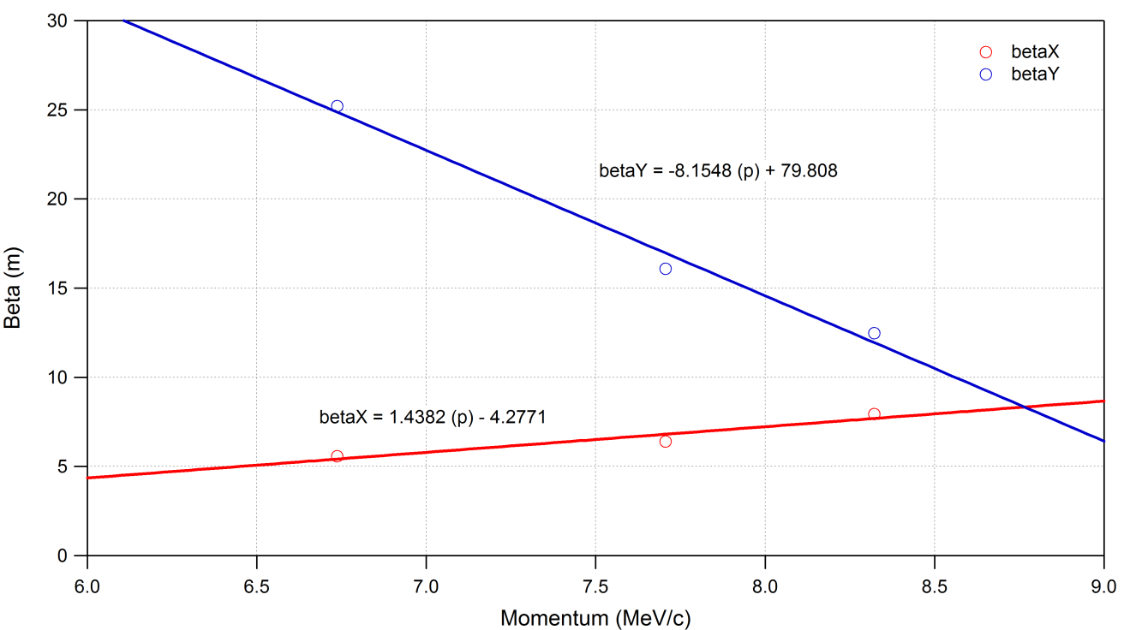

Figure B1: Linear fits to the horizontal (red) and vertical (blue) beta functions as a function of momentum.

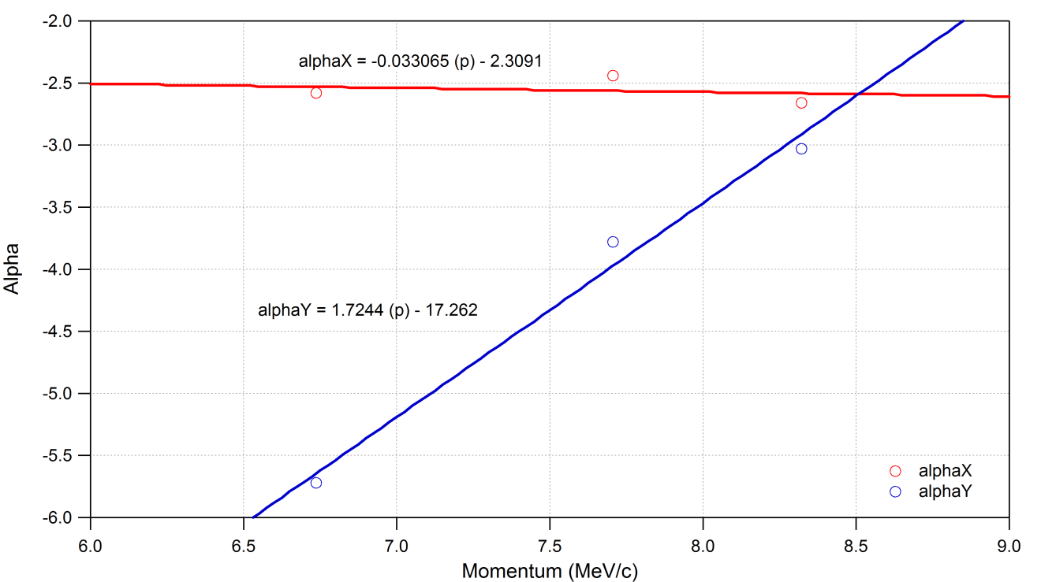

Figure B2: Linear fits to the horizontal (red) and vertical (blue) alpha functions as a function of momentum.

