UITF PSS BCM System Proposal
Trent Allison, Jim Kortze, Jerry Kowal, John Musson
7/20/2017

Background
The Radiation Control Group (RCG) has analyzed the Upgraded Injector Test Facility (UITF) shielding and determined what beam loss levels can generate radiation hazards outside the beam enclosure. A system to limit the beam current and/or beam loss, thus limiting the potential radiation, is desired to protect personnel outside the beam enclosure. It is also desirable to add passive shielding and keep out areas to mitigate the hazard as well as deploying radiation detection devices to directly measure the hazard and turn off beam when necessary. The analysis determined that the loss in cave 1 with MeV beam after the Quarter Cryomodule (QCM) must be less than 1 uA due to control room shielding. Loss in Cave 2 must be limited to 200 nA due to the roof shielding and location of the Test Lab High Bay. Also, loss at the boundary of the caves could cause shine inside the labyrinth [5, 9].
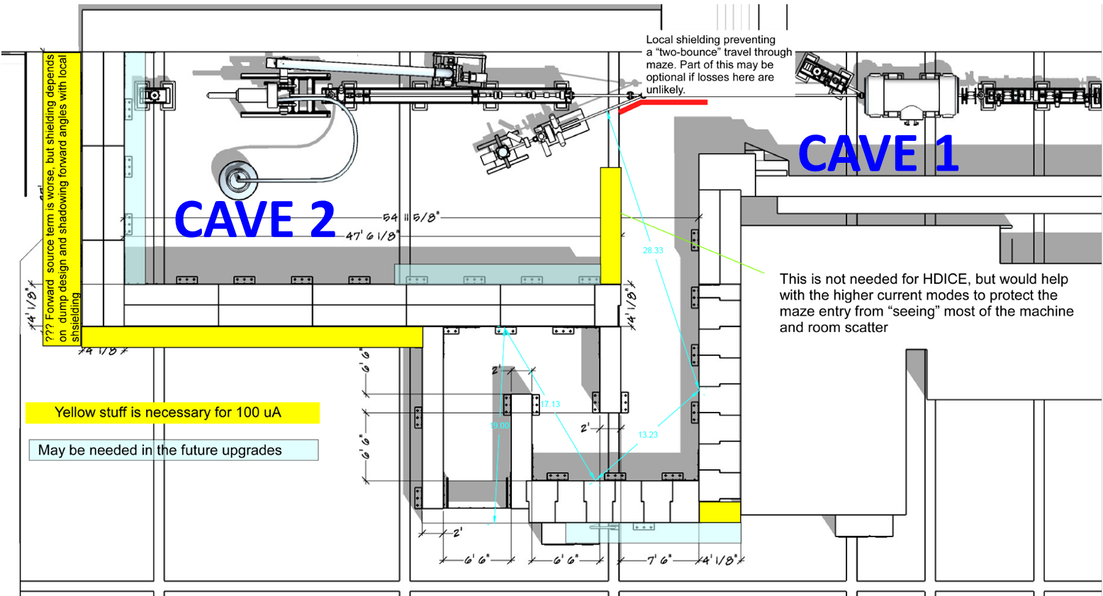
Figure 1: UITF Shielding Layout

Beam Current Monitor (BCM) cavities are TM₀₁₀ mode, 1497 MHz, stainless steel pillbox cavities with a Q of 500 or 1800. They have one or two probe antenna ports to pick up the cavity field proportionally to beam current and a test port input for exciting a field for functional verification. The cavities are tuned to 1497MHz via a tuning slug and some are temperature stabilized to hold the tune. BCM systems at Jefferson Lab have been used in the Personnel Safety System (PSS) but not in such a direct capacity as what is being proposed for the UITF.
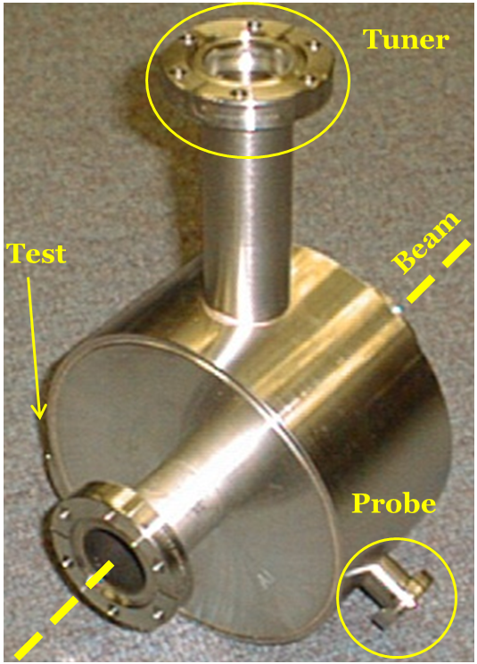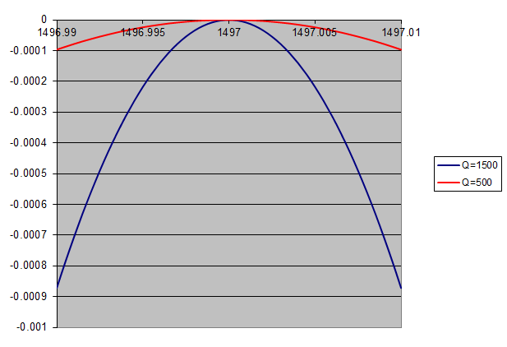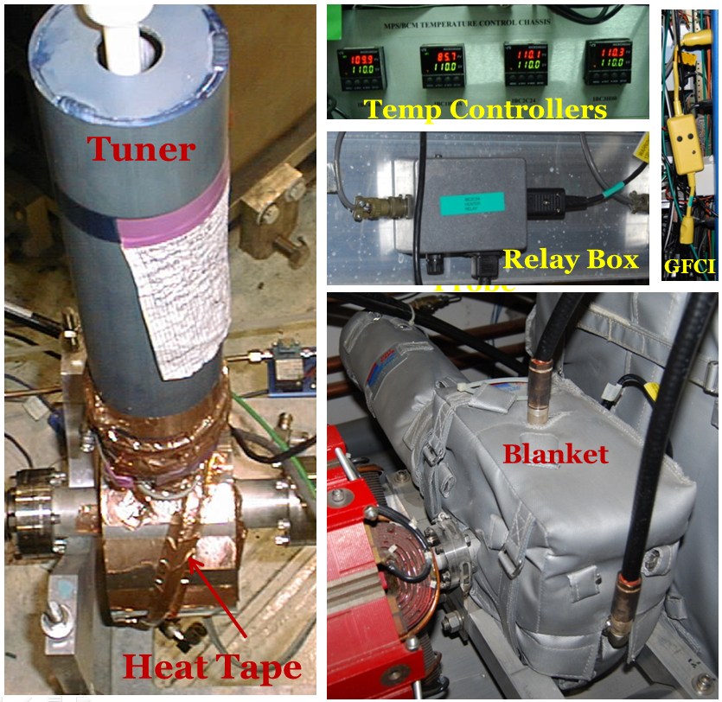
H
Probe
Figure 2: BCM Cavity, Qs and Temperature Control

The Continuous Electron Beam Accelerator Facility (CEBAF) PSS BCM system is mainly used to protect the Beam Stoppers from burn through. They are located in front of the Beam Stoppers and shut off the beam if over 1 uA of beam current is detected when the stoppers are inserted. Together, the PSS BCM and Beam Stoppers are a credited control that protects personnel from prompt beam-induced radiation. The CEBAF PSS BCM system was also used to limit Continuous Wave (CW) beam current going into CEBAF, before the Beam Envelope Limit System (BELS) was installed, and still limits Hall B CW beam current to 1 uA so that high current beam it is not inadvertently directed upward toward the counting house. The CEBAF PSS BCM system was evaluated for use in the UITF BCM application and found to be inadequate, a review was held Oct. 21, 2016 [1, 2, 3, 4, 6].
The Beam Loss Accounting (BLA or sometimes referred to as MPS BCM) system uses BCMs to monitor beam current levels entering and exiting CEBAF and calculates the beam loss. Using a leaky bucket algorithm, if the loss is too high for too long then the BLA systems turns off the beam via the Fast Shutdown (FSD) system. The BLA is a Machine Protection System (MPS) so it does not have all the redundancy and fail safe features required for PSS. The BLA system was commissioned in 1996 and has been providing MPS protection to CEBAF since. It meets some of the requirements needed for the UITF PSS BCM system but the electronics are obsolete and not recommended for future designs [7, 8].
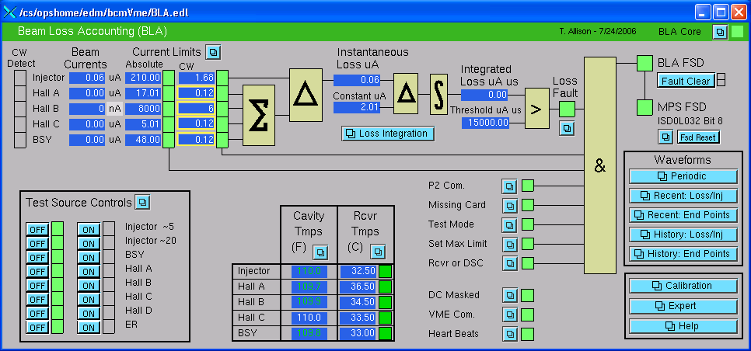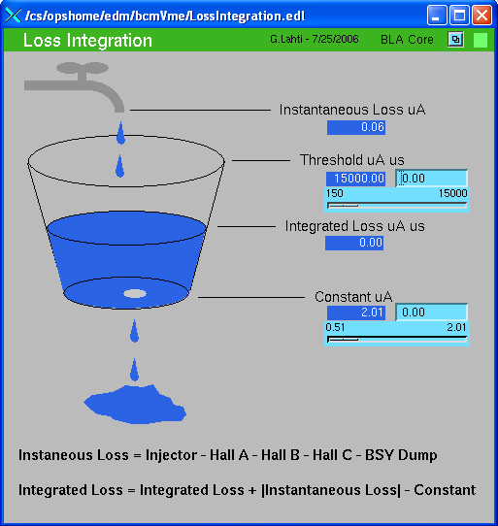
Figure 3: BLA Experimental Physics and Industrial Control System (EPICS) screens
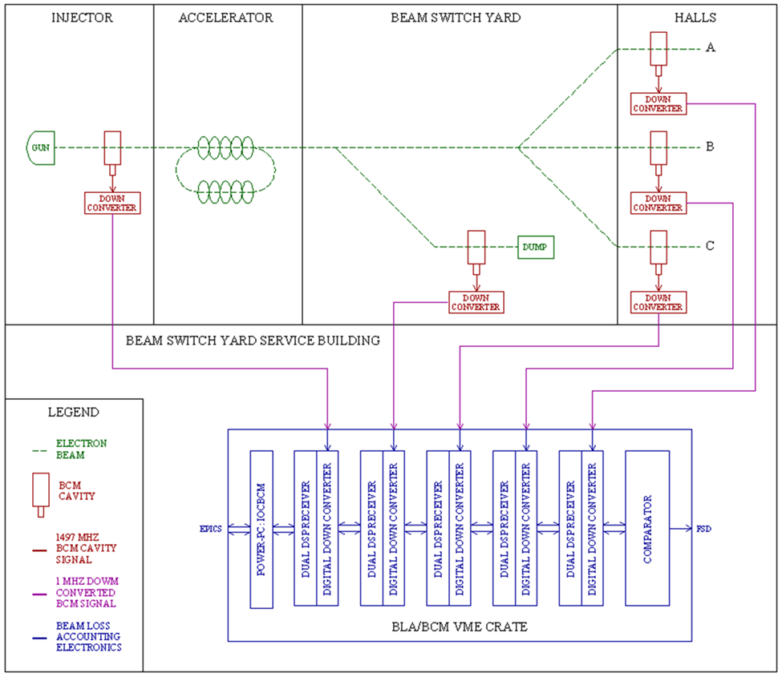
Figure 4: BLA (or MPS BCM) System Diagram

Beam Position Monitor (BPM) Receivers were developed for Hall D during the 12 GeV upgrade and 39 have been running in the accelerator since 2014. They are also being used for Cavity BPMs, 24 Inch BPMs, M56 Path Length, and BCM receivers. An early version of the receiver is connected to the Injector 0L02 BCM with a MPS FSD output for limiting current. These receivers should be able to meet the needs of the UITF PSS BCM system if redundancy, continuous test features and firmware are suitably implemented. The same receiver technology has also been used in Low Level Radio Frequency (LLRF) applications to control and protect the C100 Cryomodules in CEBAF since 2011.

Hall D BPM Receivers
The Hall D BPM receivers have a Calibration Cell (Cal Cell) located near the BPM and a BPM Receiver Chassis outside the beam enclosure with a Radio Frequency (RF) Down Converter (DC) and Intermediate Frequency (IF) Receiver PCB inside. The Cal Cell multiplexes BPM signals so they share a common electronics path. This ensures that any temperature related gain changes in the electronics affect both signals the same and drop out when calculating the difference-over-sum positions. The noise source reference can be used to verify the BPM functionality and compensate for temperature related gain changes in the electronics when making wire sum beam current measurements. Multiplexing PSS BCM signals would add complexity and failure modes so the use of Cal Cells will be avoided in the UITF PSS BCM System.
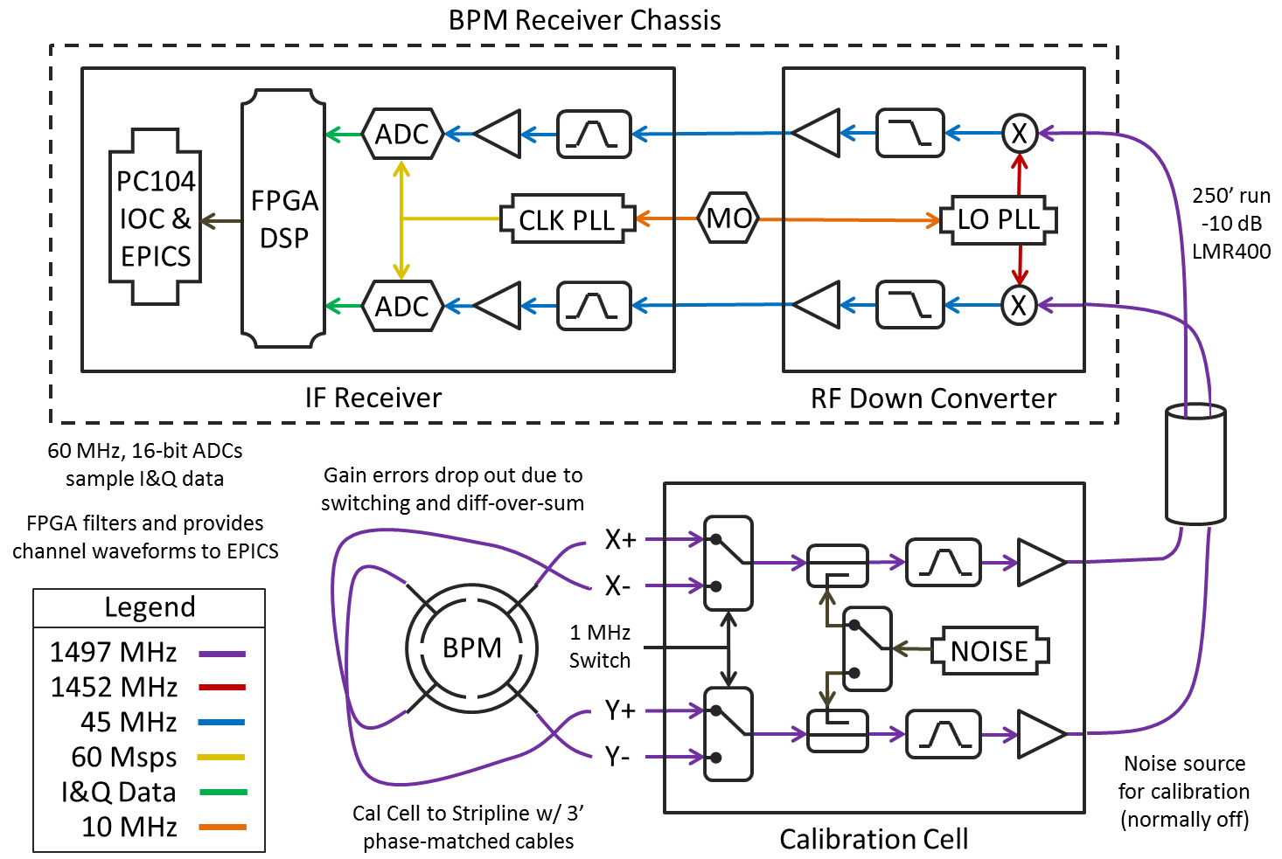
Figure 5: 12 GeV Hall D BPM System Diagram

The Hall D BPM Receiver Chassis is a hybrid heterodyne and Digital Down Conversion (DDC) system. It has a 2 channel RF DC that converts the 1497 MHz RF input to a 45 MHz IF using a 1452 MHz Local Oscillator (LO). The 45 MHz signals are then passed to the 2 channels of the IF Receiver PCB which are comprised of filters, Variable Gain Amplifiers (VGA) and Analog-to-Digital Converters (ADC). Each 45 MHz input signal is sampled by an ADC at 60 Msps to retrieve the In-Phase and Quadrature (IQ) digital data. The LO and ADC sample clock is locked to an external 10 MHz reference that is derived from the accelerator Master Oscillator (MO) for synchronous detection. Once digitized by the ADCs, the BPM data is de-multiplexed and filtered to provide the 4 wire signals corresponding to X+, X-, Y+, and Y-. The X and Y position are then calculated via the difference over the sum and the wire sum beam current is calculated by adding the 4 wire signals together.
UITF PSS BCM System
The main focus of the UITF PSS BCM System is to limit the current after the QCM to 200 nA due to Cave 2 shielding limitations. Another option is to measure the current after the QCM and at dumps downstream to implement something similar to the CEBAF BLA system. This option would calculate the loss and shutdown the beam if the loss exceeds 200 nA, thus allowing for higher beam currents to be delivered to well shielded dumps. The UITF PSS BCM System will be designed to limit the current after the QCM and to be upgradable to add a dump BCM so the BLA option could be implemented in the future. Multiple dump BCMs could also be accommodated with additional hardware and firmware.
The UITF PSS BCM cavity will have a Q of 500 to limit temperature related tuning effects and two probe ports for redundancy that will be connected to separate A and B electronics chains. A pilot tone that is off-frequency from the detected beam current signal will be continuously injected into the cavity. This will be detected by the cavity probes and allow a mechanism for constant system verification. The probe signals from the BCM cavity will be connected to the first RF input channel of two repurposed Hall D BPM Receiver Chassis (referred to as PSS BCM Receiver Chassis hence forth); the BPM Cal Cell will not be used. The pilot tone will be connected to the second RF input of each chassis. The Pilot Tone Generator (PTG) and PSS BCM Receiver Chassis will be phase locked to a 10 MHz reference signal that is derived from the UITF MO for synchronous signal detection. The beam fault output from each PSS BCM Receiver Chassis will be connected to the PSS in order to shut down the beam. The standard BLA cavity temperature control setup of heat tape, thermal blanket and controller will be used to stabilize the cavity at 110⁰ F. The PSS BCM Receiver Chassis will also monitor the temperature of each cavity. The temperature controller and both PSS BCM Receiver Chassis’ will communicate with EPICS for remote monitoring.
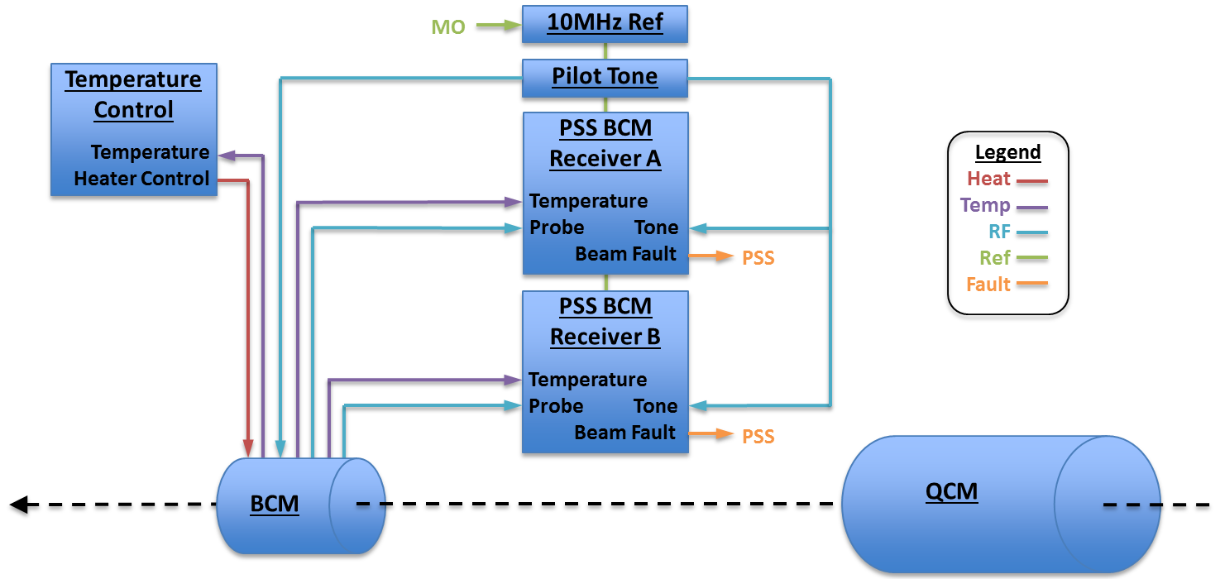 Figure 6: UITF PSS BCM System Diagram

The firmware for each chain will be developed independently by different Hardware Description Language (HDL) programmers. Digital Signal Processing (DSP) techniques will separate the probe channel’s detected pilot tone from the beam signal in the PSS BCM Receiver Chassis firmware. The detected beam current from the cavity will be compared to the limit and a current limit fault will be pulled if it is breached. An integrating algorithm will be implemented to ignore Tune Mode beam but trip within the necessary timeframe for CW mode beam. The PTG will also have a 1497 MHz test oscillator for simulating 1 uA of beam that can be turned on remotely. It will be used periodically to verify system functionality by ensuring a trip occurs if more than 200nA of beam is detected.
UITF PSS BCM System Faults
Type | Condition | Description
Current Limit | Detected beam current surpasses limit | Protects from sending more beam current than safely allowable
Pilot Tone Amplitude | Detected pilot tone amplitude from cavity probe is outside acceptable window | Verifies that the pilot tone is on, the Pilot Tone Generator is stable, and confirms end-to-end system functionality
Pilot Tone Differential Amplitude (1) | Detected pilot tone amplitude from cavity compared to PTG is outside acceptable window | Ensures cavity tune is stable and the electronics are stable
Pilot Tone Differential Phase (1) | Detected pilot tone phase from cavity compared to PTG is outside acceptable window | Ensures cavity tune is stable and the electronics are stable
Cavity Temperature | Cavity temperature is outside acceptable window | Ensures cavity temperature control loop is stable and thus no detuning due to temp
RF Temperature | RF DC PCB temp reaches limit | Prevents failures from RF board overheating
IF Temperature | IF Rx PCB temp reaches limit | Prevents failures from IF board overheating
RF PLL Lock | RF DC not locked to 10 MHz | Ensures synchronous RF signal detection
IF PLL Lock | IF Rx not locked to 10 MHz | Ensures synchronous RF signal detection
PTG PLL Lock | PTG not locked to 10 MHz | Ensures synchronous pilot tone generation
Pilot Tone Frequency | Pilot tone frequency drifts outside acceptable window | Ensures the pilot tone is on and the entire system is locked to the 10 MHz reference
Loss Limit (2) | Detected beam loss surpasses limit | Protects from losing more beam current than safely allowable
Notes: (1) In the 2 cavity system, the detected pilot tones from the 2 cavities will be compared opposed to the generator
(2) Only applicable to the 2 cavity system
Table 1: UITF PSS BCM System Faults
If the amplitude of the continuously detected off-frequency pilot tone from the BCM cavity probe varies outside a window then the system will trip on a pilot tone amplitude fault. This window will be large enough to ignore the amplitude drifts inherent to the PTG. The pilot tone amplitude will also be measured directly via the second RF input channel and subtracted from the detected BCM cavity pilot tone amplitude to provide a more precise differential measurement that is not effected by the PTG drift. If the differential pilot tone amplitude signal wanders outside this tighter window then a pilot tone differential amplitude fault will occur. The detected pilot tone phase and the phase of the PTG will also be compared and if it drifts outside a window then a pilot tone differential phase fault will occur. These tone faults ensure that the pilot tone is on, electronics are stable, cavity is holding tune, and the system is functioning properly.
If the cavity temperature is outside a window then a cavity temperature fault will be pulled. This is somewhat redundant to the tone faults by ensuring the cavity temperature control system is behaving correctly and thus holding the cavity tune stable. The onboard temperatures of the RF DC and IF board will also be monitored and cause temperature faults if outside their windows. This helps prevent damage to hardware but is also partially redundant to the tone faults in that it helps limit the possible electronic gain drift. The PSS BCM Receiver Chassis and PTG will generate DC, IF and PTG Phase Lock Loop (PLL) faults if the PLLs come unlocked or the 10MHz reference is not stable. DSP techniques will be employed to measure the frequency of the pilot tone. If the pilot tone frequency is outside an acceptable window then a pilot tone frequency fault will occur. This further verifies that the pilot tone is on and that the entire system is locked properly to a stable 10MHz reference.
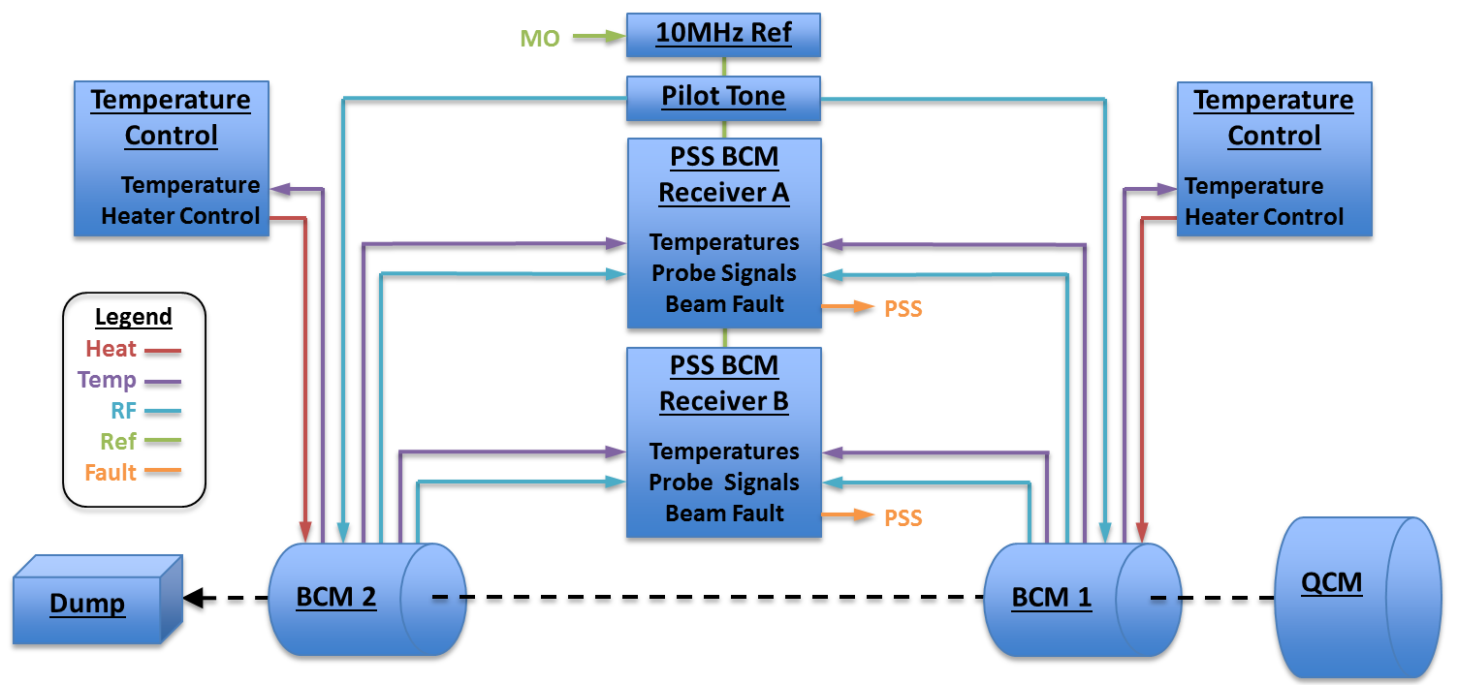
Figure 7: Two Cavity UITF PSS BCM System Diagram

The system can be upgraded to have two BCM cavities and look for the loss between them to allow higher beam current delivery to a shielded dump. If the loss is more than 200 nA then a loss limit fault will occur. The first cavity would still be after the Quarter Cryomodule and the second would be just before the beam dump. The second input of the receiver chassis would be the dump BCM instead of the PTG. The pilot tone differential amplitude and phase faults would then use the difference between the two cavities opposed to measuring and comparing to the PTG directly. If a differential pilot tone fault occurs then more investigation will be needed to determine which cavity caused the fault but a comparable level of protection is still present. The functionality of the current limit, pilot tone amplitude, cavity temperature, RF temperature, IF temperature, RF PLL Lock, IF PLL Lock, PTG PLL Lock, and pilot tone frequency faults would remain the same but there would be two sets; one for the QCM BCM and another for the Dump BCM.

Failure Mode Analysis
Monitoring the pilot tone provides continuous end-to-end protection against system failures. This has not been implemented in previous BCM systems but is essential to the UTIF PSS BCM application. It guards against cavity mistuning, broken cavity probes, disconnected cables, electronics failures, and most any other conceivable malfunction. Having redundant probe sensors and electronics chains further reduces the likelihood of an unsafe condition. An argument could be made that although each probe is detecting the cavity field individually, one cavity with two probes is not truly redundant because the cavity is common to both probes. However, the CEBAF PSS BCMs were implemented as a single cavity with two probes in each location during the 90’s and the cavities are fairly robust structures; a welded stainless steel cylinder about 7” in diameter and 3” long with 3 probe, 1 tuner and 2 beam ports. Of the 34 BCMs installed in various CEBAF systems over the past 22 years, 3 have stuck tuners (1 M56 BCM and 2 Hall A Unser BCMs) and 2 had damaged probes that broke vacuum (1 Hall C diagnostic BCM and 1 Hall A MPS BCM, both during beamline reconfigurations). These failure modes are rare and would be detected by the pilot tone injection and monitoring schemes outlined earlier.
This will be the first time Field Programmable Gate Arrays (FPGAs) are implemented in a PSS application at Jefferson Lab. FPGAs are present in vital automobile, airplane and space flight systems. There are hundreds of FPGAs installed at Jefferson Lab in almost every other system including MPS, RF, IC, DC Power, SRF, and Physics. These FPGAs control and protect accelerator hardware such as Cryomodules, magnets, targets, dumps, vacuum, gun high voltage, and Injector cavities. They are also used to shut down the beam to prevent burn through when RF faults occur or beam loss is detected from Ion Chambers, BLMs or the BLA. The biggest concern with using FPGAs is following good digital design programming practices. This is why two HDL programmers will write the code individually to ensure no coding mistakes are common to each redundant chain. This separate coding technique is common in PSS PLC applications at Jefferson Lab. The HDL code will also be thoroughly tested and likely reviewed by two more independent knowledgeable HDL programmers to further insure proper functionality.
Miss-calibrating the UITF PSS BCM system could lead to unsafe conditions. A calibration procedure will need to be carefully thought out and strictly adhered to. The intention is to calibrate against a Faraday Cup after the BCM. Precautions should be taken to ensure there is no beam loss before calibrating. This includes performing radiation surveys and aperture scans as well as monitoring BLMs, Ion Chambers and vacuum levels. The Faraday Cup system would also need to be verified with self-tests and by comparing it to another Faraday Cup reading upstream. It might be mandatory that calibrations use Tune Mode beam (250 us beam pulse at a 60 Hz repetition rate) which would require the Faraday Cup and UITF PSS BCM to report the peak beam current of the tune beam opposed to the average current. It may also be advantageous to employ another technology such as a toroid device to further verify the calibration of the PSS BCM and Faraday Cup. UITF PSS BCM calibration numbers will be stored locally in hardware and are not to be loaded through EPICS. This ensures the system is in a valid state after power up. EPICS will check the calibration numbers to make sure they match what is expected as another level of verification.

Summary
A viable UITF PSS BCM System is achievable if a pilot tone is continuously injected into the PSS BCM cavity and monitored to ensure end-to-end system functionality. Redundant chains and independent FPGA programmers will be utilized to further mitigate possible failures. The existing Hall D BPM Receiver design can be modified and reprogrammed for use as a UITF PSS BCM Receiver. A Pilot Tone Generator and reference distribution system will need to be developed. Standard BLA temperature control hardware will stabilize the PSS BCM cavity temperature and tune. A robust system calibration procedure needs to be carefully crafted and employed. This includes evaluating the use of external beam current measuring devices such as Faraday Cups and Toroids.

Acronyms
ADC: Analog to Digital Converter
BCM: Beam Current Monitor
BELS: Beam Envelope Limit System
BLA: Beam Loss Accounting System
BLM: Beam Loss Monitor
BPM: Beam Position Monitor
Cal Cell: Calibration Cell
CEBAF: Continuous Electron Beam Accelerator Facility
CW: Continuous Wave
DC: Down Converter
DDC: Digital Down Conversion
DSP: Digital Signal Processing
EPICS: Experimental Physics and Industrial Control System
FPGA: Field Programmable Gate Array
FSD: Fast Shutdown
HDL: Hardware Description Language
IF: Intermediate Frequency
IQ: In-phase and Quadrature
LLRF: Low Level Radio Frequency
LO: Local Oscillator
MHz: Mega Hertz
MO: Master Oscillator
MPS: Machine Protection System
Msps: Mega samples per second
PLL: Phase Lock Loop
PSS: Personnel Safety System
PTG: Pilot Tone Generator
QCM: Quarter Cryomodule
RCG: Radiation Control Group
RF: Radio Frequency
Rx: Receiver
UITF: Upgraded Injector Test Facility
References
[1] Allison, T. et al., “UITF PSS BCM Electronics Characterization”, Oct. 19, 2016
[2] Cuevas, C. et al., “Safety Review: Proposed PSS PCM for the Upgrade Injector Test Facility”
Nov. 16, 2016
[3] Hutton, A. et al., “Beam Current Monitors for Personnel Safety and Machine Protection”
Rev. 1/10/95
[4] Mahoney, K. et al., “PSS Beam Current Monitor Conceptual Design Review” May 23, 1995
[5] Poelker, M., “UITF PSS BCM Mini-Review, Limit Beam Current to Limit the Radiation Dose Outside
UITF Enclosure”, October 21, 2016
[6] Robertson, H. et al., “Beam Current Monitor System Functional Description”, Oct. 21, 2016
[7] Ursic, R. et al., “CEBAF Beam Loss Accounting” CEBAF-PR-95-043
[8] Ursic R. et al., “Operation Experience with the CEBAF Beam Loss Accounting System”,
CEBAF-PR-96-007
[9] Vylet, V., “Desirable BCM Performance”, UITF BCM Discussion, Oct. 21, 2016

