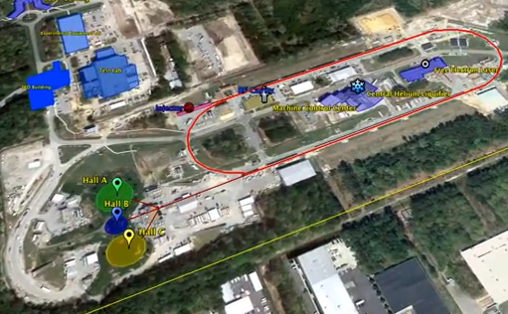
Location A
Location B
Location C
Location D

At location A: boneyard behind Hall A, near hockey “rink”
21”
3’
10”
10”
30”
T-shaped roof blocks
17’ x 3’ x 21” 20 count
24’ x 3’ x 21” 4 count
26’ x 3’ x 21” 25 count

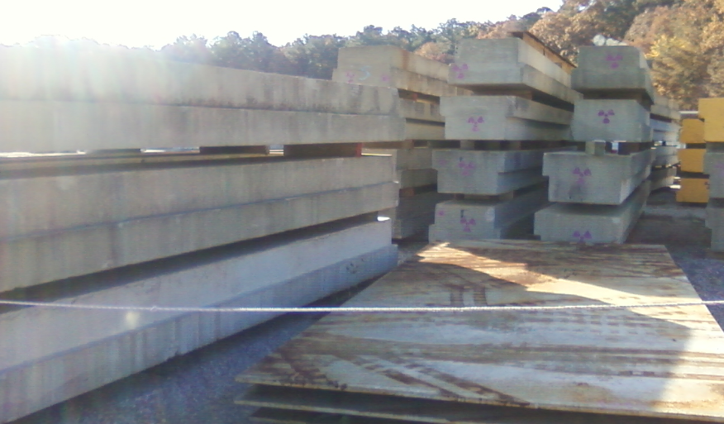
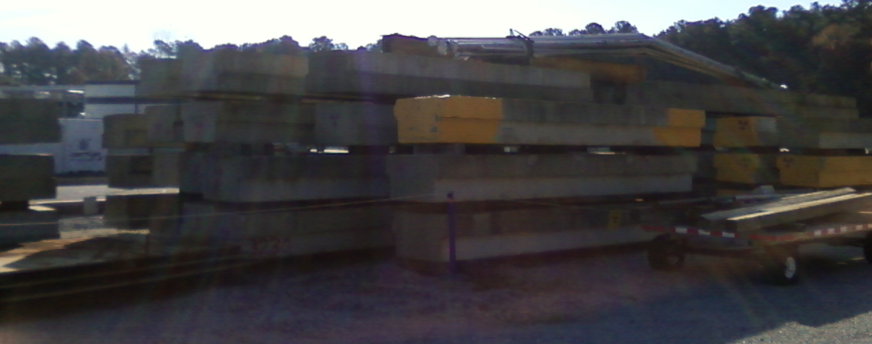

Also at location A:
Yellow rectangles
52” x 52” x 26” 24 count
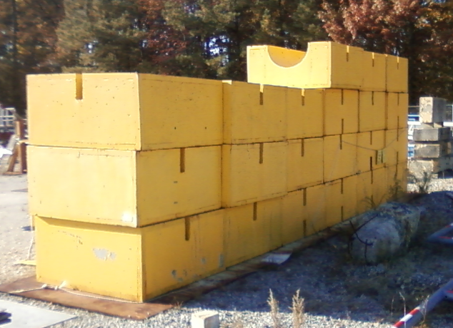

Also at location A:
Long thin slabs
78” wide x 12” thick x 14’ long 6 count plus assorted pieces, all 12” thick
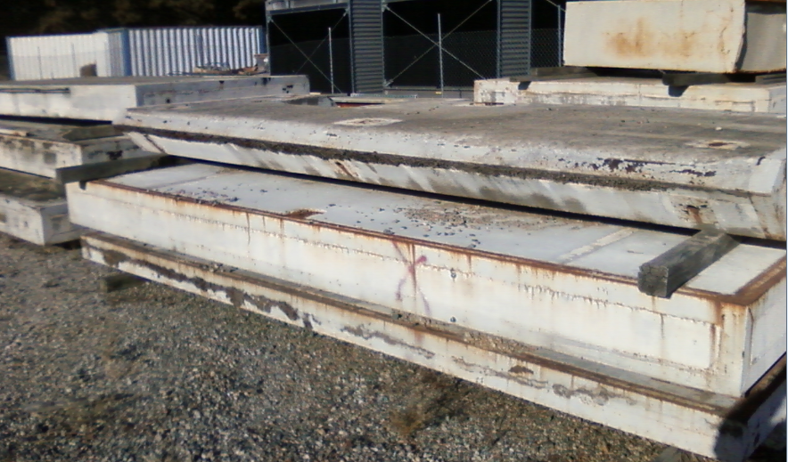

At location B: behind Hall C, near the Hall B ramp:
Green rectangles
52” x 52” x 26” 166 count (wow)

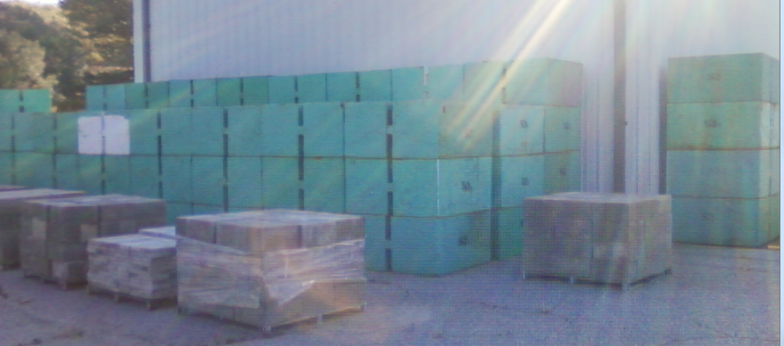

At location C: near entrance to Hall C ramp:
4’
3’
2’
2’
30”
Long rectangles, stored in metal racks
9’ x 4’ x 3’ 71 count

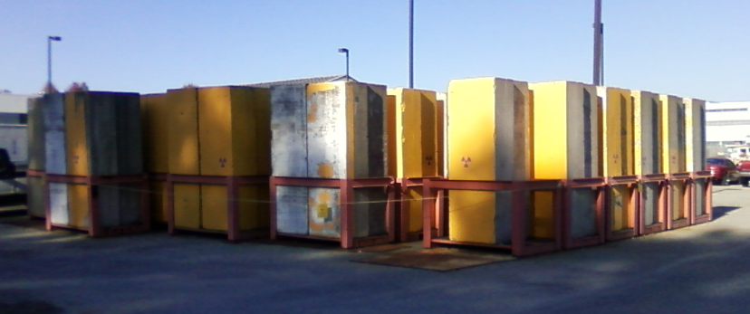

Also at location C, near the Physics utility building:
Many rectangular blocks
2’ x 3’ x 4.5’ ~ 65 count + many assorted sizes
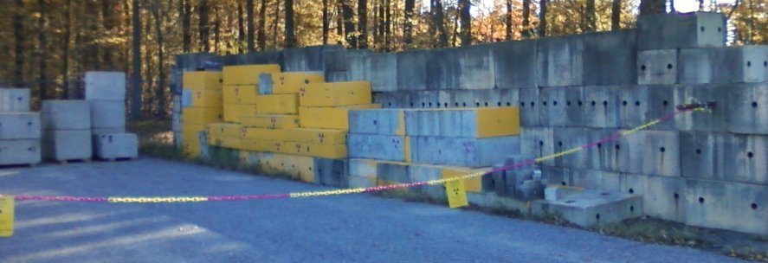

At location D, on the side of building 23
T-shaped roof blocks
24’ x 3’ x 21” 5 count and 1 in pieces, all labeled “scrap”
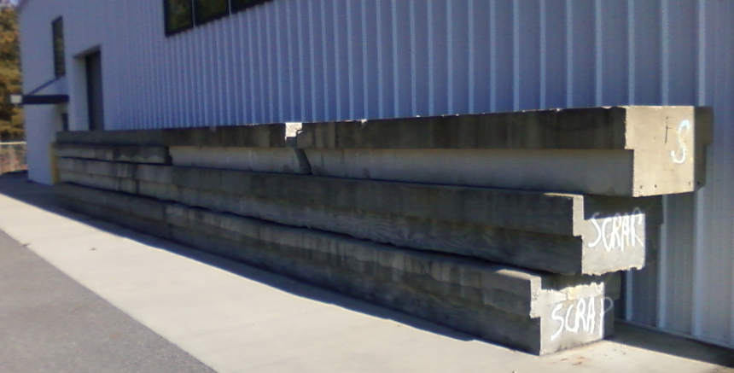

From: Vashek Vylet &lt;vylet@jlab.org&gt;
To: Matt Poelker;poelker@jlab.org; Hari Areti;areti@jlab.org;
Suresh Chandra;chandra@jlab.org&gt, Rebecca Yasky
;ryasky@jlab.org&gt, Evelyn Akers;eakers@jlab.org&gt, Walt Akers;akers@jlab.org&gt;

Cc: Bob May;may@jlab.org&gt;, Keith Welch;welch@jlab.org&gt;

Sent: Fri, 28 Mar 2014
17:31:39 - 0400 (EDT)
Subject: ITFU shielding
-
First assessment for HDIce

Colleagues,
The purpose of this message is to provide the first assessment of the draft ITFU shielding design. I am referring to the latest version of drawings provided by Walt Akers, where the side wall consists of two layers of 3 ft concrete blocks (6 ft total thickness) and 2 ft thick concrete blocks spanning the roof. The executive summary is that the proposed shielding is more than adequate for HDIce.

This is a preliminary assessment. Following our shielding design tracking and approval process, the final design will undergo a QA check within RadCon and final approval by the Safety Configuration Management Board (SCMB). HDIce plans to run approximately 900 hours, using a 5 nA average current about 80% of the time and a 100 nA average current the remaining 20%. The latter would be used for tuning, terminating the beam either in Faraday cups in the old injector cave or in the new experimental area.

It is assumed that approximately 5% of the beam current could be lost anywhere along the beam line during normal operation, with an occasional 100% loss due to mis-steering. We are further assuming that all Faraday cups and beam termination points will have sufficient local shielding. Shielding estimates were done using source terms and attenuation factors from NCRP Report No. 51.

1) Side wall
A side wall thickness of 3 ft would be more than sufficient for HDIce parameters (if there were no cracks between blocks). The proposed 6 ft thickness would provide adequate protection for average beams up to 170 micro-A. This is assuming the above 5% beam loss and using an acceptable dose rate limit of 50 micro-rem/h, i.e. JLab limit for a Radiologically Controlled Area (RCA).

2) Roof
The roof is adequate for the 5 nA beam. At 100 nA, a 5% (point) beam loss could lead to dose rates marginally exceeding the RCA limit of 50 micro-rem/h. However, considering the running time in this regime, the total integrated dose in this area would not exceed the 100 mrem/year limit for members of the public (without even applying occupancy factors). The decision about posting this area will be taken based on radiation surveys.

3) 2nd Floor in Test Lab North Annex Based on the results for radiation levels on the roof above, there is no concern for occupancy by non-radiation workers in this area.

4) Items needing attention
-
The entrance maze needs to be modified, taking into account constraints that have not been fully discussed and resolved so far: penetrations in the side wall or roof

Please let me know if you have any questions or comments.
Thanks,
Vashek
Vaclav "Vashek" Vylet
Radiation Control Manager
Jefferson Lab
12050 Jefferson Avenue
Newport News, VA 23606
Phone: 757-269-7551

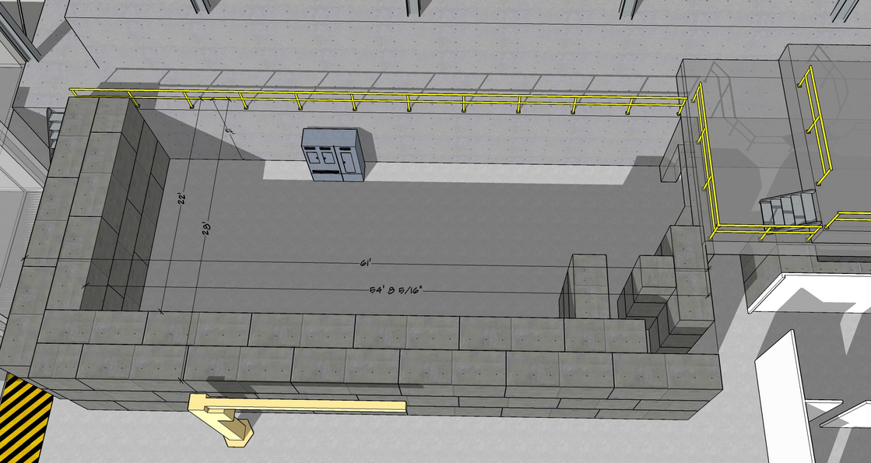

Walt’s preliminary drawings indicate the L-shaped perimeter of the new cave can be formed using roughly 51 T-shaped blocks of the sort pictured below, and sitting at location C (3’x4’x9’) plus some combination of smaller rectangles, although it seems there’s a height mismatch that could confound us.
And for the roof, we would need ~ 19 of the T-shaped roof panels that are 26’ long, and we have 25 of them.
There are plenty of rectangular blocks that could be used to form the labyrinth.
My conclusion (?): A combination of on-site blocks plus ~ one layer of wall composed of new custom-made blocks will do the trick. With the new custom blocks, the L-shaped new wall height will be equal to the height of the ledge/walkway of the existing East wall, thereby greatly simplifying the addition of roof panels, which would rest entirely on the concrete walls.

