What is the measurement speed of the harmonic cavity, and how does its speed influence its measurement of bunch FWHM?

The harmonic cavity and oscilloscope used to measure CEBAF’s beam are not infinitely fast, so, they have non-zero rise and fall times. Their rise and fall time contribute to the measurement of electron bunch FWHM. Determining the contribution of the measurement equipment to the measured FWHM could help resolve differences between the measured and modeled bunch lengths.

The measurement speed of sensors and oscilloscopes are most often benchmarked by their 10/90 rise time and/or by their bandwidth. Because sensors and oscilloscopes are not infinitely fast, their measurement of a step function has a slope. The time between the measured 10% of peak and 90% of peak along this slope is the measurement of 10/90 rise time.

Bandwidth is the Frequency domain’s equivalent to rise time, and is the highest frequency contribution in the signal. In Gaussian systems the rise time and bandwidth are interchangeable by the equation:

$$Rise Time (ns)=\frac{0.35}{Bandwidth (GHz)}$$

The Oscilloscope used to make these measurements was a Tektronix 11810b with a 40 GHz SD-30 sampling head and an 8.75 ps rise time.

$$.00875 ns=\frac{0.35}{40 GHz}$$

The harmonic cavity also has a bandwidth and rise time. The combination of the harmonic cavity and the oscilloscope is the system bandwidth (BW).

$System Bandwidth = \frac{1}{\sqrt{ {\left( \frac{1}{{BW}_{harmonic cavity}}\right)}^{2}+ { \left( \frac{1}{{BW}_{oscilloscope}}\right)}^{2} }}$

The system bandwidth can be explored using measurements of the 500 kV beam made with the harmonic cavity. There were four measurements that included a full wavelength of data, enabling their Fourier series to be calculated and compared to their measured rise time using the Bandwidth / rise time relationship. The 10/90 risetime was measured graphically, the bandwidth calculated from it can be compared to the first 40 terms of the waveforms Fourier series
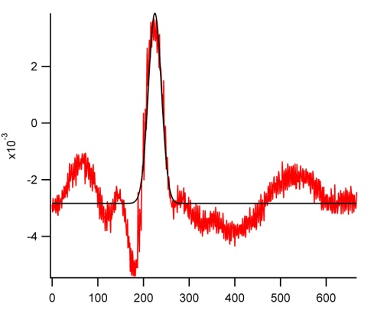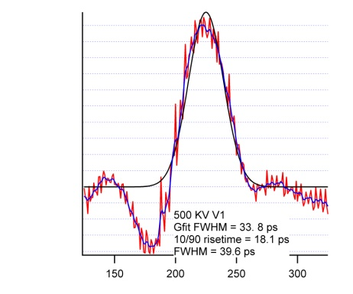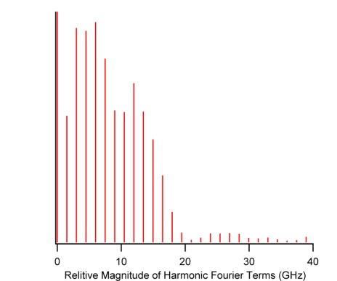
Measured rise time = 18.1 ps, Bandwidth = .35/ .0181ns = 19.33 Ghz
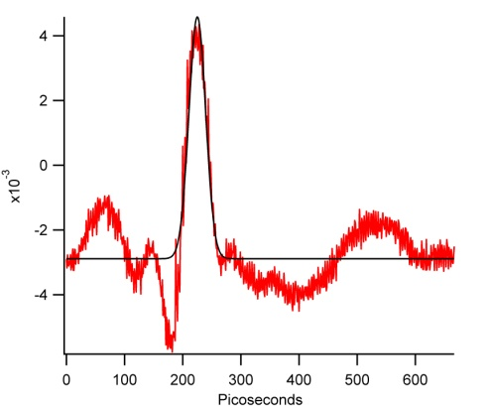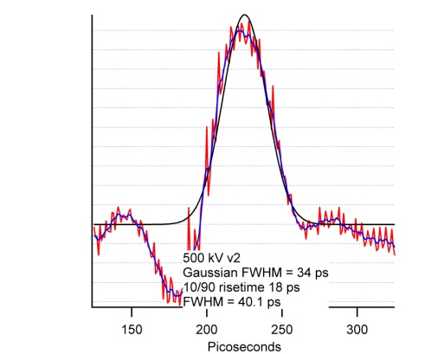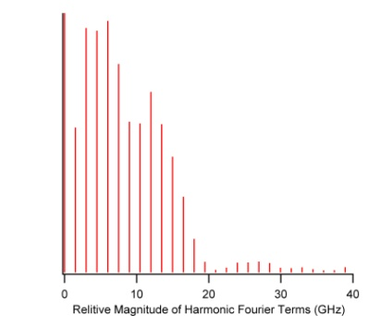
Measured rise time = 18 ps, Bandwidth = .35/.018 ns = 19.4 GHz
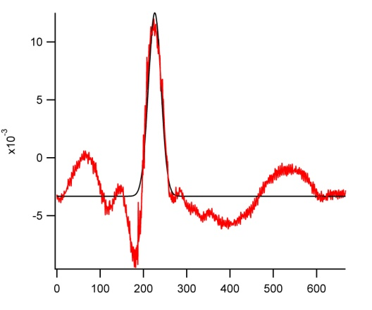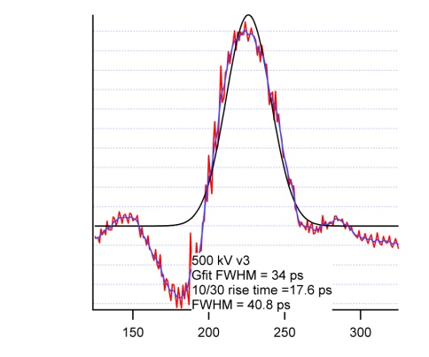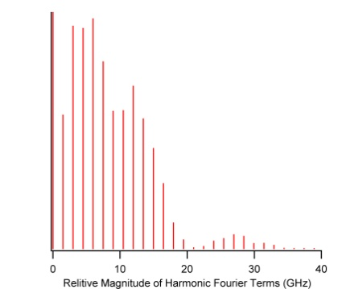
Measured rise time = 17.6 ps, Bandwidth = .35/.0176 ns = 19.9 GHz

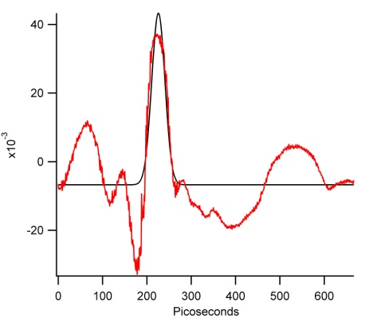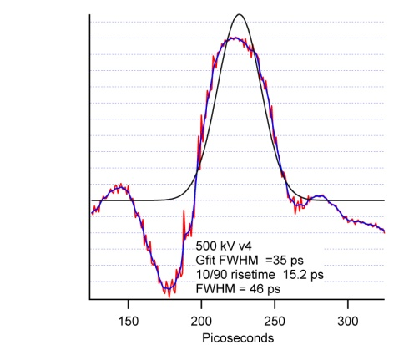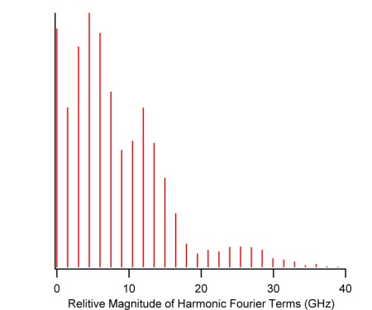

Measured rise time = 15.2 ps, Bandwidth = .35/ .0152 ns = 23 GHz

The measured rise time is related to the system rise time by the expression:

$$Measured rise time= \sqrt{{{(RT }_{electron bunch })}^{2}+({{RT}_{harmonic cavity and scope})}^{2} }$$

If it is assumed the 500 kV electron bunches are extremely brief and the system bandwidth rise time is entirely due to the harmonic cavity and the oscilloscope, then the system bandwidth is approximately 20 GHz, and the system rise time is approximately 17.5ps. What does a 20 GHz, 17.5 ps rise time measurement system have on an electron bunch FWHM measurement?

A 50 ps FWHM Gaussian has a 10/90 rise time of 36 ps. If the system rise time is 17.5 ps, the measured rise time, by the above equation, will be 40 ps.
A 75 ps Gaussian has a 10/90 rise time of 54 ps. With a system rise time of 17.5 ps, the measured rise time would be 57 ps.
A 100 ps Gaussian has a 10/90 rise time of 71 ps. With a system rise time of 17.5 ps, the measured rise time would be 73 ps
A 150 ps Gaussian has a 10/90 rise time of 107 ps. With a system rise time of 17.5 ps, the measured rise time would be 108 ps.

The rise time and bandwidth of the measurement system, the harmonic cavity and scope, contribute to the beams measured FWHM. The briefer the electron bunch, the more significant the effect. As the electron bunch gets longer, the effect diminishes.

A simplistic model of the effect of the contribution of the measurement systems rise and fall time to a FWHM measurement is illustrated in the triangular waveforms below:
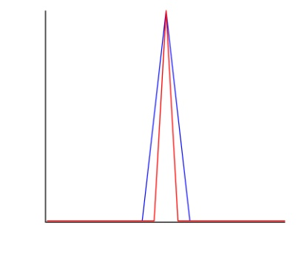
If the red triangle is the true electron bunch, the blue is the measured waveform that includes the measurement systems rise and fall times. In this example, the width of the measured waveform is wider than the electron bunches waveform at the half max, by their difference in rise times. A 50 ps electron bunch would measure 54ps, a 75ps bunch would measure 78ps, 100ps would measure 104ps and a 150 ps bunch would measure 152 ps. The measured FWHM of electron bunches are influenced by the rise and fall time of the measurement system. Careful analysis of this could help resolve differences between the measured and modeled bunch lengths.

