Jefferson Lab
Center for Injectors and Sources
Cathode exchangers
Carlos Hernandez-Garcia (chgarcia@jlab.org), Joe Grames, and Matt Poelker

The Gun Test stand at Jefferson Lab consists of an inverted geometry ceramic insulator DC electron gun. The gun is connected to a diagnostic beam line. Multi-alkali photocathodes are prepared and transferred to the DC gun in a vacuum chamber connected to the back of the gun via a gate valve. This preparation chamber / cathode exchanger is an adaption from earlier Jefferson Lab versions for GaAs photocathodes utilized in the main accelerator (CEBAF) and in the Injector Test Stand (,).
Regarding particulate generation in the cathode electrode vicinity during photocathode puck exchanges, we have not implemented yet any diagnostics (particle counters for example), but radiation monitors do not seem to indicate any problem due to field emission. This does not mean there are no particulates generated; it only means that the gradient (about 10 MV/m DC) is not sufficiently high to cause field emission from any potential particulates. One must note also that the cathode puck exchange mechanism is all contained within the hollowed cathode electrode ball, and the photocathode surface comes to a rest a few microns behind the ball electrode aperture, i.e. the photocathode does not protrude outside the surface of the cathode electrode.

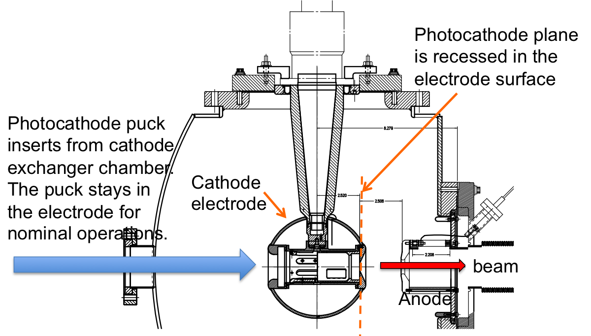

Top: Side view of the Cathode preparation chamber / cathode exchanger connected to the DC electron gun (orange). Bottom: Cross section of the gun showing the puck retainer mechanism internal to the spherical cathode electrode (15 cm diameter)

To test for potential particulate production, one could imagine a vacuum chamber with two opposite viewports in such a way that the line of sight of the particle counter is just below the gun electrode where the puck comes to rest for nominal operations.

:
The puck has a groove with two slots so that the puck holder engages (key mechanism) with two ears that line up to the puck slots, see Fig. 1. Then the puck holder is rotated and the ears turn inside the puck groove, ensuring engagement. We found this simple key/keyhole method is convenient to implement and can work reliably however there is room for improvements. We learned that disengaging the male manipulator from the female puck can be tricky when done ‘blindly’ in the HV chamber. Typically we insert the manipulator with the manipulator key aligned to the puck keyhole mitigating the need to disengage it ‘blindly’. For retraction we do insert the manipulator key and engage a quarter-turn, but assuming the key will rotate cleanly in the puck. This is accomplished by exerting a slight pressure into the puck. The puck has also a ‘tab’ to prevent the puck from continuously rotating inside the electrode during extraction manipulations. We realized this solution early on after a puck rolled off a manipulator into the vacuum chamber; the pinned ear works well as a stop in the rolling direction, but similarly acts as a wedge if it protrudes in one of the manipulators that hold the puck from it’s outside surface. Alignment between the electrode and the long puck holder manipulator is critical, otherwise the manipulator puck holder ears won’t line up to the puck’s slots. To achieve this a bellows with fine pitch and yaw control must be installed between the cathode exchanger chamber and the long manipulator puck holder.. On a positive note, we have the ability to rotate and set the azimuthal orientation of the puck (and photocathode) by rotating the manipulator azimuth; this is very useful for GaAs photocathode where the strained orientation of the photocathode is an additional degree of freedom. Again one must take care that the orientation of the pinned ear does not conflict with springs in the electrode support as the springs can be damaged and the puck will not seat, so could fall into an un-retrievable position in the electrode. Seating a puck in the electrode is highly reproducible, however, the stable position is defined by the quality of the spring/puck alignment and holding force of the springs. For example, a puck can be inserted/retracted multiple times and a laser reflection from the photocathode will reproduce after the manipulator is disengaged, however one can apply a small force ~few lbs. to rear of puck and move the retro-reflection by as much as a few milliradians.

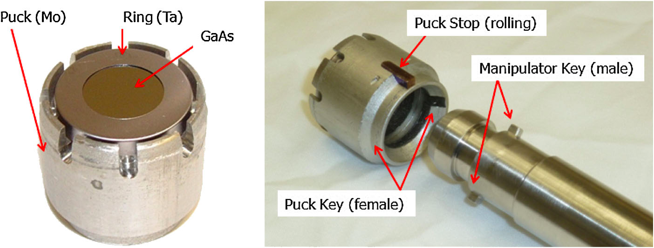

Fig. 1 – Extracted from Reference 1. Left: The exposed GaAs diameter is 13 mm. Right: Detail showing the back end of the puck and the manipulator.

In summary, this method is straight forward to implement and, given care and training, works reliably. However, if a new method were engineering the above points are important to take into consideration.

Grames et al., "Charge and fluence lifetime measurements of a DC high voltage GaAs photogun at high average current", Phys. Rev. ST Accel. Beams 14, 043501 (2011)
Adderley et al., "Load-locked dc high voltage GaAs photogun with an inverted-geometry ceramic insulator", Phys. Rev. ST Accel. Beams 13, 010101 (2010)

