**Physical Description of the CEBAF Mott Polarimeter**

*J. Grames, D. Machie, M. Stutzman*

*JLab-TN-17-xxx*

*May 12, 2017*

***Introduction***

This note describes the CEBAF Mott polarimeter construction, specifically as installed and used during Mott experiment Runs I and II in 2015. Drawings and images shown in this technical note may be found at */group/mottgrp/Upgrade2013*.

***CEBAF Injector***

A -130 kV dc high-voltage gun produces spin-polarized electrons from a GaAs/GaAsP superlattice photocathode via photoemission. The laser repetition rate and pulse length determine the electron characteristics, sub-harmonics of 499Mhz and 50 ps respectively. The spin polarization of the electrons is set by the circular polarization state of the laser and may be right- or left- handed and the sign (helicity) reversed at frequencies up to 1 kHz. The electron spin polarization of the electron beam may be oriented in 4 relative to the beam momentum by three successive spin rotators (Rx Wien filter, Rz solenoid, Rx Wien filter) described as the “Two Wien Spin Flipper”. The electron bunch train is deflected within a TM010 chopping system where the longitudinal acceptance may be defined, as large as 60° at the fundamental of the chopping cavities 499 MHz. The electron bunches are compressed by a drift-buncher system to about 1 ps and accelerated by a 5-cell graded  cavity to 500 keV. The relativistic beam is then accelerated by two 5-cell niobium superconducting cavities submersed in liquid helium at 2 Kelvin within a cryostat. The beam passes through a beam current monitor cavity and then goes to the CEBAF accelerator, or may be deflected by a dipole magnet to one of three dedicated extracted lines; a spectrometer (-30 deg), Mott polarimeter (-12.5 deg) or spectrometer (+25 deg).

Macintosh HD:Users:grames:Downloads:sheet1july12-2.pdf

Fig. 1. CEBAF injector shows photogun, spin manipulator, chopping-bunching-accelerating and extraction lines to spectrometers or Mott polarimeter.

***Mott Polarimeter Beam Line***

The polarimeter beam line begins at the dipole magnet. A short length of 1.375” ID beam pipe transitions from the beamline in the dipole to the polarimeter. Along this length a pair of X/Y steering coils, a vacuum isolation valve interlocked to the main beam line vacuum pressure, a view screen and 45 L/s DI ion pump are located. The beam pipe connects by a 2-3/4” Conflat™ (CF) flange to entrance of Mott polarimeter. The polarimeter itself is composed of three sections (see Fig. 2).

Macintosh HD:Users:grames:Downloads:sheet2july12-2.pdf

Fig. 2. Mott polarimeter beam line indicating beam line components: Scattering Chamber, Extension Spool, Beam Tube/Dump.

## *Scattering Chamber*

The scattering chamber vacuum vessel chamber is composed of 304 stainless steel. The main tube is 8.0” ID and about 20” long with two opposing vertical ports to support the target ladder, which passes vertically through the chamber. The upstream chamber flange is welded to the chamber body; four ports (spaced 90 apart) with CF flanges are welded to the upstream flange and point at the scattering angle (reference -173°) to the target location. Each detector port is terminated by a 0.050 mm Al window epoxied between two copper CF gaskets to make a vacuum seal. To minimize backscattering from the vacuum chamber walls an aluminum baffle with ID 6.5” and 0.5” thick runs along the inner surface over the last 11.56” of the scattering chamber.

A CF viewport is attached to a tube welded to the chamber radius; a fixture within the tube supports a mirror polished stainless steel disc to view the target ladder and collect optical transition radiation (OTR) from the target foils. The mirror is about 4” upstream of the target foil and inserts to about 0.5” of the beam line, collecting light at the backward angle of about 167 deg.

The electron beam scatters from a target foil and then passes through an acceptance defining aperture toward the detector ports (see fig. 3). The targets are supported on mounts that are fixed to a general purpose multi-position target ladder; for Mott Experiment Run I/II three types of mounts were used: a) large round, b) small round, c) rectangular. The design of the mounts precisely locates each foil at the same relative location to the acceptance defining collimator.

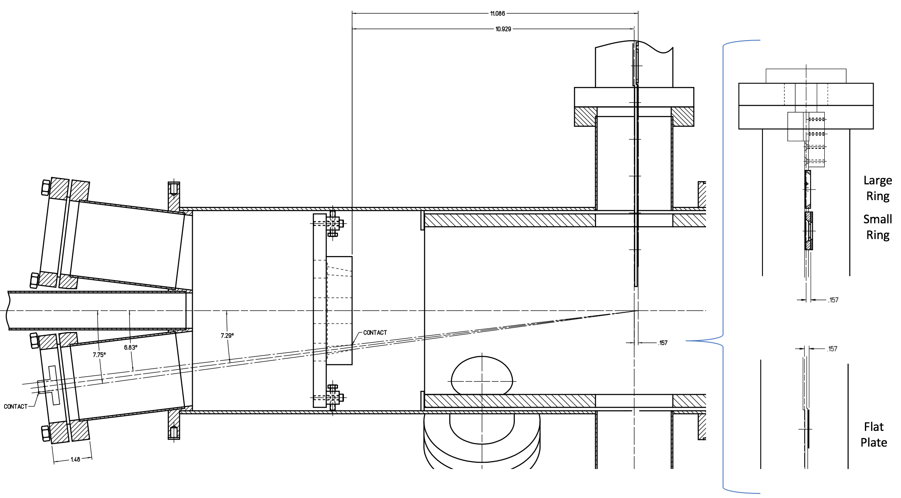

Fig. 3. Electrons scatter from a target foil backward through four acceptance defining apertures toward four detector ports (LEFT, RIGHT, UP, DOWN).

The adjustable collimator 1.0” thick aluminum mounted to a fixed aluminum baffle 0.5” thick define a single central cylindrical aperture 1.0” ID on chamber centerline for the incoming electron beam, and four conic apertures (90° apart) defining the

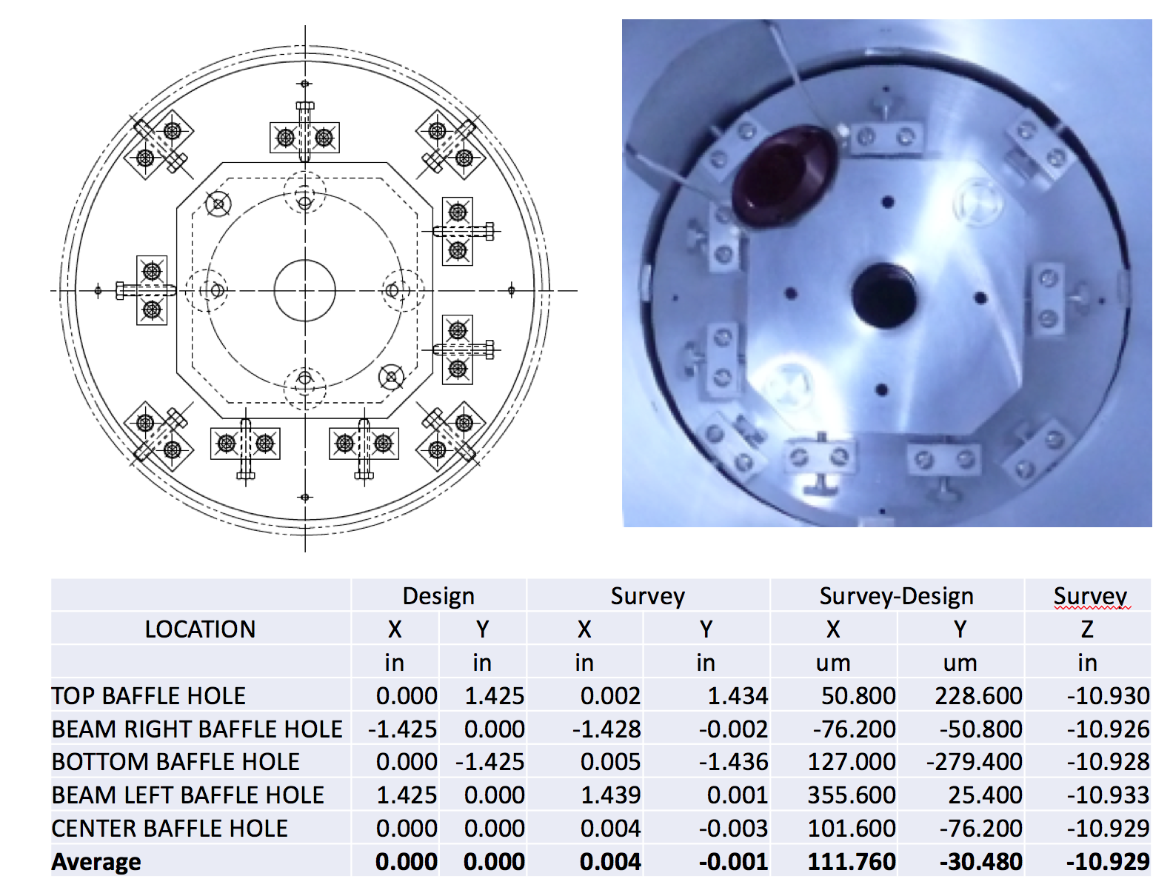

mirror

apertures

Fig. 4. Electrons scatter from a target foil backward through four acceptance defining apertures toward four detector ports (LEFT, RIGHT, UP, DOWN).

detector acceptances for scattered electrons. The conic aperture is 1.0” thick with upstream ID 0.314” and downstream ID 0.192” centered on scattering angle of 172.6°. The collimator is precisely position and finally surveyed (see fig. 4).

The location of the adjustable collimator relative to the target foils is then used to calculate the central scattering angle and detection solid angle; for Mott Run I/II the scattering angle is 172.7 degrees and the solid angle is 0.232 msr (see fig. 5).

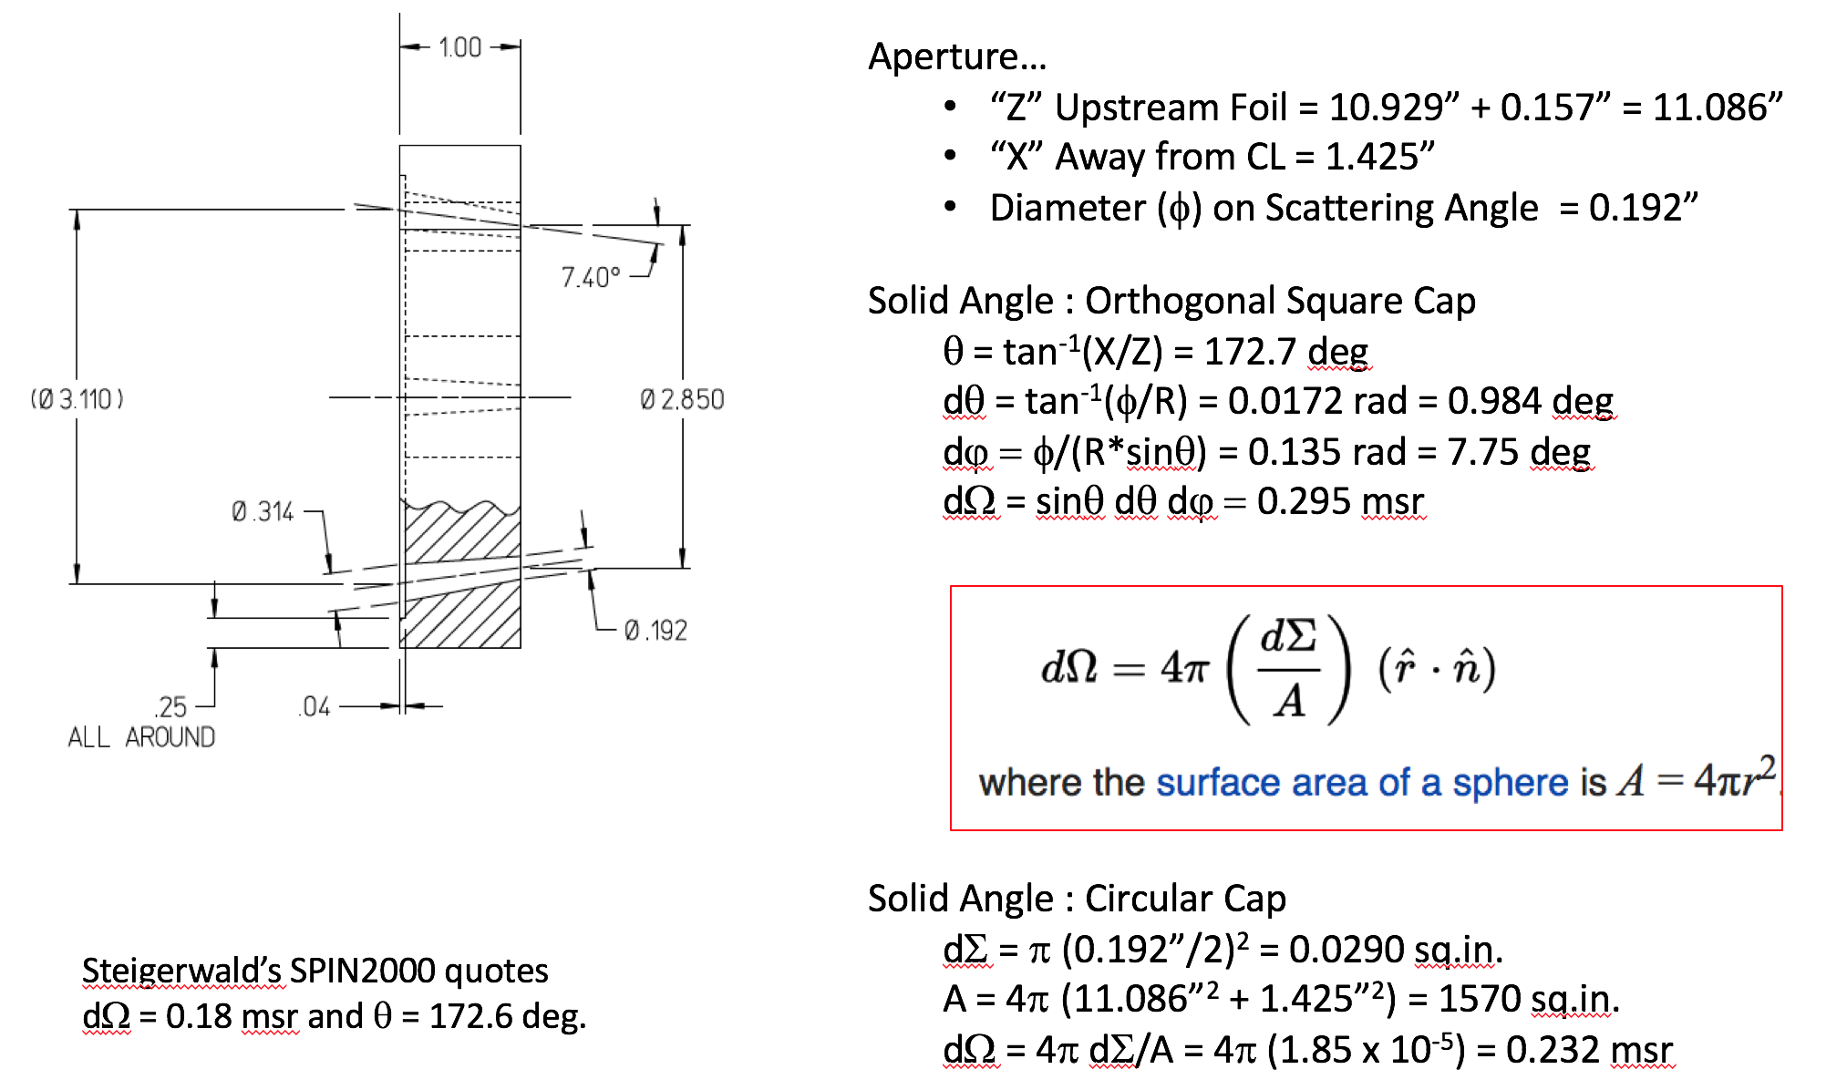

Fig. 5. Electrons scatter from a target foil backward through four acceptance defining apertures toward four detector ports (LEFT, RIGHT, UP, DOWN).

## *Extension Chamber*

The extension chamber is composed of 304 stainless steel components. The main tube is 8.0” ID and about 11” long. A tee with CF flange is attached to a single port welded to the top of the extension chamber. The tee is used to attach both a 45 L/s DI ion pump and a GP100 combination pump with a non-evaporable getter (NEG) and an ion pump. Similar to the main scattering chamber an aluminum baffle with ID 6.5” and 0.5” thick and 9.85” long spans inner surface of the vacuum walls.

## *Beam Tube*

The Beam Tube is composed of aluminum. It is 8.0” ID and 58.25” long. The flanges are aluminum. A horizontal dipole magnet straddles the beam tube and may be rolled on a movable sled along the length of the tube; it is typically positioned at the end of the tube.

## *Beam Dump*

The Beam Dump is composed of a beryllium disc 0.25” thick and 7.0” OD bolted to the vacuum side of a copper end flange 0.75” thick and rear surface of ID 7.5” (Assembly Drawing No. JL0004709). A Kalrez o-ring fit into a machine groove in copper makes the vacuum joint to end flange of tube chamber. A copper tube brazed to a copper plate is clamped to the 8.5” OD surface of the copper dump flange and cooled by the CEBAF LCW system using a flowmeter interlocked to the fast shutdown system. A small 4” thick wall of stacked lead bricks is stacked behind the copper dump to suppress prompt gamma radiation.

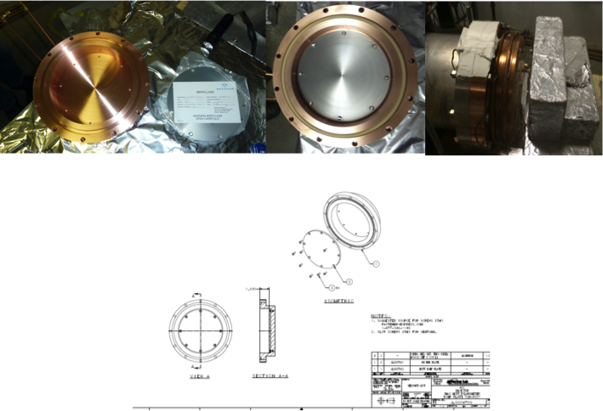

Fig. 4. Beryllium and cooled copper dump images are shown.

***Mott Target Foils***

The target foils used are all gold foils from Lebow company, 99.99% pure gold, the foils thicker than 50 nm were freestanding across the 1” target frame. Foils 6809 and 6845 have a Kapton disc mounted to the 1” target frame with a 10 mm diameter circular hole, and the freestanding gold foil spans that 10 mm circle rather than the entire 1” frame.

|  |  |  |  |  |  |  |  |  |  |
| --- | --- | --- | --- | --- | --- | --- | --- | --- | --- |
| Ladder | |  | Foils for Fall 2014 onward | | | | | | |
| # | Type | Material | Thickness (μm) | P/N # | Run | Foil ID | Mount | Support | Sibling |
| 1 | R | Au | 0.225 | 0.22Au-0-C1in. | 7029 | A | 1” ID rectangular | NONE | B |
| 2 | R | Au | 0.625 | 0.62Au-0-C1in | 7028 | A | 1” ID rectangular | NONE | B |
| 3 | R | Au | 0.870 | 0.87Au-0-C1in  -O-C1in | 3057 | A | 1” ID rectangular | NONE | C |
| 4 | R | Au | 0.750 | 0.75Au-0-C1in | 5134 | A | 1” ID rectangular | NONE | B |
| 5 | R | Au | 0.500 | 0.5Au-0-C1in | 5275 | A | 1” ID rectangular | NONE | C |
| 6 | C | Au | 0.070 | 0.07Au-0-L1 | 6405 | A | 10 mm ID circle |  | NONE |
| 7 | C | Au | 0.070 | 0.07Au-0-C5mm | 4605 | A | 5 mm ID circle |  | B |
| 8 | C | Au | 0.350 | 0.35uAu-0-C1in | 5613 | B | 1” ID circle | NONE | A |
| 9 | C | Thru | - | - | - | - | - |  | - |
| 10 | C | Viewer | - | - | - | - | - |  | - |
| 11 | C | Au | 0.040 | 0.04Au-0-L0.5(Al) | 6457 | A | 5 mm ID circle |  | B |
| 12 | C | Au | 0.050 | 0.05Au-0-1in, Kapton 1 cm | 6845 | A | 1” ID circle | Yes | NONE |
| 13 | C | Au | 0.050 | 0.05Au-0-1in, Kapton 1 cm | 6809 | A | 1” ID circle | Yes | B |
| 14 | C | Au | 0.350 | 0.35uAu-0-C1in | 5613 | C | 1” ID circle | NONE | A |
| 15 | C | Au | 1.000 | 1.0Au-0-C1in | 5385 | A | 1” ID circle | NONE | B |
| 16 | C | Au | 1.000 | 1.0Au-0-L1.0 | 5383 | A | 10 mm ID circle |  | B |
|  |  |  | (thickness/material/support, 0=unsupported/mounting size) | | | | |  |  |

Holders in red were adapted from 100 keV Mott with smaller aluminum supports, and background rates at 5 MeV made these foils unsuitable for use in this series of measurements.

## *FESEM thickness measurement Sample preparation*

Gold foil thickness was measured using a field emission scanning electron microscope (FESEM) technique. A gold foil that was manufactured in the same batch as the target foils, referred to as the “sibling” foil, was mounted to a silicon substrate. For the nominally 50 nm foils, static electricity was sufficient to adhere the foil to the substrate. For the thicker foils, a commercial carbon suspension in alcohol, Aerodag™, was used as a conductive adhesive between the foil and the silicon crystal. A drop of Aerodag was typically put on either the substrate or foil and the foil placed on the substrate. In some of the early foils, the foil was set on the substrate then the aerodag applied at the edge of the foil, which yielded some evident carbon flakes over the foil. The samples were then cleaved by applying pressure to the edge of the silicon substrate with a curved blade, cleaving the silicon and separating the gold foil to expose a thickness cross section for SEM imaging.

## *Measurement*

A Hitachi s-4700 FESEM model using an electron energy of 15.0 kV was used image the gold foil edges. Magnifications between 10k and 150k were used depending on the foil thickness. The working distance was varied until the image was in focus, and varied between 10 and 14 mm. Images were typically made at a single location for each sample prepared. For two of the samples, to test uniformity across a small area of the foil, the sample was translated and 3 or 4 spots were measured along the edge of a sample. Additionally, for two foils, two FESEM samples were prepared from a single target foil, one near the center and one near the edge, and both were analyzed. Finally, the tilt (pitch) dependence of the mounting in the FESEM was studied for one foil.

## *Image analysis*

The software program “ImageJ[1]” was used to determine the foil thickness from the FESEM images. For each image, the measurement gradation line was used to set the scale between nm and pixels, and measurements of the distance between the top and bottom of the foil were made using the built in measurement feature of the software. Depending on the quality of the image, the enhancement features of the software, including “edge find” and “sharpen”, as well as rotation correction were used to assist in the process of determining the edge of the foil in the image. A systematic study was also performed to determine the effect of sample tilt, intentionally varying the angle of the sample holder in the FESEM by angles of -1.7 through +2.5 degrees and measuring the variation due to that change.

***Error sources and error analysis***

#### Random (Statistical) Uncertainties

The random uncertainty in the measurements can be either estimated from trying to approximate and sum the sources of random thickness uncertainty, such as tilt, focus, ImageJ distance uncertainty. However, repeated measurements of images that are nominally identical yields a more accurate measurement of our random uncertainty. For example, with foil 3057 (nominally 870 nm), the estimates on uncertainties due to tilt, focus, and line analysis are 8, 4.2 and 8.4 nm respectively, which would be added in quadrature to determine the random uncertainty of 12.3 nm. Using the variation between measuring several different images of the nominally identical spot, the random uncertainty is only 7.1 nm, which we will use as a more accurate measure of random uncertainty in the measurements. Experimentally measured random uncertainties in the data are shown in Table 1 line 3.

#### Systematic Uncertainties

Systematic uncertainties in the foil measurements include inherent limitations of the FESEM machine, the uncertainty in image analysis which is estimated through the variation in thickness measured on the same image in multiple analyses, and finally the specification from Lebow that the sibling foils may vary as much as 5% within a batch.

The inherent resolution of the FESEM is 1.2 nm, and this uncertainty is the first systematic uncertainty considered in row 5 of Table 1. Repeated analysis of a particular image gives a systematic uncertainty for the measurement that is shown in row 6 of Table 1.

The target foils used in the Mott study were manufactured in the same batch as the samples mounted for FESEM measurements, but the manufacturer guarantees only that these sibling foils are consistent with the target foils to 5%. This comprises the largest source of uncertainty in the target foil measurement at 5%, listed in Row 7 of Table 1.

#### Additional uncertainties

Uncertainties that have not been quantified are any difference between the thickness of the foil as mounted and any difference introduced by the mounting and cleaving process. This could be significant, but is a parameter that can’t be well measured. Additional extrapolation with rate rather than measured target thickness is used to help account for any systematic discrepancies in the foil mounting, cleaving, imaging and measuring process.

## *Summary of Mott Experiment Run I and II Target Foils*

The summary of the measurements of the foils are listed in Table 1. The target foils are each labelled with a 4-digit batch identification, and “sibling” foils from the same batch are distinguished by suffixes from A-D. One of the foils, 50 nm foil 6845, did not have a sibling foil available for analysis. Two of the target foils, ladder positions 8 and 14, were both siblings of the same measured foil, 5613A.

Table 1: Summary of gold foil thicknesses measurements for “siblings” of the Mott target foils measured with FESEM technique. Random and systematic sources of uncertainty in these measurements are shown in rows 3-8, and final uncertainty in the thickness measurements is shown in line 9.

|  |  |  |  |  |  |  |  |  |
| --- | --- | --- | --- | --- | --- | --- | --- | --- |
|  | Au_5385_B Ladder pos.15 | Au_3057_C Ladder pos.3 | Au_5134_B Ladder pos.4 | Au_7028_B Ladder pos.2 | Au_5275_C Ladder pos.5 | Au_5613_D Ladder 8&14 | Au_7029_B Ladder pos.1 | Au_6809_B Ladder pos.13 |
| *Nominal Thickness (nm)* | *1000* | *870* | *750* | *625* | *500* | *355* | *225* | 50 |
| Thickness (all data, nm) | **943.7** | **836.8** | **774.6** | **561.2** | **482.0** | **389.4** | **215.2** | **52.0** |
| random: nominally identical | 29.0 | 7.1 | 9.1 | 8.0 | 9.7 | 4.5 | 1.9 | 2.3 |
| Systematic |  |  |  |  |  |  |  |  |
| * FESEM resolution | 1.2 | 1.2 | 1.2 | 1.2 | 1.2 | 1.2 | 1.20 | 1.2 |
| * same image reanalysis | 22.6 | 12.4 | 13.3 | 10.2 | 9.7 | 9.2 | 3.80 | 2.9 |
| * Lebow sibling 5% | 47.2 | 41.8 | 38.7 | 28.1 | 24.1 | 19.5 | 10.80 | 2.6 |
| Systematic total | 52.4 | 43.6 | 40.9 | 29.9 | 26.0 | 21.6 | 11.51 | 4.1 |
| dT (nm) | **59.8** | **44.2** | **41.9** | **31.0** | **27.7** | **22.1** | **11.7** | **4.7** |

1. ImageJ software can be found at https://imagej.nih.gov/ij/index.html