UITF PSS BCM System Specifications version 2
November 11, 2018
M. Poelker (with input from K. Welch, V. Vylet, K. Kowal, J. Musson, O. Garza and others)
A system is required to limit the MeV beam current and/or MeV beam loss, to protect personnel outside the UITF enclosure. We propose a system based on rf-cavity beam current monitors (BCMs).
We expect the maximum beam energy at UITF to be 10 MeV, for beam accelerated through the new QCM. An analysis of the UITF shielding by the Radiation Control Group (RCG) recommends that the system must reliably detect 10 MeV beam loss of 200 nA within 2 minutes of this condition. Based on this recommendation, the beam shutoff criterion can be defined as an integrated current loss value 200 nA x 2 minutes = 0.2 uA x 120 seconds = 24 uA seconds.
The permissible beamloss quantity and shutoff time specified above are preliminary values. Exact values may change following formal RCG assessment, which is forthcoming.
No action is required to terminate MeV beam, when beamloss is less than 200nA. There is adequate shielding at UITF to operate safely with sustained beamloss of < 200 nA at 10 MeV.
The system should have two modes of operation: a) one BCM mode, used to monitor the beam current at the exit of the QCM, and used to terminate beam delivery when current exceeds a specified value, and b) multiple BCM mode, with BCMs configured in a beam loss accounting (BLA) system, where beam is terminated if the current measured at a downstream BCM does not equal the current exiting the QCM. For both modes of operation, beam must be terminated within a time window consistent with the integrated current loss value specified above, 24 uA seconds. Integrated loss need only be calculated when the maximum beam current, or measured loss, exceeds 200nA.
For “low current” operation of the UITF, for example HDIce testing at nanoAmpere currents, we expect to operate in One BCM mode. “Low current” describes the MeV beam current for which the UITF shielding is adequate. As mentioned above, preliminary RCG assessment suggests UITF shielding is adequate for 200 nA beam loss. As such “low current” describes any beam current less than 200 nA. For “high current operation”, for example, beam current ~ 100 uA needed to qualify QCM functionality before installation at CEBAF, we expect to operate in Multiple BCM mode and using a BLA system. “High current” is any current above the RCG specified value for which there is adequate shielding.
One BCM mode:
For low current operation, the BCM near the exit of the QCM will be used to trip OFF beam when current exceeds the nominal RCG-designated value 200 nA, and within 2 minutes of this condition.
When current exceeds 200 nA, the system should begin integrating, initiating a beam trip when the value 24 uA seconds is reached. The integration should accrue only the current exceeding the approved 200nA value ((Measured Current – 200nA) * time). If current is reduced below 200 nA before reaching integrated current loss limit, the system should be configured to reinitialize the integration period following some agreed upon time period (e.g., minutes).
The integration system should periodically refresh the calculation of loss.
The BCM and associated electronics must be sensitive to a few nanoAmps, and accurate to within 10nA when beam current is 200 nA (i.e., accurate to 5%)
In practice, and based on the assessed resolution of the BCM current measurement, the trip setpoint limit should be settable by SSG. For example, if the BCM can accurately measure current to within 10 nA, we would set the system to trip OFF beam at an integrated current value of 190 nA x 2 minutes, or 22.8 uA seconds.
The One BCM PSS system must permit operation in Viewer Limited, Tune Mode and CW (standard CEBAF beam modes). Note, standard CEBAF Tune Mode provides an 8uA macropulse, corresponding to 100 nA average current. In this mode, the PSS BCM system should not interrupt beam delivery even when all the beam is lost in the beampipe, which sometimes happens when steering beam to the final destination.
An approved calibration procedure will be required to routinely evaluate the functionality of the BCM. Fundamental to the calibration procedure is the Faraday cup immediately downstream of the BCM. Faraday cups are known to be accurate current monitoring devices, capable of measuring current to ~ 100pA, and with few percent accuracy. The procedure must ensure loss-free beam transport through the QCM, and through the short section of MeV beamline between the exit of the QCM and the differential pump station immediately upstream of the BCM/Faraday cup combination. The BCM calibration procedure will require that there be no detectable beamloss at nearby Beam Loss Monitors (BLMs). When beam delivery through the QCM, the BCM, and to the downstream Faraday cup is deemed acceptable, the current measurement of the BCM can be set equal to the measured current of the Faraday cup. See Figure 1, showing the location of the BCM and Faraday Cup at the exit of the QCM.
After verification of the PSS BCM functionality, beam will be delivered to the intended destination, where current will be measured using another Faraday cup or dump, providing additional verification of accurate current measurement.
The BCM and associated electronics must be temperature stabilized, because the UITF temperature can vary by +/- 5 C
The system must be fail safe, i.e., beam production should not be allowed when equipment related to the PSS BCM malfunctions.
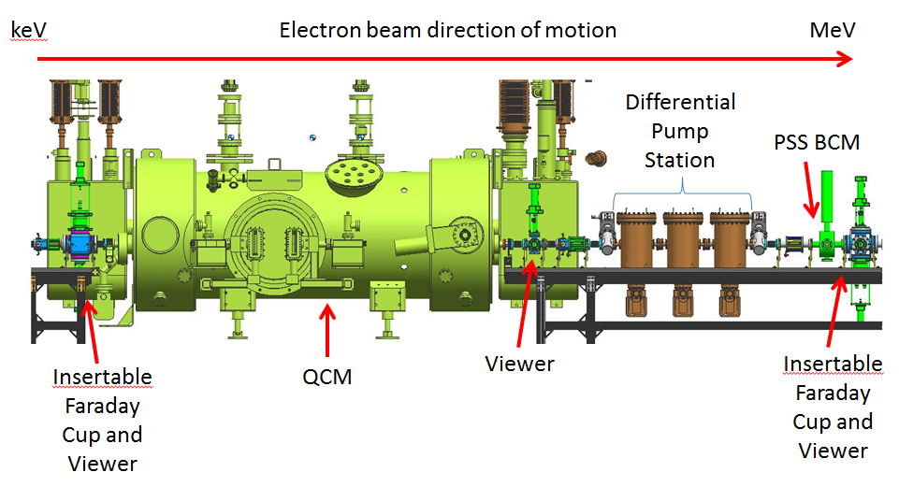
Figure 1: The QCM and adjoining beamline. Beam current measurements on both sides of the QCM using Faraday Cups provide a means to guarantee loss-free beam transport during BCM calibration.

Multiple BCM mode:
For high current operation, up to ~ 100uA, multiple BCMs will be used, configured as a BLA system. The multiple BCM system must trip OFF the beam whenever an integrated current loss of 24 uA seconds is detected. The integration should accrue only when loss exceeds 200 nA.
An approved calibration procedure will be required, to verify proper functionality of all BCMs. Fundamental to the procedure are Faraday cups placed immediately downstream of each BCM used to calibrate each BCM.
Verify clean transmission in tune mode (8uA macropulse, 100nA average current), no beamloss, quiet BLMs. Transition to CW mode at modest current and gradually increase current to desired value, limited to approved maximum value.
How to address apparent loss that is not real beamloss? How to confidently zero-out loss? I think this speaks to linearity issues. Can we calibrate at low current and expect the BCM to be accurate at high current?

The system should function properly in Viewer limited, Tune Mode and CW. In Viewer Limited and Tune modes, the PSS BCM system must allow beam delivery so long as integrated current loss does not exceed 24 uA seconds.
The BCM and associated electronics must be temperature stabilized, because the UITF temperature can vary by +/- 5 C
The system should be fail safe, i.e., beam production should not be allowed when equipment related to the PSS BCM malfunctions.

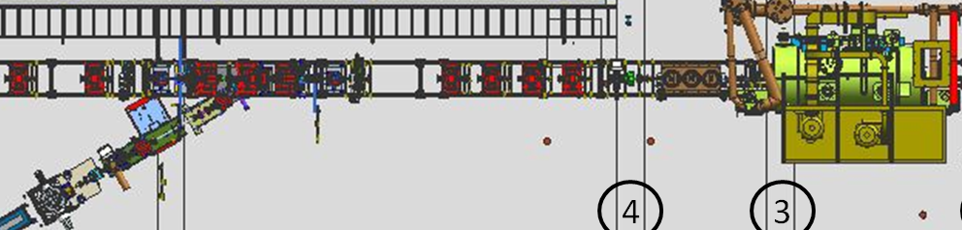
Figure 2: Schematic of UITF MeV beamline showing the locations of two BCMs configured as Beam Loss Accounting system.

Assumptions:
All beam MeV Faraday cups and beam dumps will be shielded with lead brick, and evaluated/approved by RCG.
The UITF requires a PSS based on “Two devices and One Technology”, to detect an unsafe condition and eliminate this unsafe condition. We propose that the PSS BCM cavity possess two antennas, and rely on two receivers. Two antennas/receivers = two devices. And one technology = the laser optical/mechanical shutter.
CARMs and BLMs will be part of the PSS and MPS (respectively) but these devices, placed at specific locations, cannot guarantee there is no beamloss everywhere along the UITF beamline.

