Parts list for sheep chamber:

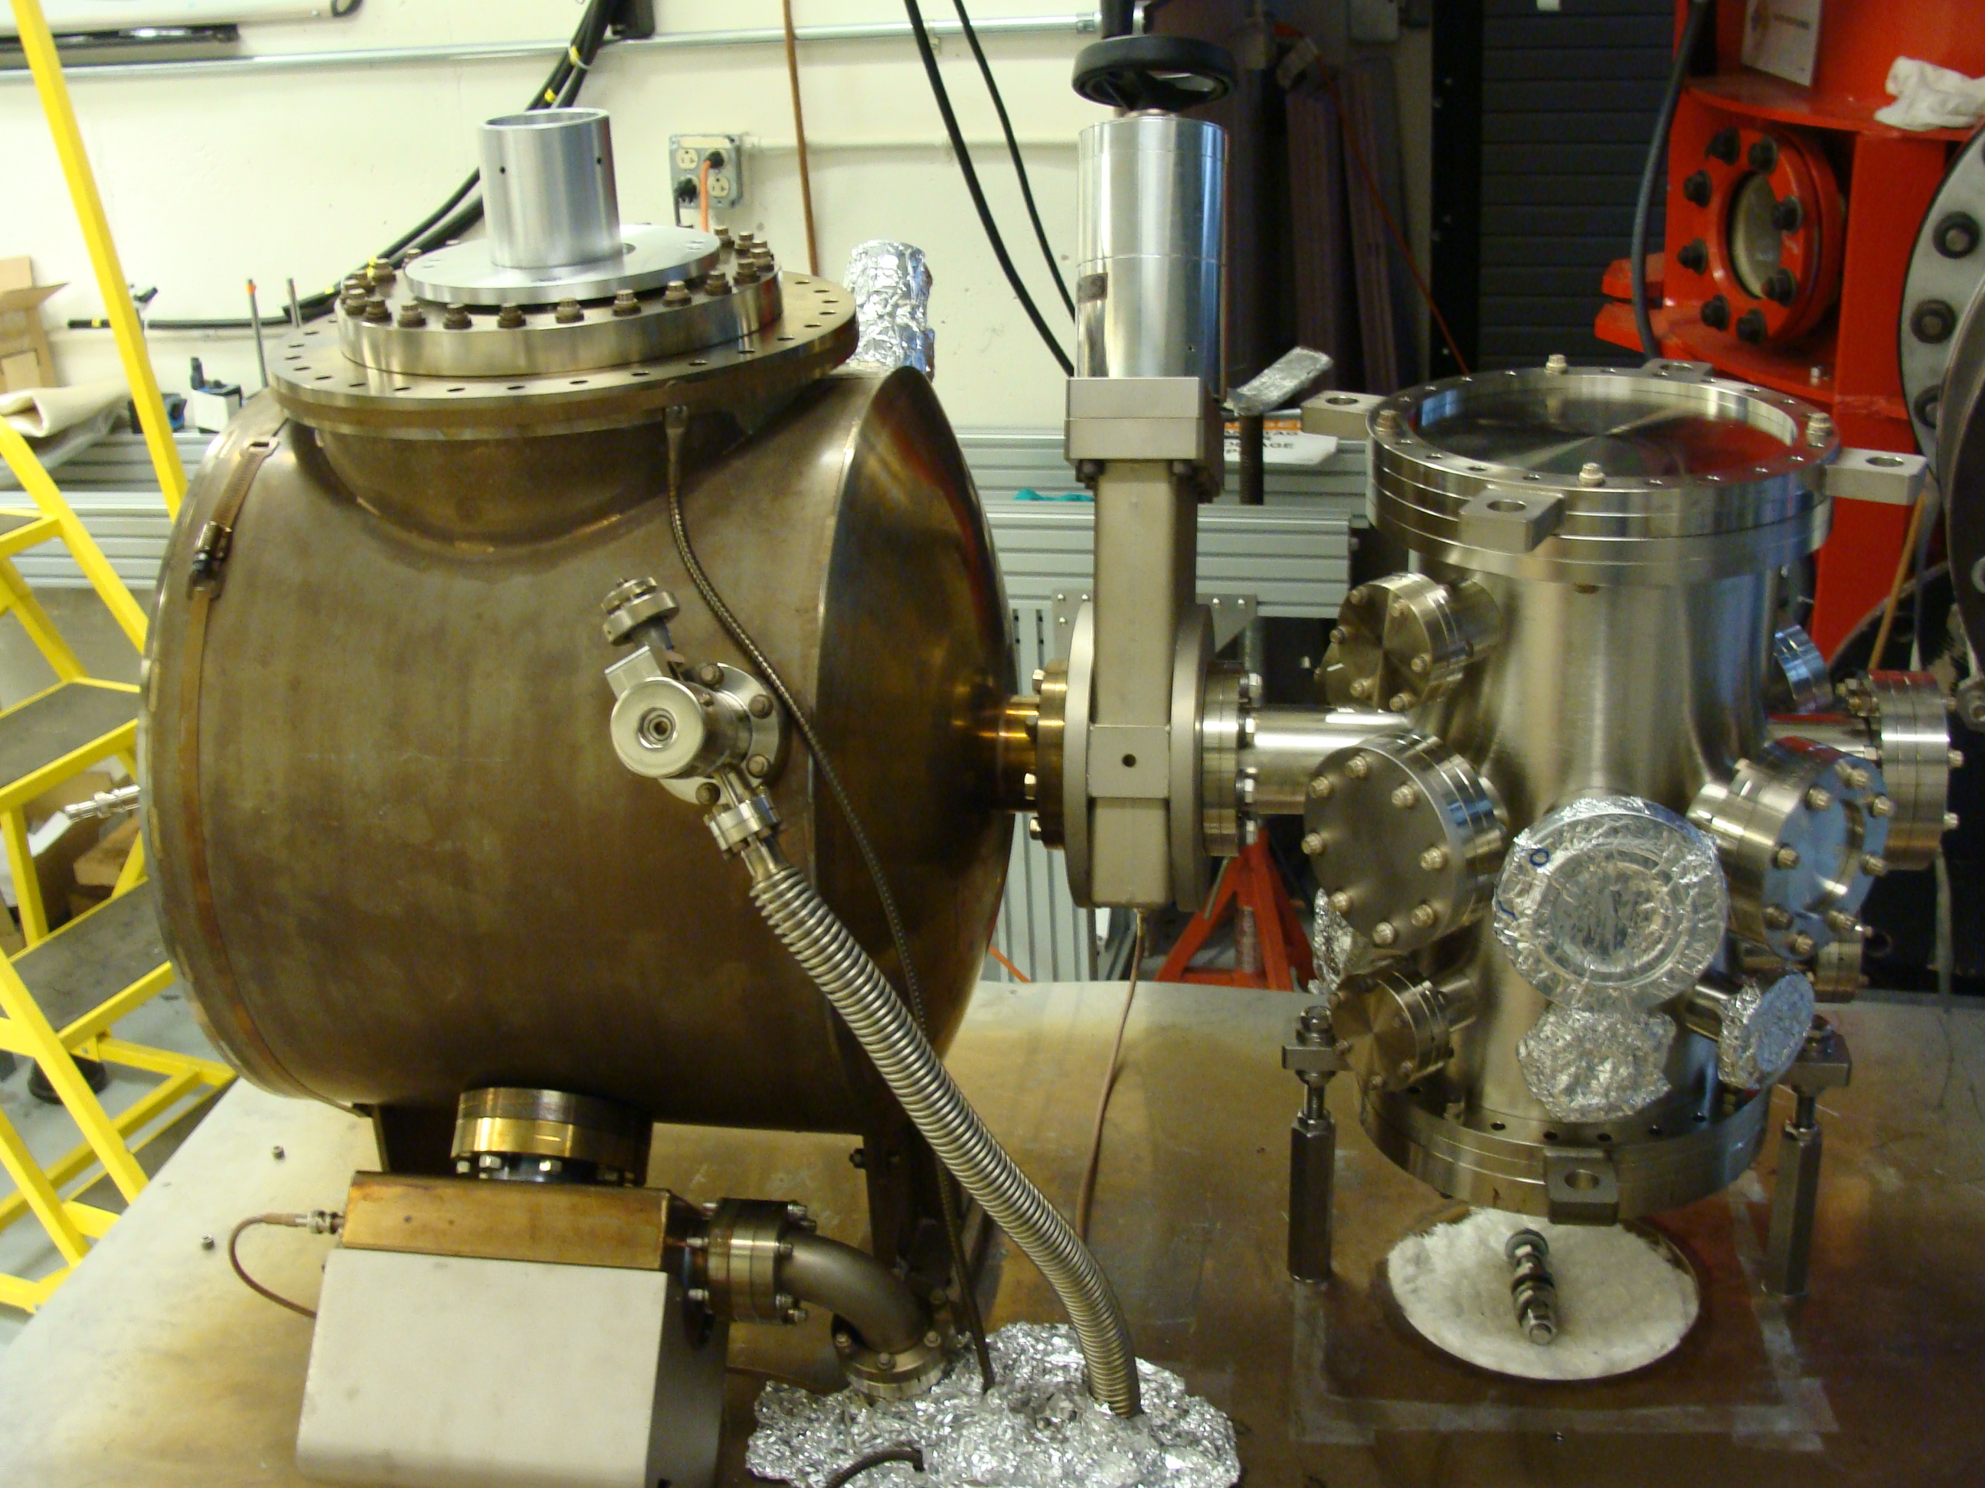
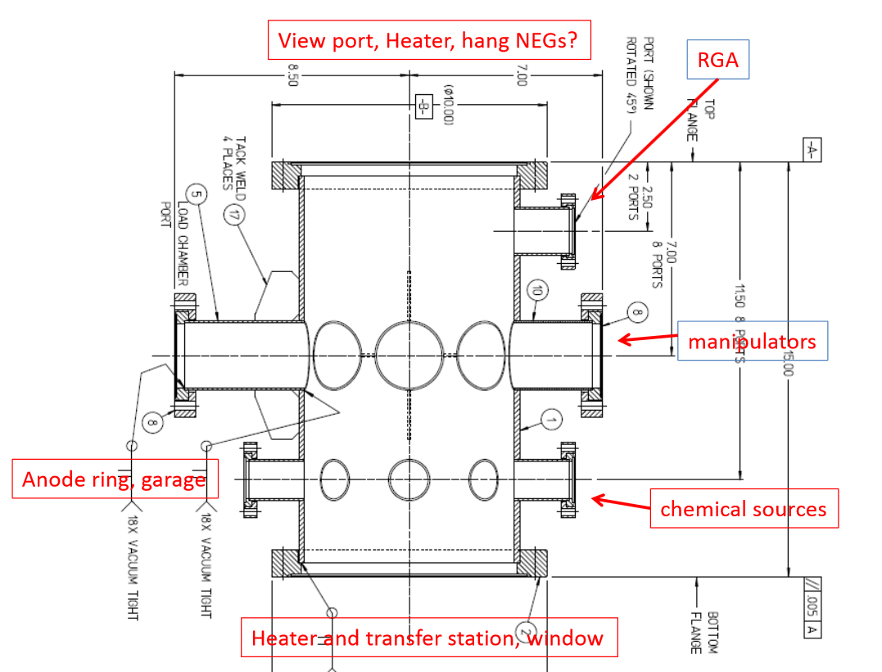

Parts list:

Bottom flange:
- 10” flange five 2.75” flanges (can we have one of the flanges from Marcy/Mamun vacuum study?). The four ports on periphery can be zero-length. The center port can be a half nipple
- ¼” copper feedthrough for NEG activation (maybe this is the activation feedthrough, but could also be from the top flange)
- Two vacuum windows
- 2.75” bellows translation stage (I think we have a few of these but maybe not with long enough stroke)
- We have a spare heater (I think), but note the heater will likely need to be lengthened
Level 1:
- Three cesiators (some combination of alkalis that Mamun specifies)
- John needs to make three heater controls for the three cesiators
- Each cesiator needs a bellows translation stage. Of course we prefer the good ones, but can also use our primitive IN/OUT stages (Thompson rails and cages)
- Garages tack welded on inside of the can so that we can completely halt the flow of alkali
- Sb boat on bellow translation stage (so four bellows translation stages total)
- Anode ring
- Paddle shutter? To avoid having alkali and Sb accumulating on bottom windows? Shutter would need bellows
- Leak valve for lifetime studies
- 2.75” window(s), if they serve a useful purpose
Level2:
- Long manipulator translation and rotation with alignment bellows, take both of these from our unused suitcase in Bubba’s room
- Long manipulator needs a schneedle to grab pucks
- Short manipulator translation and rotation, hopefully there’s one in cabinet, perhaps one purchased for Harding’s minimott apparatus that never got built.
- A bellows adjuster for this short manipulator, maybe also from Harding chamber
- A fork attached to the manipulator, we had one made, it’s in a puck storage case
- Two short manipulators translation only, for storing extra pucks
- Bellow manipulators for these storage manipulators (I think we need two storage manipulators in order to exchange one puck for another….
- Two garages to hold two extra pucks
- Ion pump with right angle valve for venting and pump out (I don’t think we need this ion pump attached to the bake pump beneath the table, sorry for not telling you this earlier)
- Paddle shutter? To avoid having alkali and Sb accumulating on top window? Shutter would need a bellows….
- 4.5” window
Level3:
- Rga
- Or Xtal thickness monitor?

Top 10” flange:
- Heater, note heater length will need to be modified
- Translation stage bellows for heater, need to determine stroke
- Window(s)
- Hang NEG modules from top flange? Use level 3 flange for activation fdeedthrough?
- Mask on rotation stage to limit active area of photocathode

