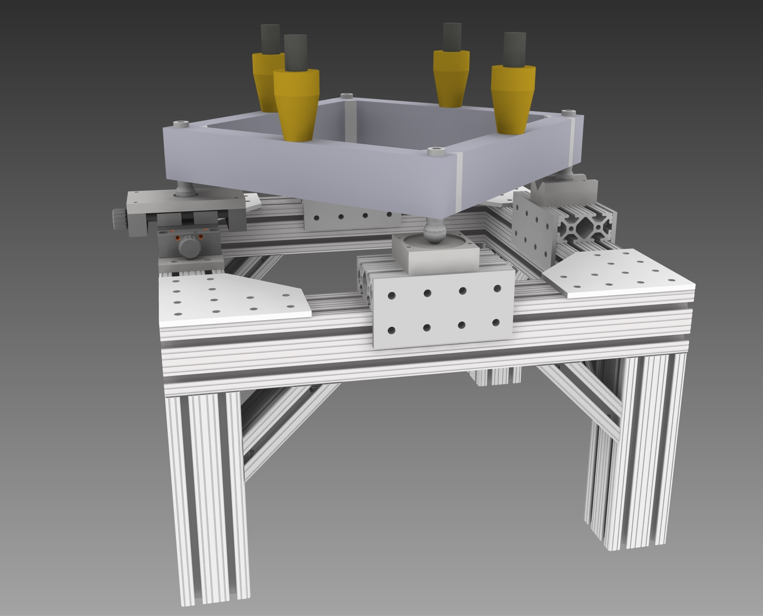

Hi Joe,

This sounds very good, I will move ahead planning on utilizing the services of the survey/alignment group. I may not use leveling feet, but perhaps utilizing precision located anchors in the floor may be useful. I will keep you informed as the design evolves.

Thank you,
Brad

-----Original Message-----
From: Joseph Grames [mailto:grames@jlab.org]
Sent: Monday, May 05, 2014 1:14 PM
To: Brad DiGiovine
Cc: Shaun Gregory; Roy Holt; Riad Suleiman
Subject: Re: Bubble Chamber Alignment

Hi Brad,

I think it would be helpful to lock-down the four legs to the floor. Two years ago we mounted a detector + lead hut weighing 12,000 lb on top of a 4' x 6' table. The table was similarly constructed of extruded aluminum, having total of five 4"x4" cross section legs. Entirely fabricated in France, the table was shipped and moved into the tunnel at just about the same place as the Bubble Chamber. Before installation the designer (I believe Shaun?) passed the points to our Survey/Alignment group who then located and marked the points on the floor for the legs. Each leg had a foot so we could essentially locate the give feet over the five points. Finally, each foot had a locking clamp which grabbed the foot to the floor by a bolt which was threaded into a receiving tap in the concrete floor. In our case we had a pneumatic jack that moved the load a ~1' over the table surface so the clamps were necessary to keep the table from wanted to jerk. Just to give an example here are links to the feet/clamps that were used for that table:

Feet :
http://elcom-eshop.com/fr/pieds-filetes/2314-pied-d80-m16x100-inox-pour-profile-aluminium.html

Clamp:
http://elcom-eshop.com/fr/plaques-de-positionnement/2326-plaque-de-positionnement-d80-noir-pour-profile-aluminium.html

Best,
Joe

----- Original Message -----
From: "Brad DiGiovine" <digiovine@phy.anl.gov>
To: "Riad Suleiman" <suleiman@jlab.org>
Cc: "Shaun Gregory" <gregory@jlab.org>, "Joe Grames" <grames@jlab.org>, "Roy Holt" <holt@anl.gov>
Sent: Friday, May 2, 2014 11:12:09 AM
Subject: RE: Bubble Chamber Alignment

Hi Riad,

Sorry I did not get back to you yesterday, I was out for the day.

In the assembly model which I have sent along to Shaun, there are details on the kinematic mount and alignment system built into the bubble chamber (I have attached a rendering without the pressure vessel for aiding this description). There are four ball mounts which the bubble chamber pressure vessel sits on, these are threaded into the support square which is attached directly to the pressure vessel. Adjusting these mounts up or down allows you to adjust pitch, roll, and Y(vertical height). These ball mounts sit in corresponding kinematic pads. One is a socket attached to a x,y translation table, one is a vee groove which only allows movement in 1D, and two are free in 2D. Adjusting this translation table allows you to adjust yaw and X(horizontal, orthogonal to beamline). This give you full 5D alignment capability of the system. Only Z(horizontal, parallel to beamline) is neglected, for obvious reasons.

The chamber needs to be roughly aligned by proper placement of the bubble chamber stand, then fine adjustments to the alignment may be made with the system described above. The four legs in the model do not exist as of now, they were thrown in to roughly approximate the beam height at J-Lab, everything above these 4 legs does exist though. We can decide among us how we would like to mount the chamber to the floor, since this part(the 4 legs) has not been built yet. Let me know what you think. This is likely stable enough to simply sit in place, but we can also do something similar to what was done at HIgS, there were kinematic mounts which were permanent in the floor of the target area which were very similar to what is done with the four balls on screws on the bubble chamber. These were fairly precisely located and mounted to the floor, so placement of equipment was fairly repeatable.

Brad

-----Original Message-----
From: Riad Suleiman [mailto:suleiman@jlab.org]
Sent: Thursday, May 01, 2014 2:28 PM
To: 'Brad DiGiovine'
Cc: Shaun Gregory; Joe Grames; Roy Holt
Subject: Bubble Chamber Alignment

Hi Brad,

We were talking to Shaun today and the alignment of the bubble chamber
came up. Shaun needs to know what we need to mount the chamber on the floor
and how to align the chamber to the beamline.

Thanks,

Riad.

