|  |
| --- |
| TITLE: **COMTRA Solenoid Power-Up and Power-Down Procedure** |

|  |  |
| --- | --- |
| BY: P K Ghoshal | DATE: 09 / 15 / 2022 |
| Intended Checker and Approvers: |  |
| CHK: S Gopinath |  |
| 1. APP: Mike Beck |  |
| 2. APP: Joe Meyers |  |
| 3. APP: 3rd Approver (if necessary) |  |

|  |  |  |  |  |  |  |  |
| --- | --- | --- | --- | --- | --- | --- | --- |
|  |  |  |  |  |  |  |  |
|  |  |  |  |  |  |  |  |
|  |  |  |  |  |  |  |  |
|  |  |  |  |  |  |  |  |
|  |  |  |  |  |  |  |  |
| 0 |  | First edition - Solenoid Power-Up and Power-Down Procedure | Ghoshal | Gopinath | Beck | Meyers | 09.03.20 |
|  |  |  |  |  |  |  |  |
| REV. | ECO# | DESCRIPTION | BY | CHK. | APP. | APP. | DATE |
| SUMMARY OF CHANGES FROM PREVIOUS REVISION: | | | | | | | | |

# 

# 

Contents

1. Scope and Requirements 3

2. COMTRA Solenoid Specification and Key Parameters 3

3. Shift Workers Guide for Regular Physics Operations 5

3.1 Introduction 5

3.2 Emergency Contact Names 5

3.3 Pre-Energization Checks 5

3.4 Magnet Operation 6

3.5 Power Up 8

3.6 Power Down 9

3.7 Reversing Polarity 9

3.8 Fast Shutdown 9

3.9 Emergency Stop 9

3.10 What to do after an interlock has tripped and the magnet has run down to zero 9

Appendix A – How to Connect Remotely to the Magnet Power Supply GUI 10

# Scope and Requirements

This document describes the power up and power down procedure for the COMTRA Solenoid Power-Up and Power-Down Procedure (normal conducting magnet with limited cooling) within UITF.

# COMTRA Solenoid Specification and Key Parameters

|  |  |
| --- | --- |
| Magnetic Field at the magnet center, B(0,0,0) in T | 1.7 (Nominal) |
| Maximum length (mm) | < 500 (Nominal) |
| Clear bore diameter (inches) | 9.5 |
| Operating current (A) | 3.5 (Nominal), (Allowed up to 15A max.) |
| Operating voltage (V) | 10 (Nominal) |
| Maximum supply voltage (V) | < 20 (MPS) |
| Ground voltage Isolation (V) | 1000 (min) |
| Operating temp (deg C) | 50 Nominal |
| Conductor dimensions (mm) | Square conductor, 2.05 (Nominal) |
| Winding details | 17 turns per layer, with 4 layers |

***Please also refer to - Compton Magnet Functional & Requirements Specs PMAG0000-0011-S0001 Rev 0***



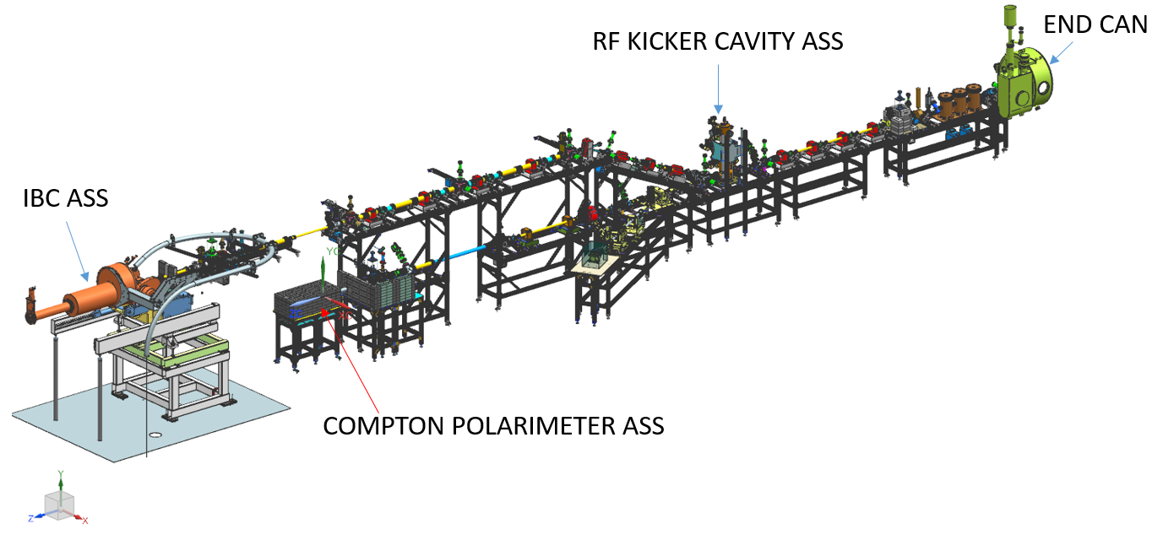

*Figure 1 – Location of the solenoid on the UITF beam line*

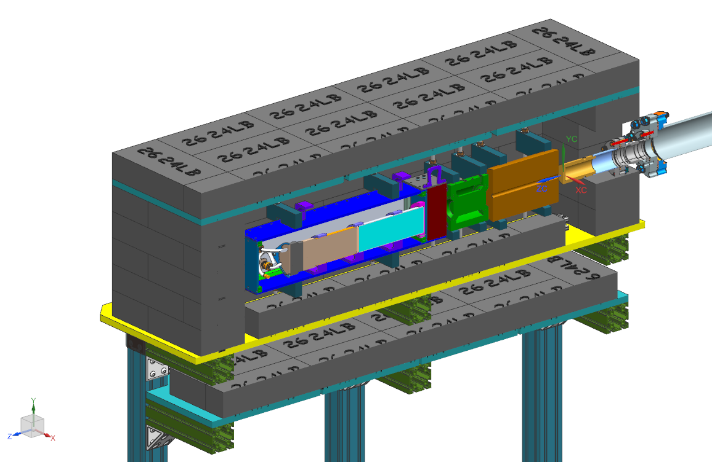

*Figure 1a – Compton Polarimeter Assembly*

SG

*Figure 2a – The COMTRA solenoid all electrical (power) connections*

# Shift Workers Guide for Regular Physics Operations

## 3.1 Introduction

This section summarizes the power up (energization) and power down (de-energization) procedure for the **COMTRA Solenoid**. It is primarily a guide for shift workers.

## 3.2 Emergency Contact Names

Should the need arise, first call the ‘COMTRA TEAM’.

The COMTRA Team will then (if necessary) call in the relevant Subject Matter Experts (SME) in the order shown for each of the indicated sub-systems.

Table I – Contact Names

|  |  |
| --- | --- |
| **Sub-System** | **SME** |
| Magnet Power Supply (MPS) | Sarin Philip, Nick Falls |
| Magnet | Probir Ghoshal, Sandesh, Mike Beck |
| Instrumentation and Control (I and C) | COMTRA team (Nick Falls/Chris C team) |

## 3.3 Pre-Energization Checks

The following checks should already have been completed. Note that some checks are only necessary during the initial commissioning of the magnet. They should be repeated if the magnet has not been operated for 6 months or longer.

**IF IN DOUBT PLEASE CONTACT THE ‘SME’**

**Initial Commissioning of Magnet** *(or if magnet has not been operated for 6 months or longer)*

1. Magnet coil resistance
2. Magnet resistance to ground
3. Magnet Hi-pot and leakage current test
4. Prefer to have a separate GND wrt to physics diagnostics

**Before Each Magnet Run**

1. Leak checks - Check floor and stand??
2. Instrumentation checks

*Verify that all signals are reading in EPICS and refer to Table XX and Figure X in section XX*

1. Interlock and control checks

*Verify that all signals are reading in EPICS and refer to Table XX and Figure X in section XX*

1. Power supply checks

*Verify that all signals are reading in EPICS and refer to Table XX and Figure X in section XX*

1. Magnetic Field Vector Direction in Solenoid

* *Run 5 Amps into the solenoid.*
* *If the bore is still accessible, use a hand-held hall probe to check that the direction of the magnetic field vector in the bore is pointing downstream/upstream depend how UITF team needs to define.*
* *If the bore is not accessible, then use the hand-held hall probe to measure the field on the side of the solenoid – Note: if the field vector in the bore is at a direction, then the field vector measured on the side of the solenoid.*

## 3.4 Magnet Operation

The Operator controls the Magnet Power Supply (MPS) for the magnet and monitors the magnet and its sub-systems via a PLC using a series of EPICS screens. Bringing the Solenoid to operating field is done using a linear current ramp (or slew) rate. Each time the operator enters the desired current within the *Current Setpoint* field on the magnet power supply control screen and hits Enter, the power supply automatically begins the ramp to the set point current at a pre-programmed slew rate (Ramp rate). This slew rate is set within the PLC code and is not accessible to the operator.

The default rate of the hardware in the power supply is XXA/s on a set point change, and XXA/s down to zero when an interlock is detected. There are XX redundant interlocks (high temperature, and high voltage) listed in Table XX, monitoring dry contact closures at 24/12 volts, available from the power supply.

Shift workers will typically operate the magnet using the Magnet Power Supply (MPS) Control Screen shown in Figure 3 below.

NF

*Figure X – Magnet Power Supply Control Screen*

*Figure X – Interlock Screen*

Table XX – Monitored Parameters and Interlock Thresholds

The temperature of the magnet is interlocked to the power supply using thermal sensor (50°C) mounted on the outer sleeve of the magnet.

Figure XX indicate the stray field contours of the magnet whilst operating at a higher central field of XX – note that nominal operating field is 2.0 T. Units are Tesla for the magnetic field and mm for the distances shown. The 5 Gauss line (5E-04 Tesla in the figure) is located approximately XXX in the X and Y directions and approximately XXX in the Z direction (i.e. along the beam line).

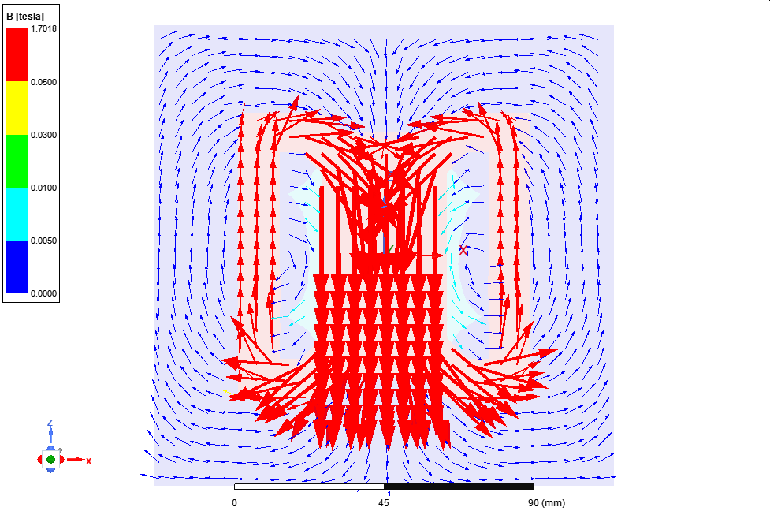

*Figure XX – Stray field plot with approx. 2 T central field – Units are Tesla for magnetic field and mm for distance.*

## 3.5 Power Up

**IMPORTANT**

Sweep the area around the dump solenoid and verify that there are no unsecured ferromagnetic materials within 1 (one) meter of the solenoid. If in doubt, consult with the appropriate Subject Matter Expert.

If you need to connect remotely to the power supply GUI, refer to Appendix A for instructions.

The controls for the power supply (Figure XX) are available from the:

*ITF Jmenu -> UITF Ops Menu -> Magnets -> XXXXX Solenoid*

For access to the monitoring GUI (Figure X), a terminal through the ‘hallgw’ using two factor will be required to access XXXX controls,

OR

Use the one of the XXXX comuters in the UITF control room and at that terminal follow:

*CLAS12 menu -> Solenoid -> HDICE*

|  |  |  |
| --- | --- | --- |
|  | **Instruction** | **Action** |
| **CHECKS AND INITIAL SETTINGS ON THE MPS CONTROL SCREEN BEFORE ENERGIZING MAGNET** | | |
| 1 | Set the *Current* *Setpoint* to 0 (zero) A. [This is to avoid any unintentional current ramps before all checks have been completed]. | * Type ‘0’ (i.e. zero) in the ‘current set point’ field and hit the *Enter* key on the keyboard. * If the control screen does not allow you to do this, call the MPS SME |
| 2 | Turn ON the Magnet Power Supply (MPS) | * Click the ‘Contactor’ *ON* button to turn the power supply on |
| 3 | Check that all the indicator LEDs are green. (Figure 3) | * If any are RED, click the ‘Faults’ *Reset* button * If the faults cannot be cleared, call the MPS SME |
| 4 | Check that all interlock indicator LEDs are green. (Figure 4) | * If any are RED, click the *Interlocks* *Reset* button * If the interlocks cannot be cleared, call the I and C or Magnet SME |

|  |  |
| --- | --- |
| **ENERGIZING (POWERING UP) THE MAGNET** | |
| 5 | Type in the required magnet current (0-15 A) in the *Current Setpoint* field hit *Enter* on the keyboard to start the ramp up. The magnet current will increase to the required set point at a rate of XX A/s. |
| 6 | If there are any trips, one of more of the *Interlock LED* indicators will turn RED and the magnet will run down to zero current at a rate of XX A/s. If this happens call the SME. |

## 3.6 Power Down

Reference should be made to Figures X and X.

|  |  |  |
| --- | --- | --- |
|  | **Instruction** | **Action** |
| **DE-ENERGIZING (POWERING DOWN) THE MAGNET** | | |
| 1 | Type in the required magnet current in the *Current Setpoint* field and hit *Enter* on the keyboard to start the ramp down. The magnet current will decrease to the required set point at a rate of XX A/s. | |
| 2 | If there are any trips, one of more of the *Interlock LED* indicators will turn RED and the magnet will run down to zero current at a rate of XX A/s. If this happens call the SME. | |
| 3 | Turn OFF the magnet power supply if the magnet is not to be energized for several days. | |

## 3.7 Reversing Polarity

Reversing polarity can be achieved by swapping the POSITIVE and NEGATIVE lead connections at the power supply end, and not at the solenoid end as the connections there are all insulated. This task should only be carried out by qualified and trained Electrical Workers.

Once all the interlock checks have been completed, the magnet can be energized as usual via the power supply EPICS control screen.

## 3.8 Fast Shutdown

A FSD (Fast Shut Down) signal from the PLC/Power Supply has been provided to allow the beam to be shut down if the solenoid power supply shuts down.

## 3.9 Emergency Stop

There is 1 Emergency Stop button (E-Stop) for the solenoid.

|  |  |  |
| --- | --- | --- |
| **How Many E-Stops?** | **Where is the E-Stop located?** | **What does it do?** |
| 1 | On the front of the power supply | It shuts down the power supply and the magnet will run down to zero amps at a rate of XX A/s |
| **ALWAYS OBTAIN CONFIRMATION FROM THE SME BEFORE RESETTING THE EMERGENCY STOP** | | |

## 3.10 What to do after an interlock has tripped and the magnet has run down to zero

* Always contact an engineer from the Magnet Group (i.e. whomever is ‘On Call’):
  + Probir Ghoshal (518 334 3289)
  + Sandesh Goipinath
* On the ‘phone to the magnet engineer, please have the following information ready:
  + Status of Magnet Power Supply control screen *(Figure X)*
  + Status of interlock screen *(Figure X)*
  + Any other information you feel is relevant
* Re-setting the interlocks remotely
  + Click on the *Reset Interlocks* button first *(Figure X)*
  + Then click on the power supply *Faults* reset button *(Figure X)*
* Powering up the magnet
  + Ensure that all the LEDs are once again all green *(Figures X and X)*
  + Get verbal approval from the engineer on call to re-run the magnet.
  + Follow steps in Sub-Section xx earlier

# Appendix A – How to Connect Remotely to the Magnet Power Supply GUI

NX-Connects will be used to access the power supply GUI.

1. Go to: <https://cebaf.jlab.org/accelerator-remote-access>
2. And download the relevant tool for your system:

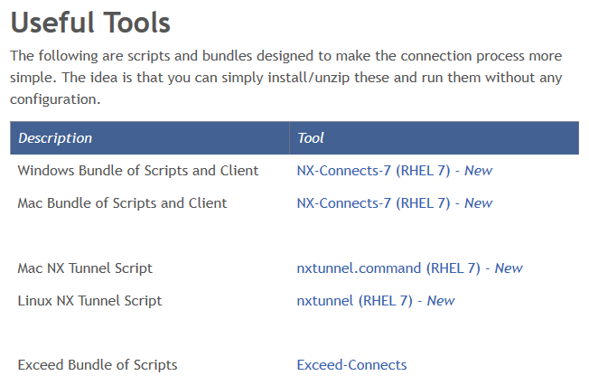

1. Save the zipped file on your hard disk and unzip the file.
2. Run the *NX-Connects-7.cmd* file
3. The following menu window will appear:

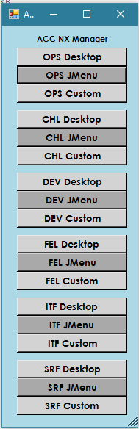

1. Click on ‘ITF JMENU’
2. You will be prompted to login using your two-factor password:

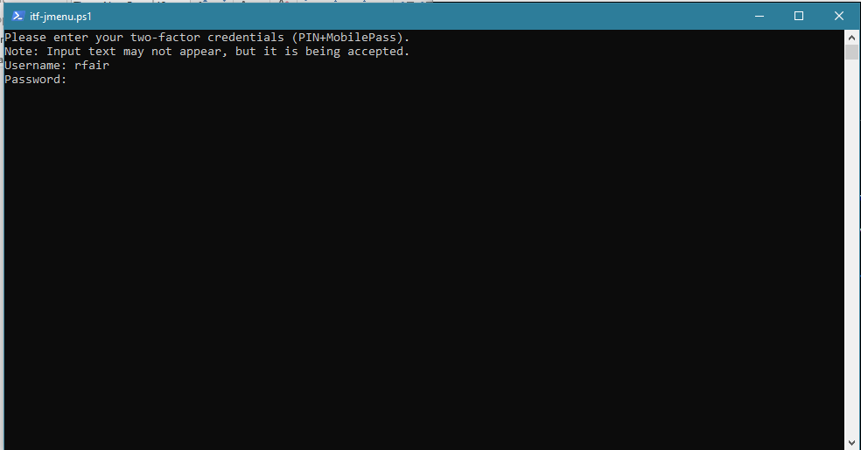

1. The following window will appear:

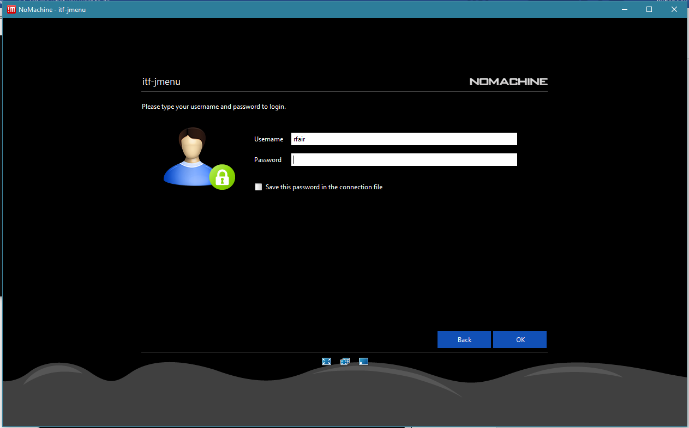

1. Login using your Accelerator (ACE) login account.
2. Ensure that all the ‘Interlocks/Faults’ indicators on the right are green. If any are red, you will need to clear the fault and interlock. Call an SME if necessary.
3. You are now ready on type in target current in the ‘*Current Setpoint*’ field​

*-----------------------------------End of document--------------------------------------------*