Electron Beam Characteristics of Alkali-Antimonide photocathodes grown on GaAs and Molybdenum Substrates
Y. Wang^{1,2}, M. A. Mamun, P. Adderley, B. Bullard, J. Grames, J. Hansknecht, C. Hernandez-Garcia, R. Kazimi, G. A. Krafft^{1,2}, M. Poelker, M. L. Stutzman, R. Suleiman, M. Tiefenback, S. Wijethunga, and S. Zhang
¹Thomas Jefferson National Accelerator Facility, Newport News, VA 23606 USA
²Old Dominion University, Norfolk, VA 23529, USA

Abstract:
Cs_{x}K_{y}Sb photocathodes grown on GaAs and molybdenum substrates were evaluated using -300 kV dc high voltage photogun and diagnostic beamline. Photocathodes grown on GaAs substrates with different antimony layer thickness yielded similar thermal emittance values but very different operating lifetime. Similar thermal emittance values were obtained for photocathodes grown on molybdenum substrates but with markedly improved lifetime.
Introduction:
Free electron lasers [1], energy recovery linacs [2] and electron-cooling [3] applications require un-polarized electron beams with high bunch charge (nC) and high average current (tens to hundreds of milliamperes). For these applications, alkali-antimonide photocathodes are the photocathodes of choice because they provide high quantum efficiency and exhibit relative insensitivity to ion bombardment compared to GaAs photocathodes. And alkali-antimonide photocathodes are prompt emitters with relatively low intrinsic emittance, thus capable of generating bright beams suitable for light source applications [4], and perhaps even for ultrafast electron diffraction applications if fabrication techniques can provide a sufficiently smooth surface [5][6].
Photodetectors employ transmission-mode photocathodes fabricated on transparent substrates, whereas electron guns typically employ reflection-mode photocathodes grown on a variety of electrically conductive substrates [7]. There are a number of documented recipes for fabricating Cs_{x}K_{y}Sb photocathodes for dc high voltage photoguns [x,y,z]. Chemicals can be applied to the substrate at the same time (co-deposition) or sequentially, using a variety of chemical sources that contain one, two or all three of the chemical species. Besides substrate type and chemical delivery system, the temperature of the substrate factors into each recipe [a, b]. Ultimately, for photoguns, the three most important defining metrics of the photocathode are quantum efficiency (QE), intrinsic thermal emittance and operating lifetime.
As described in ref [8], it is reasonable to assume that a rough photocathode surface could significantly influence measured beam emittance. At Jefferson Lab, sequential deposition via thermal evaporation has been employed, with antimony deposited first followed by application of cesium and potassium at the same time from an effusion source containing both species. Past work at Jefferson Lab included surface science evaluation of the foundational antimony-layer as a function of antimony deposition time. For long deposition times - which we assume correlates to a thicker Sb layer - the antimony exhibited crystalline structure with micron-size dimensions, leading some to believe thick alkali-antimonide photocathodes would be very rough and possess relatively large intrinsic thermal emittance. But recent measurements at x-ray light sources indicate photocathode formation to be an exothermic reaction, with the Sb foundational layer completely transformed in the process [9]. The work reported here supports this observation – the photocathodes fabricated with different Sb thicknesses provided essentially the same thermal emittance, and similar to nominally “thin” photocathodes reported in literature, namely ~ 0.X mmmrad [x,y,z].

Experiment: Gun
The -300 kV photogun used for these photocathode studies is shown in Figure 1, and described in detail in reference [10]. The photogun employs a so-called “inverted insulator” geometry, with voltage applied using a high voltage cable that inserts into a conical-shaped insulator that extends into the vacuum chamber and serves to support the cathode electrode. The spherical cathode electrode includes a specially designed screening electrode that reduces the field strength at the triple-point-junction where arcing is thought to originate [11]. The drive laser beam passes through entrance and exit holes in the anode electrode at 25° angle of incidence, thereby eliminating the need for in-vacuum laser mirrors which can restrict the effective aperture of the beamline. The anode is electrically isolated from ground potential using sapphire balls to enable biasing as a means to repel downstream ions created by the beam [10]. The vacuum pressure inside the photogun while delivering electron beam is ~ x10⁻⁹ Torr achieved using non-evaporable getter and ion pumps.
The spherical electrode possesses a front face with 1.3 cm opening and 25° Pierce focusing geometry. The photocathode is pushed against the back of the focusing faceplate using spring-loaded sapphire rollers. The field strength at the photocathode reaches X MV/m then the cathode is biased at -300 kV.
The focusing electrode and the side-insulator design introduce field non-uniformity at the photocathode surface and within the cathode/anode gap that can impact measured values of emittance. However as described below, uniform beam emittance was measured across a significant portion of the photocathode, and for comparative evaluation of thermal emittance for different photocathode samples, beam always originated from the center of the photocathode.

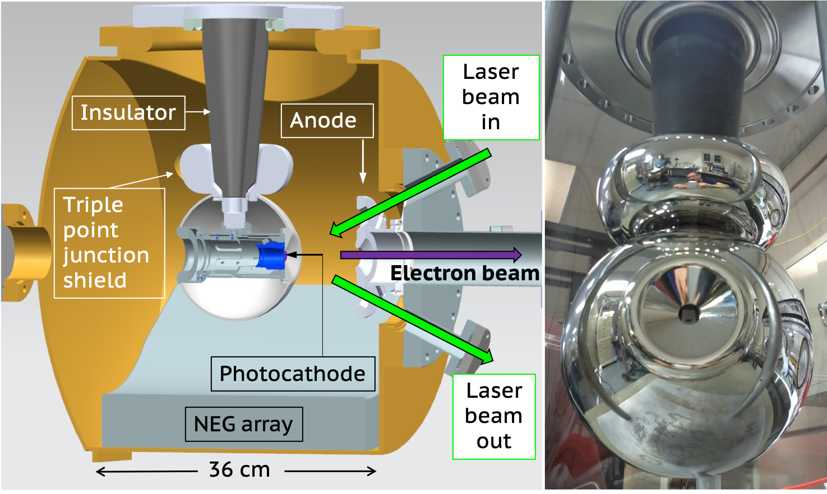
Figure 1: Cross-section view of the -300kV photogun with inverted geometry ceramic insulator (dark grey). The photocathode (purple) and puck (blue) sit inside the spherical cathode electrode with Pierce focusing element. Right: Photograph of the polished cathode assembly (spherical and screening electrodes) mounted to a doped alumina inverted-insulator on a 25 cm diameter Conflat flange.

Experiment: Photocathode Deposition Chamber
Cs_{x}K_{y}Sb photocathodes were manufactured in a vacuum chamber designed to accommodate up to five molybdenum pucks, where each puck supports one photocathode substrate. Pucks are cylindrical and cup-shaped with a front face that accepts a 15 x 15 mm substrate and a hollow back that accepts a heater and sample manipulator for puck movement. The preparation chamber (Figure 2) has four magnetically-coupled sample manipulators: a long manipulator with translation and rotation capability for moving pucks into or out of the photogun, a short manipulator with translation and rotation capability for moving pucks from/onto the heaters and for transferring pucks to/from the long manipulator, and two short manipulators with translation capability that serve as puck storage.
The photocathode deposition chamber was equipped with two SAES WP1250 NEG modules, a 20 L⋅s⁻¹ ion pump, and a residual gas analyzer mass spectrometer (SRS model RGA200). A vacuum level ~1x 10⁻¹¹ Torr was achieved following a 36 hr vacuum bake at 190 °C with a full activation of the NEG pumps at the end of the bake cycle.
There are two internal puck heaters: one capable of reaching high temperature for boiling away residual chemicals on the substrate (i.e., substrate cleaning), and one for maintaining the photocathode substrate at an elevated temperature during photocathode fabrication. The heaters are inserted into the cup-shaped pucks using bellows linear-motion translation stages. For substrate cleaning, the puck faces UP, and for photocathode fabrication the puck faces DOWN. A 304L stainless-steel paddle with three holes (0.3, 0.5, and 0.7 cm) can be rotated into position between the chemical sources and the substrate, to limit the dimensions of the photocathode and to position the photocathode active area off-axis relative to the photocathode center.

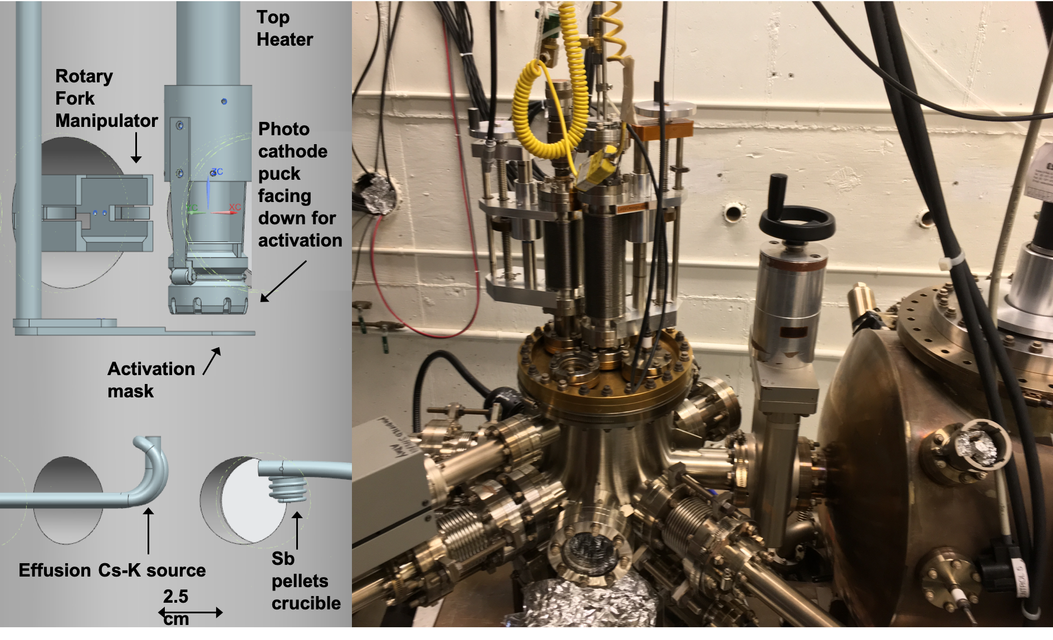
Figure 2. (left) Diagram of the photocathode deposition vacuum chamber internal components showing the photocathode puck facing down behind the mask for photocathode fabrication; (right) Photograph of the photocathode deposition chamber. The photogun high voltage chamber can be seen at the right, with the gate valve separating the two vacuum chambers.

Photocathodes were fabricated using a two-step sequential deposition technique similar to that described in references [12, 13]. The chemical sources were moved below the puck substrate, one source at a time. Antimony was deposited first from a heated crucible containing Sb pellets held in place by gravity. The alkali metals cesium and potassium were co-deposited using an effusion source containing both species.
Photocathodes were fabricated on GaAs and molybdenum substrates firmly attached to the pucks using indium foil and a tantalum retaining ring crimped tightly to the edge of the puck. Molybdenum substrates, 1 mm thick, were hand polished with diamond paste to obtain a mirror-like surface finish. GaAs substrates, 600 micron-thick with <110> cleave plane, p-doped with Zn ~1x10¹⁹ cm⁻³ where simply cleaved to shape and installed on pucks without any chemical treatment.

The photocathode fabrication process was as follows. First, a puck was placed on the bottom heater with the substrate facing UP and heat-cleaned at ~ 450°C for ~ 8 hr. The indium foil melts during the heat cycle providing good thermal contact between the puck and the substrate. Upon cooling to room temperature, the puck was transferred to the top heater with the substrate now facing DOWN because the antimony pellets are held in place inside the heated crucible by gravity. The substrate must be maintained at an elevated temperature during photocathode fabrication. As such, the top heater employs sapphire rollers attached to leaf springs that mate with a slot cut into the outer surface of the puck, to hold the puck securely in place and to provide good mechanical contact to the heater surface. In addition, the top heater is attached to an electrically-isolated bellows translation stage, to position the puck approximately 2 cm above the evaporation sources and 0.1 cm from the activation mask, and to bias the puck at -240 VDC during photocathode fabrication.

The top heater maintains the substrate temperature at ~ 120°C during chemical deposition. Antimony was evaporated for different durations by supplying 25 A to the tungsten heater coil wrapped around the crucible, and then retracted. Then the effusion source was positioned below the photocathode. The effusion source was heated using hot nitrogen gas passing through stainless-steel tubing brazed to the main Cs and K dispenser tube. A valve on the effusion source, together in combination with the nitrogen gas temperature, was used to control the alkali source flow. Instead of a crystal thickness monitor, a residual gas analyser served as a relative deposition monitor for the photocathode chemical species. The quantum efficiency (QE) of the photocathode was continuously monitored during fabrication using a low-power 532 nm laser, with alkali species applied to the photocathode until QE stopped increasing achieving typical QE values in the range of 5 to 10%. Once a photocathode was fabricated, it was transferred to the photogun or stored on one of the short linear translation magnetic manipulators.

The total time required to fabricate a photocathode varied as a function of antimony deposition time, which we assume to be related to antimony-layer thickness. Figure 3 shows the evolution of photocurrent for each photocathode, as function of alkali-deposition time, with longer Sb deposition times requiring more alkali metal to achieve the highest QE.

Figure 3: Measured photocurrent versus alkali deposition time for photocathodes fabricated on GaAs and molybdenum substrates as a function of Sb deposition time

Table 1: Fabrication details of manufactured photocathodes. The error in reflectivity values was estimated to be 5% due to ….

Sample # | Substrate | Sb Deposition time (min) | Alkali Deposition time (min) | QE (%) | Reflectivity (%)
1 | GaAs | 10.0 |  |  | not measured
2 | GaAs | 30.0 |  | 5.23 | 26.4 +/- 0.4
3 | GaAs | 60.0 |  | 8.79 | 13.3 +/- 0.2
4 | GaAs | 90.0 |  | 6.3 | 14.6 +/ -0.3
5 | molybdenum | 10.0 |  | 8.25 | 9.1 +/- 0.1
bare | molybdenum | N/A | N/A | N/A | 31.8 +/- 0.4
bare | GaAs | N/A | N/A | N/A | 33.4 +/- 0.6

Experiment: Photocathode Reflectivity and Thickness Estimates

The photocathode deposition chamber does not possess a quartz crystal microbalance, the device commonly used to assign a thickness value to manufactured photocathodes, with “thickness” in the photocathode community typically referring to the thickness of the Sb foundational layer, and not the fully formed photocathode. References describe optical measurements of reflected and transmitted light from alkali-antimonide photocathodes grown on transparent substrates to determine the real and imaginary parts of the complex index of refraction and photocathode thickness [14, 15]. Unfortunately, only the reflected light can be measured in our apparatus, and no attempt was made to measure the polarization of the reflected light. Despite this shortcoming, the analysis below based on photocathode reflectivity provides some insight into the physical properties of the photocathodes that were fabricated.
The photogun design provides easy access to the reflected laser beam, with linear polarization oriented to provide maximum absorption (i.e., p-polarized light). Most of the alkali-antimonide photocathodes used for these studies were manufactured with limited active area, leaving a large amount of bare substrate exposed around the edge. As a check of methodology, the reflectivity of bare GaAs and molybdenum at 532 nm was measured (Table 1), and the Fresnel equation for p-polarized light was used to calculate the index of refraction of these materials:
$R_{p }={\left|\frac{n_{1}cosθ_{t}-n_{2}conθ_{i}}{n_{1}cosθ_{t}+n_{2}cosθ_{i}}\right|}^{2}={\left|\frac{n_{1}\sqrt{1-{\left(\frac{n_{1}}{n_{2}}sinθ_{i}\right)}^{2}}-n_{2}conθ_{i}}{n_{1}\sqrt{1-{\left(\frac{n_{1}}{n_{2}}sinθ_{i}\right)}^{2}}+n_{2}cosθ_{i}}\right|}^{2}$ (1)
where n₁ is the index of refraction of vacuum (=1), n₂ represents the index of refraction of the substrate, and θ is the angle of incidence equal to 25º. Using measured reflectivity values, and solving for n₂ in equation 1, index of refraction values of 3.9 and 3.6 were obtained for GaAs and molybdenum, respectively, in reasonably good agreement with published values (4.0, 3.75) [14, 15]. However when light was directed onto the Cs_{x}K_{y}Sb photocathodes deemed thickest (i.e., samples fabricated with long Sb deposition times), the Fresnel equation yields an index of refraction of only 1.9, compared to the published value of 3.6 for CsK2Sb [16] suggesting that our photocathodes possess a different stoichiometry. As described below, this assertion is supported by surface science measurements that indicate our photocathodes were potassium-deficient.
Consider a thin-film analysis where reflectivity is influenced by the index of refraction of the photocathode and substrate, the photocathode thickness and the multiple reflections at the photocathode/substrate and photocathode/vacuum interfaces that add or subtract depending on the effective thickness of the film. For our photocathodes, reflection at the photocathode/substrate could be significant because the index of refraction of the photocathode material appears to be much smaller than the index of refraction of the substrate. Although resonance conditions were not observed, because we were not setup to see them, we can expect multiple reflections at the photocathode/substrate interface to be manifest when photocathode thickness $t \sim λ/n4$ which is of the order of tens of nanometers.
On-line calculators [17] are available to quickly plot reflectivity versus film thickness. For this case, the “film” is the photocathode sandwiched between vacuum and substrate, with each region assigned an index of refraction, n₁, n₂ and n₃. In Figure 4, reflectivity is plotted versus photocathode thickness for two values of photocathode index of refraction: the published value for CsK₂Sb and the value 1.9 suggested by reflectivity values obtained for the samples deemed thickest. Clearly oscillatory behavior is present stemming from multiple reflections within the photocathode thin-film but note that the predicted reflectivity is too low for an infinitely thin cathode and this analysis does not consider absorption of light within the photocathode film. The horizontal lines represent measured reflectivity values of photocathode samples fabricated on GaAs substrates as listed in Table 1. Assuming photocathode thickness was always less than $t \sim λ/n2$, this plot suggests our photocathodes possess a relatively small index of refraction, closer to n = 1.9 than the published value of 3.26. Based on this simple analysis and the plots of Figure 4, our samples were between ~ 10 and 50 nm thick.

Figure 4: reflectivity versus photocathode thickness based on thin-film calculations that do not consider absorption of light within the photocathode. The plot presents results for two different PC indices of refraction, with horizontal lines denoting measured values of reflectivity for photocathodes grown on GaAs substrate.

Alternatively, consider a range of photocathode thicknesses where n₁<n₂<n₃: for an “infinitely thin” photocathode, the reflectivity is simply that of the substrate, and for an “infinitely thick” photocathode, the reflectivity is solely a function of the photocathode material. In between these extremes, reflectivity would exhibit an exponential-decay stemming from absorption of light within the photocathode material which can be loosely described with the functional form:
$R\left(t\right) ∝ R_{max}e^{\frac{-αt}{cosθ}}$ (2)

where R_{max} is the reflectivity of the “infinitely thin” photocathode equivalent to the reflectivity of the bare substrate, t is the photocathode thickness, θ is the angle of incidence and α is the material absorption coefficient defined as:
$α=4πκ/λ$ (3)

where λ is the wavelength of the incident light, and κ is the extinction coefficient described by the material’s complex index of refraction, $n^{*}=n+i κ$ , with n simply being the conventional refractive index defined as v/c. Combining equations 2 and 3, the photocathode thickness would be proportional to:

$t∝ \frac{λcosθ}{4πκ} ln\left[\frac{R_{max}}{R(t)}\right]$ (4)
Figure 5 presents reflectivity values based on this approach, and for a range of extinction coefficients including 1.86, which is the published value for CsK₂Sb [14]. As in Figure 4, the dashed lines represent the measured reflectivity values for photocathodes grown on GaAs substrates. When considering a broad range of extinction coefficients, the uncertainty in photocathode thickness is very large but the plots suggest photocathode thickness less than ~ 150 nm.

Figure 5: reflectivity versus photocathode thickness assuming exponential decay of reflected light due to absorption within the photocathode. The plot presents results for three different extinction coefficients, with horizontal lines denoting measured values of reflectivity for photocathodes grown on GaAs substrate

Neither approach described above is mathematically rigorous but these simple analyses suggest our photocathodes are similar to photocathodes fabricated elsewhere and with Sb layer quoted to be of the order ~ 10 to 50 nm thick [ref?]. This seems reasonable, in that the Sb layer was applied in a manner similar to that of other groups, albeit the cesium and potassium originated from the same source lacking independent control of both species.

Experiment: Diagnostic beamline and drive laser
The photogun was connected to a 4-meter long diagnostic beamline with nominal 6.3 cm diameter aperture (Figure 6). The beamline includes two differential pumping stations to vacuum-isolate the photogun high voltage chamber from the beam dump. There are three diagnostic crosses with insertable YAG crystal view screens, 100-micron thick and 5 cm diameter. The fluorescent beam image produced by the incident electron beam is imaged onto the CCD sensor with a 50 mm 1∶1.8 lens attached to the camera with 0.12 mm/pixel resolution. The electron beam strikes the YAG screen at normal incidence, with the beam image delivered to the CCD camera via a mirror mounted at 45° behind YAG crystal. The third diagnostic cross located 50 cm upstream of the beam dump includes a wire scanner consisting of a frame with a tensioned 20 micron-thick, 75% tungsten + 25% rhenium wire.
The beamline was vacuum baked at 200°C for approximately 72 hours, the time when the pressure drop registered by an external pumping station was less than 10% in 24 hours. NEG modules within the differential pump stations and at the viewer crossed were activated just before the cool down to room temperature. All of the ion pumps are powered by an in-house power supply designed to measure sub-nanoampere current levels [17]. This sensitive ion pump current monitor is beneficial to characterize vacuum conditions (after calibration against a vacuum gauge), and in particular serves as a diagnostic for beam loss. The baseline ion pump current in the beamline was 2 nano-Amperes a few days after the vacuum bake, equivalent to ~1x10⁻¹¹ Torr.
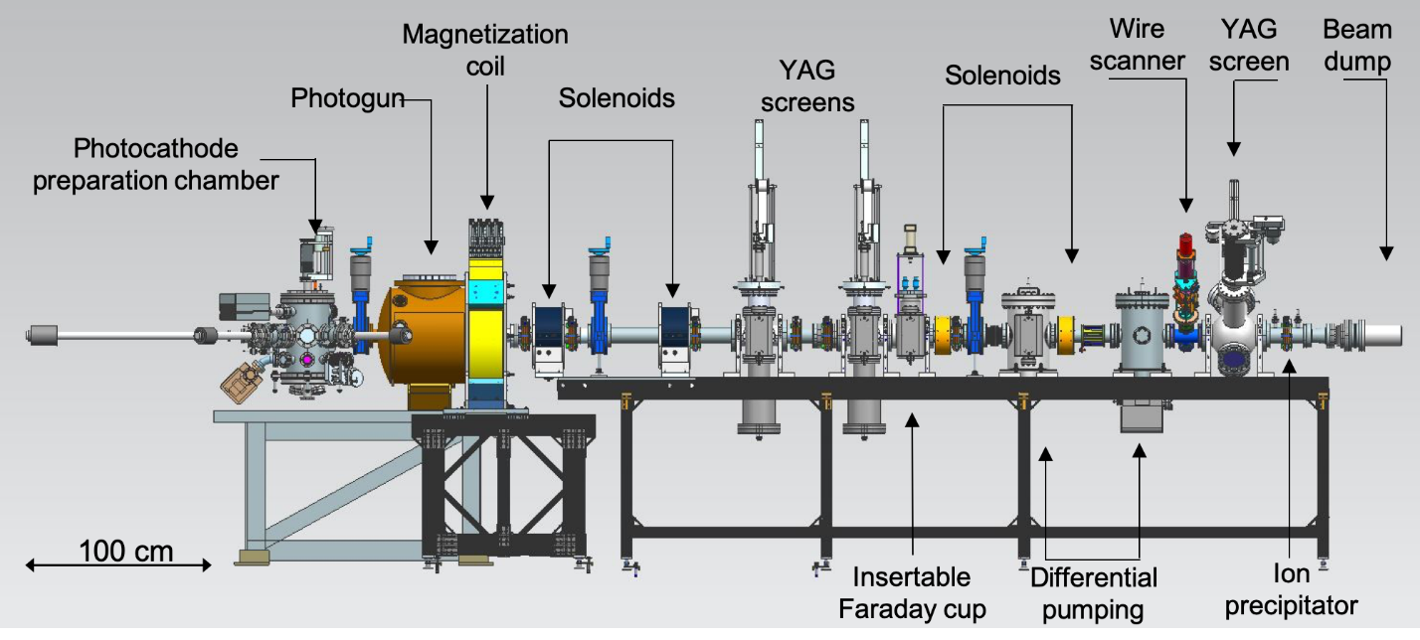
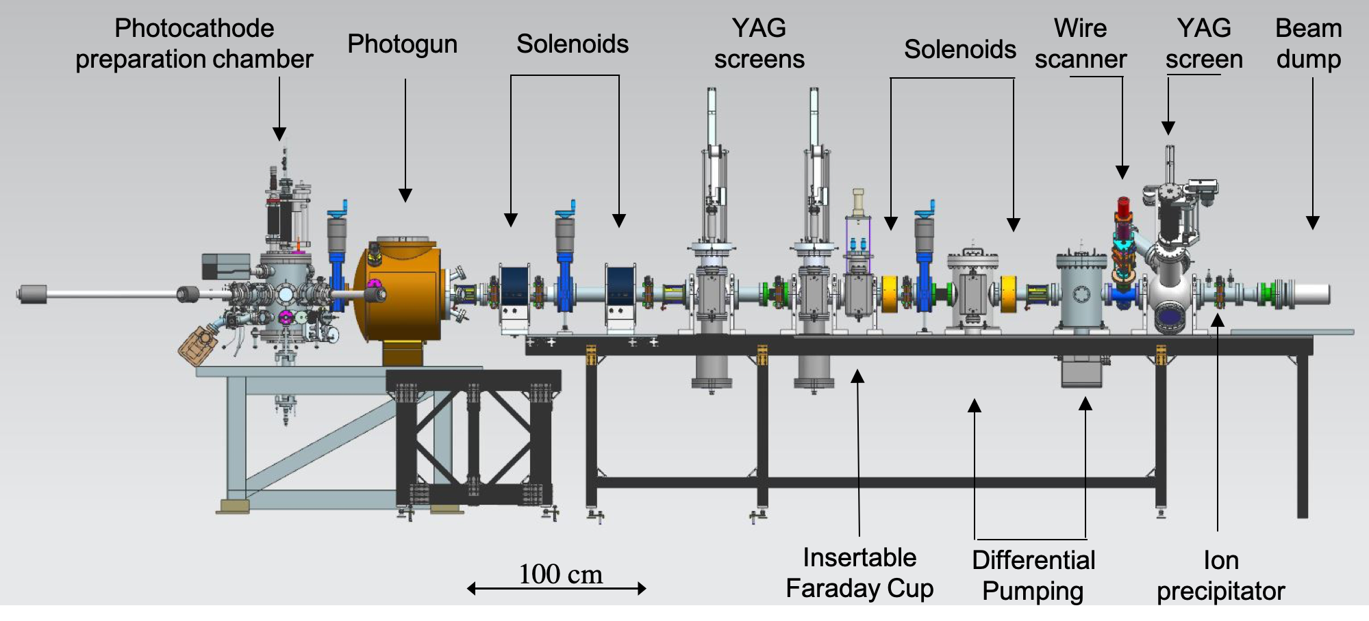
Figure 6. Schematic of the photogun test stand and diagnostic beamline

The photogun drive laser provided Watts of power at 533 nm, with 22 ps rms optical pulses at 374.25 MHz pulse repetition rate. It consists of a gain-switched diode laser operating at wavelength 1.066 μm followed by a multi-stage Yb-fiber amplifier chain and PPLN wavelength converter [10]. Light from the drive laser was delivered to the photogun approximately 5 m away. The average power and laser pulse energy could be varied using a rotating-waveplate attenuator. Low duty-factor “machine-safe” electron beam was produced using an RTP “tune-mode” generator, where “machine-safe” refers to protection of the YAG view screens and wire-scanner beamline diagnostics. The size of the laser beam incident on the photocathode was adjusted using a simple telescope lens system. A cylindrical lens was employed to ensure a circular laser profile at the photocathode illuminated at 25 degree angle of incidence (Figure 1). The laser linear polarization was oriented p-polarized to enhance laser absorption. The transverse profile and size of the laser spot on the photocathode was measured by placing a beam splitter between the last lens and the viewport in the photogun vacuum chamber. The diverted laser beam was guided to a “virtual photocathode” composed of a CCD camera positioned at the same distance as that from the beam splitter to the photocathode. The image from the CCD camera was processed by Spiricon laser beam profiler software.

Experiment: Emittance measurements
Emittance measurements were frequently made using both diagnostics - YAG screens and the wire scanner - to cross compare and validate results. Beam emittance was first measured as a function of average current and bunch charge to find beam conditions without significant space charge effects, but at currents sufficiently high to be resolved by the wire scanner electronics. This was achieved by adjusting the drive laser power and macro-pulse time structure to 250 μs long pulses at 1.5% duty factor to generate ~ 100 nA average current resulting in ~ 20 fC bunch charge. Next, the beam emittance was measured as a function of gun bias voltage, to validate that normalized emittance values were constant. It was noted that the signal from the wire scanner was nearly indistinguishable from background with the photogun biased at -300 kV, possibly because electrons at 300 keV pass through the wire, or perhaps the secondary electron yield from the wire was comparable to the delivered beam current. Both mechanisms depend on the incident electron beam energy. So although the photogun operated reliably at -300 kV, the emittance measurements described below were performed at -200 kV bias voltage.
The emittance was measured across the photocathode vertical and horizontal axes with the single-solenoid scan method, imaging the electron beam on a YAG screen 30 cm downstream of the first solenoid. Figure 7 shows the vertical and horizontal emittances measured at several positions along the vertical and horizontal axes of the photocathode to a radius of 0.25 cm. Beyond this radius, the focusing electrode produced very astigmatic beam, making emittance measurements difficult and inacurate. The normalized rms emittance for beam produced at the photocathode center was 0.09 +/- 0.01 mm mrad for a laser spot size of 0.2 mm rms. Emittance variations, particularly noticeable when the laser beam was moved in the vertical plane, are a result of the side-insulator gun design and the large triple-junction screening electrode that results in a non-uniform electric field within the cathode/anode gap [10].
The experimental results shown in Fig. 7 were obtained using YAG screen images obtained for a range of solenoid current settings. To determine x,y rms beam sizes, beam images were first captured on the YAG screen with an in-house video “frame-grabber” software that was also used to rotate each beam image by the Larmor angle to account for the coupling between the x,y transverse planes incurred by the solenoid magnet [18]. The solenoid scan formalism in Ref. [19] was then implemented to find $x_{rms}^{2}$ and $y_{rms}^{2}$ from the projected x, y rms beam sizes versus solenoid current. The transfer matrix of the solenoid scan beamline without aberrations is expressed as 𝑅 ≡ $R_{d}R_{foc}$, where $R_{d}$ is the drift matrix and $R_{foc}$ is the focusing matrix. A rotation matrix was not employed in the calculation since beam transverse profile images were rotated by the Larmor angle using the video “frame grabber” software. Equation 15 in Ref [19] shows the analytical expression for the expected x-beam sizes squared as:
$σ^{2}$=($C- L_{d}$KS)²$<x_{1}^{2}>+2\left(C -L_{d}KS\right)\left(S/K+CL_{d}\right)<x_{1}x_{1}^{'}>+\left(S/K+CL_{d}\right)$²$<{xx}_{1}^{'2}>$ (5)

where $<x_{1}^{2}>, <x_{1}x_{1}^{'}>and <x_{1}^{'2}>$are the beam moments at the solenoid entrance, and 𝐾 = $\frac{eB_{0}}{2βγmc}$, L and 𝐵₀ are the strength, effective length and the peak magnetic field of the solenoid respectively, 𝐿_{d} is the length of the drift, 𝐶 ≡ cos (𝐾𝐿), and 𝑆 ≡ sin (𝐾𝐿). A similar expression exists for y-beam sizes. To provide confidence in the experimental results and subsequent implementation of the solenoid scan formalism, the particle tracking code Elegant was utilized to calculate 𝑥_{rms} and 𝑦_{rms} from a 10,000 particle distribution defined by the Twiss analysis resulting from the curve fitting of equation (5) for the solenoid scan. From the Elegant results, 𝑥_{rms} and y_{rms} versus solenoid current were calculated and compared to the measured values and showing good agreement.

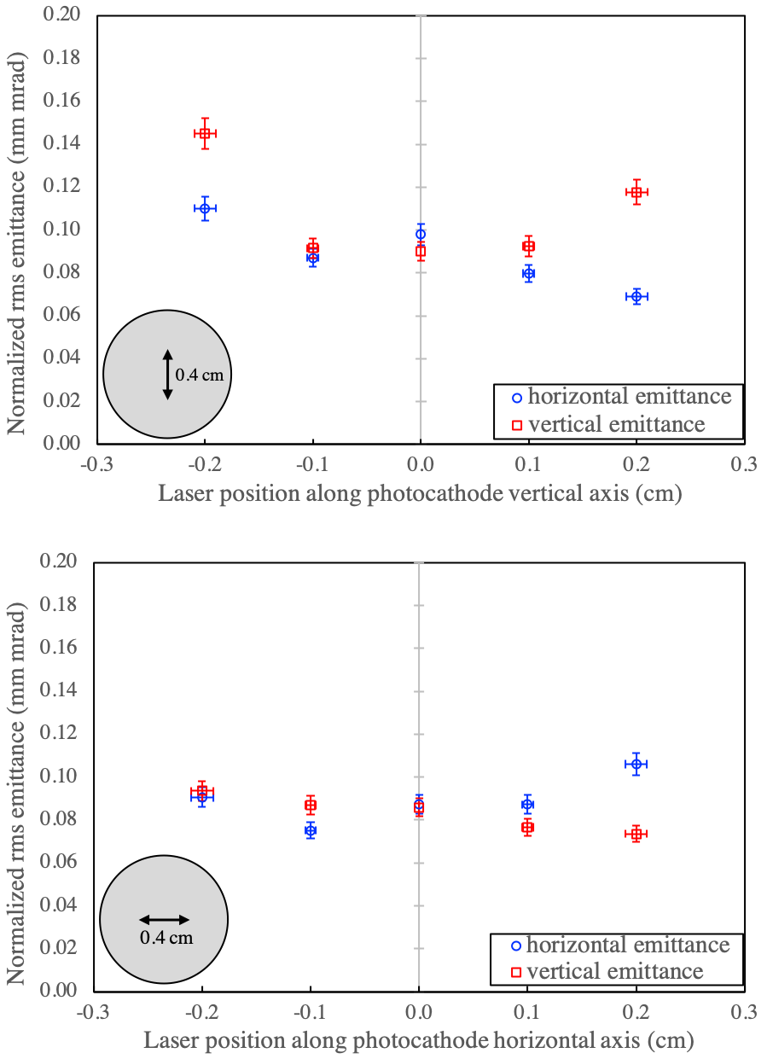

Figure 7: RMS normalized beam emittance as a function of laser position on the photocathode

Results: Intrinsic thermal emittance/MTE of photocathode samples
The solenoid scan method was then used to measure the photocathode thermal emittance. For these measurements, beam was generated from the center of the photocathode and a cylindrical focusing lens was used to adjust the laser beam spatial profile to make very round electron beams on view screens. The x,y rms beam sizes were obtained from the beam profile image projections and utilized in the vertical and horizontal emittance calculations but because the beam was always round, video “frame-grabber” analysis and rotation matrices were not required, which served to expedite the measurement process. Figure 8 shows the results of normalized rms emittance geometric mean $ɛ_{n }=\sqrt{ɛ_{x,rms}ɛ_{y,rms}}$measured as a function of laser spot size using ~ 20 fC bunch charge. The slope of each curve fit represents the thermal emittance for each sample with values summarized in Table 3. Sentence here saying not many laser spot sizes, what about the error bar. Measured values of ~ 0.4 mrad are consistent with published results for Cs_{x}K_{y}Sb photocathodes [20].

Figure 8. Normalized emittance vs. laser spot size

The mean transverse energy (MTE) is a figure of merit used to characterize the photocathode thermal emittance, obtained from the slope of normalized rms transverse emittance (𝜀_{n}) as a function of the rms laser spot size 𝜎_{x} as shown in the expression [6];
$slope= \frac{ɛ_{nx,y}}{σ_{x,y}}=\sqrt{\frac{MTE}{m_{0}c^{2}}}$ (6)
where 𝑚₀ is the electron rest mass and 𝑐 is the speed of light. For a simple photoemission model, the theoretical MTE is defined as described in$Ref [19]$. Table 3 includes the calculated MTEs for the fabricated photocathodes. These measured values can be compared to the theoretical value of MTE defined as:
$MTE=\frac{hυ-\left(E_{g}+E_{a}\right)}{3}$ (2)
where E_{g} is the energy gap, and E_{a} is electron affinity, and hν is the photon energy. Using values from reference X (E_{g} = 1.2 eV, E_{a} = 0.7 eV and hν = 2.33 eV), the theoretical value of MTE is 143 meV. All of the tested photocathodes yield smaller MTE values, and this might be due to…..

Table 2: Thermal angle and MTE values for tested photocathode samples

Photocathode sample | Substrate | Sb deposition  time (min) | Thermal angle (mrad) | MTE  (meV)
1 | GaAs | 10.0 | 0.39 +/- 0.01 | 78.28 +/- 0.01
2 | GaAs | 30.0 | 0.41 +/- 0.01 | 86.44 +/- 0.01
3 | GaAs | 60.0 | 0.44 +/- 0.01 | 100.87 +/- 0.01
4 | GaAs | 90.0 | 0.43 +/- 0.02 | 92.56 +/- 0.02
5 | Molybdenum | 10.0 | 0.37 +/- 0.03 | 71.32 +/- 0.02

Thermal angle values are plotted in Figure 9 versus Sb deposition time and inverse sample reflectivity, 1/R, which as described above, we believe to be proportional to photocathode sample thickness. Neither plot illustrates a large variation in thermal angle over the entire range of samples studied, but when thermal angle is plotted versus 1/R, a correlation can be seen. Emittance grows with thickness - and ostensibly roughness – consistent with past studies of the bare Sb foundational layer [12, 13]. However the correlation is relatively small, and nothing like what was implied by past measurements which showed crystal formation with rough surfaces possessing micron-size dimensions for long Sb deposition times. The relative insensitivity of emittance to Sb depo time/thickness illustrated in both plots of Figure 9 supports observations made at x-ray light sources, namely an exothermic reaction that takes place during photocathode fabrication that completely transforms the Sb layer [16]. These beam-based emittance studies support this observation, such that even photocathodes manufactured with relatively thick Sb layers can provide “good” emittance, where good is in quotation marks because some applications may require a thermal angle smaller than 0.4 mrad.
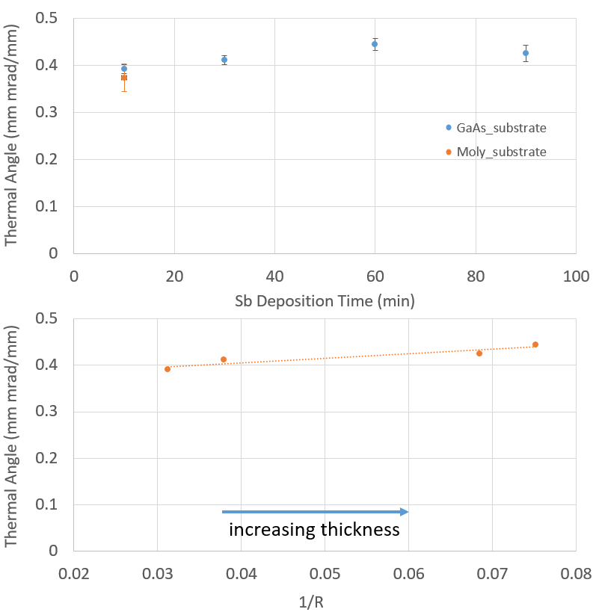
Figure 9. Average thermal emittance versus (top) Sb deposition time and (bottom) the inverse reflectivity 1/R which we speculate is proportional to photocathode thickness.

Results: Photocathode Charge Lifetime
Fabricating photocathodes that provide long photgun operational lifetime is especially important for applications requiring very high average current. Charge lifetime is a useful photocathode metric defined as the amount of charge that can be extracted before QE falls to 1/e of the initial value. An application at Jefferson Lab requires greater than 100 mA current [21], however for these studies, beam current was limited by the power limitations of available high voltage power supplies: 4.5 mA at 300 kV, 6.75 mA at 200 kV, and 30 mA at 100 kV. As described in ref. 10, uninterrupted beam delivery from the photogun was only possible when a positive bias voltage was applied to the photogun anode electrode. Table 3 summarizes the charge lifetime measurements for beam delivery under various conditions for four photocathodes, each fabricated with 5 mm active area centered on the substrate. Laser spot was X? and positioned X? mm from the electrostatic center of the photocathode, and the anode was biased at +1000 VDC for each measurement. Comparing only the results for photocathodes grown on GaAs substrates, there is no dicernable trend based on Sb deposition time. The best observed charge lifetime was 6600 C obtained from the photocathode with 90 minute Sb deposition time (which is not the sample deemed to have the thickest Sb layer). Charge lifetime was dramatically better for Cs_{x}K_{y}Sb photocathodes grown on a molybdenum substrate, and by many orders of magnitude. In fact, charge lifetimes were difficult to measure because QE was often observed to slowly increase during the run, and because the charge extracted during the run was comparatively small. For the photocathode grown on molybdenum substrate, noticeable QE degradation was only discernable at the highest demonstrated current, 28 mA.
Table 3. Photocathode Charge Lifetime Summary with the anode bias on
Substrate | Sb depo time (min) | HV (kV) | Current (mA) | Run time (h) | LT (C)
GaAs | 10 | 200 | 4.5 | 6 | 160
GaAs | 30 | 200 | 1.0 | 6 | 110
GaAs | 60 | 200 | 1.0 | 9 | 28
GaAs | 90 | 200 | 4.5 | 10 | 6600
Moly | 10 | 100 | 28.0 | 58 | 9400
Moly | 10 | 100 | 20.0 | 20 | 3.3e11
Moly | 10 | 200 | 14.0 | 90 | 1.0 e13
Moly | 10 | 200 | 4.5 | 37 | 9.0e11
Moly | 10 | 200 | 4.5 | 11 | 2.2e05

Results: Surface Science evaluation of photocathode composition
The intention was to always fabricate photocathodes with the precise ratio of chemical species; Cs, K and Sb with relative concentrations 1:2:1, but it was not possible to precisely control the concentration of the alkali species, especially because Cs and K originate from the same effusion source at the same temperature. After finishing the beam-based studies, the photocathodes were removed from the photogun and transferred in air to an EDS-SEM apparatus to determine chemical composition (energy dispersive X-ray spectroscopy used in conjunction with a scanning electron microscope: Noran System Six by Thermo Electron and JSM-6060LV by JEOL). Exposure to air results in a heavily oxidized surface such that the samples studied in the EDS-SEM are not precisely the samples used to generate electron beam, but a comparative assessment of chemical composition performed in this manner was still deemed useful.
Table 4 summarizes the chemical composition of four photocathodes with analysis performed at multiple locations on each photocathode. The chemical concentration was averaged over regions X x X um. Overall, the ratio of Cs to K was much higher than desired for photocathodes grown on GaAs substrates compared to the photocathode grown on molybdenum: photocathodes grown on GaAs substrates are potassium deficient, whereas the photocathode grown on molybdenum possess very nearly the desired Cs/K ratio. This may explain why the photocathode grown on molybdenum exhibited the best QE and the highest charge lifetime. Interestingly, the SEM-EDS could not detect the Sb element for the photocathode grown on the molybdenum. It should also be mentioned that this sample exhibited low reflectivity, and comparable to the reflectivity of samples grown on GaAs deemed the thickest.

Table 4. Chemical composition of photocathodes after exposure to air during installation in the SEM-EDS machine. The intended ratio of chemical species Cs, K and Sb was 1:2:1. Alkali element concentrations were normalized to the concentration of Sb, which was set to “1”. Sb was not detected for the photocathode grown on the molybdenum substrate.
Substrate | Sb deposition time (min) | [Cs] | [K] | [Sb]
Ideal composition |  | 1 | 2 | 1
GaAs | 30 | Location1: 1.68  Location2: 2.16 | 0.74  0.66 | 1  1
GaAs | 60 | Location1: 0.91  Location2: 1.33  Location3: 1.24 | 0.43  0.63  0.62 | 1  1  1
GaAs | 90 | Location1: 1.12  Location2: 1.49  Location3: 1.52 | 0.44  0.65  0.54 | 1  1  1
molybdenum | 10 | Location1: 0.72  Location2: 1.44  Location3: 1.44 | 2  2  2 | ?  ?  ?

Conclusion:
The thermal emittance of Cs_{x}K_{y}Sb photocathodes increased only slightly as a function of photocathode thickness, and this was manifest only when thermal emittance was plotted as a function of photocathode sample reflectivity which we assert to be inversely proportional to Sb thickness. The exact thickness of each photocathode was not measured, but simple estimates based on sample reflectivity and published values of the complex index of refraction of CsK₂Sb photocathodes suggest our samples were similar to photocathodes fabricated at other laboratories - between 10 and 50 nm thick.
The observed relative insensitivity of thermal emittance to Sb thickness is consistent with studies performed by others that indicate the Sb foundational layer is completely transformed during the exothermic photocathode fabrication process [refs].
All of the photocathodes grown on GaAs exhibited poor operational lifetime, and with no obvious correlation to Sb deposition time. Poor operational lifetime is perhaps related to a deficiency of potassium indicated by SEM-EDS measurements of photocathodes (that were analyzed after being exposed to air). The effusion source containing both alkali species provides convenience but does not provide a means to independently vary the alkali concentration of each element. For future photocathode studies, the Jefferson Lab alkali-antimonide deposition chamber should be modified to include separate alkali sources and a quartz-crystal microbalance to provide more accurate thickness assessment.
The molybdenum-substrate results are interesting, providing thermal emittance comparable to photocathodes grown on GaAs substrates but with markedly improved photocathode lifetime. Further investigation into the role of the substrate will be pursued.

Acknowledgement:
Authored by Jefferson Science Associates, LLC under U.S. DOE Contract No. DE-AC05-06OR23177 and supported by Laboratory Directed Research and Development funding. The U.S. Government retains a non-exclusive, paid-up, irrevocable, world-wide license to publish or reproduce this manuscript for U.S. Government purposes.

References:
- M. Altarelli, R. Brinkmann, M. Chergui, W. Decking, B. Dobson et al., The European X-ray Free Electron Laser technical design report, Report No. DESY 2006-97, 2006
- H. Abe, S. Adachi, K. Amemiya, T. Arima, K. Asakura et al., “ERL conceptual design report”, KEK Report No. 2012-4, 2012
- Yaroslav S. Derbenev, “Theory of electron cooling”, https://arxiv.org/ftp/arxiv/papers/1703/1703.09735.pdf
- D. H. Dowell, I. Bazarov, B. Dunham, K. Harkay, C. Hernandez-Garcia, R. Legg, H. Padmore, T. Rao, J. Smedley, and W. Wan, Nucl. Instrum. Methods Phys. Res., Sect. A 622, 685–697 (2010)
- Xuan Wang, Yutong Li, “Ultrafast electron diffraction”, Chinese Physics B, Volume 27, No. 7, 2018
- S. Schubert, J. Wong, J. Feng, S. Karkare, H. Padmore, M. Ruiz-Osés, J. Smedley, E. Muller, Z. Ding, Mengjia Gaowei, K. Attenkofer, X. Liang, J. Xie, and J. Kühn, “Bi-alkali antimonide photocathode growth: An X-ray diffraction study”, Journal of Applied Physics 120, 035303 (2016)
- RP Photonics Encyclopedia – photocathodes, https://www.rp-photonics.com/photocathodes.html
- J. Feng, S. Karkare, J. Nasiatka, S. Schubert, J. Smedley, and H. Padmore, “Near atomically smooth alkali antimonide photocathode thin films”, Journal of Applied Physics 121, 044904 (2017)
- M. Gaowei, Z. Ding, S. Schubert, H. B. Bhandari, J. Sinsheimer, J. Kuehn, V. V. Nagarkar, M. S. J. Marshall, J. Walsh, E. M. Muller, K. Attenkofer, H. J. Frisch, H. Padmore, and J. Smedley, “Synthesis and x-ray characterization of sputtered bi-alkali antimonide photocathodes”, APL Materials 5 (11), 116104 (2017)
- C. Hernandez-Garcia, B. Bullard, J. Benesch, J. Grames, J. Gubeli, F. Hannon, J. Hansknecht, J. Jordan, R. Kazimi, G. A. Krafft, M. A. Mamun, M. Poelker, M. L. Stutzman, R. Suleiman, M. Tiefenback, Y. Wang, S. Zhang, C. A. Valerio Lizarraga, R. Montoya Soto, and A. Canales Ramos, “Compact -300 kV dc inverted insulator photogun with biased anode and alkali-antimonide photocathode”, Phys. Rev. Accel. Beams 22, 113401 (2019)
- C. Hernandez-Garcia, D. Bullard, F. Hannon, Y. Wang, and M. Poelker, “High voltage performance of a dc photoemission electron gun with centrifugal barrel-polished electrodes”, Rev. Sci. Instrum. 88, 093303 (2017)
- Md Abdullah A. Mamun, Abdelmageed A. Elmustafa, Carlos Hernandez-Garcia, Russell Mammei, and Matthew Poelker, “Effect of Sb thickness on the performance of bialkali-antimonide photocathodes”, J. Vac. Sci. Technol. A 34 021509 (201)
- M. A. Mamun, C. Hernandez-Garcia, M. Poelker, and A. A. Elmustafa, "Correlation of CsK₂Sb photocathode lifetime with antimony thickness", APL Materials 3, 066103 (2015)
- Md. Abdullah A. Mamun, Abdelmageed A. Elmustafa, Marcy L. Stutzman, Philip A. Adderley, and Matthew Poelker, “Effect of heat treatments and coatings on the outgassing rate of stainless steel chambers”, J. Vac. Sci. Technol. A 32(2), Mar/Apr 2014, 021604
- J. O. Akinlamiéand A. O. Ashamu, “Optical properties of GaAs, Journal of Semiconductors”, Vol. 34, No. 3 March 2013
- “Refractive Index Database – Table of Refractive Index”, https://www.filmetrics.com/refractive-index-database
- M.E. Moorhead, N.W Tanner, “Optical properties of an EMI K2CsSb bialkali photocathode”, Nucl. Instr. and Meth. A 378 (1996) 162-170
- “CalcTool: Thin film optical coating calculator”, http://www.calctool.org/CALC/phys/optics/thin_film
- J. Hansknecht, P. Adderley, M. L. Stutzman, and M. Poelker, “Sensitive ion pump current monitoring using an in-house built ion pump power supply”, AIP Conference Proceedings 1149, 1143 (2009)
- I. Bazarov, L. Cultrera, A. Bartnik, B. Dunham, S. Karkare, Y. Li, X. Liu, J. Maxson, and W. Roussel, “Thermal emittance measurements of a cesium potassium antimonide photocathode”, Appl. Phys. Lett. 98, 224101 (2011)
- L. Zheng, J. Shao, Y. Du, J.G. Power, E.E. Wisniewski, W. Liu, C.E. Whiteford, M. Conde, S. Doran, C. Jing, C. Tang, and W. Gai, “Overestimation of thermal emittance in solenoid scans due to coupled transverse motion”, Phys. Rev. Accel. Beams 21, 122803 (2018)
- M. Poelker, P. Adderley, J. Benesch, B. Bullard, J. Grames, F. Hannon, J. Hansknecht, C. Hernandez-Garcia, R. Kazimi, G. Krafft, M. A. Mamun, R. Suleiman, M. Tiefenback, Y. Wang, S. Wijiethunga, J. Yoskovitz, and S. Zhang, “Magnetized Electron Beam for JLEIC Re-circulator Cooler Ring”, Proceedings of Science(2018), https://pos.sissa.it/324/012/pdf

To do list:

- Go through references again, ask Mamun for help. Be generous with references, especially with the ones describing photocathode measurements. Because it mattes but also because the referees will likely be photocathode experts and they like it when you reference their work.
- I gave you my excel spreadsheets for Figures 4 and 5, so that you can “own” this figure. You will need to double check my math and add the correct lines for sample reflectivity
- FYI, I got figures 6 and 7 from Carlos, these are fine for the paper
- You need to clean up Figure 8
- Make your own bottom plot for Figure 9

