Thomas Jefferson National Accelerator Facility

12GeV Upgrade Injector Cryomodule Project

**vacuum vessel design and Analysis**

Author(s): Gary Cheng

Document No.: CRM1107090A0001

Effective Date: 4/4/2013

|  |  |  |
| --- | --- | --- |
| Reviewer 1: |  |  |
|  | Joseph Matalevich | Date |
| Reviewer 2: |  |  |
|  | Joe Preble | Date |

|  |  |  |
| --- | --- | --- |
| Table of Revisions | | |
| Revision | Description | Date |
|  |  |  |
|  |  |  |
|  |  |  |

Table of Contents

1. Vacuum Vessel Design 1

2. Vacuum Vessel Analysis 6

2.1 Weight Estimations 6

2.2 Allowable Stresses and Required Wall Thickness 6

2.3 Reinforcement Area at Welds for Openings 7

2.3 Design Welds for Vacuum Vessel Openings 12

2.4 Welds for Vacuum Vessel Flanges 14

2.5 Lock Down Studs ad Washers Design 15

2.5.1 Lockdown Studs Subjected to Dynamic Loads During Transportation 15

2.5.2 Lockdown Studs under Static Load 16

2.5.3 Lockdown Stud and Washer Welds Sizing 17

2.6 Support Bracket Design 18

2.7 Waveguide Support Bracket Design 18

3. References 19

# List of Figures

Figure 1 Injector Cryomodule vacuum vessel. 2

Figure 2 First row of spaceframe wheels rolled into the VV 4

Figure 3 Second row of spaceframe wheels rolled into the VV 5

Figure 4 Lockdown stud design diagram 15

Figure 5 Waveguide Support Bracket Force Diagram 19

# List of Tables

Table 1 Bill of Material from vacuum vessel top assembly drawing 3

Table 2 Weight Estimations 6

Table 3 Determining trn for nozzles under internal pressure 8

Table 4 Comparison of actual nozzle wall with required minimum thicknesses 8

Table 5 Determining reinforcement areas for VV openings subjected to internal pressure 9

Table 6 Determining trn for nozzles under external pressure 10

Table 7 Nozzles under external pressure and lateral load: thickness per UG-45(a) 10

Table 8 Comparison of actual nozzle wall thicknesses with required minimum thicknesses for external pressure case 11

Table 9 Determining reinforcement area for vacuum vessel nozzles subjected to external pressure 12

Table 10 Vacuum Vessel major openings weld design and strength verification 13

# Vacuum Vessel Design

Figure 1 shows the Injector Cryomodule (INJ CM) vacuum vessel (VV). For convenience, the bill of material from INJ CM VV top assembly drawing CRM1107090-0001 is listed in Table 1 to identify the items in Fig. 1. The overall length of this vessel is 60.75ʺ, which is roughly one-fifth of the length for the C100 Cryomodule vacuum vessel (CRM1207090-1000). In fact, INJ CM VV is somewhat like the supply/return end section of the C100 CM VV in sense of the number and sizes of penetrations. During the design and analysis of INJ CM VV, C100 VV is used as a guide.

The size of the tophat mount weldment, i.e. item 7, was determined to make sure that there will be approximately 0.5ʺ radial clearance between the inner surface of the item 7 nozzle and outer surface of magnetic shields that are wrapped onto the tophat. Lockdown studs & washers (items 4 & 5), instrumentation port (item 11), tuner ports (item 1), etc. are consistent with C100 designs.

Currently in the tunnel, there are a set of two stands (refer to drawing 11100-0008 sheet 3 and drawings 11180-0022 & -0029) to support the existing Quarter Cryomodule. Now the new VV has its center port (item 7) moved to the upstream direction so that the two vessel support tabs (item 8) are both shifted to upstream direction. The distance between the two tabs is kept to be 37.66ʺ. The plan is to either design an adapter for the saddles that support the new INJ CM or adjust the top plates of the stands (drawings 11180-0022 & -0029).

The traditional vacuum vessel support on the rails during CM assembly is checked for its compatibility with the INJ CM VV. No potential interferences are detected. The compatibility of spaceframe supports with vacuum vessel support during wheeling of the spaceframe & shielding assembly into the vacuum vessel is also checked. Figures 2 and 3 illustrate the engagements of the two rows of wheels (mounted on the spaceframe) with the vacuum vessel. Again, no issues are found. The spaceframe supports can be removed once the wheels are landed inside the VV.

The VV is a Category II vacuum system per JLAB ES&H Manual 6151 Appendix T5 “Requirements for Vacuum Systems”. Thus, the VV is not required to be stamped. The structural design of this VV adopts similar approaches as what the C100 VV adopted, i.e. using the ASME Boiler & Pressure Vessel Code (BPVC), Section VIII, Division 1 (S8D1) rules as reference. The design pressures are 29.4 psi internal and 14.7 psi external, respectively. Transportation accelerations of 4 g vertical and 2 g axial are also considered in design calculations. Details of INJ CM VV structural analysis are presented in the next section of this report.

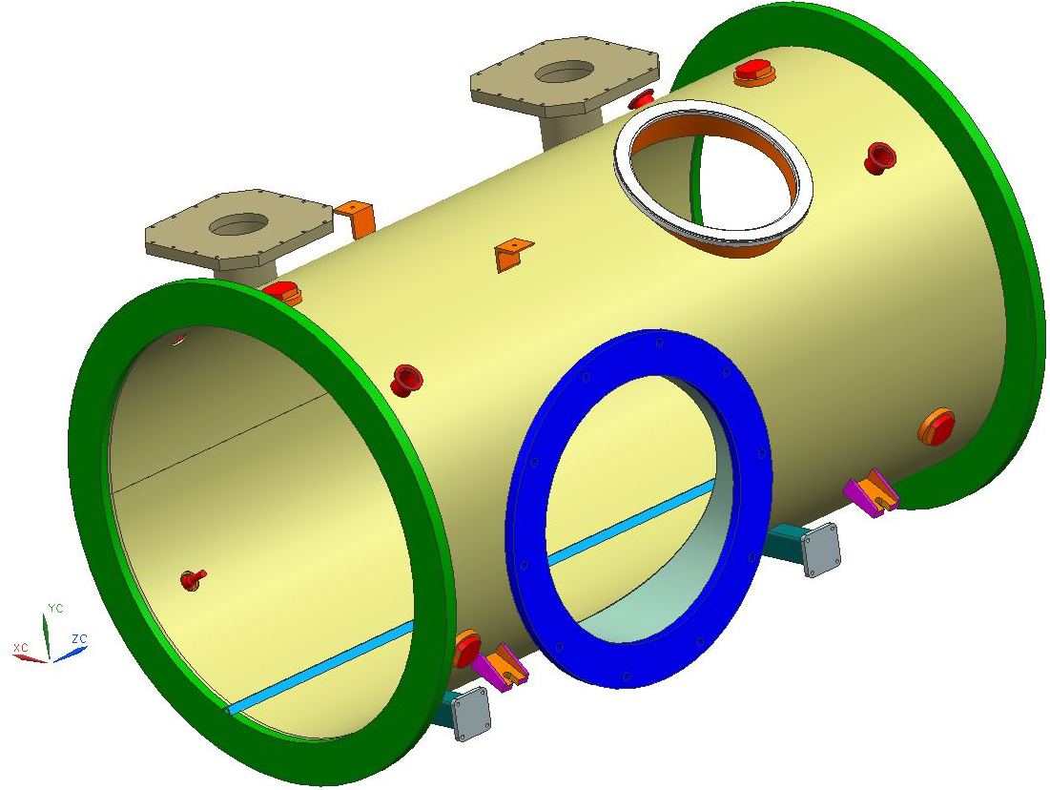

1

2

3

5

4

6

7

8

9

10

11

12

Figure 1 Injector Cryomodule vacuum vessel.

Table 1 Bill of Material from vacuum vessel top assembly drawing



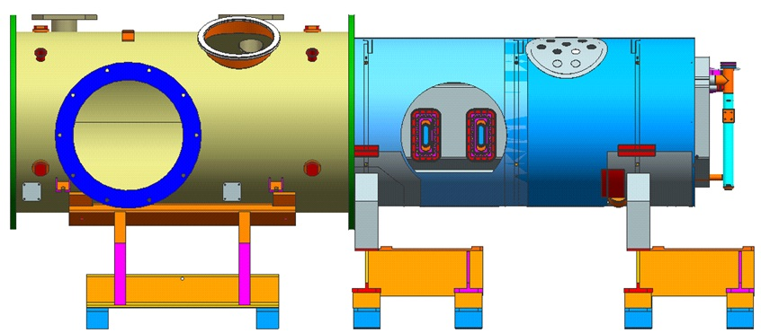

Figure 2 First row of spaceframe wheels rolled into the VV

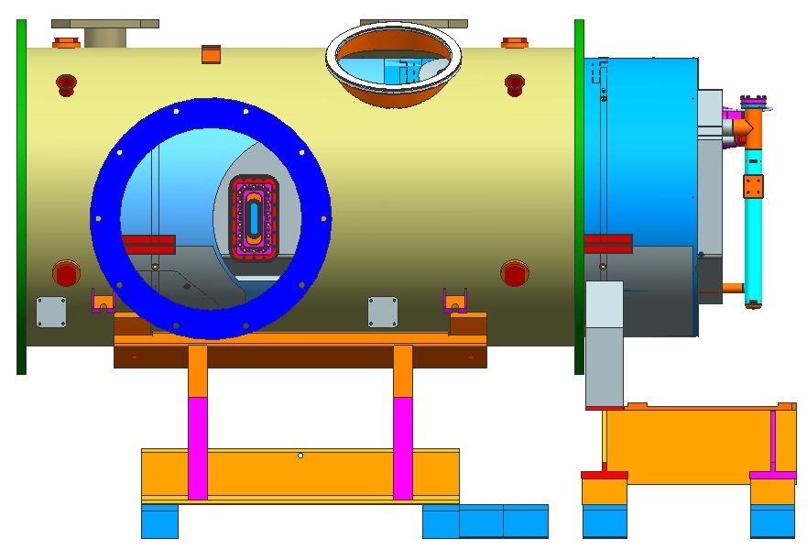

Figure 3 Second row of spaceframe wheels rolled into the VV

# 2. Vacuum Vessel Analysis

## 2.1 Weight Estimations

Table 2 lists some estimated weights that are useful in vacuum vessel (and spaceframe) relevant calculations.

Table 2 Weight Estimations

|  |  |  |
| --- | --- | --- |
| **Part name** | **volumes, in3** | **weight, lbs** |
| 7-cell cavity, HV, headers, tuner, rods & brackets |  | 331.00 |
| 2-cell cavity, HV, headers, tuner, rods & brackets |  | 165.50 |
| Outer mag shield | 851.6 | 269 |
| Thermal shield | 363.7 | 117 |
| Spaceframe assy | 1,347 | 389 |
|  |  |  |
| **Spaceframe & Shielding Assy Total** |  | 1,272 |
|  |  |  |
| Supply End Can | 3,913.6 | 1,131 |
| Return End Can | 3,653.3 | 1,056 |
| Vacuum Vessel | 2,598.9 | 751 |
| Two warm tuners | 616.0 | 178 |
| Tophat, warm waveguides, warm to cold transition, ion pumps,support brackets | 3,811.0 | 1,101 |
|  |  |  |
| **CM Total** |  | 5,490 |

In JLAB-TN-07-081 [1] section 5.1.4, the weight for the dual fundamental power coupler waveguides and some accessories was estimated and some approximate dimensions were measured to facilitate the waveguide ports weld strength calculation. From C100 to INJ CM, the waveguides did not change. Herein, the item 7, tophat mount weldment, also requires weld analysis so the previous weight estimation on waveguides and associates is updated to reflect the weight increase caused by the use of bigger nozzle and flange. The updated number is 428 lbs. Note that the dimensions given in JLAB-TN-07-081 Fig. 7 are still valid.

## 2.2 Allowable Stresses and Required Wall Thickness

ASME BPVC S8D1, UG-23 (a) states that for tensile allowable stress, Section II tables are to be used. For 304 stainless steel, the allowable tensile stress at room temperature is found to be 20,000 psi.

UG-23(b) describes the steps to calculate the compressive allowable stress, the Factor B, according to vessel geometrical dimensions. During normal operation, the vacuum vessel is under external atmospheric pressure, hence, in compression. The allowable compressive stress is determined as follows (thickness is chosen per UG-16(b)):

At room temperature, 304 stainless steel’s young’s modulus per Section II, Part D, Subpart 3, Table HA-1 is E = 2.8×107 psi.

|  |  |  |
| --- | --- | --- |
| Ro= | 16.0 | inches |
| t= | 0.0625 | inches |
| Factor A= | 0.000488 |  |
| Do interpolation in Table HA-1 for Factor B= | 6,770 | psi |

The Factor B is the allowable compressive stress to use.

In JLAB-TN-09-029 [2] sections I.2 and I.3, detailed stress analysis was carried out to prove that the 0.25ʺ wall thickness for C100 VV is sufficient per ASME BPVC S8D1 rules for both the internal and external pressure loadings. The NJ CM end cans are the same as C100’s end cans. INJ CM’s spaceframe & shielding assembly weighs about a quarter of that of the C100’s spaceframe & shielding. The ground supports for INJ CM are much closer to the end cans than C100 CM’s ground supports are:

* for INJ CM, the distance from upstream VV flange, where the supply end can will be welded onto, to center of the upstream saddle is 11.545ʺ. This distance is 52.67ʺ in C100 CM.
* for INJ CM, the distance from downstream VV flange, where the return end can will be welded onto, to center of the downstream saddle is also 11.545ʺ. This distance is 65.53ʺ in C100 CM.

Based on all these facts, it is determined that no extensive stress analysis is needed to re-confirm that the 0.25ʺ VV wall thickness, which is also used in INJ CM VV design, is sufficient per BPVC rules.

## 2.3 Reinforcement Area at Welds for Openings

Same procedures as what was applied in JLAB-TN-09-029 Section II to check the reinforcement areas for vessel under internal/external pressure are executed. For brevity, only the results are presented here. For detailed explanations, the reader is referred to JLAB-TN-09-029 Section II.

Note that the NW40 half nipples (item 12 in CRM110709-0001) have an OD of 1.5”, per UG-36(c)(3), these half nipples are exempt from weld reinforcement area calculations.

Table 3 Determining trn for nozzles under internal pressure

|  |  |  |  |
| --- | --- | --- | --- |
|  | center waveguide port | instrumentation port | tuner port |
| Item number in CRM1107090-0001 | 7 | 11 | 1 |
| ID of nozzle | 19.53 | 12.51 | 4.26 |
| Inner radius of nozzle | 9.765 | 6.26 | 2.13 |
| Vertical force, Fy, lbf | 428 | 0 | 0 |
| Distance from C.G. to interface, in | 13 |  |  |
| Bending moment, Mz, lbf-in | 5564 | 0 | 0 |
| Nozzle thickness by UG-45(a) | 0.0625 | 0.0625 | 0.0625 |
| Nozzle thickness by UG-45(b)(2), UG-16(b) | 0.0625 | 0.0625 | 0.0625 |
| Nozzle thickness by UG-45(b)(4) | 0.375 | 0.375 | 0.258 |
| Nozzle thickness by UG-45(b) | 0.0625 | 0.0625 | 0.0625 |
| Required nozzle wall thickness, trn | 0.0625 | 0.0625 | 0.0625 |
| OD of nozzle with required wall thickness | 19.66 | 12.64 | 4.39 |
| Cross-section area | 3.847 | 2.469 | 0.849 |
| Maximum shear stress, psi | 1,166.2 | 753.5 | 268.5 |
| Allowable shear stress by UG-45(c) | 14,000 | 14,000 | 14,000 |
| Is UG-45(c) satisfied? | Yes | Yes | Yes |

Table 4 Comparison of actual nozzle wall with required minimum thicknesses

|  |  |  |  |
| --- | --- | --- | --- |
| Nozzle OD | 19.77 | 12.75 | 4.50 |
| Actual nozzle wall, tn | 0.12 | 0.120 | 0.12 |
| Nozzle inner radius, Rn | 9.77 | 6.26 | 2.13 |
| Req’d nozzle wall, trn | 0.0625 | 0.0625 | 0.0625 |
| Is tn > trn? | Yes | Yes | Yes |

The S8D1 UG-37 rules are applied to determine if reinforcement areas are needed for any of the openings’ welds. The constants are:

F = 1 for all nozzles except tuner ports. F = 0.5 for tuner ports assuming θ=90°.

fr1 = 1 for all nozzles because they are welded as UG-40 sketch (n).

fr2 = Sn/Sv = 1 because tensile strength (see UG-23(a)) of nozzle and vessel materials are the same.

fr3 = Sn/Sv = 1.

E1 = 1 because no nozzles will pass through other welds. The longitudinal weld is “clearly identifiable” and can be avoided to overlap with openings.

t = 0.25" is the specified vacuum vessel wall thickness.

For the tuner ports, the equivalent chord length, which is used in place of diameter of opening for a tuner port subjected to internal pressure, is determined as follows:

|  |  |  |
| --- | --- | --- |
| Rm = R+tr/2= | 15.78 | inches |
| L= | 8 | inches |
| α1 = cos-1((L+Rn)/Rm) = | 50.07 |  |
| α2 = cos-1((L-Rn)/Rm) = | 68.16 | ° |
| α = α2- α1 = | 18.10 | ° |
| d = 2 Rm (1-cos2(α/2))1/2 = | 4.96 | inches |

Table 5 Determining reinforcement areas for VV openings subjected to internal pressure

|  |  |  |  |
| --- | --- | --- | --- |
|  | center waveguide port | instrumentation port | tuner port |
| Item number in CRM1107090-0001 | 7 | 11 | 1 |
| diameter of opening d= | 19.53 | 12.51 | 4.26 |
| wall thickness of nozzle tn= | 0.12 | 0.120 | 0.12 |
| required nozzle thickness trn= | 0.0625 | 0.0625 | 0.0625 |
| A= | 1.22 | 0.78 | 0.13 |
| A1 from 1st equation is: | 3.66 | 2.35 | 0.93 |
| A1 from 2nd equation is: | 0.14 | 0.14 | 0.16 |
| larger A1 from above two = | 3.66 | 2.35 | 0.93 |
| A2 from 1st equation is: | 0.0719 | 0.0719 | 0.0719 |
| A2 from 2nd equation is: | 0.0345 | 0.0345 | 0.0345 |
| smaller A2 from above two = | 0.0345 | 0.0345 | 0.0345 |
| Nozzle weld size = | 0.22 | 0.22 | 0.21 |
| A41= | 0.0469 | 0.0472 | 0.0453 |
| A1+A2+A41 = | 3.74 | 2.43 | 1.01 |
| A1+A2+A41>A? | Yes | Yes | Yes |

Clearly, for internal pressure load, no reinforcement at any VV openings is needed.

For external pressure load of 14.7 psi, per S8D1 UG-37, the required nozzle wall thicknesses, trn’s, are determined as shown in Table 6:

Table 6 Determining trn for nozzles under external pressure

|  |  |  |  |
| --- | --- | --- | --- |
|  | center waveguide port | instrumentation port | tuner port |
| ID of nozzle | 19.53 | 12.51 | 4.26 |
| Inner radius of nozzle | 9.765 | 6.26 | 2.13 |
| Vertical force, Fy, lbf | 428 | 0 | 0 |
| Distance from C.G. to interface, in | 13 |  |  |
| Bending moment, Mz, lbf-in | 5564 | 0 | 0 |
| Nozzle thickness by UG-45(a) | 0.0625 | 0.0625 | 0.0625 |
| Nozzle thickness by UG-45(b)(2), UG-16(b) | 0.0625 | 0.0625 | 0.0625 |
| Nozzle thickness by UG-45(b)(4) | 0.375 | 0.375 | 0.258 |
| Nozzle thickness by UG-45(b) | 0.0625 | 0.0625 | 0.0625 |
| Required nozzle wall thickness, trn | 0.0625 | 0.0625 | 0.0625 |
| OD of nozzle with required wall thickness | 19.66 | 12.64 | 4.39 |
| Cross-section area | 3.847 | 2.469 | 0.849 |
| Maximum shear stress, psi | 1,166.2 | 753.5 | 268.5 |
| Allowable shear stress by UG-45(c) | 14,000 | 14,000 | 14,000 |
| Is UG-45(c) satisfied? | Yes | Yes | Yes |

In Table 6, the nozzle thickness per UG-45(a) is determined from Table 7:

Table 7 Nozzles under external pressure and lateral load: thickness per UG-45(a)

|  |  |  |  |
| --- | --- | --- | --- |
|  | center waveguide port | instrumentation port | tuner port |
| OD of nozzle | 19.77 | 12.75 | 4.50 |
| Outer radius of nozzle | 9.885 | 6.375 | 2.3 |
| Assumed wall thickness | 0.0625 | 0.0625 | 0.0625 |
| Factor A | 0.00079 | 0.001225 | 0.003472 |
| Factor B | 8,976 | 10,106 | 12,884 |
| fr2 = Sn/Sv | 1.33 | 1.49 | 1.90 |
| Hoop stress due to external pressure, σz | -2,347 | -1,522 | -552 |
| Radial stress due to external pressure, σy | -14.7 | -14.7 | -14.7 |
| Compressive stress due to bending | -717 | 0 | 0 |
| Axial/longitudinal stress (pressure & bending), σx | -1,883 | -753 | -268 |
| cross-section area | 3.870 | 2.491 | 0.871 |
| Transverse shear stress, τxy | 221 | 0 | 0 |
| von Mises stress (neglect transverse shear effect) | 2,138 | 1,305 | 465 |
| Safe (von Mises stress < Factor B)? | Yes | Yes | Yes |

Note that Sv = 6,770 psi calculated earlier is used in the calculation of fr2’s and fr3 = fr2 for all nozzles. Table 8 compares the actual nozzle wall thicknesses to the required minimums.

Table 8 Comparison of actual nozzle wall thicknesses with required minimum thicknesses for external pressure case

|  |  |  |  |
| --- | --- | --- | --- |
| Nozzle OD | 19.77 | 12.75 | 4.50 |
| Actual nozzle wall, tn | 0.12 | 0.12 | 0.12 |
| Nozzle inner radius, Rn | 9.77 | 6.26 | 2.13 |
| Req’d nozzle wall, trn | 0.0625 | 0.0625 | 0.0625 |
| Is tn > trn? | Yes | Yes | Yes |

Per Table 8, all nozzles have wall thicknesses greater than the required wall thicknesses.

To determine whether reinforcement area is needed for any of the nozzles subjected to external pressure, per UG-37(a), some parameters need to be determined first:

|  |  |  |
| --- | --- | --- |
| tr = | 0.137 | refer to JLAB-TN-09-029 section I.3. |
| F = | 1 |  |
| fr1 = | 1 | for nozzle wall abutting vessel wall & UG-40 sketch (n) |
|  |  |  |
| E1 = | 1 |  |
| t= | 0.25 | This is the actual vessel wall thickness |

For the tuner ports subjected to external pressure, the equivalent chord length, which is used in place of diameter of opening for the port, is determined as follows:

|  |  |  |
| --- | --- | --- |
| Rm = R+tr/2= | 15.82 | inches |
| L= | 8 | inches |
| α1 = cos-1((L+Rn)/Rm) = | 50.18 |  |
| α2 = cos-1((L-Rn)/Rm) = | 68.22 | ° |
| α = α2- α1 = | 18.04 | ° |
| d = 2 Rm (1-cos2(α/2))1/2 = | 4.96 | inches |

Table 9 lists the steps toward deciding whether reinforcement area is needed when vacuum vessel is subjected to external pressure.

Table 9 Determining reinforcement area for vacuum vessel nozzles subjected to external pressure

|  |  |  |  |
| --- | --- | --- | --- |
|  | center waveguide port | instrumentation port | tuner port |
| diameter of opening d= | 19.53 | 12.51 | 4.26 |
| wall thickness of nozzle tn= | 0.120 | 0.120 | 0.120 |
| required nozzle thickness trn= | 0.0625 | 0.0625 | 0.0625 |
| From Eq. (4), A= | 1.34 | 0.86 | 0.15 |
| A1 from 1st equation is: | 2.21 | 1.41 | 0.77 |
| A1 from 2nd equation is: | 0.08 | 0.08 | 0.13 |
| larger A1 from above two = | 2.21 | 1.41 | 0.77 |
| A2 from 1st equation is: | 0.0953 | 0.1073 | 0.14 |
| A2 from 2nd equation is: | 0.0457 | 0.0515 | 0.07 |
| smaller A2 from above two = | 0.0457 | 0.0515 | 0.07 |
| Actual outer weld leg | 0.22 | 0.22 | 0.21 |
| From Eq. (7), A41= | 0.0622 | 0.0705 | 0.0862 |
| A1+A2+A41= | 2.31 | 1.54 | 0.93 |
| A1+A2+A41>A? | Yes | Yes | Yes |

Based on Table 9, no weld reinforcement area is needed.

## 2.3 Design Welds for Vacuum Vessel Openings

The NW40 half nipples (item 12 in CRM1107090-0001) are exempt from detailed weld strength calculations per UW-15(b)(2).

For the center waveguide port (item 7), instrumentation port (item 11) and tuner port (item 1), the welds are typically made up of an outside skipped weld plus an inside continuous fillet weld. The weld strength verifications, for both internal and external pressures and lateral load if exist, are shown in Table 10:

Table 10 Vacuum Vessel major openings weld design and strength verification

|  |  |  |  |
| --- | --- | --- | --- |
|  | Center waveguide port | Instrumentation port | Tuner port |
| Item number in CRM1107090-0001 | 7 | 11 | 1 |
| Skip weld leg, ho = | 0.15 | 0.15 | 0.15 |
| Skip weld length, Lw = | 2 | 2 | 1.25 |
| Skip weld pitch, p = | 3 | 3 | 2.0 |
| Nozzle OD | 19.77 | 12.75 | 4.50 |
| Nozzle outer perimeter, Lp=π*OD | 62.11 | 40.06 | 14.14 |
| Number of skip welds, N=Lp/p | 20 | 13 | 7 |
| Actual weld length, L=N*Lw | 40.00 | 26.00 | 8.75 |
| Skip weld throat area, At=0.707*ho*L | 4.24 | 2.76 | 0.93 |
| Equivalent continuous weld from skip weld, heq=At / (1.414*π*OD/2) | 0.10 | 0.10 | 0.09 |
| Wall thickness of nozzle, tn | 0.12 | 0.120 | 0.12 |
| Inside weld leg, hi = | 0.12 | 0.12 | 0.12 |
| Equivalent total weld leg, h = heq+hi | 0.22 | 0.22 | 0.21 |
| ASME BPVC S8D1 Fig. UW-16.1(k), t1+t2 = 0.707*h | 0.15 | 0.15 | 0.150 |
| ASME BPVC S8D1 UW-16 tmin = min(tn, 0.75", 0.25") | 0.12 | 0.120 | 0.120 |
| Is t1+t2 > 1.25 tmin? | YES | YES | YES |
| Weld inner radius, i.e. port tube outer radius, ro = | 9.89 | 6.38 | 2.25 |
| Port tube inner radius, ri = | 9.77 | 6.26 | 2.13 |
| Throat area A=1.414 h ro | 9.51 | 6.16 | 2.13 |
| Unit 2nd moment of area, Iu=  ro2 | 306.98 | 127.68 | 15.90 |
| MOI, I = 0.707h*Iu | 47.01 | 19.62 | 2.39 |
| Stainless steel yield strength Sy, psi | 30,000 | 30,000 | 30,000 |
|  |  |  |  |
| Internal pressure Pi, psi | 29.4 | 29.4 | 29.4 |
| Logitudinal force due to pressure Fx= Pi  ri2, lbf | 8,807.28 | 3,613.70 | 419.04 |
| Vertical force Fy, lbf | 428 | 0.00 | 0 |
| Distance from C.G. to weld center, inches | 13.00 |  |  |
| Moment Mz, lbf-in | 5,564 |  | 0 |
|  |  |  |  |
| Shear stress due to Fy, y=Fy/A, psi | 45.00 |  | 0.00 |
| Shear stress due to Fx and Mz, x = Fx/A+Mz*r/I, psi | 2,095.95 | 587.06 | 196.98 |
| Hoop stress due to pressure, z = (ro2+ri2)Pi/(ro2-ri2) | 2,407.21 | 1,547.31 | 536.95 |
| von Mises stress,  = [3(x2+y2+y2)]1/2, psi | 5,528.93 | 2,866.44 | 990.63 |
| Safety factor = Sy /  | 5.43 | 10.47 | 30.28 |
|  |  |  |  |
| External pressure Po, psi | 14.7 | 14.7 | 14.7 |
| Logitudinal force due to pressure Fx= Po  ro2, lbf | 4,512.53 | 1,876.84 | 233.79 |
| Vertical force Fy, lbf | 428 | 0.00 |  |
| Distance from C.G. to weld center, inches | 13.00 |  |  |
| Moment Mz, lbf-in | 5,564 |  |  |
| Shear stress due to Fy, y=Fy/A, psi | 45.00 |  |  |
| Shear stress due to Fx and Mz, x = Fx/A+Mz*r/I, psi | 1,644.41 | 304.90 | 109.90 |
| Hoop stress due to pressure, z = 2 ro2Po/(ro2-ri2) | 1,218.31 | 788.36 | 283.18 |
| Von Mises stress,  = [3(x2+y2+z2)]1/2, psi | 3,545.58 | 1,464.04 | 526.12 |
| Safety factor = Sy /  | 8.46 | 20.49 | 57.02 |

All weld strength safety factors are substantial.

## 2.4 Welds for Vacuum Vessel Flanges

For the vacuum vessel flanges (item 2 in CRM1107090-0001), they are counterparts of the so called “offset flange” in C100 cryomodule vacuum vessel. Such VV end flanges are welded to the vacuum vessel shell. The end cans will be welded to them too. In JLAB-TN-09-029 section III.2, detailed weld strength verification for welds between offset flanges and C100 VV shell was given. As mentioned earlier in this report, for the INJ CM, the end cans are actually closer to vacuum vessel flanges as compared to the C100 case. So, using C100 offset flange weld sizes in INJ CM VV flanges is structurally acceptable. No weld strength analysis on top of what was done for C100 is needed.

## 2.5 Lock Down Studs ad Washers Design

For the C100 cryomodule, two 1” diameter lift studs are used to lift the spacframe & shielding assembly during the C100 CM general assembly. The INJ CM spaceframe & shielding assembly is much lighter. It is found that the “normal” size of studs, i.e. φ0.75”to φ0.5” stepped stud, are strong enough for all loading scenarios. The following presents detailed strength analysis procedure and results. All safety factors (SF) are sufficient.

### 2.5.1 Lockdown Studs Subjected to Dynamic Loads During Transportation

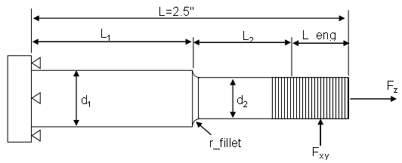

Figure 4 Lockdown stud design diagram

|  |  |  |  |  |  |  |  |  |
| --- | --- | --- | --- | --- | --- | --- | --- | --- |
| Wtotal = | 1,272 | lbf | az = | 4 | g, vertical | Fz= | 848 | lbf |
| L = | 2.50 | in. | ax = | 2 | g, axial | Fx= | 141 | lbf |
| L1= | 1.00 | in | ay = | 0.5 | g, horizontal | Fy= | 35 | lbf |
|  |  |  |  |  |  | Fxy= | 146 | lbf |

|  |  |  |  |  |  |  |  |  |
| --- | --- | --- | --- | --- | --- | --- | --- | --- |
| d1 = | 0.75 | in. | d2 = | 0.5 | in. | r_fillet = | 0.125 | in. |
| A1 = | 0.442 | in2 | A2 = | 0.196 | in2 | 304 SS Sa = | 20,000 | psi |
| I1 = | 0.0155 | in4 | I2 = | 0.00307 | in4 | 304 SS Saa = | 35,000 | psi |
| c1 = | 0.375 | in | c2 = | 0.25 | in | 304 SS Sy = | 30,000 | psi |

|  |  |  |  |  |  |  |
| --- | --- | --- | --- | --- | --- | --- |
| _z1= | 1,920 | psi | _z2= | 4,320 | | psi |
| SF_z1= | 18 |  | SF_z2= | 8 | |  |
| _1= | 330 | psi | _2= | 742 | | psi |
| L_eng | L2 | L_arm2 | M2 | _b2 | _von Mises | | | SF2 |  |
| 1.00 | 0.5 | 0.875 | 127.51 | 10,390 | **10,469** | | | 3.34 |  |
| 0.875 | 0.625 | 0.9375 | 136.61 | 11,132 | **11,206** | | | 3.12 | in design |
| 0.625 | 0.875 | 1.0625 | 154.83 | 12,617 | **12,682** | | | 2.76 |  |
|  |  |  |  |  |  | | |  |  |
|  |  | L_arm1 | M1 | b1 | _von Mises | | | SF1 |  |
|  |  | 2.00 | 291.44 | 7,037 | **7,060** | | | 4.96 |  |
|  |  | 2.06 | 300.55 | 7,257 | **7,279** | | | 4.81 | in design |
|  |  | 2.1875 | 318.76 | 7,696 | **7,718** | | | 4.54 |  |

### 2.5.2 Lockdown Studs under Static Load

There is still a need to carry the entire spaceframe & shielding assembly by use of two lockdown studs.

1. *Lockdown Studs Strength Under Tensile Forces*

|  |  |  |  |  |  |
| --- | --- | --- | --- | --- | --- |
| Fz1= Wtotal / 2 | 636 | lbf |  |  |  |
| tensile stress in d1 | 1,440 | psi |  | SF_d1 = | 13.9 |
| tensile stress in d2 | 3,240 | psi |  | SF_d2 = | 6.2 |

1. *Lockdown Studs Thread Stresses due to Tensile Force*

|  |  |  |  |
| --- | --- | --- | --- |
|  |  | UNC |  |
| Thread nominal major diameter, d = |  | 1.00 | in. |
| Threads per inch, N = |  | 8 |  |
| Thread pitch, p = 1/N |  | 0.1250 | in. |
| Thread minor dia., dr = d-1.299038p |  | 0.8376 | in |
| Thread pitch dia., dp = d-0.649519p |  | 0.9188 | in. |
| Thread mean dia., dm=(dp+dr)/2 |  | 0.8782 | in. |
| Tensile stress area, At =π/4 dm2 |  | 0.606 | in2 |
| Body tensile stress,  = Fz1/At |  | 1,050 | psi |
| Safety factors SF = Sa/ |  | 19.0 |  |
| COF for threaded pairs, dry SS, f = |  | 0.15 |  |
| Thread angle, 2α = |  | 29 | degree |
| Raising torque, TR = |  | 56 | lbf-in |
| Lowering torque, TL = |  | 30 | lbf-in |
| Thread bending stress, x = |  | 4,410 | psi |
| Thread axial stress, z = |  | -439 | psi |
| Thread body shear stress, τyz = |  | 488 | psi |
| Thread von Mises stress, VM = |  | 4,721 | psi |
| Allowable safety factors SFa=Sa/VM |  | 4.2 |  |
| Yield safety factors SFy =Sy/VM |  | 6.4 |  |

### 2.5.3 Lockdown Stud and Washer Welds Sizing

1. *Sizing the Fillet Weld Between Stud and Washer*

|  |  |  |
| --- | --- | --- |
| Weld size h = | 0.12 | in. |
| stud cap radius | 1.25 | in |
| stud cap flat face to flat face distance | 2 | in |
| Stud cap perimeter Lp = | 7.64 | in. |
| Weld equivalent radius, r = Lp/(2π) | 1.22 | in. |
| Throat area A = h*Lp*0.707 | 0.65 | in2 |
| Primary Shear stress τ1 = Fxy/A | 225 | psi |
| Bending moment, M = Fxy*L_arm1 | 301 | lbf-in |
| Unit 2nd MOA, Iu = π*r3 | 5.64 | in3 |
| 2nd MOA, I = 0.707*h*Iu | 0.48 | in4 |
| shear stress due to bending and vertical force, τ2 = M*r/I+Fz/A | 2,073 | psi |
| total shear, τ = (τ12+τ22)1/2 | 2,085 | psi |
| Safety factor = 0.577*Sy/τ | 8.3 |  |

1. *Sizing the Skip Weld between Washer and Vacuum Vessel Shell*

|  |  |  |
| --- | --- | --- |
| Skip weld size, ho = | 0.19 | in. |
| Length of each weld, a = | 0.5 | in. |
| Pitch of weld, p = | 1 | in. |
| Wahser OD, OD = | 3 | in. |
| Washer perimeter Lp = π*OD | 9.42 | in. |
| Number of welds, N = Lp/p | 9 |  |
| Total weld length, Lw = N*a | 4.5 | in. |
| Skip weld equivalent radius, r = Lw/(2π) | 0.72 | in. |
| Effective skip weld throat area, Ao = ho*Lw*0.707 | 0.60 | in. |
| Inside fillet weld size, hi = | 0.12 | in. |
| Washer inside diameter, ID = | 1.25 | in. |
| Effective inside fillet weld throat area, Ai = hi*π*ID*0.707 | 0.33 | in2 |
| Equivalent size of inside fillet weld, hieq = Ai/(2π*r*0.707) | 0.10 | in. |
| Total effective weld size, h= ho+hieq | 0.29 | in |
| Total effective throat area, A= Ao+Ai | 0.94 | in2 |
| Primary shear stress, τ1 = Fxy/A | 155 | psi |
| Bending moment, M = Fxy*(L_arm1-0.5) | 228 | lbf-in |
| Unit 2nd MOA, Iu = π*r3 | 1.15 | in3 |
| 2nd MOA, I = 0.707*h*Iu | 0.24 | in4 |
| shear stress due to bending and vertical force, τ2' = M*r/I+Fz/A | 1,583 | psi |
| total shear, τ = (τ12+τ22)1/2 | 1,590 | psi |
| Safety factor = 0.577*Sy/τ | 10.9 |  |

## 2.6 Support Bracket Design

The support bracket (item 9 in CRM1107090-0001) is the same design as used for C100 CM VV. In JLAB-TN-09-029, very detailed strength analysis for this support bracket design was given. Since the loading condition has not really change much (just the center waveguide port grows slightly bigger), there is no need to revisit the analyses done in JLAB-TN-09-029 for INJ CM VV design.

## 2.7 Waveguide Support Bracket Design

Figure 5 gives the force diagram of the waveguide support bracket (item 3 in CRM1107090-0001). The weld sizing for the two brackets are carried out as follows:

|  |  |  |
| --- | --- | --- |
| Estimated waveguide assembly weight | 428 | lbf |
| Percentage of weigt to carry by item 3: | 100 | % |
|  |  |  |
| weld leg, h= | 0.12 | inch |
| weld distance, d = | 0.25 | inch |
| weld length, b= | 2 | inches |
| Throat area, A = 1.414*h*b | 0.3394 | in^2 |
| Load from waveguide assembly, F = | 428 | lbf |
| Shear force at near bracket, R1=(13+18+7.25)F/(7.25+7.25) | 1129.03 | lbf |
| Shear force at far bracket, R2 = F-R1 | -701.03 | lbf |
| Yield stress, Sy = | 30,000 | psi |
| Shear stress in far bracket welds, = R1/A | 3,327 | psi |
| Safety factor for far bracket welds, SF1 = 0.5*Sy/1 | 4.51 |  |
| Shear stress in far bracket welds, = R2/A | 2,066 | psi |
| Safety factor for far bracket welds, SF2 = 0.5*Sy/2 | 7.26 |  |

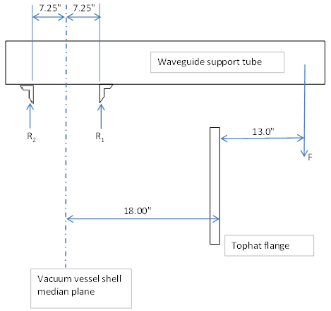

Figure 5 Waveguide Support Bracket Force Diagram

The safety factors on the chosen weld size are deemed acceptable.

# 3. References

1. G. Cheng and E. F. Daly, “C100 Cryomodule Vacuum Vessel Structural Analysis,” JLAB-TN-07-081, Jefferson Lab, Newport News, VA.
2. G. Cheng, E. F. Daly and M. Wiseman, “C100 Cryomodule Vacuum Vessel Structural Analysis-Addendum II to JLAB-TN-07-081,” JLAB-TN-09-029, Jefferson Lab, Newport News, VA.