How does the bandwidth of the oscilloscope and the Harmonic cavity influence the measurement of electron bunch FWHM?
Brock Roberts 5/18/15

CEBAF’s beam was measured using a 1497 MHz harmonic cavity whose antenna was connected directly to a Tektronix 11801b oscilloscope’s SD-30 sampling head. The oscilloscope and sampling head have a bandwidth of 40 GHz. The harmonic cavities bandwidth can be estimated and used to calculate the system bandwidth. Applying the system bandwidth to hypothetical electron bunches can help determine the combined influence of the oscilloscope and the harmonic cavity on the measurement of electron bunch FWHM.

An ideal harmonic cavity beam monitor has at least as many harmonic modes as the periodic beam has non-zero terms in its Fourier series. As the beam passes through its bore, the cavity modes resonate with amplitudes in-proportion to and in-phase with the terms of the beams Fourier series. The superposition of these modes is uniformly coupled by the cavities’ antenna and detected by the oscilloscope, accurately measuring the beams current vs. time.

The harmonic cavities that have been tested thus far have had a limited number of TM0N0 modes. The experimental data can be used to determine how many modes in the cavity are operational. Combining this with the oscilloscope bandwidth provides an estimate of the system bandwidth. Applying the system bandwidth to hypothetical electron bunches can help understand how it effects beam measurements.

Estimating the Harmonic Cavities Bandwidth:

The buncher and capture sections of the CEBAF injector were energized to produce the briefest electron bunches achievable. A 500kV beam passed through the harmonic cavity with bunches estimated to be 10ps (by Matt) FWHM Gaussians. The Fourier transform of the detected waveform can be used to observe the harmonic frequency content of the detected signal, suggesting the cavity has at least 13 operational harmonic modes (to 20 GHz).

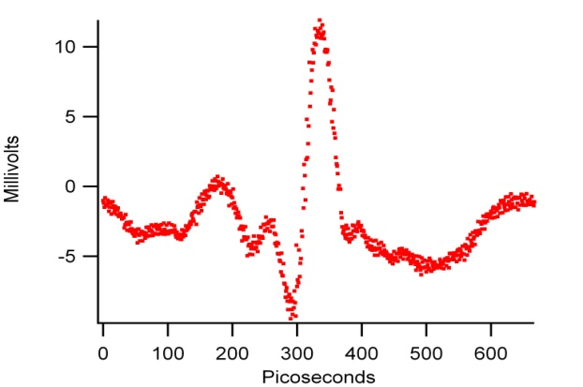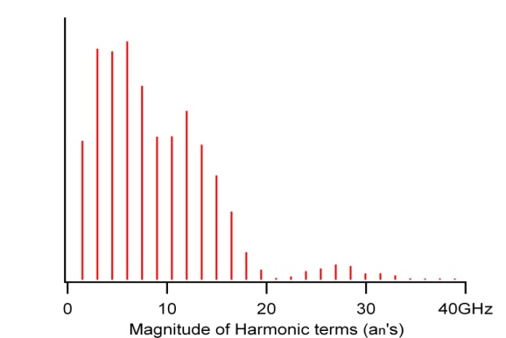

Assuming that each operational cavity mode is ideal, (perfectly efficient and phase linear), the frequency response of the Harmonic cavity can be approximated to be the leftmost pane in the graphical equation below.

The System Bandwidth is the product of the frequency response of the ideal thirteen mode 1497 harmonic cavity and the frequency response of the 40 GHz oscilloscope:

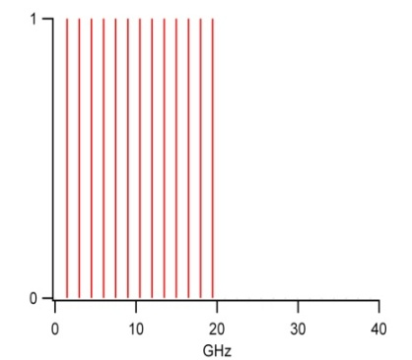X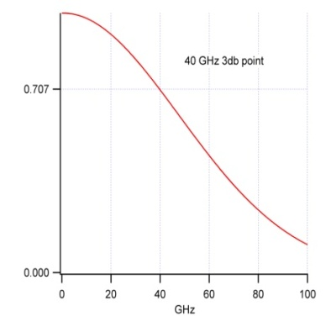=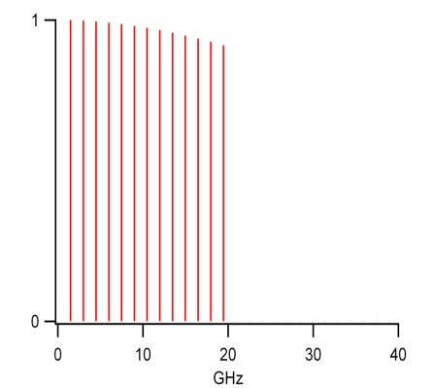

The system bandwidth can be used to measure the system rise time, as was done with the Gaussian systems (the oscilloscope and the photo-detector). The system rise time is defined as the systems 10-90 rise time in response to a step function.

$F^{-1}(F$(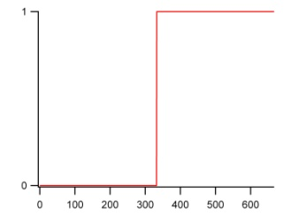)X(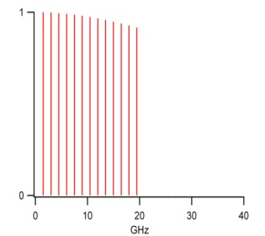))=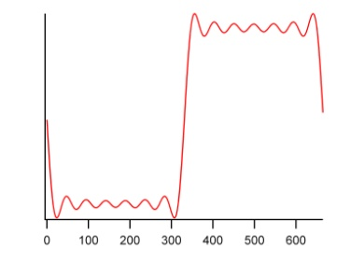

The non-gaussian system frequency response truncates the Fourier series of the step function, decreasing its rise time and caused the signal to ripple, indicating that the non–gaussian system bandwidth can affect slope timing as well as cause distortion. The systems 10-90 rise time graphically measures 22 ps.

When using the harmonic cavity to measure electron bunches, it is more relivent to determine the effect of the system bandwidth on Gaussians of varing FWHM. Below are examples of applying the estimated system bandwidth on 10, 20, 30, 40 and 50ps FWHM gaussian bunch shapes.

$F^{-1}(F$(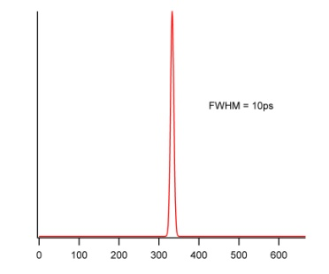)X())=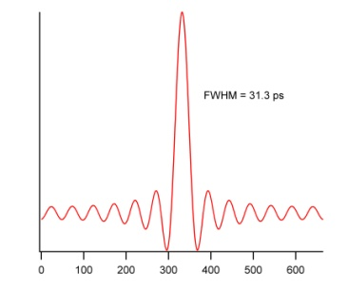

$F^{-1}(F$(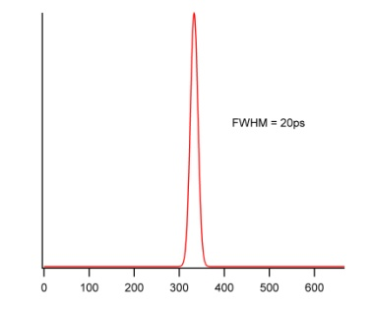)X())=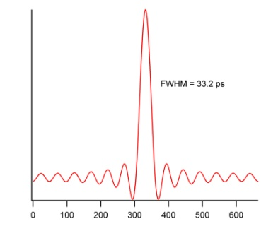

$F^{-1}(F$(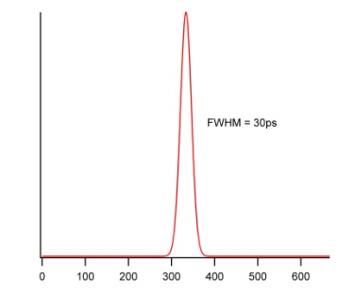)X())=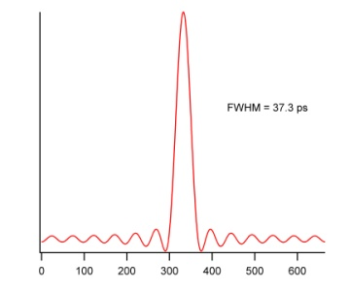

$F^{-1}(F$(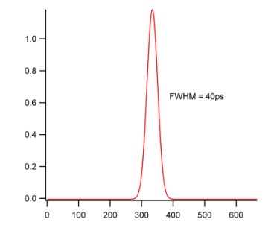)X())=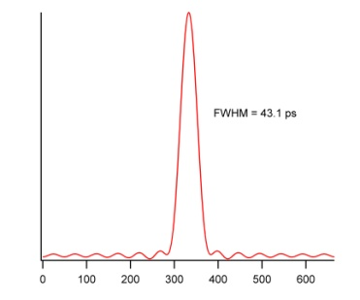
$F^{-1}(F$(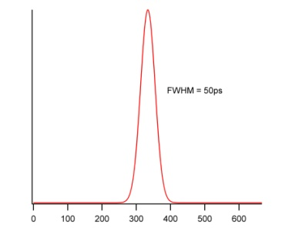)X())=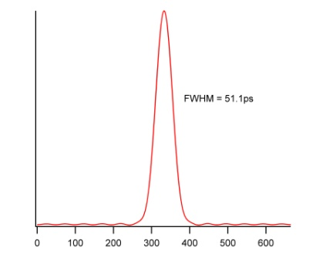

When these calculations and others are graphed, it can be seen that an idealized 13 mode harmonic cavity can measure electron bunches that are very brief, however the accuracy of the measurement decreases and distortion increases as the bunches decrease in width below about 50 ps. A graph of the magnitude of a 50 ps Gaussian bunch stream’s Fourier series illustrate why, beams with FWHM greater than 50 ps have only zero terms past the thirteenth harmonic. For electron bunches that are briefer, the system bandwidth truncates the beams Fourier terms above 20 GHz, causing distortion and increasing their measured FWHM.

