JLab New Injector Cryomodule Design, Fabrication and Testing*
G. Cheng†, M. Drury, J. Fischer, R. Kazimi, K. Macha, H. Wang, Thomas Jefferson National Accelerator Facility, Newport News, U.S.A.
Abstract
A new Injector Cryomodule (INJ CM) aimed to replace the existing Quarter Cryomodule in the CEBAF tunnel has been developed at Jefferson Lab (JLab). It is scheduled to be first tested in the Cryomodule Test Facility (CMTF) for module performance then the Upgraded Injector Test Facility (UITF) with electron beam. This new cryomodule, hosting a 2-cell and 7-cell cavity, is designed to boost the electron energy from 200 keV to 5 MeV and permit 380 μA – 1.0 mA of beam current. The 2-cell cavity is a new design whereas the 7-cell cavity is refurbished from a low loss cavity from the retired JLab Renascence Cryomodule. The INJ CM adopts quite a few designs from the JLab 12 GeV Upgrade Cryomodule (C100). Examples of this include having the cold mass hung from a spaceframe structure by use of axial and transverse Nitronic rods, cavities to be tuned by scissor-jack style tuners and the end cans are actually modified from C100 style end cans. However, this new INJ CM is not a quarter of the C100 Cryomodule. This paper focuses on the major design features, fabrication and alignment process and testing of the module and its components.

introduction
Since its installation back in the early 1990s, the quarter cryomodule (QCM) presently in CEBAF injector section has been in service for 24+ years. JLab was granted to start its accelerator energy upgrade from 6 GeV to 12 GeV in 2004 [1]. Upgrade of the injector section is part of the 12 GeV project [1-3]. Although not part of the 12 GeV project, the QCM having a pair of 5-cell cavities and serving as the booster is aimed to be replaced by a new Injector Cryomodule (INJ CM) that also accommodates two RF cavities. The INJ CM’s cavity string layout was optimized by conducting beam dynamics simulation [4] and determined to consist a 2-cell and a 7-cell cavity. Basing on operation experience, the QCM has a couple known issues [2, 4]: transverse deflecting field, or transverse “kick”, and x/y coupling. Cavity RF design [5] then focused on optimizing the 2-cell cavity shape and minimizing the transverse kick due to power couplers to be less than 1 mrad in theory. The 12GeV upgrade cryomodule, also known as the C100 cryomodule, has eight 7-cell cavities, which adopt fundamental power couplers (FPC) and cavity end groups that bear up/down symmetry [6]. This symmetry is the remedy to cancel the x/y coupling that the original CEBAF cryomodule cavities, known as C50 cavities, have. The INJ CM 2-cell and 7-cell cavities are built with C100-style FPC and end group configuration so x/y coupling shall not exist in theory. In fact, the C100-style FPC’s stub length was not optimized to minimize the transverse kick, but its 100mm length is deemed to be acceptable since the kick angle generated meets specification [5].
Mechanical design of the INJ CM cavities [7] and cryomodule commenced in 2011. The 2-cell cavity is a new design whereas the 7-cell cavity is refurbished from a low loss cavity used in JLab’s Renascence cryomodule [8-9]. The INJ CM project experienced multiple halts due to funding issues. INJ CM design work finished in the Fall of 2015 and the machine is fully assembled by September 2016. It was then tested in JLab’s CMTF. Before it is delivered to CEBAF tunnel injector section, the INJ CM needs to make a stop at the UITF to be commissioned and tested in a mimicked injector section that is equipped with a 200 kV DC gun to generate electron beam.

cryomodule design
The QCM presently in service in CEBAF injector section is somewhat “a quarter” of a standard C50 cryomodule in that two 5-cell cavities are identical to C50 cavities and the supply & return end cans are duplicates of those for a C50 cryomodule. However, the new INJ CM is not really a quarter of any existing cryomodules at JLab. Its design largely mimicked C100 cryomodule but the core of the module, i. e. the cavity string, is unique. Things built around the cavity string are C100-style with modifications when necessary. The following paragraphs will go through the subsystems of the INJ CM with some details.

Cavity String
The 2-cell cavity [5, 7] is designed to be a β = 0.6, f = 1497 MHz elliptical cavity. Its location in the cryomodule with respect to upstream interface flange is dictated by beam dynamics studies. This cavity is built with 4-mm thick fine grain high RRR niobium and stiffening rings are added to raise the vibrational natural frequency and resistance to pressure induced stress [7]. The cavity is hosted in a stainless steel helium vessel that has one bellows permitting cavity tuning and a round helium inlet and an oval shape outlet for increased heat transfer capacity. To attenuate the geomagnetic field, a layer of 1-mm thick Cryoperm 10® magnetic shield is wrapped around the 2-cell cavity helium vessel. The 2-cell magnetic shield’s openings take up a large percentage of the shield area so a thicker material is used than that of the 7-cell cavity’s magnetic shield.

* Authored by Jefferson Science Associates, LLC under U.S. DOE Contract No. DE-AC05-06OR23177. The U.S. Government retains a non-exclusive, paid-up, irrevocable, world-wide license to publish or reproduce this manuscript for U.S. Government purposes.
† cheng@jlab.org
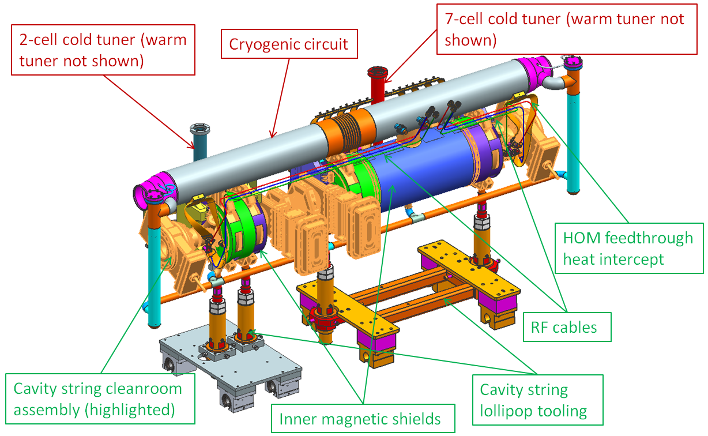
Figure 1: New INJ CM cavity string assembled with magnetic shields, cold tuners, cryogenic circuit, etc.

The 7-cell cavity is refurbished from a Renascence low loss cavity. It is a β = 0.97 and f = 1497 MHz elliptical cavity with 3-mm wall thickness and stiffening rings in between cells and end dishes. The original Renascence cavity was encapsulated in a titanium helium vessel so it had end groups suited the titanium helium vessel. The old end groups are then trimmed off and replaced with C100-style cavity end groups that are featured to have a stainless steel to niobium brazed joint. This cavity is shielded by 0.5-mm thick Cryoperm 10® magnetic shield.
Both cavities are suspended by a set of 4 transverse Nitronic rods. Each cavity also gets a pair of longitudinal Nitronic rods to lock their longitudinal locations at the downstream end of the 2-cell cavity and upstream end of the 7-cell cavity. All rods are preloaded. The transverse rods are used to adjust the alignment of the cavity string after assembly.
Figure 1 illustrates the INJ CM’s cavity string supported by lollipop-shape assembly tool.
To facilitate cavity string assembly, alignment, and mitigate potential coupling between the two cavities when there are vibrations from ground or plumbing, an inter-cavity bellows is inserted in between these two cavities.

Cavity Tuners
Both cavities adopt C100’s scissor-jack style of cavity tuners. For C100, the tuners have undergone a major modification to beef up the pivot arms in order to attenuate the microphonics vibration on the C100 cavities [10]. The INJ CM tuners are also scissor-jack style with stiffened pivot arms, see Fig. 2 for an illustration of the 7-cell cavity tuner. Driven by a step motor mounted atop the warm tuner, the jack arms squeeze to extend the cavity under tuning as the primary design goal. In fact, because the 2-cell cavity is much shorter than the 7-cell cavity, its cold tuner had to be miniaturized to suit the cavity. There is a piezo assembly designed for each warm tuner for fine tuning. They are temporarily not installed and will be installed if CM operation demands fine tuning.
The C100 tuner pivot arms are made of aluminium. For added stiffness, hence reduced pressure sensitivity, the INJ CM cold tuners adopt stainless steel pivot arms. This is especially needed for the 2-cell cavity that is very sensitive, say 2.63 MHz/mm [7] tuning sensitivity, to pressure or tuning induced cavity deflections. Stainless steel pivot arms certainly slow the cool down of the machine, however, they on the other hand provide more thermal resistance between the warm tuner and 2K environment than their aluminium counterpart does. High pressure sensitivity means more tuner movements and hence more consumption of electric power and potentially reduced tuner fatigue life.
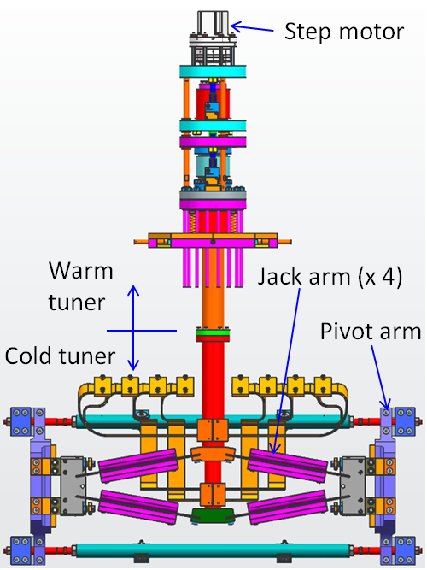
Figure 2: 7-cell cavity tuner.

Cryogenic Circuit
As shown in Fig. 1, the cryogenic circuit consists of a supply pipe underneath the cavities, a return pipe above the cavities and a pair of liquid level pipes. From the cryomodule flow diagram point of view, the above described cryogenic circuit is an essential part of the primary circuit that allows input cold helium gas to be refrigerated by a J/T valve in the supply end can, then the liquid helium flows through supply side liquid level and accumulates in the supply pipe. Cavities are chilled in a bot tom-up manner. The cryogenic circuit connects to cryogenic piping in the return end can.

Thermal Shield
- Mainly octagonal shape with bottom massaged to suit the 2-cell tuner etc.
- Made of 0.094” thick C11000 ETP copper
- Single-pass cooling pipe
- Main function is to reduce thermal radiation heat
- Also provides heat stationing to tuners, couplers, beam pipe, etc.

Spaceframe & Vacuum Vessel
The INJ CM also utilizes a spaceframe structure like C100 to carry the cold mass (cavities, helium vessels, inner magnetic shields, thermal shield, etc.). The INJ CM spaceframe is made up of four support tubes and 3 rings. It is anchored to the vacuum vessel via 6 lock down studs. The vacuum vessel is simply a 32″ outer diameter stainless steel pipe with a few openings.

End Cans
The end cans are C100 end cans with a few modifications. One noteworthy change is the addition of an ASME stamped burst disc assembly to the pressure relief stack at the return end can. This is done to meet JLab ES&H policy on pressure safety that is in line with ASME Boiler & Pressure Vessel Code regulations on pressure relief device.

cryomodule fabrication
The cavities are fabricated and processed per standard procedures at JLab [11]. Frequency recipes for both cavities are developed and executed throughout the cryomodule fabrication. They are utilized to control the cavities frequencies at various stages of fabrication so that after machine cool down, by applying a reasonable amount of tuning, cavities can reach their target frequency of 1497 MHz.
The cavity string is assembled in a cleanroom environment. After assembly, the entire string is pumped and leak checked. The INJ CM cavity string actually experienced a roll back to the cleanroom due to an incorrectly oriented cold gate valve that interferes with cryogenic pipe. The valve was reoriented, relevant fasteners are cleaned, string is pumped down and leak checked again. Performance testing proved the corrective action was successful.
Outside of the cleanroom, other cold mass items such as the magnetic shields, cryogenic pipes, cold tuners, thermal shields, etc. are installed. When the cold mass sub-assembly is installed onto the spaceframe, alignment of cavities is done with special attention to the cavity cell center locations. According to the bare cavity survey data, both the 2-cell and 7-cell cavity cells are not really aligned, see Fig. 3 for an illustration of 2-cell cavity cell center’s lateral locations. The cell centers are not aligned in vertical and lateral directions. For the 2-cell, the line connecting the two cell centers have tilting angles with respect to the imaginary beam line in both vertical and lateral directions. The tilts can result in undesirable “transverse kick”. To minimize the “transverse kick” that may originate from the cavities, especially the 2-cell cavity that locates at upstream, elaborate alignments are performed to minimize the tilt of the line connecting the two cell centers for the 2-cell cavity, and the line at the average cell centers for the 7-cell.
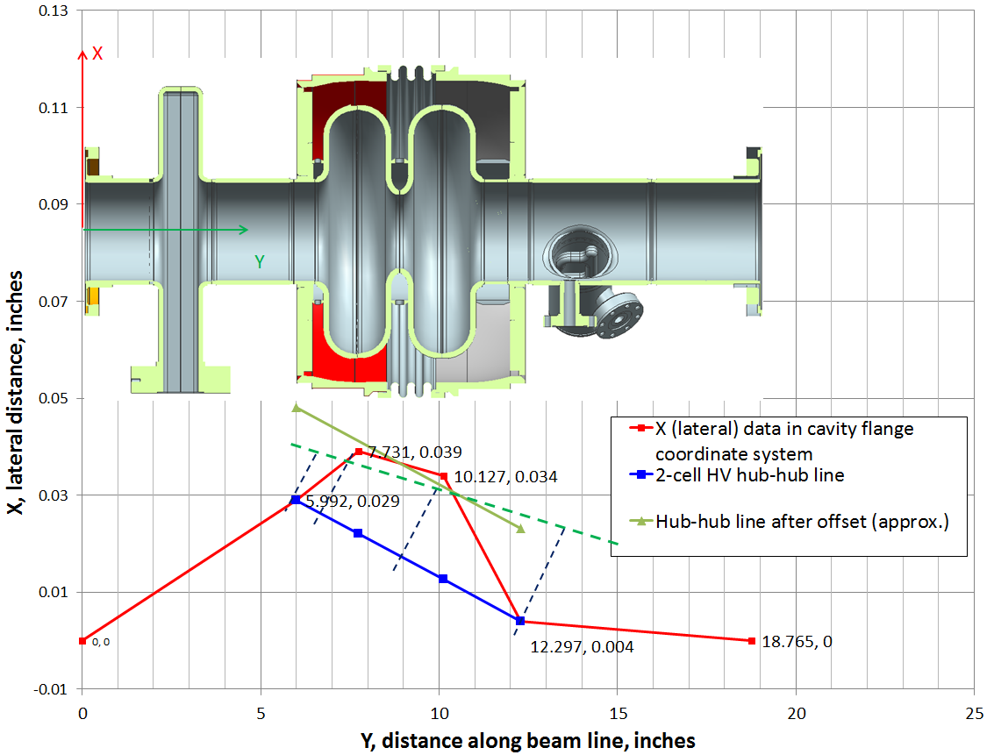Figure 3: 2-cell cavity cell centers lateral locations.
The warm magnetic shield is mounted on the spaceframe. During C100 CM fabrication, it was found that the warm magnetic shield material does not have the high permeability as advertised by the shield vendor. The remedy to C100 was to add a secondary layer of mu-metal onto the main section of C100 CMs’ warm magnetic shields. For the INJ CM, additional layers of Metglas® 2605 SA 1 foils [12] with a nominal permeability of 45,000 are added onto the main section of the warm magnetic shield for enhanced shielding performance. Figure 4 shows the INJ CM warm magnetic shields with Metglas® foils wrapped on.
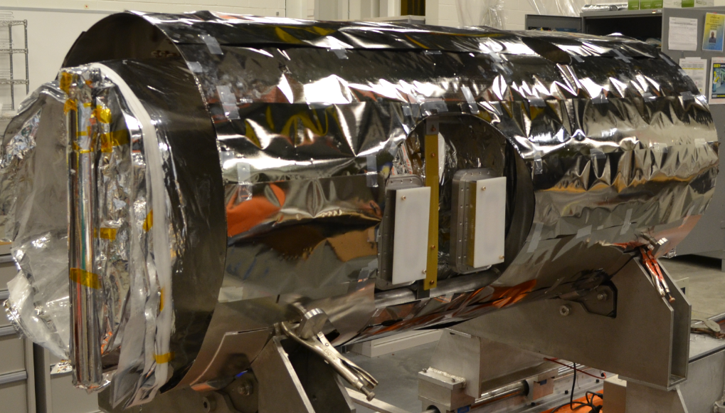
Figure 4: Mangetic foils wrapped onto INJ CM warm magnetic shield.
The spaceframe carrying the cold mass is wheeled into the vacuum vessel at the final stage of assembly. At this stage, the supply and return end cans are connected to the
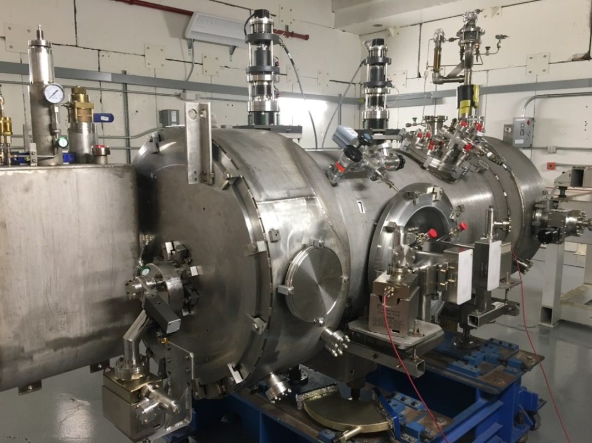
Supply side bridging
ring cut-out
Figure 5: New INJ CM final assembly

main body of the module via bridging sections. Figure 5 shows the INJ CM after it is fully assembled. Note that there is a cut-out on the supply side bridging ring. This was done to allow sliding of the ring toward the central nozzle to gain sufficient room to make connections between cryogenic pipes, thermal shield, magnetic shields, etc. between the main body and supply end can. The cut-out piece is welded back in place after the interconnections are done.
In the end, the assembled cryomodule is relocated into the CMTF to get ready for pump down insulating vacuum pressure test, leak check and acceptance test.

test in cmtf
As mentioned earlier, the INJ CM was tested in CMTF for basic performance characteristics and it will soon be tested again with beam in the UITF.
Table 1: Test Results vs. Specifications
Items | Specification | Measured
2-cell E_{acc} with TTF (range), MV/m | 2.6 (1.1-4.5) | 16.5
2-cell Q_{o} | 8e9 | >1.0e10 @ 8 MV/m
Q_{ext} for 2-cell | 6e6 | 5.8e6
Q_{HOM} for 2-cell | <1e8 | <1.4e6
7-cell E_{acc} with TTF (range), MV/m | 7.1 (4.3-14.1) | 19
7-cell Q_{o} | 8e9 | 1.4e10 @ 19 MV/m
Q_{ext} for 7-cell | 9e6 | 8.5e6
Q_{HOM} for 7-cell | <1e8 | <5.5e7

Table 1 shows a comparison of a few measured data versus corresponding specifications. Generally speaking, the cryomodule met the specifications on those aspects. Table 2 lists additional data measured during the CMTF test. Note that for the 2-cell cavity, field emission (FE) onset starts at 12.5 MV/m but this cavity is not expected to run at a gradient higher than 4.5 MV/m.
Table 2: Additional Test Results
Items/cavity | 2-cell | 7-cell
Q_{extFP} | 2.8e12 | 4.2e12
Q_{extHOMA} | N.M.* | 4.3e13
Q_{extHOMB} | N.M. | 1.4e12
E_{maxop} (1hr run), MV/m | 16 | 19
FE Onset | 12.5 MV/m | N.M.
Max radiation | 118 mR/hr (beamline return) | N.M.
Q_{o} at E_{maxop} | 6.6e9 | 1.4e10
Pressure sensitivity (Hz/torr) | 486 | 209
*N.M. = Not Measured.
The quality factor Qo vs. acceleration gradient Eacc plots for the 2-cell and 7-cell are shown in Figs. 6 and 7, respectively. As can be seen, for the 2-cell cavity, if the operation E_{acc} is less than 4.5 MV/m, then its Q_{o} is above 1e10. And for the 7-cell cavity, its Q_{o} is above 1e10 for all achievable E_{acc} on this cavity. Note that JLab CMTF has low ambient magnetic field because of mu-metal shields inside its wall. So the Q_{o} measured at CMTF will drop once the CM is moved to UITF or eventually in CEBAF tunnel.

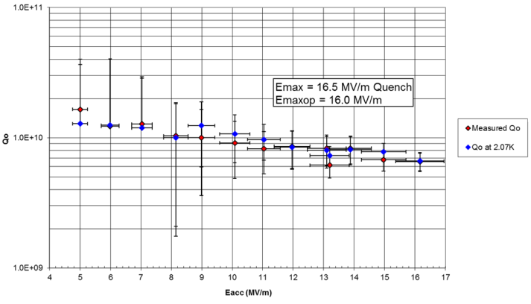
Figure 6: 2-cell cavity Q_{o} vs. E_{acc}.
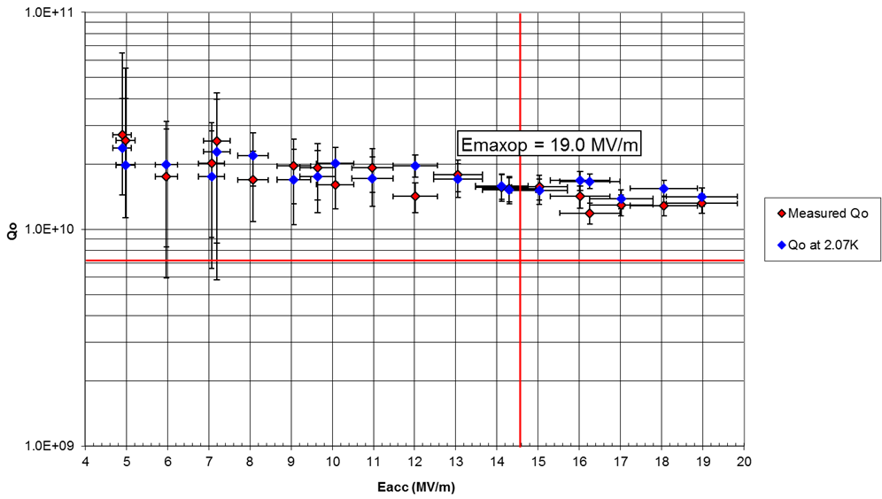
Figure 7: 7-cell cavity Q_{o} vs. E_{acc}.
Tuner hysteresis is measured for both 2-cell and 7-cell during the testing in CMTF. Data are not reported here for brevity. Once the INJ CM is tested in UITF with beam, more cavity/cryomodule performance data will become available.

acknowledgment
The authors would like to express our sincere acknowledgement to all other JLab staffs who worked on this project over the years. The INJ CM is a small cryomodule but it does have all essential subsystems that a typical cryomodule would have. It is indeed a team effort to make the module and meet the major specifications in the end. The following is just a subset of many who should have been mentioned herein: J. Henry, R. Lassiter, B. Legg, F. Marhouser, J. Mammosser, J. Matalevich, R. Rimmer, D. Spell, K. Wilson, M. Wiseman and S. Yang.

References
- A. Freyberger, “Commissioning and Operation of 12 GeV CEBAF,” in Proc. IPAC’15, Richmond, VA, USA, May 2015, paper MOXGB2, pp. 1-5.
- R. Kazimi, A. Freyberger, F. E. Hannon, A. Hofler, and A. Hutton, “Upgrading the CEBAF Injector with a New Booster, Higher Voltage Gun, and Higher Final Energy,” in Proc. IPAC’12, New Orleans, LA, USA, May 2012, paper TUPPR055, pp. 1945-1947.
- Y. Wang, A. Hofler, and R. Kazimi, “Commissioning of the 123 MeV Injector for 12 GeV CEBAF,” in Proc. IPAC’15, Richmond, VA, USA, May 2015, paper TUPMA037, pp. 1920-1922.
- F. E. Hannon, A. Hofler, and R. Kazimi, “Optimizing the CEBAF Injector for Beam Operation with a Higher Voltage Electron Gun,” in Proc. PAC’11, New York, NY, USA, March 2011, paper WEP288, pp. 2023-2025.
- H. Wang, G. Cheng, F. Hannon, A. Hofler, R. Kazimi, J. Preble and R. A. Rimmer, “RF Design Optimization for New Injector Cryounit at CEBAF,” in Proc. IPAC’13, Shanghai, China, May 2013, paper WEPWO073, page 2471-2473.
- F. Marhauser and H. Wang, “Quadrupole Decomposition of the C100 Cavity Accelerating Field,” JLAB-TN-09-016, Thomas Jefferson National Accelerator Facility, Newport News, VA.
- G. Cheng, J. Henry, J. Mammosser, R. A. Rimmer, H. Wang, M. Wiseman and S. Yang, “Mechanical Design of a New Injector Cryomodule 2-cell Cavity at CEBAF,” in Proc. PAC’13, Pasadena, CA, USA, September 2013, paper WEPAC47, page 880-882.
- C. E. Reece et al., “Design and Construction of the Prototype Cryomodule Renascence for the CEBAF 12 GeV Upgrade,” in Proc. SRF’03, Lübeck/Travemünder, Germany, September 2003, paper MoP38, page 131-134.
- C. E. Reece et al., “Performance of the CEBAF Prototype Cryomodule Renascence,” in Proc. SRF’07, Beijing, China, October 2007, paper WEP32, page 540-544.
- K. Davis, J. Matalevich, T. Powers, and M. Wiseman, “Vibration Response Testing of the CEBAF 12 GeV Upgrade Cryomodules,” in Proc. LINAC’12, Tel-Aviv, Israel, September 2012, paper MOPB031, page 240-242.
- H. Wang, G. Cheng, B. Clemens, K. Davis, K. Macha, R. Overton and D. Spell, “Injector Cavities Fabrication, Vertical Test Performance and Primary Cryomodule Design,” in Proc. IPAC’15, Richmond, VA, USA, May 2015, paper WEPWI030, page 3551-3553.
- G. Wu, et al., “Magnetic Foils for SRF Cryomodule,” in Proc. SRF’15, Whistler, BC, Canada, Sep 2015, paper TUPB099, pp. 844-846.

