

Figure 1

Overview of Operation for component selection

**F1** - Output of 6 Watt Er-Yb Fiber laser amplifier. Primary wavelength of interest is 1560nm.

**L1 –** ( ***f***= 7.5 mm) Captures output of fiber and collimates beam for approx 1mm diameter.

**W1-** 1560nm λ/2 wave plate. Will serve two functions:

1. Rotate the linear polarization of the 1560nm light for perfect alignment with the SHG crystal axis.
2. “Screw up” the polarization of other wavelengths so they are less likely to create SHG.

**L2- *f****=* 30mm for focusing into a 10mm SHG crystal.  ***f****=* 10mm for focusing in a 1mm SHG crystal.

**SHG-** PPLN crystal in oven. Two sizes purchased to perform efficiency tests. 1mm and 10mm.

**L3- *f***= 30mm or 10mm to adjust size of the final output beam.

**M3-** Dichroic mirror designed to reflect 780nm and dump all higher wavelengths

**M4-** Same as M3. Reflects final 780nm light to our experiment.

The following document provides the list of components actually used in the construction of our PPLN second harmonic generator.

The parts list follows the physical layout from fiber launch through to 780nm beam delivery.

Fiber Launch:

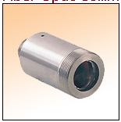

The lens above was provided with the Keyopsys amplifier and is mounted in the adapter below using two set screws. It has an 11mm outside diameter. It is not required for the IPG Fiber amplifier since they are already collimated with a permanently attached lens.

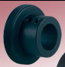



Note: The IPG photonics amplifier comes with a built-in collimator. We specified a collimated beam size of 1.5mm. This collimator has an outside diameter of 12mm. So

the Thorlabs model AD12F Adapter is used in place of the AD11F listed above.

The Adapter above fits in the 30mm Cage Plate below.

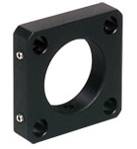

The Cage Plate has 4 rods (2” length) to form the front cage assembly.

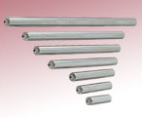

The Amplifier output is now collimated and launching into the card cage.

The next item on the card cage is the waveplate rotator.

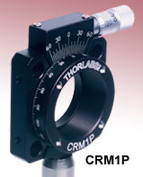

This device comes with the internal SM1 threads and a SM1 retaining ring.

Inside this device we insert a S1LM9. This adapter has an additional small insert designed for mounting a 5mm laser diode. The Telecom waveplate we purchase is so small that we must glue it to this 5mm adapter and mount the whole apparatus inside the cage rotation mount.

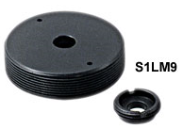

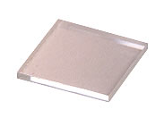

The mounted version of this waveplate is $395 from Thorlabs. But it is an alternative if we choose to get away from the glued waveplate.

After Passing the waveplate, the collimated beam will strike the 30mm focusing lens.

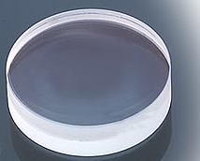

This Thorlabs lens is an Achromatic Doublet coated for C band. Because it is a doublet and a short focal length it is rather thick. It must be mounted in the lens tube below. Remember “flat toward focus”.

2016 edit: We found the doublets were problematic because the beam was too powerful and would burn the glue in the junction. We switched to Thorlabs best form lenses LBF254-040-C and replaced all lenses in tunnel.

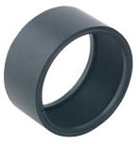



This Lens Tube mounts in a Second CP02 (30mm cage plate).

To be determined: Post size and Post holder for front end assembly.

This completes the parts list for the front end assembly. This portion of the assembly is hard mounted to the laser table and has no pitch, yaw, or focusing motions. The only moving object on the assembly is the rotation of the half wave plate. All components purchased were from Thorlabs.

The second part of the assembly holds the PPLN Second harmonic generation crystal. The crystal is mounted in an oven and the entire oven assembly has full degrees of motion for pitch yaw,X,Y and Z axis. There is no need for a rotation axis because the waveplate in the front assembly will rotate the polarization to match the crystal axis.

We start with a Linear Translation Stage. We have several spare 426 Series stages from Newport Corporation. This stage is 4X4 inches and has a 1” travel. The stage height from the table is 1 inch. This linear stage is mounted so the motion of the stage will move the PPLN oven closer or further from the 30mm focusing lens on the front end assembly. The center of travel on this stage is set so the center of the PPLN crystal will be 30mm away from the lens face ***original plan *** Changed later to use an XYZ mount from Line Tool Company. Micropositioner Model A. See final photo of setup at end of document.

We designed our own L-bracket hardware that allows a New Focus model 9071 (Four-Axis Tilt Aligner) to mount vertically on the Line Tool stage. Its adjustment screws are now accessed from the top. Another adapter plate attaches to the ¼-20 threaded screw of the 9071 and the PPLN oven is held to the side of the 9071. 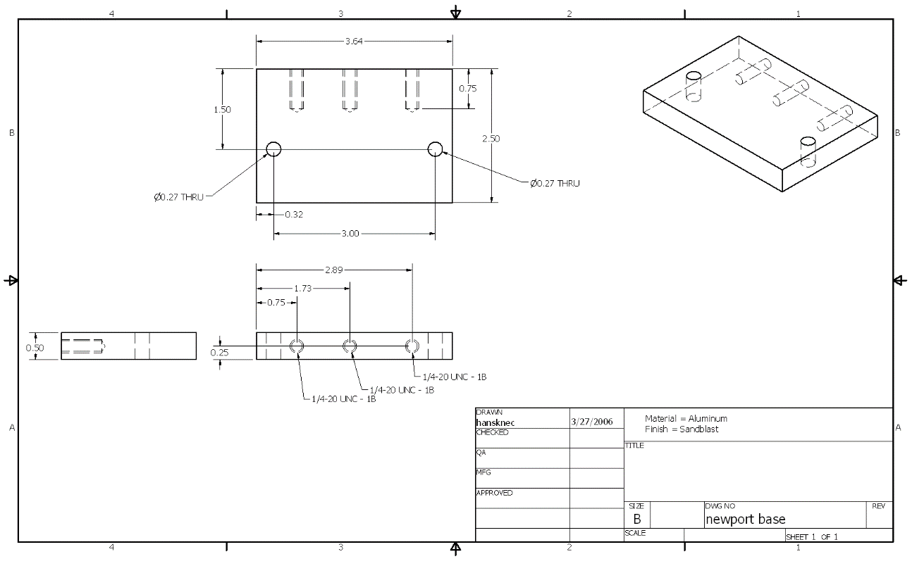

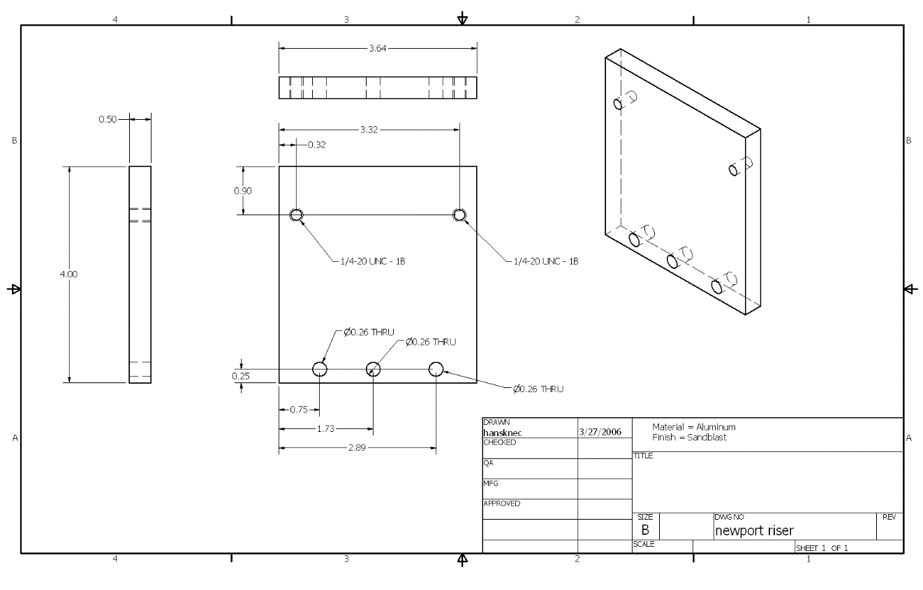

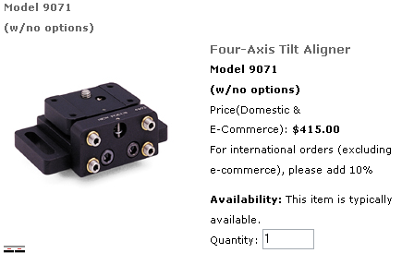

The PPLN OVEN is sold by Thorlabs. Manufactured by Stratophase. It is mounted to the 9071 using our own adapter arm. 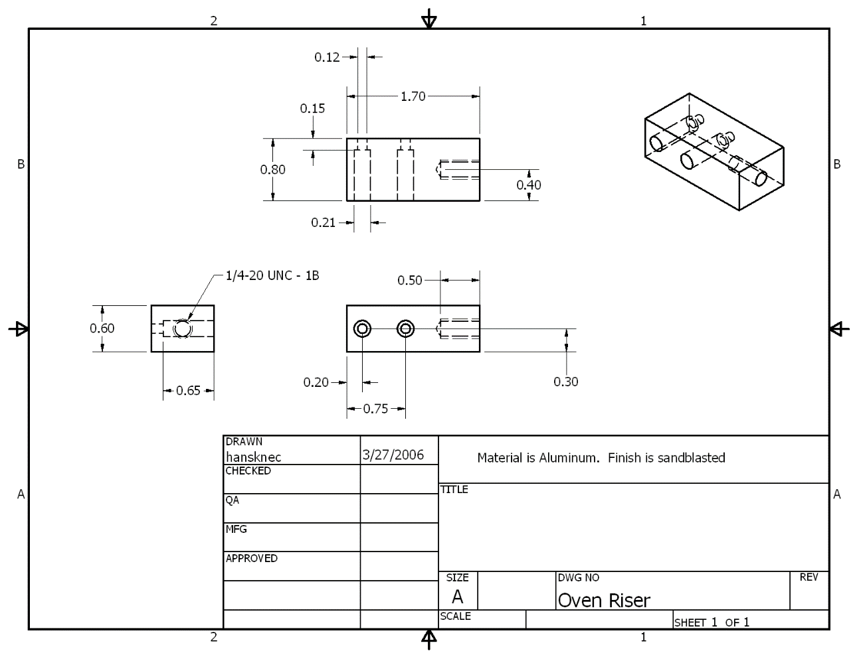

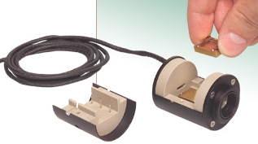 

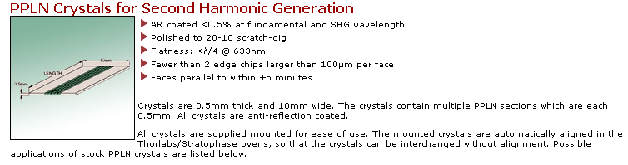 

Our tests thus far have used the SHG5-10 crystal. We have a SHG5-1 crystal but have not tested it.

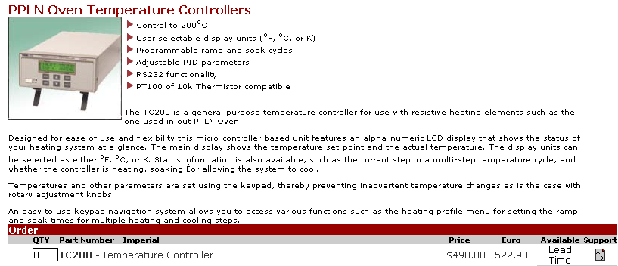

The Thorlabs oven controller is used to maintain temperature of the PPLN.

This concludes the parts list for the PPLN oven section.

The final output section consists of another 30mm lens (AC254-030-C), mounted in another SM05L05 lens tube that is mounted in a CP02 (30mm cage plate). This assembly sits atop another Newport Model 426 Linear Translation stage. The axis of translation allows us to adjust the Z-position of the 30mm lens to capture the beam leaving the PPLN oven and adjust it for collimation. This is significant overkill for the output collimation, but we had several linear stages left over from our days of building our own Ti-Sapphire lasers. For persons building this device on a budget, we would recommend using a Thorlabs Z Translator. Thus the course position can be set by sliding the translator along the cage and the fine can be set with the micrometer.

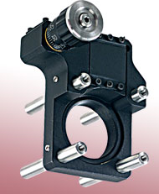

The 30mm lens and lens tube will screw into the translators female SM1 threads.

The final optic in the system is a Dichroic mirror that passes the 1560nm light and reflects the 780nm light. We purchase the following lens from CVI laser corporation:

LWP-45-RS780-TS1550-PW-1025-C

This is a 25mm optic that will fit in a standard mirror holder. Since a significant amount (Watts) of 1560nm light remains, you need to choose a mirror holder that will allow the exit beam leaving the rear of the mirror to pass cleanly. The 1560nm light should be safely dumped into a black-body beam dump. We use a razor blade dump. Kentek laser sells “Trap-it” beam dumps.

The reflected 780nm light is then sent to our optical system.

UPDATE: PPLN and Oven are no longer sold by Thorlabs. The company that was selling through Thorlabs is Covesion. We now buy direct.

**Subject:** in stock Re: PPLN 1560nm to 780nm

**From:** Christian Rahlff <christian.rahlff@covesion.com>

**Date:** Wed, 10 Feb 2010 17:40:00 +0000

**To:** John Hansknecht <hansknec@jlab.org>

Hi John,

Yes, we can except credit card (Master or Visa only) and have the SHG5-10 in stock.

MSHG1550-10 is also in stock (periods from 18.5-20.9um)

2 off SHG5-10: US$ 1400.00 each (reduced from 1 off price $1560)

2 off MSHG1550-10 US$ 1550.00 each (reduced from 1 off price $1720)

Shipping by UPS express $50 (or free on your own shipping account)

We can also offer length up to 40mm (minimum is 0.5mm) in MgO doped material.

Please let me know if you need any further information, best regards,

Christian

--------------------------

Christian Rahlff, Ph.D.

COO

Covesion Ltd

Tel: +44-(0)1794-521638

Fax: +44-(0)8709-289714

www.covesion.com

Covesion Ltd. ; Unit 17, Abbey Enterprise Centre, Premier Way, Romsey SO51 9AQ, UK

Registered in England: Registration No.: 06338847 VAT No.: 943 1896 00

Registered Offices: The Malthouse, 22 Pettiwell, Garsington, Oxford OX44 9DB, UK

John Hansknecht wrote:

I need to order some additional PPLN crystals.

The crystal I have used before was part # SHG5-10

Right now I need the exact replacement (quantity 2)

Can I also get pricing on your MSHG-1550-10?

I need your pricing, availability and whether you take credit cards.

----------------

John Hansknecht

Jefferson Lab

757-269-7096

--

Christian

-----------------------

Christian Rahlff

Covesion Ltd.

Tel.: (0)1794-521638

christian.rahlff@covesion.com

www.covesion.com

Unit 17, Abbey Enterprise Centre, Premier Way, Romsey SO51 9AQ, UK ; VAT No.: 943 1896 00

Dichroic mirrors to reflect the 780nm and dump the 1560nm were purchased from CVI.

**CVI Laser LLC**



CVI Part No. BLD3-PM-1037-C Lot Code 194016

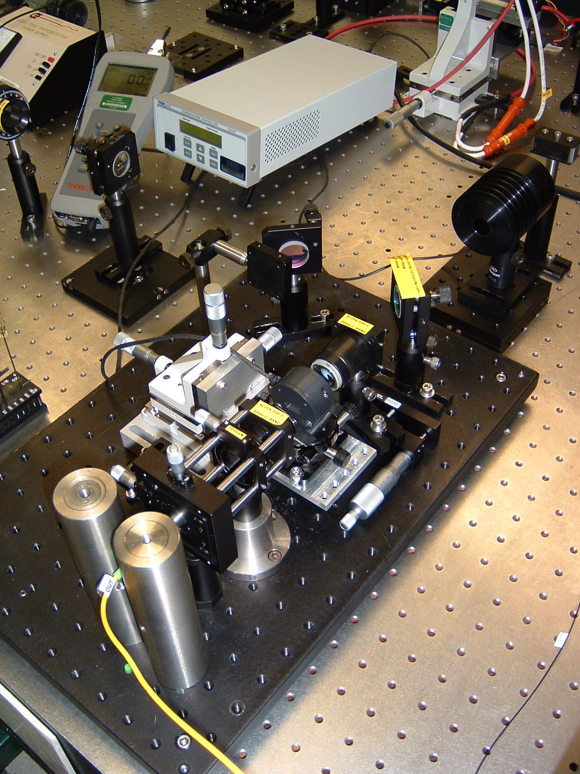

Our completed SHG assembly.

What would I change in the future?

I have burned up several PPLN crystals because I was foolishly aligning them at high power and moved the Z axis of the Line Tool stage too far. Once you have the PPLN at the right height, there is only about .5mm of freedom required for fine tuning height. I would design a fixed height system that already places it at the right height and then use a 100TPI micrometer for fine tuning height. Even with the micrometer, I would place hard stops that limit the travel to +/- .5mm from center.

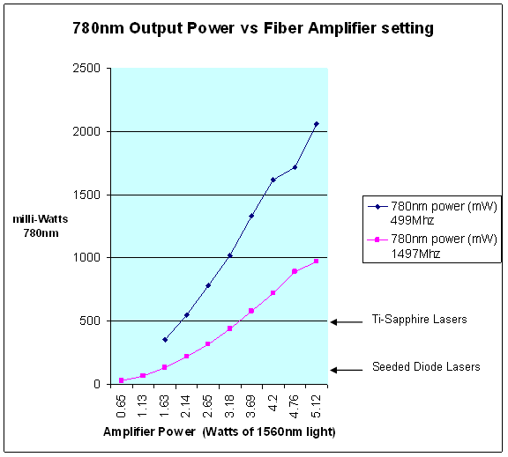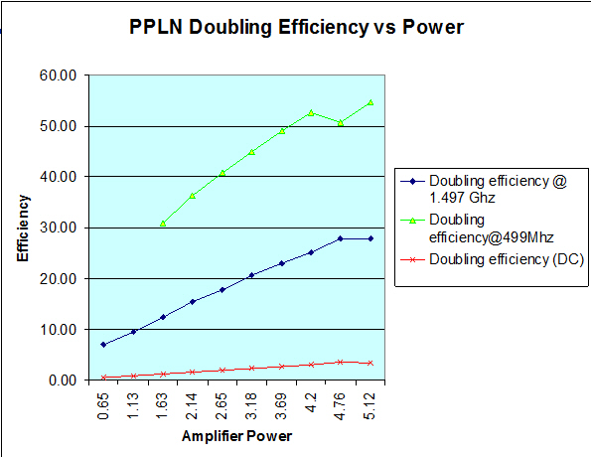

Results when seeded with 50ps pulsewidth.