Tech Note: viewer assembly for injector viewers
Marcy Stutzman and Phil Adderley

2020 air cylinder design modifications
- Air cylinder: https://misportal.jlab.org/reqs/pr/viewPr.do?prNum=398800
- Remove nuts on viewer air cylinder and remove endplate over end of hex shaft –DO NOT remove piston from cylinder. (See figure below)
- Extend hex shaft out being careful not to pull piston from cylinder body
- Attach spring guide to piston end of hex shaft.
  - JL0109878-0001-0
- Slide spring over hex shaft and centering ring
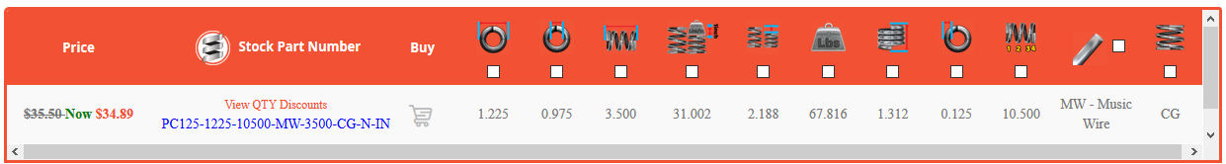
- Slide piston stop into cylinder (see figure and assy dwg for orientation)
  - JL0109878-0001-01
- Replace endplate, compress (using bar clamp as needed) and tighten nuts
- Add instrument air line to top hole
  - Dibert: Stainless Steel Swagelok Tube Fitting, Male Connector, 1/8 in. Tube OD x 3/8 in. Male NPT
- Add pinhole nut (part xxx) to bottom hole:
  - Grainger: TK48826579T Hex Plug Pipe Fitting Material Low Lead Brass Pipe Size - Pipe Fitting 38 in Standards NSF 61 Annex G Max. Pressure 1000 psi Temp. Range -65 Degrees to 250 Degrees F.
  - Drill 1/16” hole through plug, stopping 0.020” from end of plug. Drill the last 0.020” with a 0.010 or 0.015” bit to make a conductance limiting orifice for the air stop.
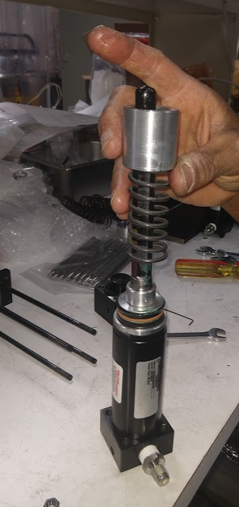

Viewer bellows alignment
- Attach support rods to bellows
  - Rods modified for 2021 air cylinder: JL0109878-0002-01
  - Bellows: 103-55-5-1-1/3” CFFR, 2-3-4” CFFNR modified with 58432-C-0100
- Install plunger weldment taking care not to tighten rotatable mini flange
  - Weldment: 58432-B-0126
  - Shaft: 58432-B-0123
  - Flange modification: 58432-B-0120
- For 45 degree alignment, camera to the right of viewer: Get print of alignment tool
  - Support bellows flange with the 2.75 knife edge UP
  - Identify upstream leak check groove as the one with a support rod at the same position
  - Install 45 degree alignment tool with knife edge up, leak check grove aligned with upstream bellows flange leak check groove
  - Rotate mini conflat until rod flat matches alignment tool flat and secure with bolt
  - Tighten gasket
- For 45 degree alignment, camera to the left of viewer:
  - Support bellows flange with the 2.75 knife edge DOWN
  - Identify upstream leak check groove as the one with a support rod at the same position
  - Install 45 degree alignment tool with knife edge up, leak check grove aligned with upstream bellows flange leak check groove
  - Rotate mini conflat until rod flat matches alignment tool flat and secure with bolt
  - Tighten gasket
Building full viewer assembly
- Attach top plate (58432-B-0116) to three support rods (JL0109878-0002-01) using 10-32, 0.5” or 5/8” long using split ring lock washer
- Attach air cylinder to top plate using 1/4-20 socket head bolds, 3/4” long using split ring lock washer
- Screw turnbuckle onto air cylinder threaded rod 2.5 turns
  - JL0109878-0002-02
- Use turnbuckle to draw in the rod and turnbuckle to desired insertion depth
  - Loosen 10/32 bolts and drive in set screw to split for turning. Back out setscrew and tighten bolts to secure at appropriate depth
Adding viewer screens
- Viewer screens assy (JL0091130-0214)
  - Front plate: JL0091130-0214-01 Modify to show 45 degree cutaway!
  - Back Plate: JL0091130-0214-02
  - Top Hat: JL0091130-0219
  - Wire: Tungsten/Rhenium (W75/Re25) 0.05mm Goodfellow
  - Viewer string jig: print?
- Assemble viewer flag
  - Place front plate in jig, front side down
  - Secure one end of wire with hemostat clamp, run wire from bottom left screw around top right screw and back, secure under screw and washer at bottom left.
  - Repeat wire stringing from bottom right around top left and back
  - Make sure wires go on the outsides of bushings if present
  - Lay chromox screen on wires and center carefully (yag can be used too, but may not need wires)
  - Gently place back plate on screen, seat into position, and insert 2 screws at top loosely (4-40, ¼” long, silver plated, button head)
  - Place top hat on bottom, insert two screws (4-40, 3/8” long, silvernplated, button head)
  - Secure all screws snugly
  - Loosen wire clamp screws, checking carefully that tension remains on the wires with the frame screws. Adjust if necessary.
  - Remove from stringing jig and clip off ends of wires
- Add shaft extension if needed
  - JL0091130-0227
- Install on depth alignment cross and adjust insertion depth with turnbuckle
  - Set 6-way 2.75 conflat cross (or other size) on flat surface
  - Use pinhole center tool to align laser through middle of cross
  - Install viewer assy on centering cross
  - Adjust height with turnbuckle
  - Adjust any tilt with shims between bellows assy and air cylinder
  - Tighten and install

