UITF
Photogun high voltage conditioning procedure with Krypton gas
Carlos Hernández-García
Ver. 01 August 22, 2019

Background

High voltage conditioning in dc photoguns is nominally performed under vacuum conditions. The purpose of this procedure is to achieve the desired operating voltage without field emission. Usually field emitters (dust particulates and/or nm-size electrode surface imperfections) can be processed out by slowly increasing the voltage and limiting the high voltage power supply current, but in some instances field emission current may be as high as 100 uA and becomes very difficult to extinguish. This is because the voltage needs to be over 50kV higher than the desired photogun operating voltage, leading to cable plug arcing at the ceramic insulator.
Introducing Kr gas to the photogun vacuum chamber has shown tremendous improvement in the high voltage processing of field emitters [] at lower voltages than those needed under vacuum conditions. Kr gas is ionized by field emitted electrons and then accelerated towards the field emission site, melting it and/or changing its shape by ion back-bombardment. In addition, Kr is ion-implanted increasing the work function. Since field emission depends exponentially on the emitter electric field and inversely proportional to the work function, Kr serves a dual role to eliminate field emission. Once field emission has been processed out about 10% higher than the desired operating voltage, Kr is evacuated and the voltage is ramped up from zero to the desired operating voltage but now under vacuum conditions.
Once the emitters are Kr-processed, a new phase in the processing begins; something we have called “voltage-induced gas desorption”. With every 1 kV increment, the pressure in the gun vacuum chamber increases by 2 orders of magnitude, and takes about 10 to 15 minutes to recover. Radiation (x-rays) and photogun high voltage power supply current track the vacuum response. This has been associated to surface ionization of residual gas trapped in the vacuum chamber walls. The effect may be present even during Kr processing. The objective is to achieve about 10% higher than the desired operating voltage under vacuum conditions without voltage induced gas desorption.
We have had great success with high voltage conditioning starting right off with Kr processing, rather than starting with vacuum conditions and waiting for field emission to appear and then switching to Kr. The procedure bellow describes the photogun high voltage processing using krypton gas and how to qualify the photogun at the desired operational voltage under nominal vacuum conditions.

Kr setup
Kr is injected into the photogun vacuum chamber with the setup shown in Fig. 1. The ¼” diameter stainless steel tubing connects the Kr outlet valve to the leak valve mounted to the photogun vacuum chamber shown in Fig. 2. The Kr pressure inside the photogun chamber should be between 2E-5 and 5E-5 Torr. It should NEVER be 1E-4 Torr. Because of conductance, the pressure in the turbo pump cart gauge is about two orders of magnitude lower. Kr is continuously pumped away with a turbo pump cart connected to the exhaust port of the photogun bake ion pump via a right angle valve (Fig. 3). There is another right angle valve installed at the exhaust port of the photogun ion pump that isolates the photogun vacuum chamber from the bake ion pump. I will add that picture later as Fig. 4.
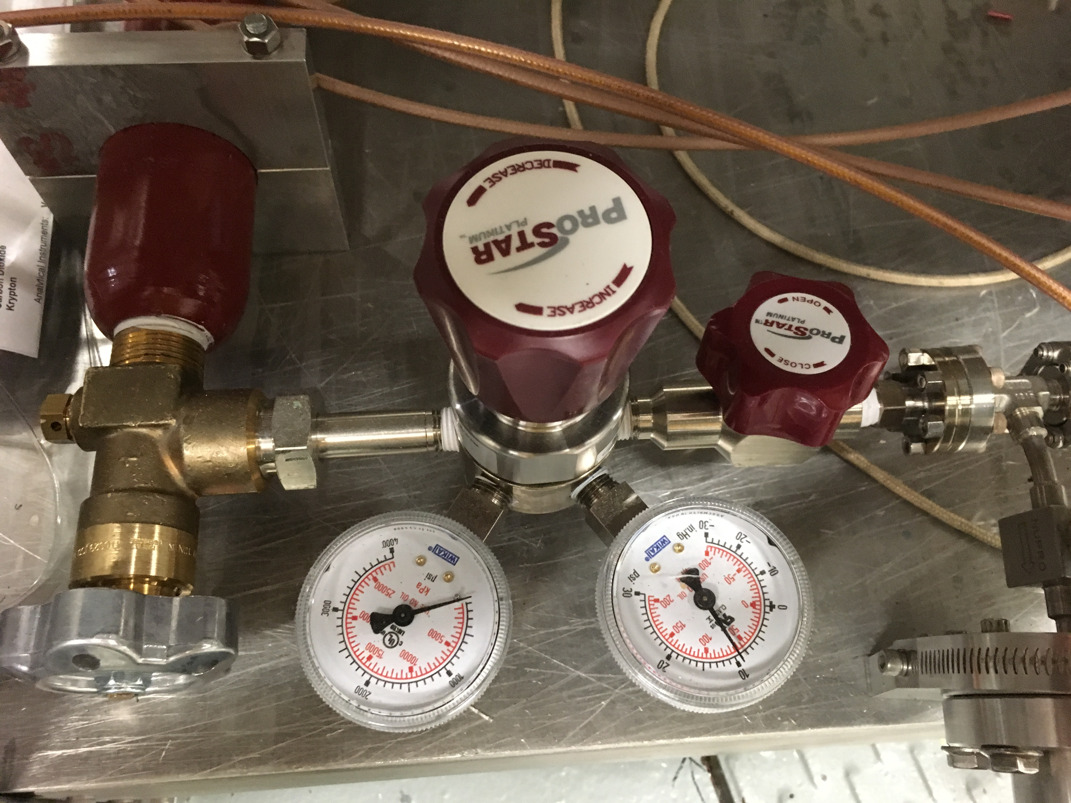
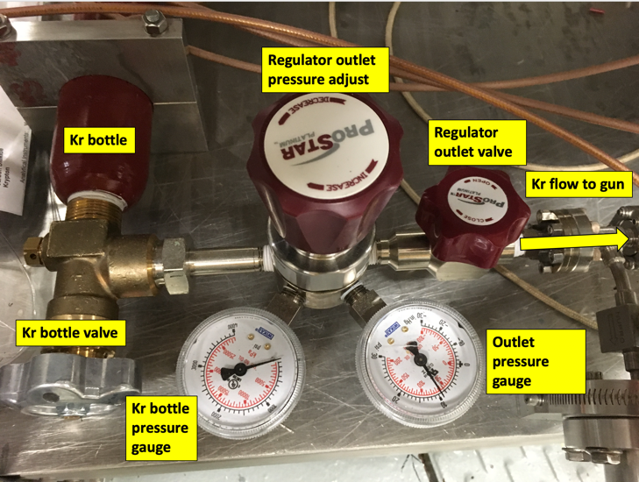
Kr bottle
Figure 1. Kr setup located under the photogun table.
Regulator outlet pressure adjust
Regulator outlet valve
Kr flow to gun
Outlet pressure gauge

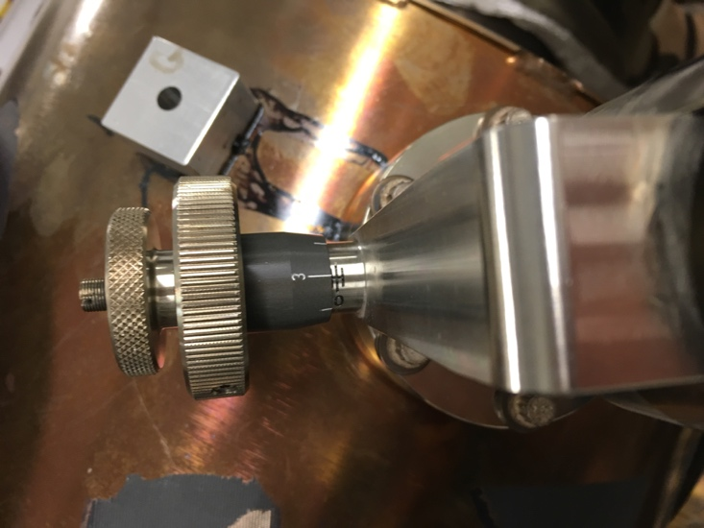
Figure 2. Leak valve mounted to the photogun vacuum chamber.
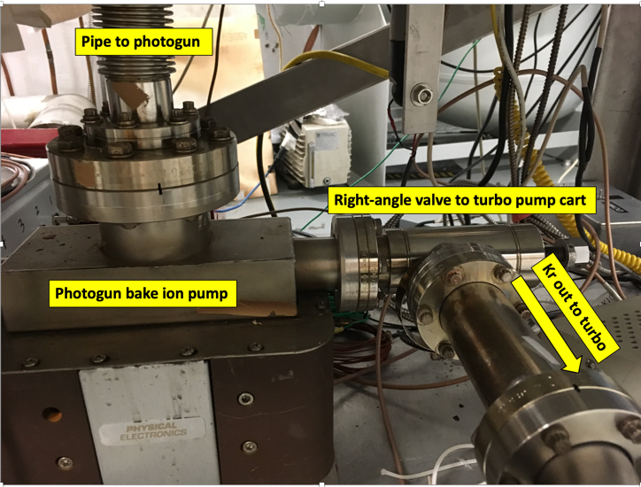
Fig. 3. Bake ion pump setup under the UITF photogun table

Fig. 4. Photogun ion pump and right angle valve isolating the photogun vacuum chamber from the bake ion pump.

System pre-conditions
The photogun is nominally in ultra high vacuum configuration.
Checklist:
- A puck with a dummy bulk GaAs wafer or polished stainless steel wafer is inside the electrode.
- Turbo pump operating and pressure gauge showing 1E-8 Torr
- Photogun leak valve CLOSED
- Photogun ion pump ON and its right angle valve CLOSED
- Bake ion pump ON and its right angle valve CLOSED
- Kr regulator outlet valve CLOSED
- Kr bottle valve CLOSED
- Kr bottle pressure gauge reading above 500 psi
- Kr outlet pressure gauge reading between 5 and 10 psi.

Kr setup in preparation for HV processing
- Ensure leak valve is CLOSED
- Ensure turbo pump is operational AND turbo pump gauge reads 1E-8 Torr. If turbo pump cart is OFF and/or gauge reading is higher than 1E-8 Torr, contact Carlos.
- Open Kr bottle valve. Pressure gauge reading should be above 500 psi
- Check Kr outlet pressure gauge. If below 5 psi, adjust Kr regulator pressure until it reads 5-10 psi. If higher than 5 psi, do not adjust Kr pressure.
- Fully OPEN regulator outlet valve
- Turn photogun ion pump OFF
- Turn bake ion pump OFF
- Fully OPEN bake ion pump right angle valve
- Fully OPEN photogun ion pump right angle valve
- Adjust leak valve until pressure in turbo pump gauge reads about 2E-7 Torr. This will have a pre-determined number of turns setpoint. I will add this info to the procedure once calibrated. It usually takes about 10 minutes for the pressure to settle down. There should be no need to adjust the leak valve after the pressure has settled down. But sometimes, HV processing requires adjusting the Kr pressure, which is achieved by adjusting the leak valve.
- Procedure complete. Kr is set to start high voltage processing

HV processing using Kr gas
Once Kr has been let into the photogun vacuum chamber, the system is ready for high voltage processing. It usually takes between 40 and 50 hours of conditioning to achieve 200kV without field emission under nominal vacuum conditions. It is important to distinguish between achieving that goal with the photogun filled Kr and achieving it with the photogun under vacuum. In most cases, once the gun is field emission free with Kr at 220kV, field emitters appear when the voltage is increased to 200 kV under vacuum conditions (nominal operating voltage) requiring going back to Kr processing. But because the photogun has been already up to that voltage, subsequent Kr processing is usually achieved within a few hours, then the photogun can be put back in vacuum configuration and the voltage ramped to 200kV for evaluation.

Processing involves increasing the photogun high voltage in steps, then waiting to evaluate the behavior of radiation and current. The action taken depends on many scenarios described below, but in summary the operator can only take the following actions: Increase, decrease, or hold the voltage constant. High voltage processing induces many high voltage power supply (HVPS) trips when a field emitter process violently drawing an excessive amount of current. The current is set to trip the HVPS to protect the photogun.

Kr HV procedure
- Ensure Kr has been setup to 2E-7 to 5E-7 Torr at the turbo pump gauge as described above.
- Open the Gun HVPS controls screen and set the current limit to 0.2 mA, the Ramp UP to 5 kV/min and the Ramp Down to 100 kV/min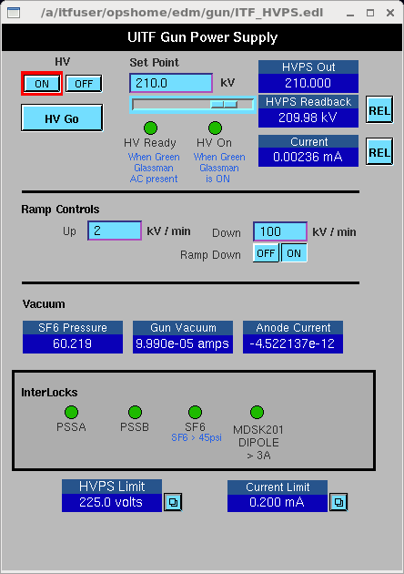
- Open the DecaRAD screen. The background fluctuates between 0 and 8 CPS. 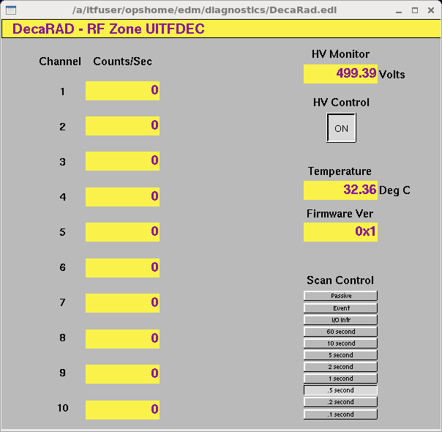
- Open a strip tool and graph the gun HVPS readback (blue trace), the HVPS current (red), and the first five of the DecRAD signals. This strip tool graph will be the guide to evaluate the behavior throughout the entire high voltage condition process. Notice the DecaRad background fluctuating between 0 and 8 CPS. 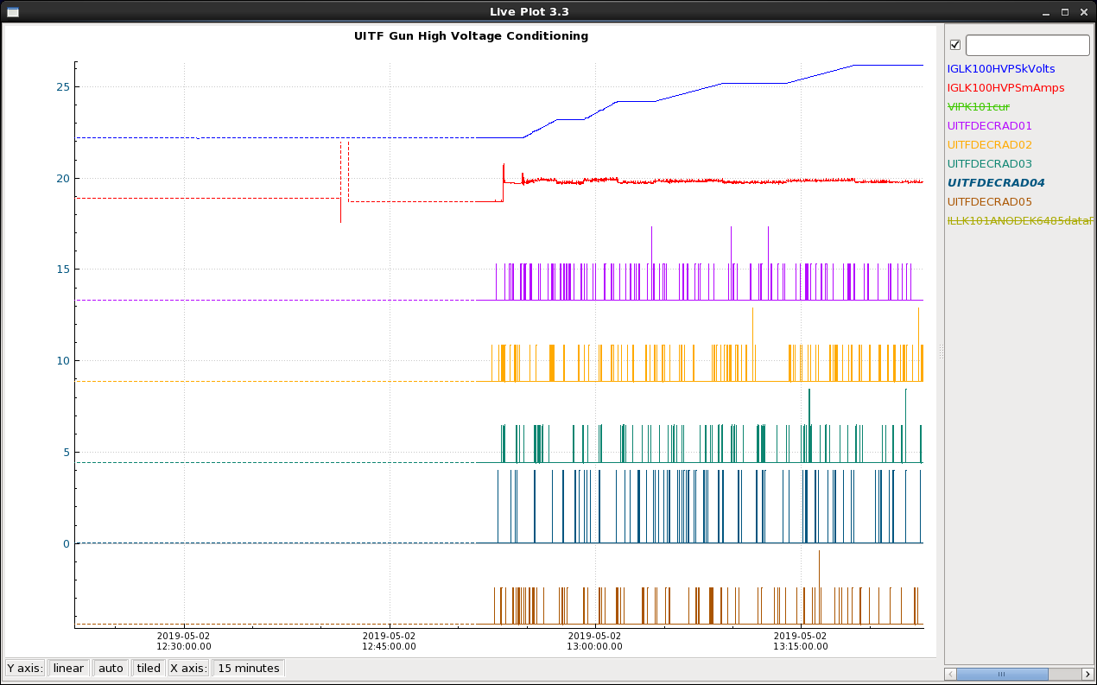
- Click the HV ON button
- Set the Voltage to 20 kV and clock HV GO.
- Wait for the HVPS Readback to reach the set point voltage, wait for about 2 minutes
- If there is no radiation or current excursions like those showed in the Figure above, repeat step 6 until reaching 120 kV. If there are current or radiation excursions during any of the 20kV steps, see guidelines below.
- If there is no current or radiation activity upon reaching 120kV, change the Ramp Up to 2 kV/min and increase the voltage in 5 kV steps waiting about 5 minutes between steps and evaluating the behavior accordingly to the guidelines below.
- When the photogun reaches 150kV, decrease the Ramp Up rate to 1 kV/min AND from now until the end of processing, only do 1 kV steps.

Kr HV conditioning guidelines

Typically, there is no field emission up to about 120kV. Because of the multiple scenarios, there is no fix procedure. Instead, guidelines will be presented as: a scenario, what is the likely cause for that behavior, and what to do.

The following scenarios describe the behavior of the radiation monitor signals and the photogun HVPS current readback (red trace) every time the voltage (blue trace) is increased to a pre-determined setpoint and the voltage is held constant for ~5 minutes. The amount of time the voltage is held constant will increase as processing progresses towards higher voltages. Typically the voltage is held constant for about 15 minutes when the voltage approaches 190 kV if there is no radiation or current activity.

Observed behavior | What’s happening | What to do
No radiation or current activity  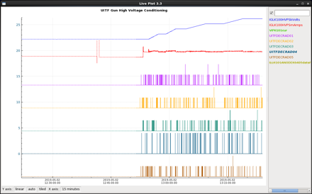 | The bias voltage is still too low to trigger field emission | Wait 5 minutes and go to the next voltage step
HVPS trips off on over-current shortly after reaching the voltage setpoint. Sometimes it takes several minutes before this happens. Radiation monitors show a large spike when the HVPS trips off.  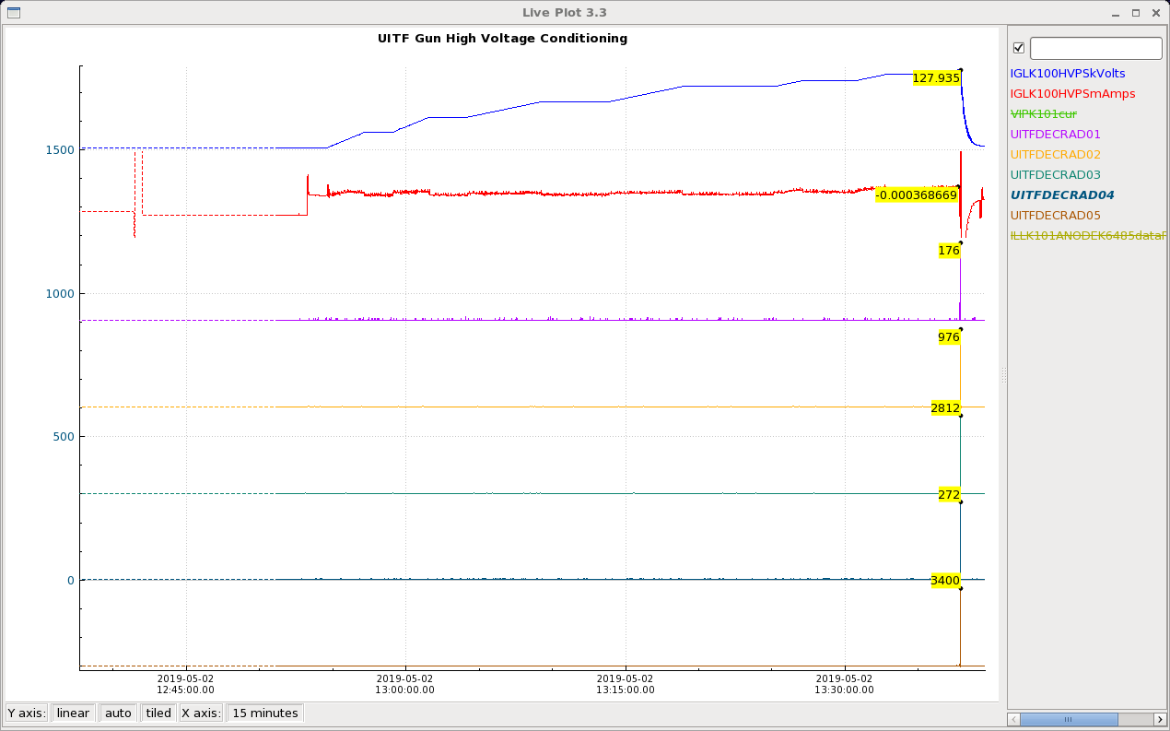 | The voltage is high enough to trigger field emission. Because there was no prior field emission, it is likely that the emitter was slowly growing until the voltage was high enough to cause a current surge. | Click HV OFF, then HV ON to reset the HVPS. Because the gun has been already up to 120kV at least, set the Ramp Up rate to 25 kV/min. Then set the voltage to the last setpoint before the trip. Click HV Go. When the voltage reaches the setpoint, change the Ramp Up rate back to 1 kV/min
Radiation shows up as >1000 CPS spikes that become more frequent with time as the voltage is held constant.  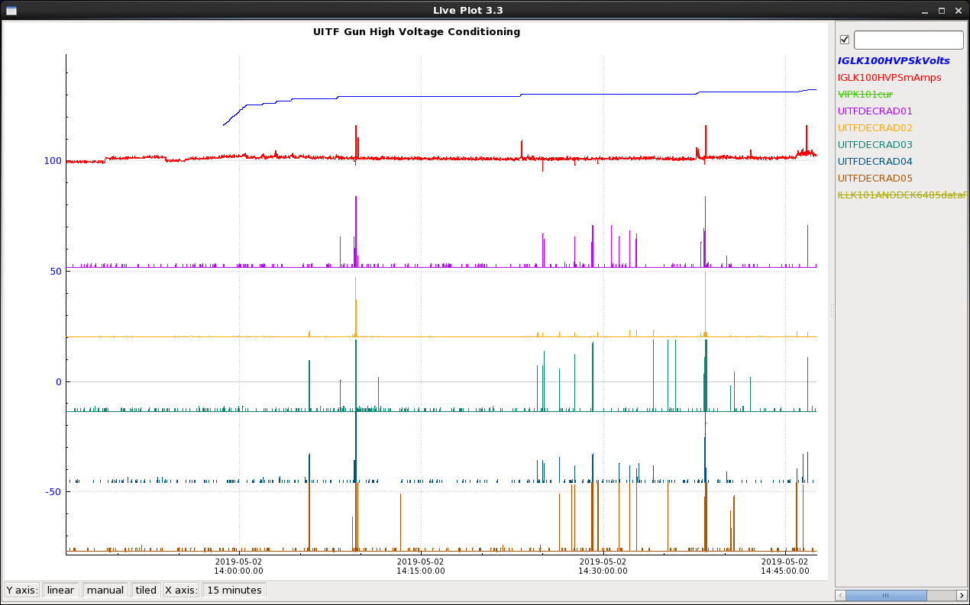 | I have no clear explanation for this, but seems to be field emission, almost as voltage at the tip of the emitters is at the emission threshold. What is clear is that the frequency of spikes increases as shown in the figure. | Continue increasing the voltage in 1 kV steps waiting for about 5 minutes between step.
Radiation spikes and settles down to tens or hundreds of CPS.  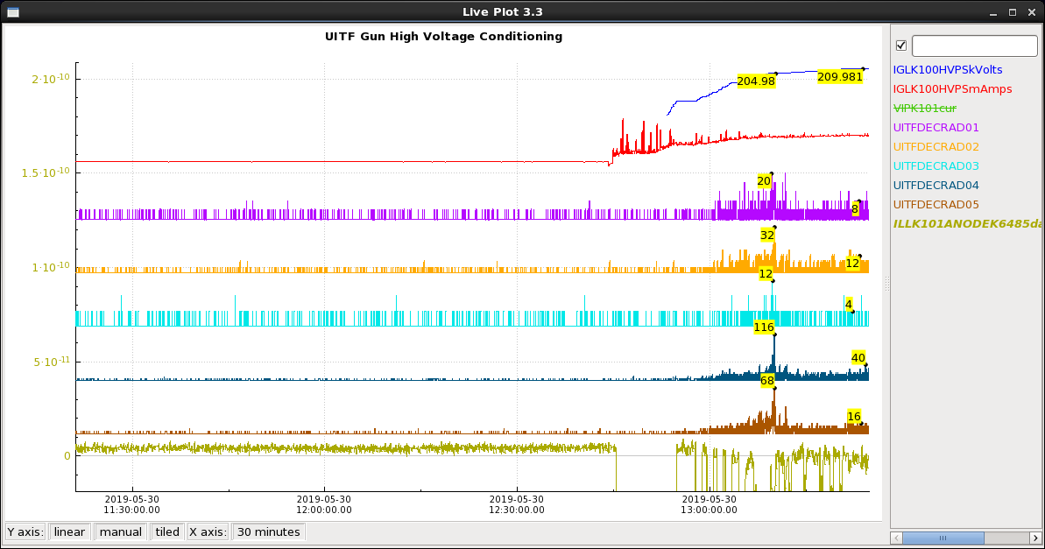 | Likely a field emitter developed but did not process out. This is classical field emission from an emitter that will grow as the voltage continues to be increased. | Continue increasing the voltage in 1 kV steps waiting for about 5 minutes between step.
Radiation creeps up in the thousands of CPS, sometimes decreasing, sometimes remaining unchanged, sometimes increasing.  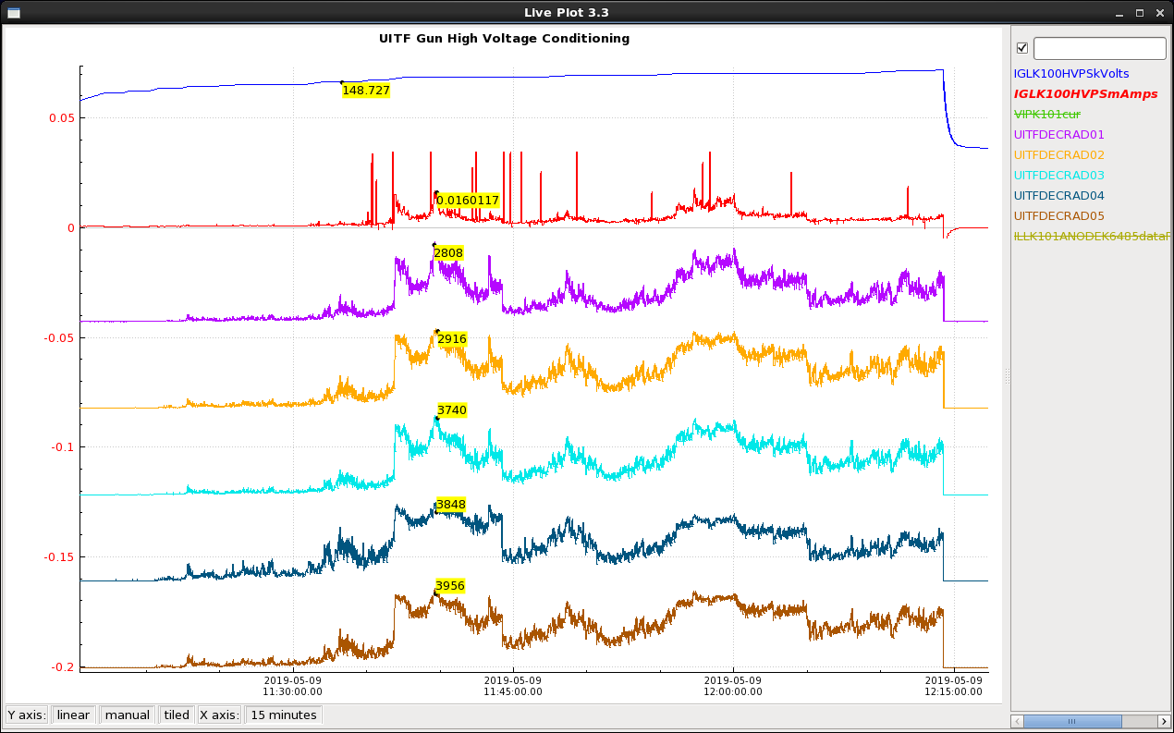 | This is classical field emission from a stubborn (large radius, small height) field emitter that is changing shape and size. Notice the current tracking radiation. At the end of the graph, voltage tripped off likely due to a violent emitter shape change leading to a current spike. Sometimes the current spikes are too quick to be captured by EPICS. | Continue increasing the voltage in 1 kV steps waiting for about 5 minutes between step.  Make sure the HVPS current does not exceed about 100 uA on average. If it does, bring voltage to zero and contact Carlos.
Radiation shows as many spikes AND a small (tens of CPS) baseline. At the last kV step, radiation slowly decreases to background with no spikes.  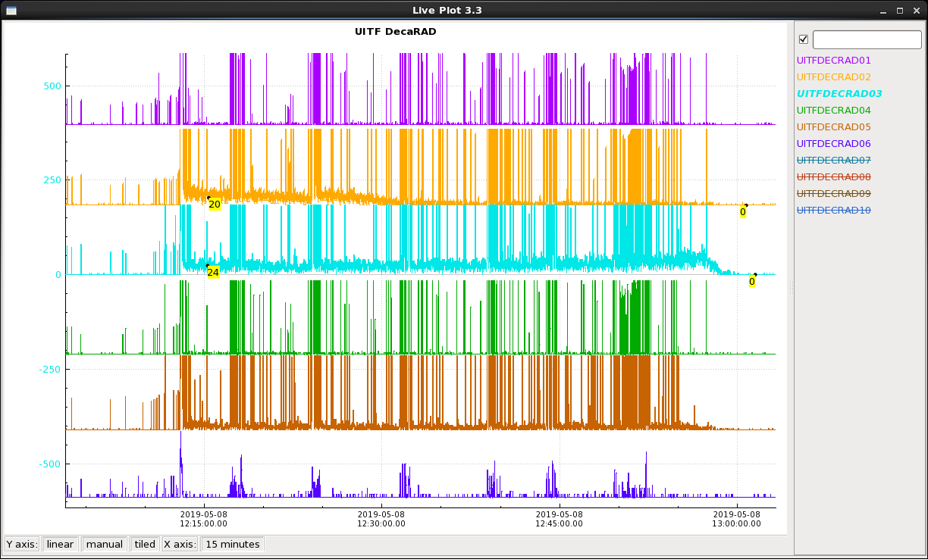 | Field emitter slowly processing out. | Wait for about 5-10 minutes before increasing the voltage to the next kV step. Eventually the emitter will process out like in this example, or will induce an HVPS trip.
Multiple HVPS trips at lower voltages than the voltage at which processing was taking place but no radiation other than when the HVPS trips off.  Later on, voltage stays up and Radiation drops to background.  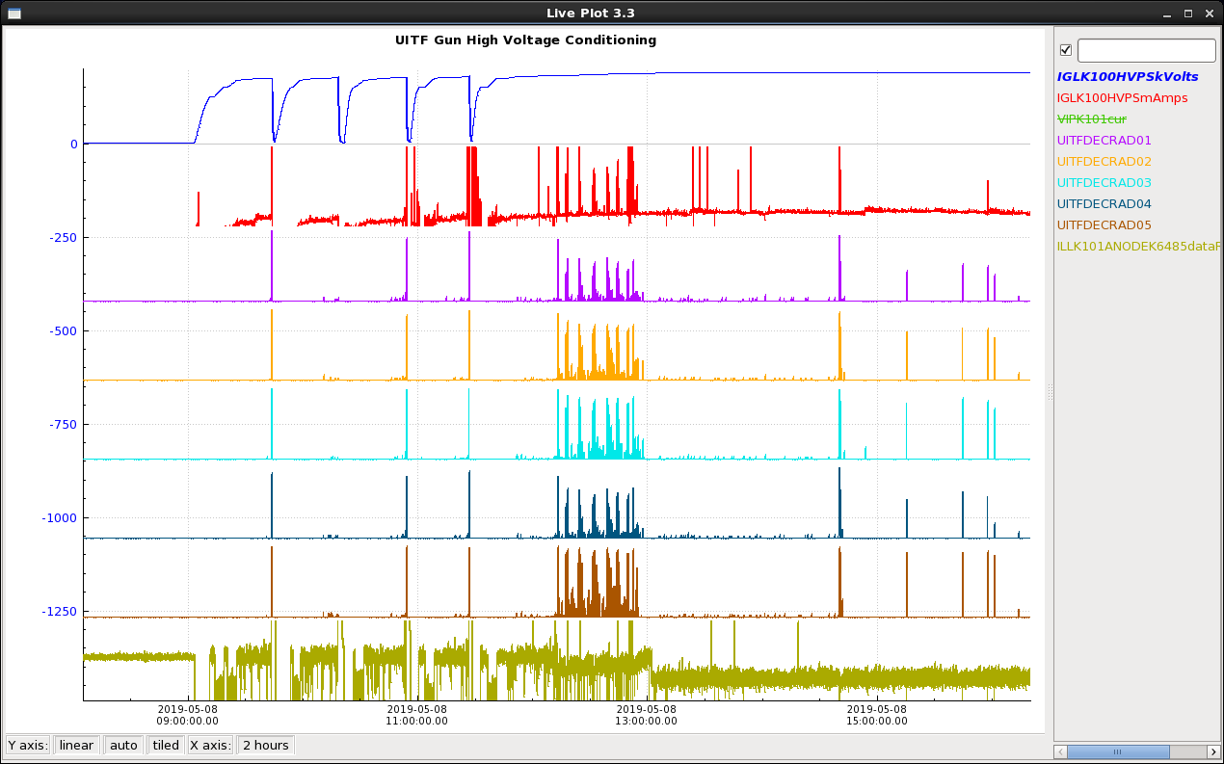 | A field emitter is trying to process but does it so violently that draws a lot of current tripping off the HVPS.  The graph also shows that after several trips, the voltage stays ON but field emission develops. Eventually after continuing increasing the voltage, field emission processed out. | To recover from a HVPS trip:  - Clear the HV fault on the gun controls screen.  - Because the electrode has been up to that voltage, change the Ramp Up rate to 100 kV/min  - Set the voltage to the last set point and click HV GO.  - Wait until the next trip and repeat  - If no trip, contine HV processing by lower Ramp Up rate to 1 kV/min and continue increasing voltage in 1 kV steps.
Multiple HVPS trips, significant radiation baseline until radiation clears off after one of the HVPS trips.  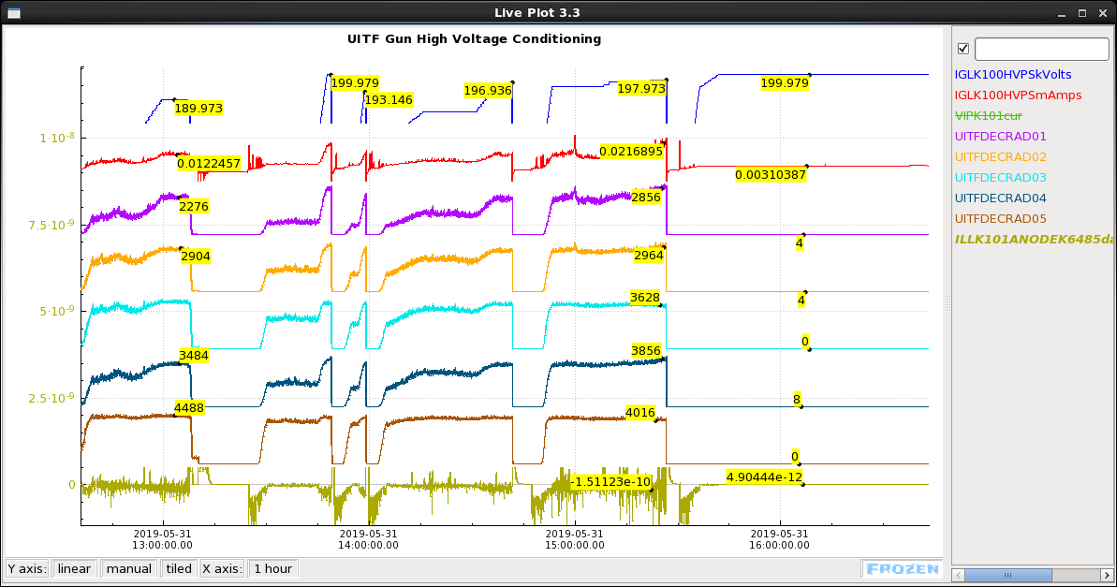 | Stubborn field emitter trying to process but its shape might be large radius as the radiation and current are both high. Trips are caused when the emitter is violently changing shape. | Recover voltage from each HV trip as described above.  If no further trips but field emitter did not process out, bring voltage down to zero and contact Carlos.  When field emitter process out, continue high voltage conditioning in 1 kV steps.
Soaking at 220kV with Kr, no field emission. Kr processing complete.  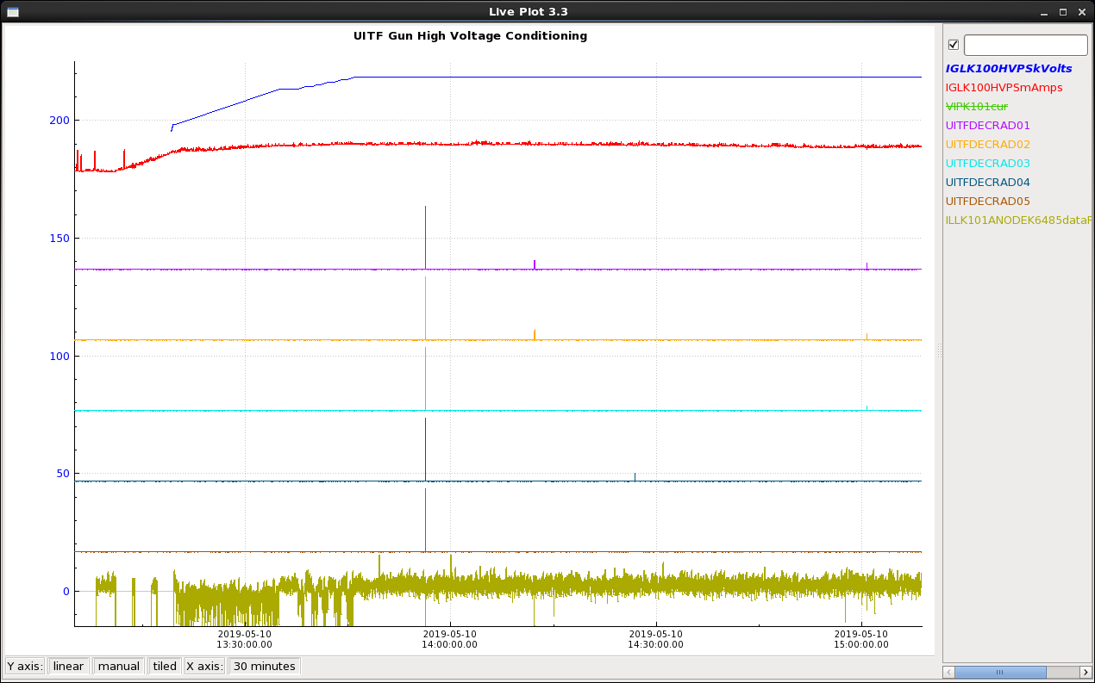 | Field emission has been processed out to this voltage. | Soak w/Kr for at least a couple of hours or longer if there is a chance before going configuring the gun back to vacuum conditions.  Once soak is complete, Ramp gun voltage down to zero and turn HV OFF.

Returning gun to vacuum configuration

The following steps assume that Kr processing has been complete and are somewhat in reverse as those in the Kr setup for HV processing section. It may take several hours for the vacuum to recover to pre-Kr-processing levels.

- CLOSE leak valve and observe the pressure dropping in the turbo pump gauge.
- CLOSE the Kr regulator outlet valve
- CLOSE the Kr bottle valve
- Wait until the pressure in the turbo pump gauge reaches 1E-8 Torr. This may take 10-20 minutes.
- Turn bake ion pump ON
- CLOSE bake pump right angle valve to turbo
- Turn photogun ion pump ON
- CLOSE photogun ion pump right angle valve
- LEAVE the turbo pump cart ON
- Procedure complete. Photogun is back into vacuum configuration.

Checking photogun high voltage in vacuum conditions

- Open the gun HVPS controls screen and ensure the Current trip limit is set to 0.2 mA, then set the Ramp Up rate to 25 kV/min and the Ramp Down rate to 200kV/min.
- Open the DecaRAD controls screen
- Open a strip tool and graph the photogun HVPS readback (blue trace), the HVPS current (red), the photogun vacuum (green trace) and the first five of the DecRAD signals. Notice the DecaRad background fluctuating between 0 and 8 CPS.
- Turn ON HV
- Set the Voltage set point to 50 kV and click HV GO. Observe the signals in the strip tool.
- Wait about 5 minutes at 50 kV
- Set the next voltage setpoint at 100 kV, click HV GO and soak for ~5 minutes
- Set the Ramp Up rate to 10 kV/min
- Set the voltage setpoint to 150 kV, click HV GO and soak for ~5 minutes.
- Set the Ramp Up rate to 5 kV/min
- Set the voltage setpoint to 175 kV, click HV GO and soak for 5 minutes.
- Set the Ramp Up rate to 2 kV/min
- Set the voltage setpoint to 200 kV, click HV GO and soak at that voltage for several hours or until further notification from Carlos.

The figure below shows an example of ramping the gun voltage under vacuum conditions without field emission
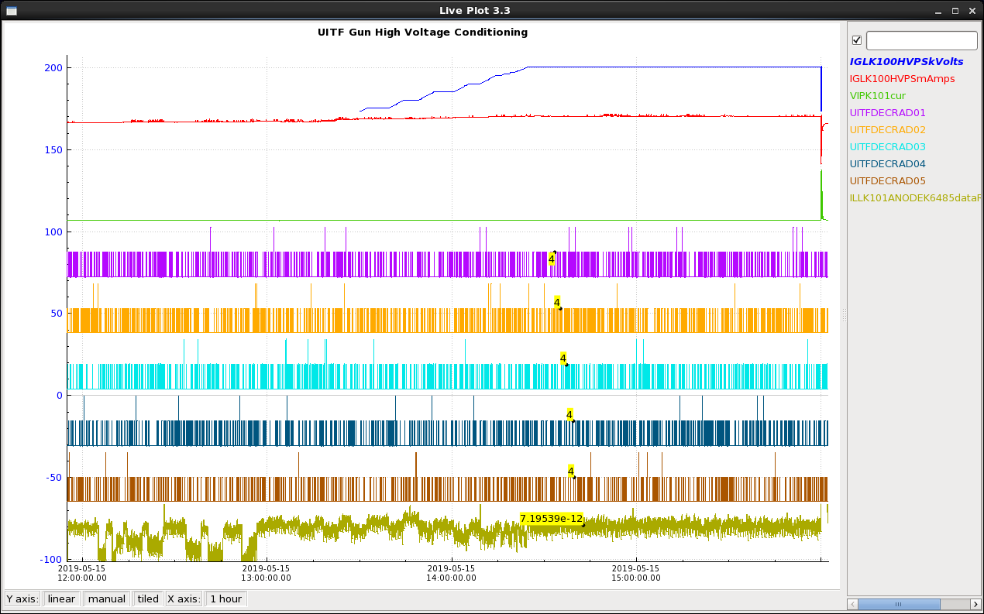

Notice the DecaRAD signals fluctuation, the same as background.
The graph shows that after one hour soak, the HVPS tripped off. In this instance, a field emitter developed.
To recover in vacuum conditions after a HVPS trip, follow the same procedure described above.
The figure below shows radiation upon recovering voltage in vacuum conditions.
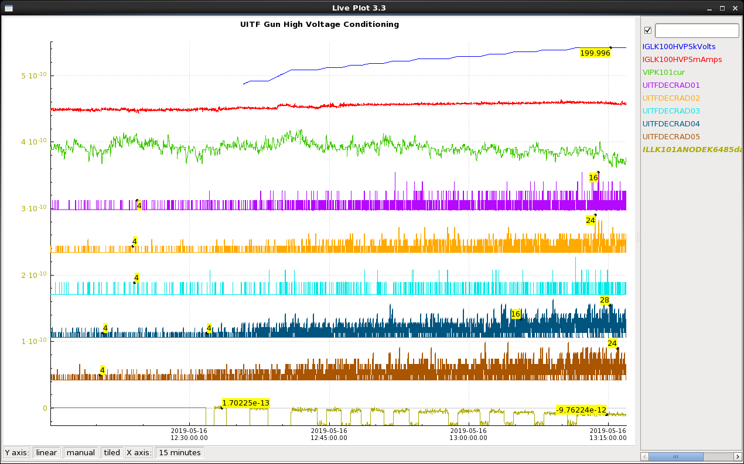

This required going back to Kr processing. It took about 8 hours to process the field emitter with Kr. Then the process to check the gun in vacuum conditions was repeated, and in that instance the last Kr processing was successful, the gun was deemed conditioned to 200 kV in vacuum and was operated shortly after over several days for several hours at a time to deliver 200 keV, 100 uA beam in the UITF.

Figure bellow shows the photogun fully conditioned to 200kV in vacuum ready for beam.
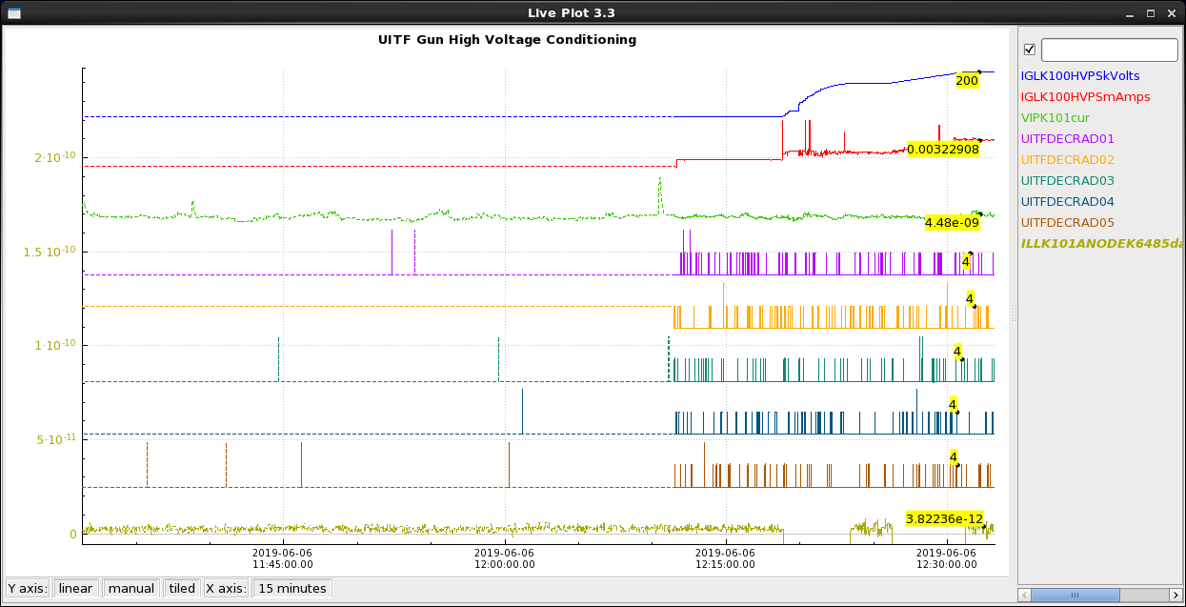

High voltage conditioning process is COMPLETE.

M. BastaniNejad, A. A. Elmustafa, E. Forman, J. Clark, S. Covert, J. Grames, J. Hansknecht, C. Hernandez-Garcia, M. Poelker and R. Suleiman, Improving the performance of stainless-steel DC high voltage photoelectron gun cathode electrodes via gas conditioning with helium or krypton, Nucl. Instr. and Meth. in Phys. Res. A, Vol. 762, pp. 135–141, 2014

