TITLE: THE TEST RESULTS OF THE MQW QUADRUPOLE MAGNET

BY: Seetha-Lakshmi Lalitha | DATE: 05 /21/2021
Reviewer: Joe Grames
Approver: Joe Grames

- | The initial release | 05/21/2021
REV. | DESCRIPTION | DATE
SUMMARY OF CHANGES FROM PREVIOUS REVISION:

Contents
1 Context 3
2 Results and Discussion 3
3 Acknowledgment 5
4 References 5

Context
A new MQW type quadrupole corrector magnet (Figure 1) is designed, built, and installed recently in the CEBAF 200 keV injector beamline. The magnet design, functional requirements, manufacturing and assembly details, the quality check of the coils as well as the magnet test plan are discussed elsewhere []. This document presents the inspection results of the coils, magnetic measurement results, and a comparison of those data with the results of the three-dimensional electromagnetic simulation based on the parameters of the actual MQW magnet assembly.
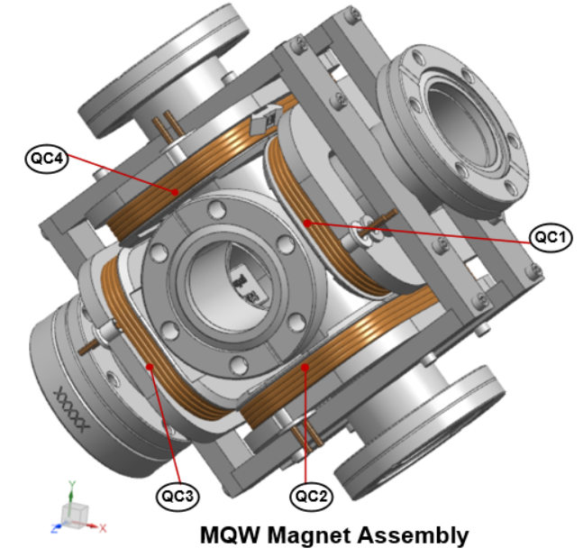
Figure 1: The MQW quadrupole corrector magnet assembled onto the CF six-way cross fitting []. The physical orientation of the assembly is such that coordinates x=0, y=0, and z=0 represent the magnet center and +Z axis point to the direction of the beam. The labels QC1, QC2, QC3, and QC4 denote the four racetrack coils arranged in the normal quadrupole configuration.

Results and Discussion
  - Quality assurance test results (Tests performed by the manufacturer before shipping the coils to the J Lab; Quantity: 32)
The hipot and surge tests were performed at 1000 V. The leakage current is found ≤0.015 µA for all coils. The surge tests rule out the presence of any internal electrical shorts in the winding pack. The nominal value of the resistance at 20 C of the coil (including the lead wires) is ∼36 mΩ and the coil inductance at 60 Hz is 60 μH.
  - The results of quality assurance tests performed at MMF, JLab
All coil (Quantity: 32) passed the visual inspection, and the hipot and surge tests at 500 V. The measured values of room temperature resistance and inductance at 60 Hz of the coils can be found in []. The temperature studies were performed on one representative coil. The test results suggest that the coil temperature at 10 A reaches a maximum of ∼31°C [].
  - Magnetic measurement results
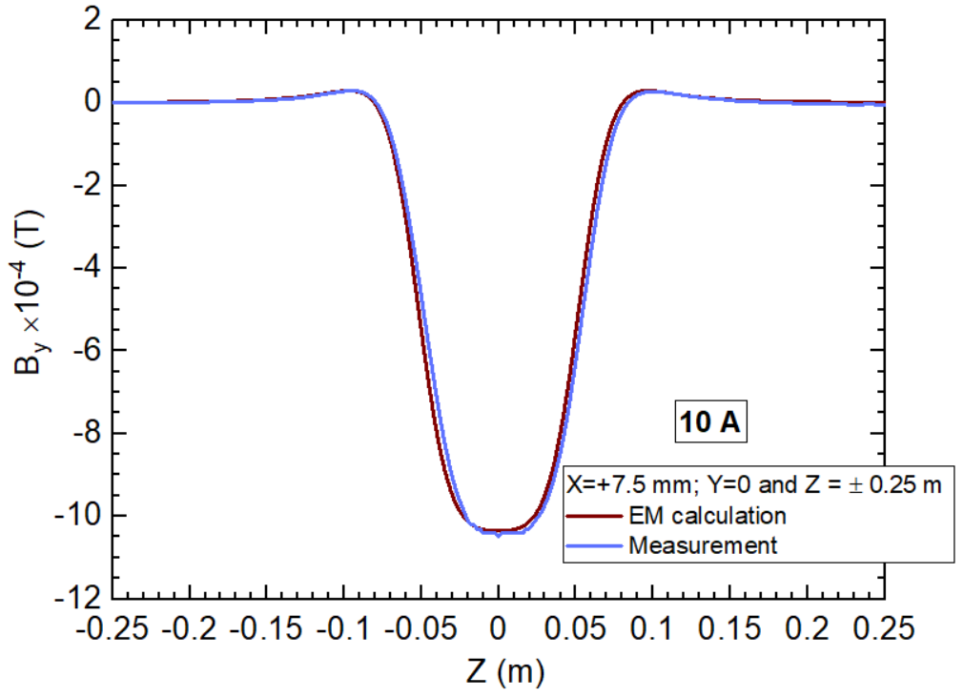
Figure 2: The vertical field (B_{y}) profile at (X=+7.5 mm, Y-=0, Z=± 0.25m) at coil excitation current of 10 A. The brown line shows the data obtained from the three-dimensional electromagnetic simulation whereas the blue line represents the measured data for the as-built MQW magnet.
The magnetic test plan is reported in section 8 of [1]. The magnetic measurement data can be found in [].
The analysis results indicate that the measured and computed vertical field ($B_{y}$) profiles along the longitudinal direction (Z-axis) overlap to a great degree for all excitation currents. For example, Figure 2 shows the $B_{y}\left(X=+7.5mm, Y=0 , Z=±0.25m\right))$ at 10 A. The center field values obtained from the magnetic measurement and the electromagnetic (EM) calculation agree within 1.3 % (Table 1) and whereas the difference between the measured and the calculated values of the integrated vertical field strengths is about 1.1 % at 10 A.
Table 1 provides a comparison between the parameters extracted from the measured and calculated vertical field characteristics over the range of the interest. As noted in the MQW magnetic design document [1], the computed field data of the as-built magnet is used to extract the leading quadrupole field and multipole field components and to provide the relevant parameters (See Table 5 of [1]] to the CEBAF machine control system.
Table 1: Value of the vertical field component (B_{y}) at X=0, Y-=0, Z=0) of the MHD vertical dipole coil assembly for coil excitation currents ≤ 4A.
Operating current  (A) | Vertical field strength (B_{y})  at the magnet center (T) |  |  | $$\int_{Z=-0.25m}^{Z=+0.25m}{B_{y}}\left(X=+7.5mm\right).∂z$$  (T.m)
 | EM simulation | Magnetic measurement | Difference between the values obtained from the magnetic measurement and EM simulation (%) | EM simulation | Magnetic measurement | Difference between the values obtained from the magnetic measurement and EM simulation (%)
0 | 0 | 0 | - | 0 | 0 | -
1 | -1.036E-04 | -1.053E-04 | 1.63 | -1.017E-05 | -1.025E-05 | 0.75
2 | -2.071E-04 | -2.091E-04 | 0.97 | -2.035E-05 | -2.055E-05 | 0.97
3 | -3.107E-04 | -3.144E-04 | 1.20 | -3.052E-05 | -3.084E-05 | 1.05
4 | -4.143E-04 | -4.178E-04 | 0.86 | -4.070E-05 | -4.111E-05 | 1.01
5 | -5.178E-04 | -5.233E-04 | 1.06 | -5.087E-05 | -5.133E-05 | 0.89
6 | -6.214E-04 | -6.271E-04 | 0.91 | -6.104E-05 | -6.170E-05 | 1.08
7 | -7.250E-04 | -7.318E-04 | 0.95 | -7.122E-05 | -7.207E-05 | 1.19
8 | -8.285E-04 | -8.361E-04 | 0.91 | -8.139E-05 | -8.228E-05 | 1.09
9 | -9.321E-04 | -9.406E-04 | 0.91 | -9.157E-05 | -9.263E-05 | 1.16
10 | -1.036E-03 | -1.049E-03 | 1.32 | -1.017E-04 | -1.029E-04 | 1.12

Acknowledgment
The coil tests and magnetic measurements were performed by J. Meyers and M. Beck.

References

[] S-L. Lalitha, “Electromagnetic design report of MQW magnet in the CEBAF 200 keV Injector Beamline”, J Lab internal document #MEG0002021-R003 REV-, May 2021.
[] J Lab NX CAD 3D Model JL0091130-0202: Wein filter girder assembly.
[]M:\MagTest\DataBase\Injector\QW\Coil inspection\MQW coil inspections 02-5-2021.xlsx
[]M:\MagTest\DataBase\Injector\QW\Temperature Study\QW_Temperature_Study_020221.xlsx
[]M:\MagTest\DataBase\Injector\QW\Analysis\MQW_Stepper_Measurements-NoShims_210221.xlsx

