Safety Systems Kicker

**x**

X+

X-

Y+

Y-

**Kicker Magnet layout showing field orientation for X direction kick**

**X and Y coils shown**

**Bx**

The beam kicker is used to quickly deflect the beam out of the accelerator after a fault is detected. This is done by energizing a set of special air coil magnets located between apertures A1 and A2. Each coil set, designated X and Y, is designed to deflect beam in a direction perpendicular to the path of the beam. The coils are mounted on each side of the beam line in order to maximize the kick for a given total magnet current.

Kicker Coil

PSS - A/FSD

**When Sw1 and Sw 2 closed Ikicker = Ibias = Ic/2**

**When Sw1 or Sw 2 open I kicker = 0; Ibias = Ic**

Sw1 Sw2

Bias Coil

IC

PSS - B

Figure 2. Kicker Theory of Operation

The magnitude of the kick can be calculated by



where 

is the velocity of the beam compared to the speed of light, *c*.

*Ek* is the beam kinetic energy = 100 keV and *E0* is the electron rest energy = 511 keV

Therefore, for 100kV beam,  = 0.548

= 1.196



The “rigidity” of the beam is the resistance to deflection radius r by a field strength B

 T [1]

For our 100keV beam, the *Br* is 0.112 T-m or 1117.3 G-cm.

To deflect a beam with Br a distance  over distance L using a magnet of length l



0.01 cm

45 cm

0.05 cm

The minimum required kick (Δx) = 0.10 + 0.02 = 0.12 cm.

In calculations used delatX = 0.5 cm (jkowal).

 radians.

Using 1, this gives a *Bl* of 12.4 G-cm

The air core magnet has an effective length of approximately 4 cm, leaving a minimum *B* of about 3 Gauss or 0.00003 Tesla.

25.003 cm

26.78 cm

ψ

r

a

s



integrated over 2π radians

 Tesla







The recent change to the kicker system sums in a copy of the FSD master output permissive signal with the PSS System A X and Y kicker signals.

0.625 MHz Decoder

5 MHz Decoder

0.625 MHz Encoder

EPICS Interface

Figure 3. Simplified Schematic of VME Summing Card Logic

PSS BCM Permit

FSD Permit

Permit Out to Kicker Module

Status

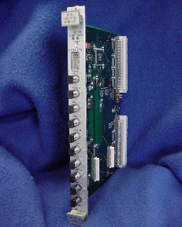

IOCIN2

625kHz PSS –AX Permit

625kHz Out

625kHz Out

FSD

5MHz

X-Bias

X-Kick

Y-Bias

Y-Kick

FSD

5MHz

Loop

IO3B01

625kHz PSS – AY Permit

100keV Beam line

0I02

X Kicker

Y Kicker

Injector PSS BCM

VME to EPICS

MICRO PLC

Modbus to EPICS

Y Status

Y Bias

Y Kick

X Status

X Bias

X Kick

VME to EPICS

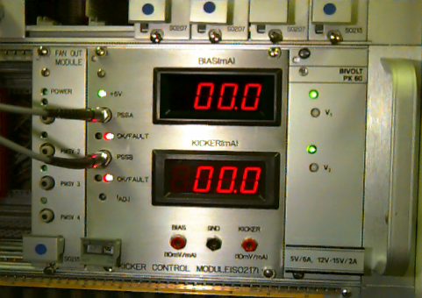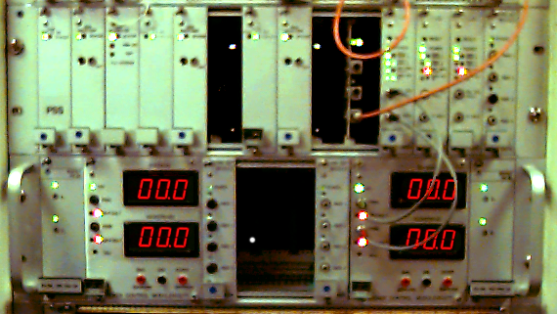

Kicker Modules

Each kicker works by equally splitting the 200 mA current of a constant current source into two magnet coils, the bias and kick windings. The two 100 mA currents flow in opposite directions, thus creating a net zero magnetic field. When a fault is detected, a switch opens in the kick leg, forcing the full 200 mA of current through the bias winging. There is now a net magnetic field forcing the beam off center. The kick is designed to deflect the full beam on to the aperture A2.

A detailed description of the kicker system can be found on the safety systems group page at:

<http://www.jlab.org/accel/ssg/fe/kickerpac.pdf>

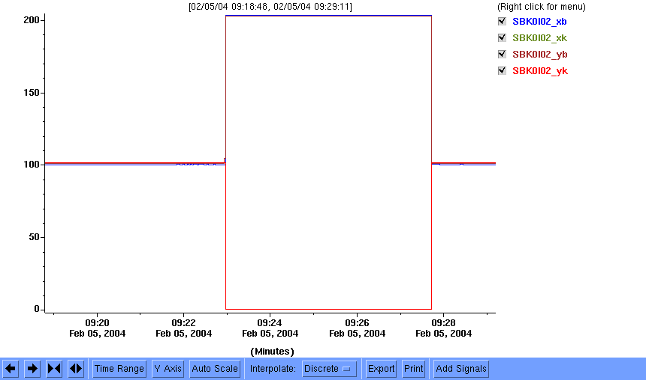

No Fault. Kick=Bias=100mA

Fault.

Kick= 0mA

Bias=200mA

**Kicker Operation:**

The following events will cause a kicker fault:

* PSS BCM fault
* Any FSD fault
* Kicker Module Internal Fault
  + Voltage
  + Current High/Low
  + Logic Fault
* Shorted or Open kicker magnet coils

**Epics - Operator Screen.**

The operator screen shows the status of the kicker system and the current in each of the four coils. There is also a heartbeat signal for IOC IN2, the host IOC for the kicker software. Figure 2a. shows the normal operation, figure 2b. shows the status when the kick is active.

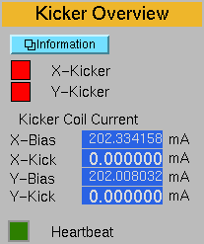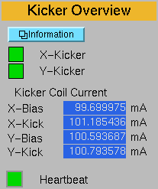

The X-Kicker, Y-Kicker status signals come from the kicker electronics modules.

**Epics - Expert Screen**

The expert screen shows the uncalibrated current read backs taken from the kicker front panel. The value of theses signals is typically 100 +/- 3 mA. A user defined calibration slope is available to adjust the Instantaneous Current read back to within 0.1% of the actual current as measured in the field. The calibration slope should only be adjusted by Safety Systems Group personnel when calibrating the system. As can be seen in figure 4, the value of the calibration slope is typically less than 3% of the raw value. The value of the instantaneous current is the value shown on the operator screen. Both the raw and the instantaneous current are archived values. All kicker EPICS signals start with the nomenclature SBK (Safety Beam Kicker).

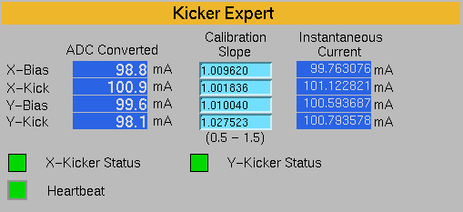

**Diagnosing the cause of a fault:**

At this time there is not a way to distinguish between PSS and FSD caused faults of the kickers using an EPICS screen. When the software is implemented to read back the status of the VME cards, this capability will then be available in EPICS.

**Normal Faults:**

For Normal Faults (PSS or FSD) the following conditions will be true:

X-Kicker and Y-Kicker status will be faulted (Red).

X Bias and Y-Bias currents will be 200mA +/- 10mA.

X-Kick and Y-Kick currents will be approximately 0.

**PSS BCM Initiated Fault:**

A PSS BCM fault will be accompanied by a drop to Power Permit. There may or may not be an indication of an FSD fault. Check the PSS display North Linac PLC screen to verify that the fault was caused by a PSS BCM. Reset the PSS BCM by cycling the keys for the appropriate areas to Beam Permit (and back to a lower state if needed).

**FSD Initiated Fault:**

FSD will be tripped.

Note that any current diverted from one coil, should show up in the other coil. If this is not the case then the problem is in the kicker control module, the calibration constants, or the wiring between the kicker control modules and the PLC.

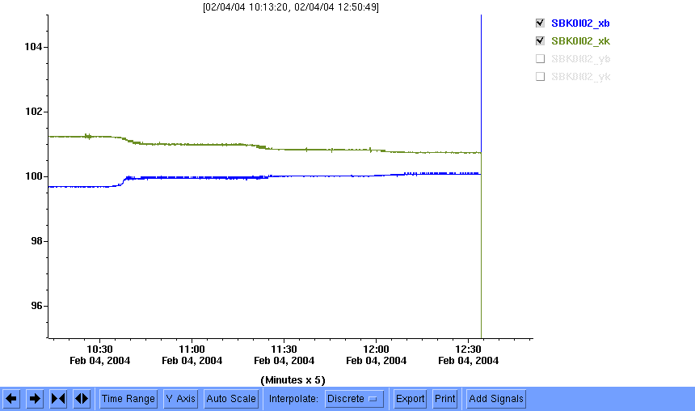

Figure 4 shows the bias and kick current for the X channel when the impedance of the Kick channel was varying. Note that the Bias current is a mirror of the Kick current. The sum of the two currents is always 200mA +/- 4%.

|  |  |  |  |  |  |  |  |
| --- | --- | --- | --- | --- | --- | --- | --- |
| **X Status** | **Y Status** | **X Bias, mA +/- 4%** | **X Kick, mA +/- 4%** | **Y Kick, mA +/- 4%** | **Y Kick, mA +/- 4%** | **Heartbeat** | **Diagnosis**  **Yellow indicates that a Controlled Access may be necessary to fix the problem.** |
|  |  | Don’t Care | Don’t Care | Don’t Care | Don’t Care | Not Blinking | Do not trust any readbacks. |
|  |  | 100 | 100 | 100 | 100 | Blinking | Normal Operation – Not Faulted |
|  |  | I ≠ X Kick +/- 4mA | = 200 – I bias | 100 | 100 | Blinking | High impedance on the lower current leg. |
|  |  | 100 | 100 | I ≠ X Kick +/- 4mA | = 200 – I bias | Blinking | High impedance on the lower current leg. |
|  |  | 200 | 0 | 200 | 0 | Blinking | Normal Operation – Faulted by PSS BCM or FSD |
|  |  | I ≠ X Kick +/- 4mA | = 200 – I bias | 100 | 100 | Blinking | High impedance on the lower current leg. |
|  |  | 100 | 100 | I ≠ X Kick +/- 4mA | = 200 – I bias | Blinking | High impedance on the lower current leg. |
|  |  | 200 | 0 | 100 | 100 | Blinking | X Kicker  Module Fault |
|  |  | ≠ 200 | 0 | 100 | 100 | Blinking | Low Impedance in X Bias Line |
|  |  | 0 | 0 | 100 | 200 | Blinking | X Bias Magnet Open Circuit |
|  |  | 100 | 100 | 200 | 0 | Blinking | Y Kicker  Module Fault |
|  |  | 100 | 100 | ≠ 200 | 0 | Blinking | Low Impedance in Y Bias Line |
|  |  | 100 | 100 | 0 | 0 | Blinking | Y Bias Magnet Open Circuit |
| Table 1. Kicker Troubleshooting Using the EPICS Screens | | | | | | | |

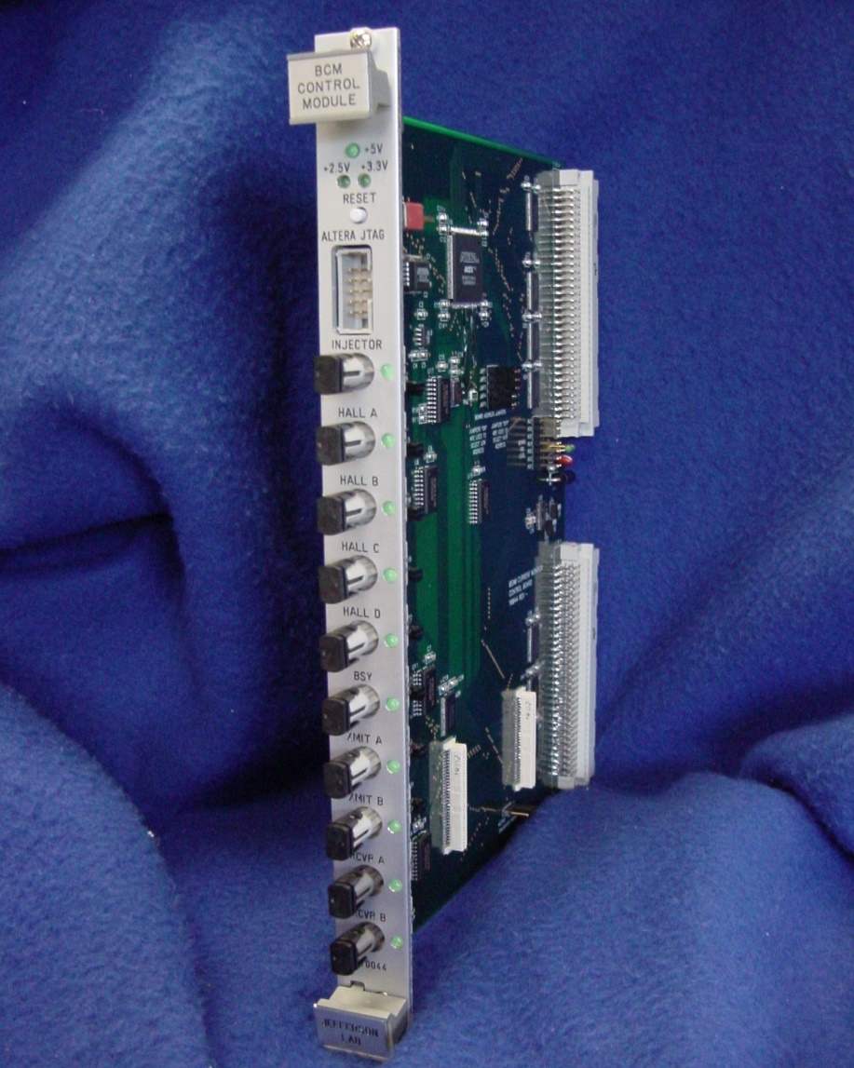

FSD IN

FSD OUT

625 kHz IN

625 kHz

625 kHz OUT

**Appendix A – The Problem to be Solved**

The photocathode injector uses polarized laser light to generate the electron beam. There are three lasers, each tailored for the beam requirements of each of the endstations. FSD signals originally went to dedicated acousto-optical modulators that changed the polarization of the beam.

A modification to the laser microcontroller was installed that will change the polarization of the pockels cell by 90 degrees within microseconds of an FSD signal. However, this method is highly dependent on the relative polarization of the beam and the pockels cell. Experience shows that even after voltage is applied to the Pockels cell, there is a 5-10% bleed through of the light and corresponding beam current. This bleed through current amounts to a pedestal on the back end of the beam.

10 ms after the initial fast shutdown a mechanical shutter closes in the laser path, terminating all beam and completely shutting off the electron beam. The PSS kicker was designed for a < 1ms shutdown time and is measured to be approximately 250 us. By summing in the FSD shutdown with the PSS BCM signal, a 250us shutdown time for both FSD and PSS is achieved. The long term benefit of this system is that it separates the configuration control of the laser table systems from the FSD functions. With that goal in mind, the kicker system will be redesigned in 2004 to accommodate both the PSS and FSD requirements, with the FSD shutdown time being reduced from 250 to less than 10 us.

Time (Not to Scale)

Amplitude (Not to Scale)

FSD

Shutter Closed

Kicker ON

Micro Shutdown

250 us

1 us

10 ms

c.

b.

a.

Figure A.1 Shows:

a.) Shutdown timing before the micro control was added;

b.) Remnant beam pedestal after the micro shutdown was added;

c.) Shutdown with micro and kicker shutdown methods.

1. W. Scharf, ‘Particle Accelerators and Their Uses”, pp 13; copyright OPA 1986