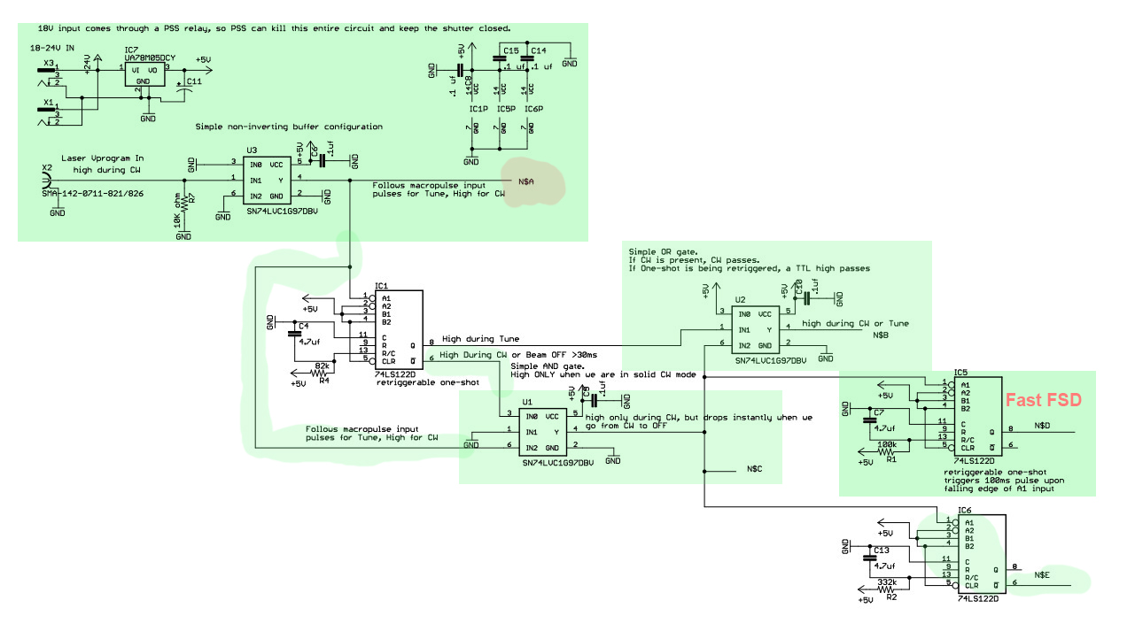
Thoughts about the problems occurring with the Tune Mode Generator:

John Hansknecht - Retiree on call

1. I don’t believe this is an issue with the Macropulse chassis or EPICS or the SCAM because Joe tells me that CW mode works every time it is called. SCAM drivers and the fibers are common to both CW and VL, Tune modes. The same is true for the fiber to 50ohm driver circuitry of the Macropulse chassis.

2. I have mentioned before that the chip that drives the shutter and the chip that drives the waveplate retract is discontinued. It is a DRV102F. Any new design needs to use a DRV103H or a DRV104PWP. I was concerned with the reasoning behind the discontinuance, but upon further investigation I found that it is only because the manufacturer was discontinuing support of the TO-263 and TO-220 packaged devices across its entire line of chips. https://media.digikey.com/pdf/PCNs/Texas%20Instruments/PCN20180715000.pdf

3. With regard to the shutters and waveplate retraction, both are activated for CW mode. If there were a problem with their inability to move, you would be having a problem calling for CW mode as well as the Tune and VL modes. We can eliminate this from our troubleshooting, yet I would suggest you consider reducing the weight of the waveplate holder in a future design. (sales pitch, I can help by manufacturing a lightweight polymer version using high strength resins now available for SLA printing)

4. What is used by Tune and VL modes that is NOT used during CW mode? Opening “tune shutter 2017.sch” found in your M:\inj_group\Official Electronic Design Package\Tune Generator design package\ tune shutter 2017

Items highlighted in green must be functional for CW beam to be produced and may also be a part of the Tune/VL circuits. Pink highlight is items needed during Tune and VL

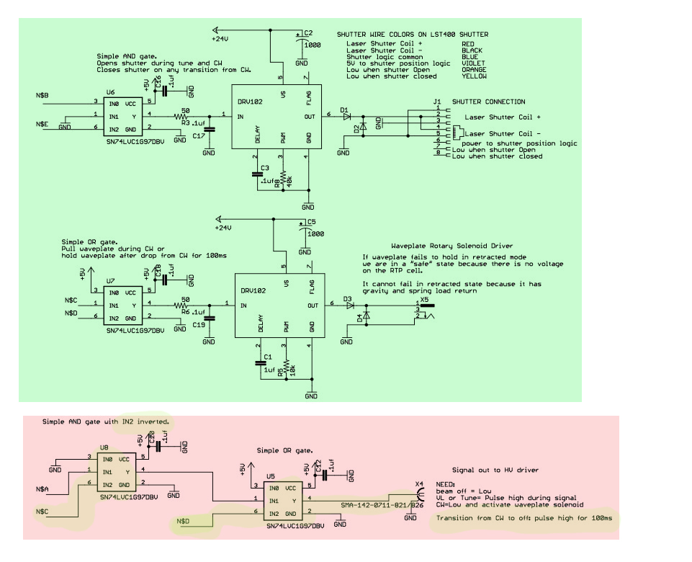
5. From the schematics above we see that almost all circuitry is common between CW mode and the Tune/VL modes. It is possible that we are getting a glitch on the IC1, which is a retriggerable MVB that differentiates the tune/VL mode from the CW mode, but I find it unlikely.

6. My suspicion lies in the HV driver and/or the RTP cell itself.

Reasoning: Once the waveplate drops, HV is required to rotate polarization so it can pass the linear polarizer downstream of the RTP.

- Is the HV driver working properly? This has to be tested on a bench with a 1000:1 divider and oscilloscope to see the HV output
- Is the RTP cell shorting out occasionally due to repeated HV stress over the years?
- Is the RTP cell getting the ion migration again?
- Is Hall C’s RTP cell installed with a reverse polarity compared to the other cells? HV applied to the common block instead of the flying lead?
- Do you have a Megger that can be set to 2000V max? With this you could test the RTP, but alternatively you could look at the RTP voltage using the 1000:1 divider and scope downstairs by sneaking in a wire to see the whole apparatus while it is running.
- Could you possibly use the fault recording DAQ system built by Trent Allison to see if the RTP cell is doing its rapid (20ns response) to a “beam off” command or FSD? This should show up as a CW beam dropping substantially within 20-30ns to a very low level, but there will still be a ghost beam until the shutter actually closes some 30ms later. As described on page 9 of Tune Generator design package 2017.pdf

Clearances in the RTP cell are quite small. I’m increasingly suspicious that there is an arc occurring in the cell. It may then overload the HV driver circuitry and draw excessive current which makes the shutter drop out. The EMI noise produced by an arc would likely disturb the TMG circuitry as well.

The other nagging issue is the fact that we appear to have situations where something only glitches when we are in Beam Permit and running beam. As soon as the tunnel is opened to investigate a problem, the problem disappears. It would have been nice to have all electronics upstairs, and I suppose some of it could be in the future, but the HV driver must be in close proximity to the RTP cell in order to maintain the (<250ns) rise and fall time requirements of Tune mode.

