CIS-TN-YY-NN
January 01, 1900

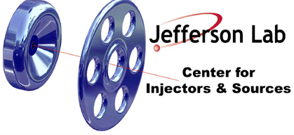

TITLE (ALL CAPS)

Authors

Affiliations

Please use Times New Roman 12pt font.

Save file and PDF to wiki : https://wiki.jlab.org/ciswiki/index.php/CIS_Technical_Notes

