Summary of Highlights UITF run0
(Poelker, August 25, 2020)
- Early in the program we stopped to krypton process the gun, field emission was unacceptable and leading to poor lifetime. Carlos reduced decarad counts from ~ 5000 to about 700.
- One photocathode activation supported the entire run, post-krypton processing.
- The booster RF system was made fully functional, a major milestone, albeit with questions about the very high GSet values required to make beam at modest energy. GSet is supposed to represent cavity gradient in MV/m, so for the 7-cell, one would simply multiply the GSet by the effective cavity length 0.7m to roughly obtain the desired beam kinetic energy. For example, to make 5 MeV beam from the booster, the GSet for the 7-cell would be 7. We learned we needed a GSet of 13 to make 5 MeV beam, so our GSet calibrations are off by a factor of 2 or more.
  - SRF is scheduled to revisit the GSet calibrations on August 27 and 28. We expect new calibration values, which means we will need to find new phases and amplitudes, with beam momenta assigned using the MeV spectrometer
- With help from Jonathan Creel, Clyde Mounts and Mike Drury, we made some changes to the epics control values for the booster cavities which resulted in better reliability and fewer trips from GDR to SEL mode. I am unfamiliar with some of the epics control tweaks, but I know that increasing the cold window trip setpoint helped reduce trips. We increased it from “1” to “2” whereas the setpoints are “4” at CEBAF. The highest beam momentum demonstrated was 8 MeV/c, beam was stable with trips to SEL mode about ~ 1/hr. HDIce wants 9.5 MeV/c
- We ran beam ~ 1 shift per day for five weeks. The first two weeks were not especially productive in terms of beam production, as we mostly spent time fixing broken things, especially getting the booster rf controls working.
- While waiting for booster rf control, we studied the buncher phase and amplitude settings. After two failed attempts to find the correct zero-crossing, we finally set the correct phase and then we used the Brock harmonically-resonant cavity to determine the correct amplitude to set the longitudinal waist at the Brock cavity, buncher GSet = 78 (see figure below). Then by simply scaling this value by the ratio of distances, (Buncher to Brock Cavity)/(Buncher to 2-cell cavity) = 1.73m/3.08m = 0.56, we very quickly and very directly put a longitudinal waist at the 2-cell. The Buncher GSet of 44 was deemed a good starting point value. Indeed, once beam was delivered to the MeV spectrometer, it was very obvious that our initial estimate for Buncher GSet was very close to optimum. Using the spectrometer to minimize energy spread, the Buncher GSet values in the range of 40 to 44 seems good.
  - Left side image: the oscilloscope measurement of the electron bunchlength at the Brock cavity as a function of Buncher GSet. Bunchlength starts large, gets smaller, and then gets larger again when we over-buncher. Right side plot shows Bunchlength versus Buncher GSet. For GSet values between 60 and 90, the Brock cavity reports a near constant bunchlength representative of the limited bandwidth of the cavity, i.e., bunches less than 37 ps will always be reported as 37 ps.

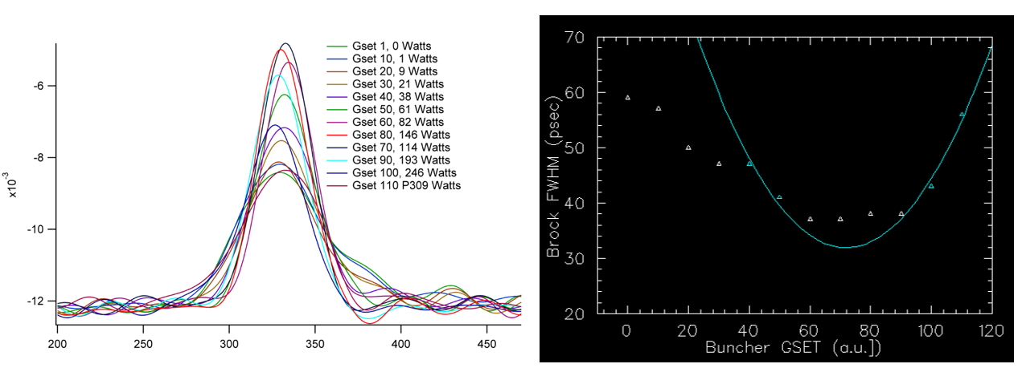

- We quickly learned that the save/restore program was insufficiently configured to save all the necessary variables, in particular, MeV magnets were missing and there were no RF variables being saved. This was corrected by the end of the run. But it does mean that most of the saved files are missing key information.
- Reliability was mostly very good, with beam restoring to the previous day’s end point destinations rather easily. The most common problem was mismatched magnets. There were about five or six magnets that frequently were not operating at setpoint. Sometimes the magnet trim card needed to be pulled and re-seated. When this happened at the beginning of the day, it was only mildly frustrating. Sometimes it would happen when beam was being delivered to a dump. If BLMs were masked, beam would go to an unintended place.
- Radiation shielding measurements were made at 2, 4, 5, and 7 MeV/c. The measurements were “sloppy” in the beginning in that my setups weren’t perfect and I couldn’t hit the 10uA CW intended current. And sometimes I could not go to both MeV dumps quickly. And finally, there was only one measurement made with beam to the insertable cup, FCup3 downstream of booster. The values in table below are in mRem/hour. Note, by design there was no shielding at the dumps or cup. We will repeat these measurements during run1.
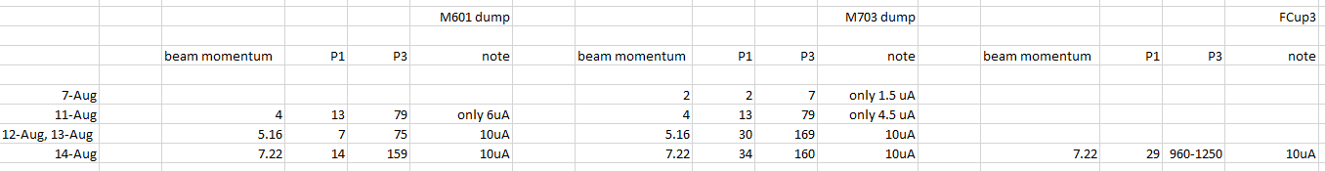
- BLM functionality tests at 5.1 MeV/c. The BLMs work and can be used to stop beam when it is mis-steered. per Paul Metcalf, there are three adjustments that can be made to a BLM: 850 V on tubes seems good, another bias voltage to move signal above a noise floor, and a trip threshold setting to avoid spurious trips. We learned some practical things: there was no point evaluating BLM performance at beam energies we never expect to operate at, e.g., 500 keV, 1 MeV. Having the dumps and cup unshielded make us prone to unnecessary trips, makes it difficult to set the voltages, etc., on the BLMs. Paul provided the assessment shown below.
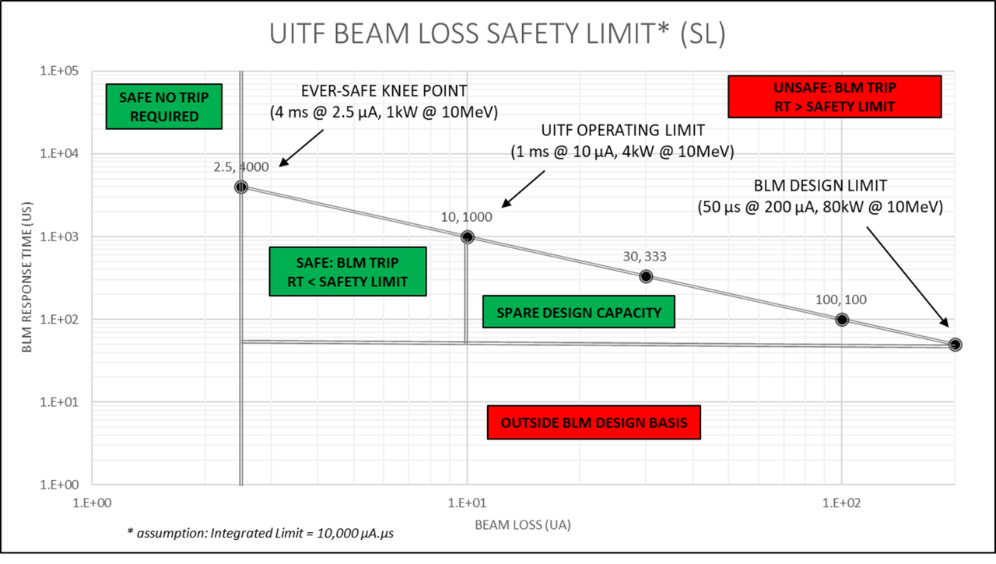

- Setting the 7-cell amplitude and phase? How to do it? Put beam into the MeV spectrometer, adjust the 7-cell phase to put beam on crest. Then adjust 7-cell GSet per the formula: Bdl [G-cm] = -1673 * p[MeV/c] relevant to our MDLM601 dipole magnet bending beam by 30 degrees. The 7-cell phase is basically constant.
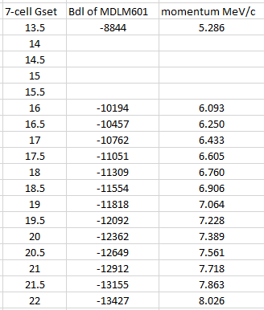
- Setting the 2-cell phase and gradient. How to do it? It’s not as simple as setting the 7 cell parameters, because we don’t operate the 2-cell on crest. It bunches and accelerates. In short, we guessed some initial 2-cell GSet, which was probably too high (GSet = 8), which could damage the 2-cell. If the GSet had actually been the cavity gradient, 8 would have been fine, but like the 7-cell, the 2-cell GSets are not representative of gradient. (btw, to get started, we guessed an initial 7-cell GSet too) It was fairly easy to transport beam downstream of the booster, leaving the GSets constant and then adjusting the cavity phases to clean up the spots on viewers. Then we steered this beam into the MeV spectrometer. Once in the spectrometer, crest the 7-cell phase, then adjust the 2-cell phase to minimize energy spread, which is what we want to do for HDIce tests. Now to adjust the 2-cell GSet to provide the intended 333 keV kinetic energy boost to 200 keV beam:
  - With 7 and 2-cells ON, measure beam momentum vs 7-cell GSet
  - Extrapolate to zero, this is the momentum provided by the 2-cell, it should be 0.91 MeV/c
  - BTW, momentum and kinetic energy, use this formula:${\left(K+m\right)}^{2}= p^{2 }+ m^{2}$, where K is kinetic energy, m is the electron rest energy 0.511 MeV and p is momentum in MeV/c.
  - And the effective length of the 2-cell is 0.12 m, and the effective length of the 7-cell is 0.7m
  - With 7 and 2 cells ON, measure momentum vs 2-cell GSet, i.e., calibrate the 2-cell momentum dependence on 2-cell GSet. We find every unit of 2-cell GSet provides variation of 0.1528 (MeV/c). Note this is only true for the phase offset we were running, which is fine.
  - Adjust the 2-cell GSet to reach the desired contribution from the 2-cell, based on the calibration obtained in step (e) above
  - In plot below, you can see we are close to design value, 0.94 MeV/c, but still driving the 2-cell harder than Haipeng’s design.

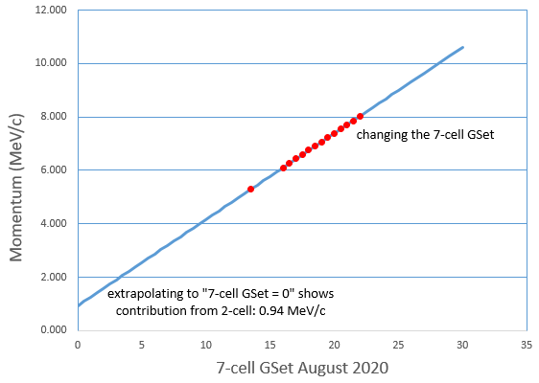

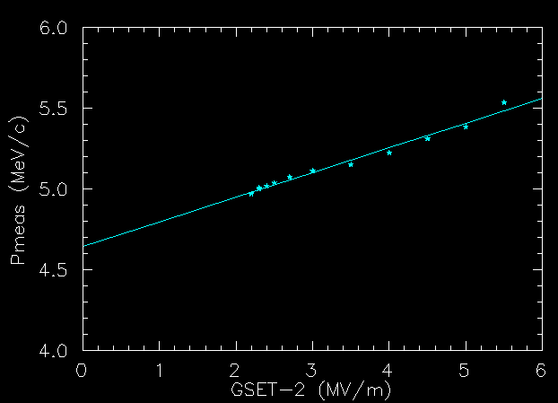
Each unit of 2-cell GSet provides a momentum variation of 0.1528 (MeV/c)
- Qsutility: Joe and Dennis Turner got qsutility working at UITF. The tool provides a measure of beam emittance, and it can also be used to tell us the beam envelope, and to optimize the beam envelope (i.e., set the quad values).
- Emittance was measured at 6.09 MeV/c using the qsutility program: normalized emittance 0.5 microns in X and 0.3 microns in Y. These are values within the expected range.

