An ideal laser seed chassis would:

- Have each seed/pre-amp combo be independent in its own chassis, so a seed and pre-amp can be changed for one hall without affecting other running lasers.
- Be immune to temperature drift effects on seed, pre-amp, and any electronics. Since “real” seeds and amplifiers are not immune, I propose building all components in an enclosure that has no fan cooling and a large aluminum thermal mass that is connected to a rack mount chiller. Quick release self-sealing fittings will be used for plug & play replacement of a chassis in the system. The four laser chassis would be run in a series water loop. The cooling channel in each aluminum plate needs to be large enough so it is not a flow restriction. The channel should be designed to allow cleaning. Perhaps a ½” copper tube pressed into a square bore around the perimeter of an aluminum box. It could use a thermally conductive epoxy too.
- Be immune to loss of rf. Pre-amp should provide enough DC light to satisfy the amplifier even if rf pulsing is lost. To first order this sounds bad.. a low dc value present all the time could cause leakage into hall B from other lasers. In reality, it appears that if rf is present, the dc is ignored and all energy is diverted into the rf pulse. This takes more time to “prove”.
- System should provide a protective interlock to the amplifier to turn it off by means of the remote interlock connection if it fails to produce any light at all. ( or if it has gone to dc?)
- Provide the ability to read the output seed power locally or via EPICS. (slow DC value)
- Provide the ability to look at pulses on a fast scope without disconnecting the primary output that goes downstairs to the amplifier.
- Ideally, a copy of the laser pulse could be fed back to the LLRF system for phase feedback, however running “open loop” has worked for over 7 years, so is it worth the effort?
- Power supplies should be independent in each system, so a failure of one will not affect the other three systems.
- Power supplies should be linear supplies if possible, unless all downstream circuitry is immune to switching noise by including appropriate filtration.
- TEC control should be analog, so switching noise does not affect the laser.
- There should be no “simple” way to expose a person to class 3B or higher laser light. All fiber connection ports should require a withdrawal of the chassis and removal of the top for final disconnect.
- Fibers leaving the chassis should be protected in an armor or flex conduit all the way to the laser room. Fibers will be PM and immune to problems of bending affecting the polarization. I still think we can get away with non-pm pre-amplifiers as long as the polarization is fixed inside the chassis.
- The aluminum block thermal mass should be insulated from the chassis with a layer of felt or equivalent so it is relatively immune to changes to the surrounding air and nearby equipment.
- There should be no heat generating equipment mounted beneath the four seed chassis. I believe the chiller will need to be above the chassis so its fill port is the high point in the system.
- Address all concerns of phase flips. We should know on EPICS if a laser is out of phase from a known reference. I have been told that the Buncher is the reference for all other signals, but the buncher has repetitive timing at 1497 MHz and cannot be used as a definitive reference for pulses coming at subharmonics. The chopper is the only item that defines the beam in time and space.
Consciousness of thought…..
If you look at the animation of a circle from a sine and cosine input with 90 degree separation, you see what is happening in the chopper.
http://en.wikipedia.org/wiki/Lissajous_curve#/media/File:Circular_Lissajous.gif
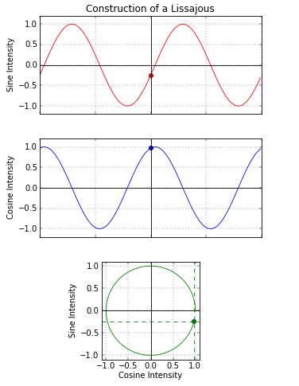
Full circle painted. (counter clockwise)
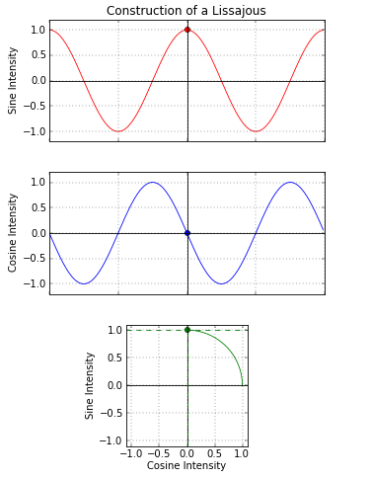
Just hitting the position of hall B slit. Sine is “high” and Cosine is falling through zero crossing. At the moment it hits zero crossing, Hall B laser would have fired and a packet of electrons is arriving at the chopper.
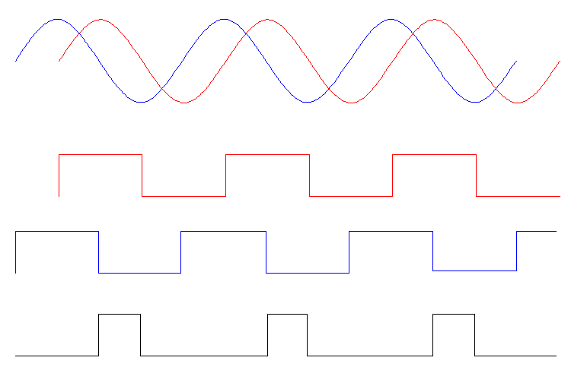
If fast digital circuitry is watching chopper X and Y (Sine and Cosine), then a logic gate is used to fire a logic pulse when X is high and Y hits the zero crossing. The rising edge of this pulse (black) is where Hall B electron packet arrives at the chopper.
I can imagine fast things, like counters running at several Ghz that could give the count from the various items and when they arrive after this trigger. Surely there are ways to do this with slow electronics as well by mixing the frequencies down, but the theory stands. We could definitively know that the buncher needs to be set “X counts” delayed from the main trigger. And each laser needs to fire “X counts” after this trigger. Since we are repetitive in nature, it would all work out.
Using 500 Mhz for the following calculation instead of 499 MHz:
Imagine if the timing source for the counter worked out with “counts=ps”. We could then say that “C” should fire 667 counts (ps) after the master pulse. If it is running at 250 Mhz and it was out of phase, the counter for hall C would 2667 counts (2.667 ns). These counters would just retrigger every few seconds and repeat the count and report to EPICS.
Pipe dream?

