300 kV DC HIGH VOLTAGE PHOTOGUN WITH INVERTED INSULATOR GEOMETRY AND CsK₂Sb PHOTOCATHODE
Y. Wang, P. Adderley, B. Bullard, J. Benesch, J. Grames, F. Hannon, C. Hernandez-Garcia, J. Hansknecht, G. Krafft, R. Kazimi, M. Poelker, M. A. Mamun, R. Suleiman, G. Palacios¹, M. Tiefen-back, S. Wijethunga¹, S. Zhang, Thomas Jefferson National Accelerator Facility, Newport News, VA 23606 USA, ¹Old Dominion University, Norfolk, VA 23529 USA

Abstract
A compact DC high voltage photogun with inverted-insulator geometry was designed, built and operated reli-ably at -300 kV bias voltage using alkali-antimonide pho-tocathodes. This presentation describes key electrostatic design features of the photogun with accompanying emit-tance measurements obtained across the entire photocathode surface that speak to field non-uniformity within the cathode/anode gap. A summary of initial photocathode lifetime measurements at beam currents up to 4.5 mA is presented.

GUN DESIGN
At Jefferson Lab, there was incentive to improve the functionality of a vent/bake style photogun that operates at -350 kV with GaAs photocathode [1] that was used to deliver milliampere beams for the free electron laser [2]. In addition, the JLEIC recirculator-cooler requires very high average current magnetized beams with nanoCoulomb bunch charge [3]. This work describes a new load-locked dc high voltage photogun operated at -300 kV with alkali-antimonide photocathodes. The new photogun relies on an inverted-insulator geometry where the insulator extends into the photogun high voltage chamber and supports the cathode electrode. Design advantages include compact size with relatively small surface area compared to photogun designs that employ large cylindrical insulators, which is good from a vacuum perspective. And because the insulator supports the cathode electrode, there is less metal biased at high voltage, which serves to minimize field emission. And finally, because high voltage is applied to the cathode electrode using a cable, an SF₆ tank is not required at the photogun to suppress corona discharge.

The photogun is a larger version of the -130 kV photogun operated at CEBAF and used to provide spin-polarized electron beams [4] (Figure 1). The new gun employs a longer tapered insulator with vendor-proprietary dopant that provides a small amount of conductivity, with the intended purpose of draining away accumulated charge. Another key difference is the spherical cathode electrode with specially designed screening electrode that reduces the field strength at the triple-point-junction where arcing is thought to originate. The screening electrode also serves to linearize the potential across the length of the insulator, as described below. The cathode electrode – composed of spherical body and screening electrode – was barrel polished to achieve a mirror-like surface finish using two types of abrasives, with total polishing time of just one hour.

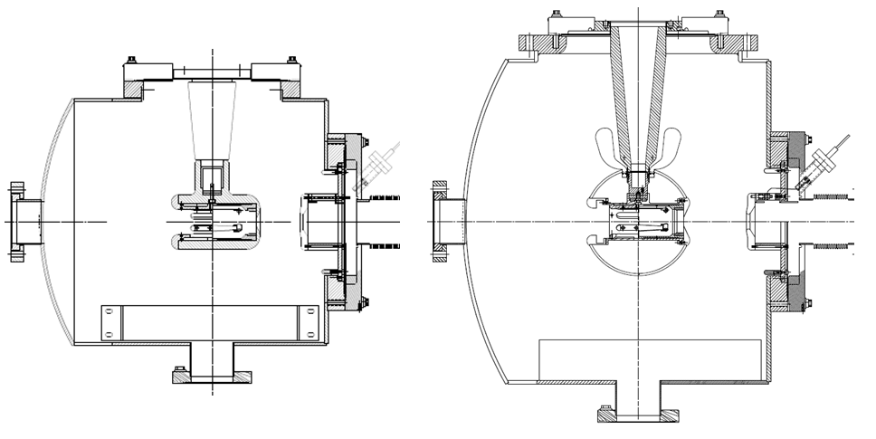

Figure 1: Jefferson Lab photoguns with inverted-insulator designs; (left) CEBAF -130 kV dc high voltage photogun and, (right) the -300 kV dc high voltage photogun described here.

Cathode Electrode
Field emission and high voltage breakdown are often the chief limiting factors related to reliable dc high voltage photogun operation, at least when bias voltages exceed ~ -100 kV. Electrostatic field maps were obtained using the Poisson Superfish electrostatic solver [5]. Iterative adjustments to the electrostatic model served to optimize the diameter of the cathode electrode within the gun chamber, set the cathode-anode gap, and to refine the shape of the triple-point-junction shield with the goal of keeping the electric field strength less than ~ 10 MV/m at -350 kV bias voltage. This led to a cathode/anode spacing of 9 cm and the contour of the shield electrode as shown in Figure 2. The following considerations were given to the shield electrode design:

- The distance between the insulator surface and the shield electrode, and the contour of the shield electrode near the triple-point junction, were adjusted to minimize the electric field strength both parallel and perpendicular to the surface of the insulator. Field-emitted electrons from the triple-point junction can initiate pre-breakdown currents that often lead to arcing along the ceramic insulator at the cable-plug interface.
- The height and radius of the triple-point-junction shield at the “cusp” were adjusted to minimize the electric field at the triple-point junction while keeping the contour field strength less than 10 MV/m at -350 kV. The height of the triple-point junction shield influences the potential along the insulator, especially at the insulator-high voltage plug interface. A “taller” triple-point junction shield will create a more linear potential gradient, but it will increase the field strength at the top because it has moved closer to the grounded vacuum chamber wall.
- The outermost radius of the triple-point junction shield was adjusted to maintain a radius smaller than the spherical electrode radius, in order to minimize distortions to the radial and longitudinal electric field within the anode-cathode gap.

Ideally, the potential along the length of the insulator should vary uniformly, to avoid exposing regions of the insulator to large field strengths, particularly near the triple-point junction. The plot in Figure 2 shows the net result of this electrostatic design and the benefit of the shield electrode, providing a significantly more uniform potential drop across the insulator.

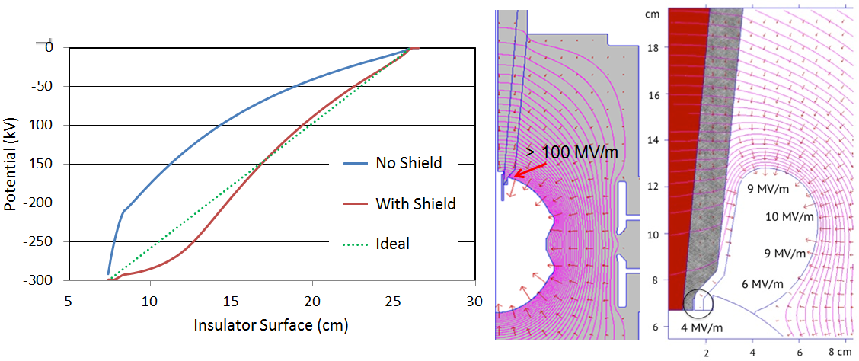Figure 2: POISSON simulated electric field inside the photogun chamber with and without the shield electrode, and the potential along the length of the insulator surface.

Gun High Voltage Conditioning
The purpose of high voltage conditioning is to eliminate field emission when biased at the desired operating voltage. The photogun was connected to a -500 kV dc Cockcroft-Walton SF₆ gas–insulated high voltage power supply (HVPS), with a 300 MΩ conditioning resistor in series. Male-type cable connectors fit precisely into the conical inverted insulator on the photogun, and into a plastic receptacle supporting the conditioning resistor inside the HVPS SF₆ tank. The ceramic insulator, plastic receptacle and the high voltage cable are industry-standard components with dimensions specified by the commercial designation “R30”.

Initially, voltage was applied to the cathode under vacuum conditions (~3x10⁻¹¹ Torr) at a rate of 10 kV/min up to 200 kV, and then in steps of 5 kV at a rate of 1 kV/min when the first vacuum disturbance was encountered at – 225 kV (~ 7 MV/m peak field) as shown by the green trace in Figure 3. The x-ray radiation signal tracks the vacuum activity, with both signals indicating the signature of field emission. At this point, krypton gas was added to the photogun vacuum chamber at pressure ~ 5x10⁻⁵ Torr, and then voltage was raised at a rate of 0.5 kV/min. Gas conditioning serves to eliminate stubborn field emitters through ion bombardment. Field emitted electrons ionize the gas resulting in localized sputtering of the emitter, and also suppressing field emission via ion implantation which serves to increase the local work function [6].

High voltage conditioning to -360 kV in the presence of krypton gas took approximately 70 hours, with numerous field emission sites eliminated. At this point, the krypton gas was pumped away and voltage was re-applied under ultrahigh vacuum conditions. The photogun was deemed conditioned at -350 kV because radiation levels were indistinguishable from background levels. Although conditioning to -350 kV, initial beam operations described here were performed at -300 kV.

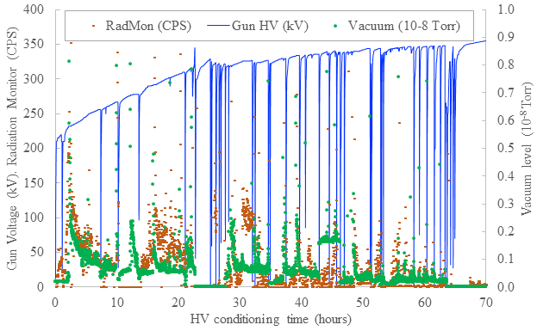
Figure 3: History of photogun high voltage conditioning to -360 kV with krypton gas, and then at -350 kV under vacuum conditions. Gun voltage (blue), vacuum level (green) and x-ray radiation level (orange). During conditioning, radiation and vacuum levels diminish as field emitters were processed out. Sharp vertical lines indicate the voltage tripping OFF, due to field emission current exceeding the current-limit setpoint of the high voltage power supply.

CsK₂Sb Photocathode
Behind the photogun high voltage chamber there is an alkali-antimonide photocathode deposition chamber. Alkali-antimonide photocathodes (nominally CsK₂Sb) were fabricated on GaAs substrates attached to molybdenum “pucks” which can be moved from the deposition chamber into the cathode electrode via a magnetic sample manipulator.

First, antimony (Sb) was deposited onto the GaAs substrate and then cesium (Cs) and potassium (K) using an effusion source that contained both alkali species [7]. Alkali was applied until photocathode quantum efficiency (QE) stopped increasing, achieving typical QE values in the range of 5 to 10% at 532 nm. The active area of the photocathode could be controlled using a mask with different hole sizes: 3, 5, 7 and 13 mm. Once a photocathode was prepared, it was quickly transferred to the photogun.

BEAM EMITTANCE STUDIES

The photogun was attached to a modest diagnostic beamline that will be described in more detail in a future publication. Relevant beamline components for this work include YAG view screens and a wire scanner, used to measure beam emittance, and a Faraday Cup beam dump for photocathode lifetime measurements at milliampere beam current. The transverse beam emittances were measured using the standard solenoid scan technique, where the solenoid current was varied and the beam size at the YAG view screen or wire scanner recorded. The data were later fitted to obtain the emittance. Studies were conducted under different conditions: varying the gun bias voltage, incident laser size, incident laser position on the photocathode, and electron beam current. The emittance near a damaged photocathode spot was also studied. A green light rf-pulsed drive laser was used for all measurements (532 nm, 374 MHz bunch repetition rate, and ~ 35 ps pulsewidth FWHM).

MEASUREMENT RESULTS
Beam emittance was first measured as a function of average current and bunch charge, to find beam conditions not influenced by space charge effects, but at currents sufficiently high to be resolved by the wire scanner electronics. Next, beam emittance was measured as a function of gun bias voltage, validating that normalized emittance values were constant with gun voltage. Finally, beamline optics were identified that provided sufficiently large beam spot sizes during the solenoid scan, that could be accurately measured using the YAG view screen and camera. Measurements were often made with both the YAG screen and wire scanner, to validate results.

With confidence that the emittance measurement techniques were reliable, beam emittance was measured with different laser spot sizes at the surface of the photocathode. The slope of normalized rms emittance as a function of rms laser spot size is often called the thermal angle. Results are summarized in Figure 4. The measured “thermal emittance” value of ~ 0.45 mrad is slightly smaller than published values [8].

Figure 4: Normalized emittance vs laser spot size at the photocathode

Concerned that the triple-point-junction shield electrode could disturb the electric field within the cathode anode gap and degrade beam quality, the beam emittance was measured by scanning the drive laser in X and Y across the photocathode surface. Beam emittance was observed to be uniform within an 8 mm dia. center region, out of the full photocathode diameter of 13 mm (Figure 5). And because long lifetime operation typically requires relatively small photocathode active area [9], it was concluded the shield electrode does not adversely affect the optics of the photogun.

Figure 5: Normalized emittance vs laser position: (top) laser beam moved horizontally, (bottom) laser beam moved vertically across the photocathode surface.

Finally, high average current beam at 4.5 mA was delivered to the beam dump, the maximum current the high voltage power supply could provide. During a six-hour period, photocathode QE fell to 1/e of its initial value after delivering 164 C, a value considerably smaller than reported elsewhere [9], indicating refinements are necessary, such as reducing the photocathode active area, modifying the photocathode recipe, changing the photocathode substrate and/or the vacuum conditions within the gun and beamline that could influence ion production [10].

CONCLUSION AND FUTURE PLAN

A compact dc high voltage photogun was designed and built and operated at -300 kV bias voltage with an alkali-antimonide photocathode. This is the highest bias voltage ever achieved with an inverted-insulator design that offers practical advantages over other designs that employ large cylindrical insulators. The triple-point-junction screening electrode served to linearize the potential across the insulator and does not appear to adversely affect beam quality. The first alkali-antimonide photocathodes manufactured at Jefferson Lab and used to deliver milliampere beam exhibit low thermal emittance values compared to the published data. Future studies will investigate photocathode recipes that provide rough photocathode surfaces, to investigate the impact on beam quality.

ACKNOWLEDGEMENTS
Authored by Jefferson Science Associates, LLC under U.S. DOE Contract No. DE-AC05-06OR23177 and supported by Laboratory Directed Research and Development funding. The U.S. Government retains a non-exclusive, paid-up, irrevocable, world-wide license to publish or reproduce this manuscript for U.S. Government purposes.

REFERENCES

[1] C. Hernandez-Garcia, T. Siggins, S. Benson, D. Bullard, H. F. Dylla, K. Jordan, C. Murray, G. R. Neil, M. Shinn, and R. Walker, “A high average current dc GaAs photocathode gun for ERLs and FELs”, Proceedings of the 2005 Particle Accelerator Conference, Knowxville, TN, USA, pp. 3117-3119, 2005

[2] G. R. Neil, C. Behere, S. V. Benson, M. Bevins, G. Biallas, J. Boyce, J. Coleman, L. A. Dillon-Townes, D. Douglas, H. F. Dylla, R. Evans, A. Grippo, D. Gruber, J. Gubeli, D. Hardy, C. Hernandez-Garcia, K, Jordan, M. J. Kelley, L. Merminga, J. Mammosser, W. Moore, N. Nishimori, E. Pozdeyev, J. Preble, R. Rimmer, M. Shinn, T. Siggins, C. Tennant, R. Walker, G. P. Williams, S. Zhang, “The JLab high power ERL light source”, Nucl. Intstr. Meth. A 557 9, (2006)

[3] S. Benson, Ya. Derbenev, D. Douglas, F. Hannon, A. Hutton, R. Li, R. Rimmer, Y. Roblin, C. Tennant, H. Wang, H. Zhang, Y. Zhang, “Development of a bunched-beam electron cooler based on ERL and Circulator Ring technology for the Jefferson Lab Electron-Ion Collider”, 11th Workshop on Beam Cooling and Related Topics, COOL2017, Bonn, Germany, JACoW Publishing ISBN: 978-3-95450-198-4, doi: 10.18429/JACoW-COOL2017-WEM12
[4] P. A. Adderley, J. Clark, J. Grames, J. Hansknecht, K. Surles-Law, D. Machie, M. Poelker, M. L. Stutzman, and R. Suleiman, “Load-locked dc high voltage GaAs photogun with an inverted-geometry ceramic insulator”, Phys. Rev. ST Accel. Beams 13, 010101 (2010)

[5] K. Halbach, “LANL SUPERFISH”, Lawrence Livermore National Laboratory Technical Report No. UCRL-17436, 1967

[6] M. BastaniNejad, A. A. Elmustafa, E. Forman, J. Clark, S. Covert, J. Grames, J. Hansknecht, C. Hernandez-Garcia, M. Poelker and R. Suleiman, Improving the performance of stainless-steel DC high voltage photoelectron gun cathode electrodes via gas conditioning with helium or krypton, Nucl. Instr. and Meth. in Phys. Res. A, Vol. 762, pp. 135–141, 2014

[7] Md Abdullah A. Mamun, Abdelmageed A. Elmustafa, Carlos Hernandez-Garcia, Russell Mammei, and Matthew Poelker, "Effect of Sb thickness on the performance of bialkali-antimonide photocathodes", J. Vac. Sci. Technol. A 34 021509 (2016)

[8] Ivan Bazarov, et al., “Thermal emittance measurements of a cesium potassium antimonide photocathode”, Appl. Phys. Lett. 98, 224101 (2011).

[9] B. Dunham, A. Bartnik, I. Bazarov, L. Cultrera, J. Dobbins, G. Hoffstaetter, B. Johnson, R. Kaplan, V. Kostroun, S. Karkare, Y. Li, M. Liepe, X. Liu, F. Loehl, J. Maxson, P. Quigley, J. Reilly, D. Rice, D. Sobol, E. Smith, K. Smolenski, M. Tigner, V. Veshcherevich, Z. Zhao, "Record high-average current from a high-brightness photoinjector", Appl. Phys. Lett. 102, 034105 (2013)

[10] S. Full, A. Bartnik, I.V. Bazarov, J. Dobbins, B. Dunham, G.H. Hoffstaetter, "Detection and clearing of trapped ions in the high current Cornell photoinjector", Phys. Rev. Accel. and Beams 19, 034201 (2016)

