UITF PSS BCM Electronics Characterization
Trent Allison, Jim Kortze, Jerry Kowal, John Musson
10/19/2016

Background
The PSS BCM electronics starts with a Beam Current Monitor (BCM) cavity that puts out -40dBm of 1497MHz signal for 1uA of electron beam. That signal goes to a DC10 down converter in a euro crate that mixes the signal down to 1MHz with a gain of 30dB. From there the 1MHz signal goes to another euro crate and is detected by a RMS-to-DC Converter Card that outputs a DC voltage to an Equalizer Card which trims the gain to yield 5V for 5uA of beam. The output from the Equalizer goes to an Integrator Card which integrates the signal once it surpasses a certain level then trips after integrating up to a threshold. The RMS-to-DC and Equalizer Cards have adjustable gain via potentiometers. The Integrator Card has a potentiometer to adjust the level at which the integration starts but the trip threshold and integration time are set with static capacitors and resistors.
The PSS BCM system in CEBAF is mainly used to protect the beam stoppers. If the CW beam current surpasses 1uA then the Integration Card integrates up and trips after some time which is then expressed in uA usec. The integrator is setup so that Tune beam (8uA of beam pulsed for 250usec with a 60Hz repetition) does not cause a trip.

Testing
The minimum detectable signal was measured to be 40nA by looking at the Equalizer output (blue trace in the pictures, 5mV/division) with no inputs signal and then ramping up the input until the Equalizer output was above the noise. This was verified to be the same with and without the Down Converter (using a 1497MHz source with the DC10 versus a 1MHz source without the DC10). We also turned the gains all the way up on the RMS-to-DC Converter and Equalizer Cards and repeated the test to find a minimum detectable signal of 30nA, which is not a large improvement.

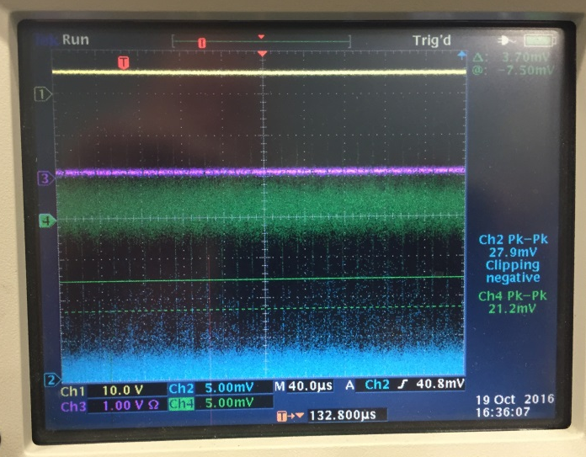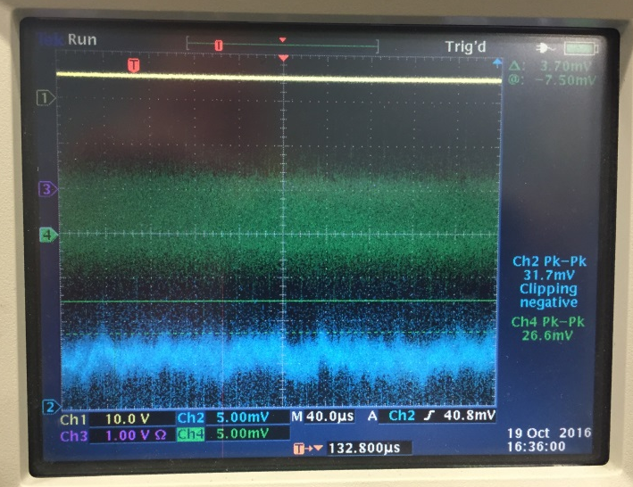
Equalizer output with no input Equalizer output with 40nA of beam

The integration time was measured to be 2,250 uA usec. To make this measurement we first setup the Integrator Card to begin integrating at 1uA and verified the trip limit with a CW input. Then we pulsed the input for 250usec with a 60Hz repetition (Tune beam setup) and varied the signal strength. It tripped at 9uA of beam after 250usec. In the figure below the trip is yellow (0 = fault), the integrator is red, the 1MHz input is green, and the equalizer output is blue.

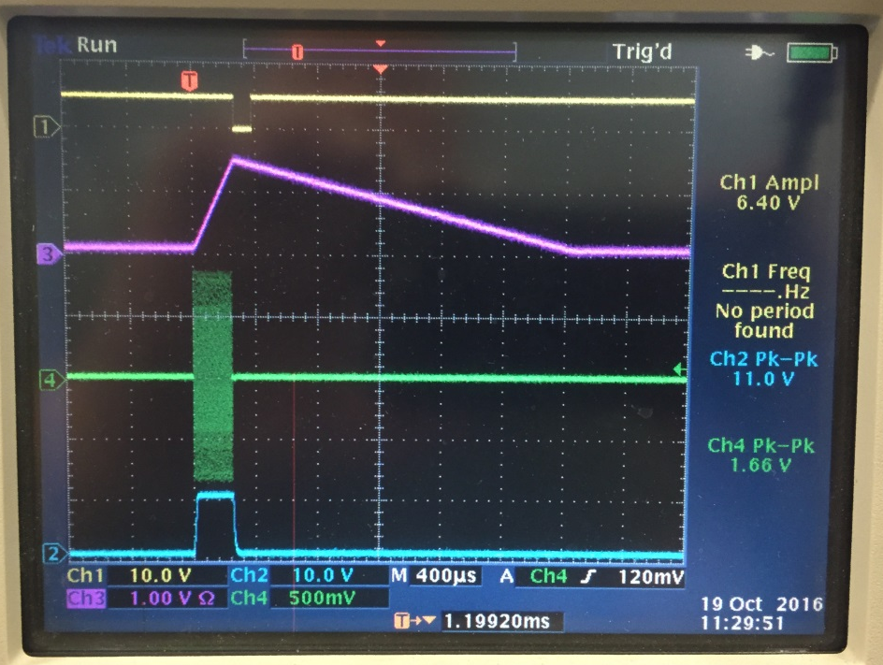

We also setup the integrator to begin integrating at 100nA and repeated the pulsed Tune beam test. You can see in the figure below that the Equalizer output is 100mV with about 30mV of noise. With the integrator set to start at 100nA, the max Tune beam before a trip was 4.5uA.

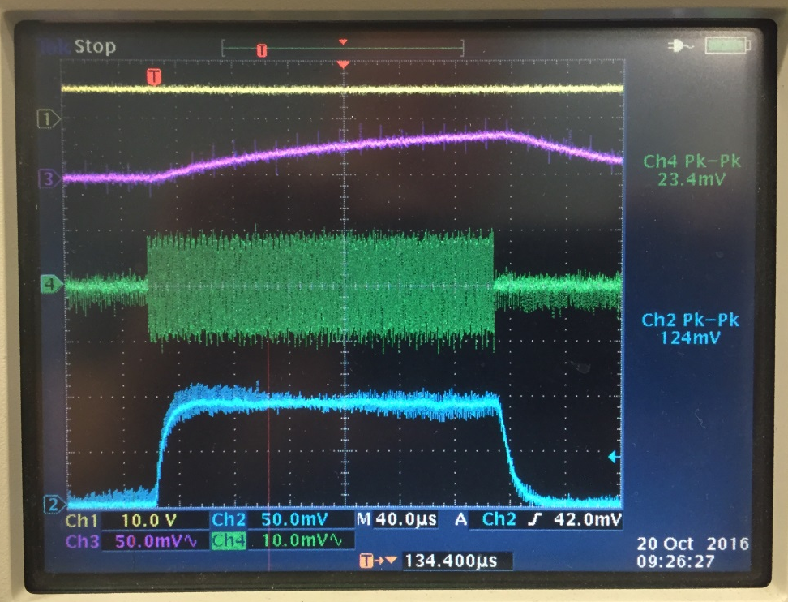
We looked at archived beam current and temperature data from the BLA system BCM cavities (Q of 500) and determined that the output of the PSS BCM cavities (Q or 1500) vary by about 5% for a 1 degree F change in temperature. So if the integration begins at 1uA and the cavity temperature drifts by 10 degrees F then the detected beam current could vary by 500nA (if we use 100nA then it would vary by 50nA). The variation could be lowered by temperature controlling the cavities and/or de-Qing the cavities, both changes would be non-standard for the PSS BCM system. We have not temperature cycled the electronics to determine the effect on the measured beam current.
The following equation (derived from a MAFIA model and verified experimentally) was used to determine the signal output of a BCM cavity and fill in the chart below. The test setup did not take in account any cable losses so the minimum detectable signal will be higher than what was measured. For example, if we lose 5 dBm with a 100’ cable run then the 40nA minimum will be closer to 70nA.

$$BCM Power in dBm= 20*Log(10000*Beam Current)$$

Beam Current | BCM Output | Equalizer Output
10 nA | -80 dBm | 10 mV
20 nA | -74 dBm | 20 mV
50 nA | -66 dBm | 50 mV
100 nA | -60 dBm | 100 mV
200 nA | -54 dBm | 200 mV
500 nA | -46 dBm | 500 mV
1 uA | -40 dBm | 1 V

Conclusions
There is a proposal to use the PSS BCM system to limit the beam current to 100nA in the UITF to protect people outside the shielded enclosure from radiation. From our test data, it appears that the lowest the system could go would be 400nA with a variation of +/-80nA. Any lower and the system will likely cause numerous false trips and require tweaking often.
In an ideal setting on the bench, we were able to set it to 100nA but that did not include cable loses or temperature drifts which adversely affect the minimum detectable signal. It may be possible to increase the integration time and lower the level to 200nA but that would require changing components on the integrator card. To achieve 100nA the down converter and/or RMS-to-DC converter would need to be redesigned to increase the frontend gain and detection sensitivity.

