TITLE: THE TEST RESULTS OF THE MHD STEERING CORRECTOR MAGNET

BY: Seetha-Lakshmi Lalitha | DATE: 05 /11/2021
Reviewer: Joe Grames
Approver: Joe Grames

- | The initial release | 04/26/2021
REV. | DESCRIPTION | DATE
SUMMARY OF CHANGES FROM PREVIOUS REVISION:

Contents
1 Context 3
2 Results and Discussion 4
3 Acknowledgment 6
4 References 6

Context
The new MHD type steering corrector magnet (Figure 1) in the aperture girder assembly of the CEBAF 200 keV injector beamline consists of two identical and independently energized dipole coil assemblies to provide the vertical and horizontal steering correction as needed for the beam transport. The horizontal steering correction to the beam is achieved by the vertical dipole coil assembly with the top and bottom pancake coils connected in series. Similarly, the horizontal dipole coil assembly of the left and right pancake coils offers the vertical beam steering correction. The magnet design, functional requirements, manufacturing and assembly details as well as the test plan are discussed elsewhere []. This document focuses on the inspection results of the coils and the analysis of the magnetic measurement data and inter-comparison with the results of three-dimensional electromagnetic simulation based on a model with the actual dimensions of the coils and parts fabricated for the assembly.
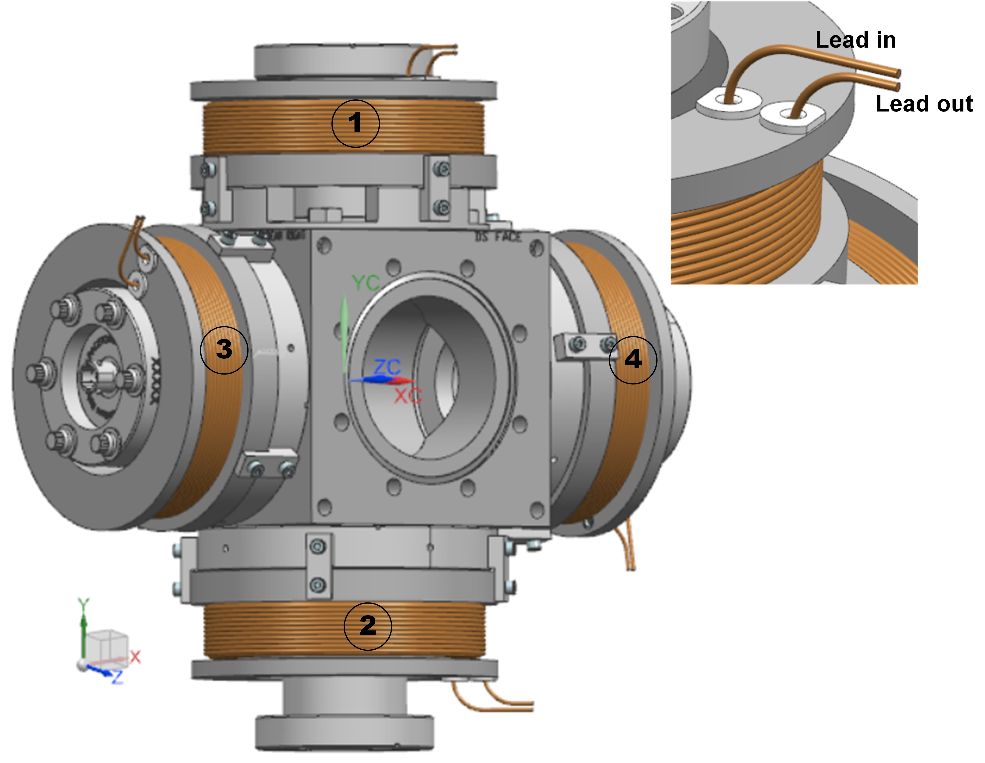
Figure 1: The MHD steering corrector magnet mounted onto the CF six-way cross cube []. The physical orientation of the assembly is such that coordinates x=0, y=0, and z=0 represent the magnet center and +Z axis point to the direction of the beam. The labels 1, 2, 3, and 4 represent respectively the top, bottom, left, and right coils in the MHD magnet. This labeling scheme follows the assumption that the observer is facing towards the magnet assembly from the exit side of the beam. Further, the top right panel in the inset of the figure shows the lead wires (lead-in and lead-out) from the coil pack.
From the functional standpoint, the horizontal and vertical dipole coil assembly, when energized separately, is required to provide a maximum integrated dipole field strength of 5.5×10⁻ ⁵ T.m (55 Gauss-cm) along the central trajectory [1]. Considering the similarity in design, construction, and performance of both dipole assemblies in the MHD magnet, the magnetic measurements were performed on the vertical dipole coil assembly to validate the magnet performance. The quality assurance plan for the coils and the magnetic test details are discussed in section 8 of the design report [1].

Results and Discussion
  - Quality assurance test results (Tests performed by the manufacturer before shipping the coils to the J Lab)
The hipot and surge tests were performed at 1000 V. The hipot results indicate that leakage current was less than 0.02 µA for all coils. The surge tests rule out the presence of any internal electrical shorts in the winding pack. The nominal value of the resistance at 20 C of the coil (including the lead wires) is ∼0.26 Ω and the coil inductance at 60 Hz is ∼1.1 mH. These data are in close agreement with the values obtained from the design calculations [1].
  - The results of quality assurance tests performed at JLab
The visual inspection results of pancake coils (Quantity: 12): The winding looks neat. The lead wires are secured in place and no noticeable kinks or aberrations where the lead wires exit from the winding pack.
All coils passed the hipot and surge tests at 500 V. The measured values of resistance and inductance [] are in close agreement with the test results from the manufacturer. Temperature studies suggest that the coil temperature at 4 A reaches a maximum of ∼36°C [3].
  - Magnetic measurement results
The anomaly and also the drift in the background signal (Figure 2) limits a reliable analysis of the magnetic field characteristics and quantification of the magnetic performance. The anomaly is possibly due to the additional weak magnetic contribution from the cube parts. The eddy current effects cannot be ruled out. From the inferences of the detailed evaluation and a careful analysis of the whole data, a decision has been made to validate the magnetic performance and benchmark the design using the measured vertical field profile only along the central axis (X=0, Y=0 and Z=±0.5 m) for coil operating current (I) up to 4 A (See Figure 3 for details).
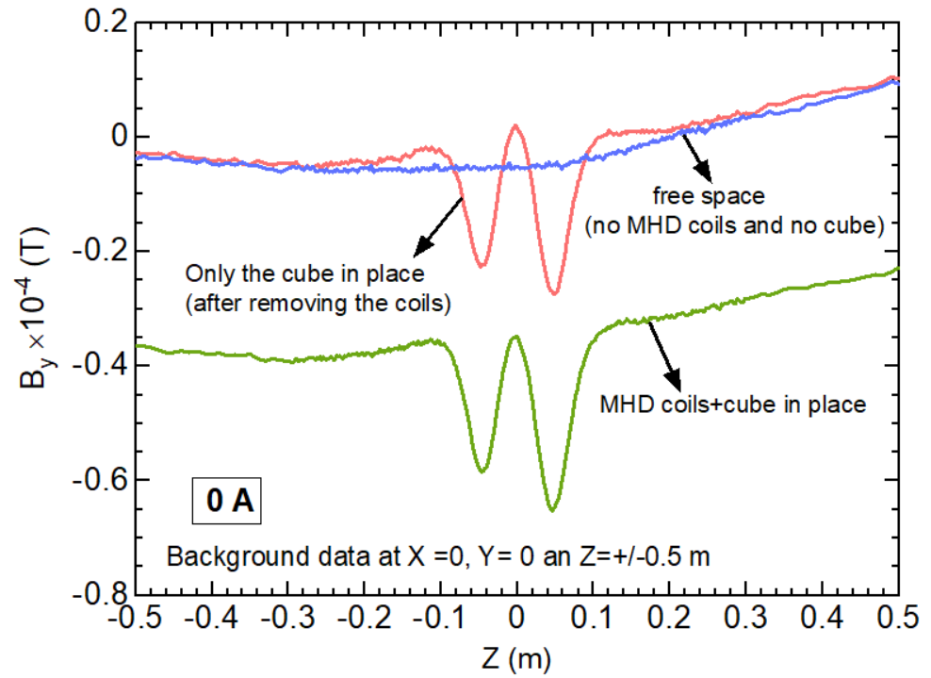
Figure 2: The background data (at I=0) over Z=±0.5 m from the magnet center (X=0, Y-=0, Z=0) of the MHD vertical dipole coil assembly. See section 8 of [1] for the measurement details.
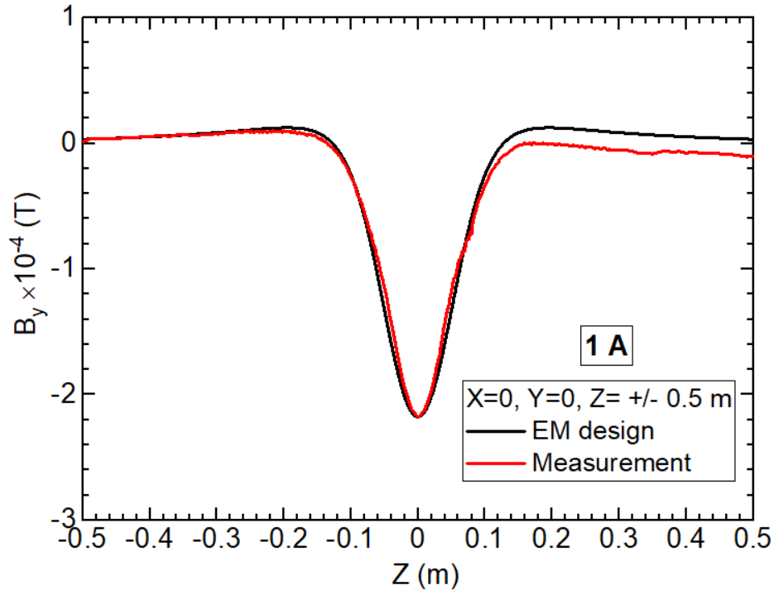 | 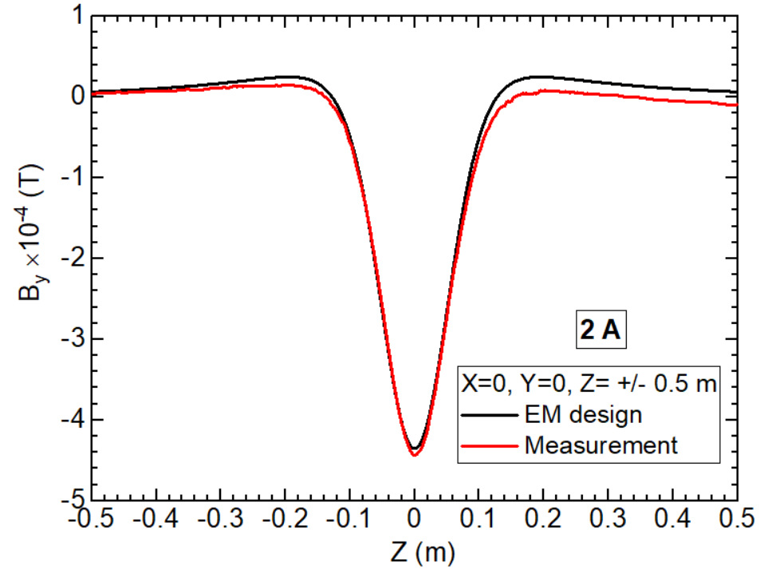
(a) | (b)
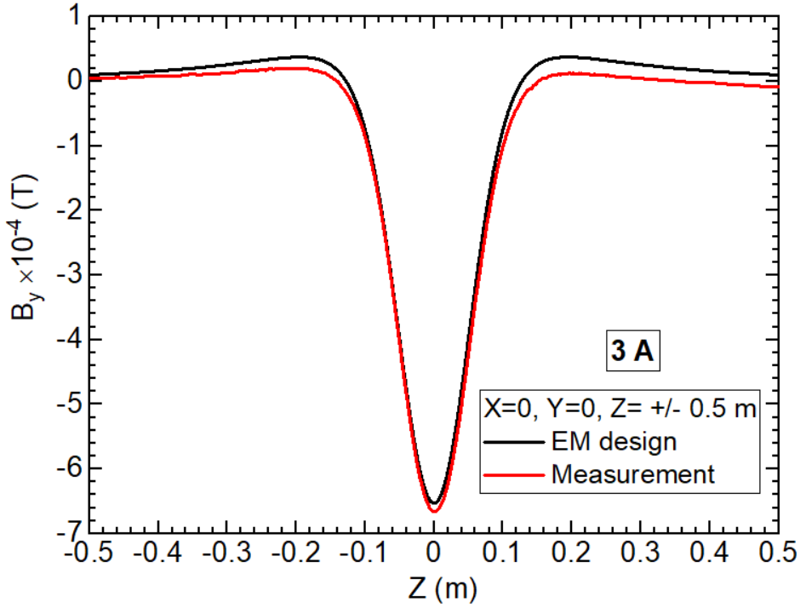 | 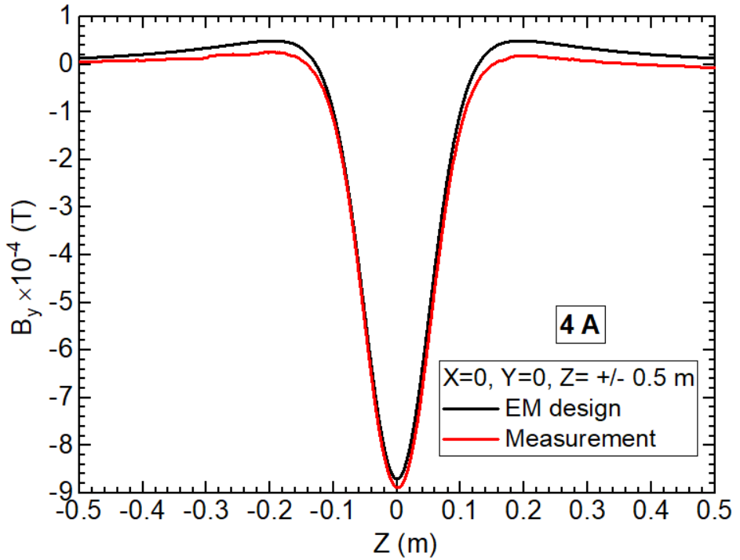
(c) | (d)
Figure 3(a)-(d): The vertical field (B_{y}) profile over Z=±1m from the magnet center (X=0, Y-=0, Z=0) of the MHD vertical dipole coil assembly for coil excitation currents ≤ 4A. The black line shows the data obtained from the three-dimensional electromagnetic simulation of the production coil assembly whereas the red line represents the measured data.
Table 1: Value of the vertical field component (B_{y}) at the magnet center X=0, Y-=0, Z=0) of the MHD vertical dipole coil assembly for coil excitation currents ≤ 4A.
Operating current  (A) | Vertical field strength (B_{y})  at the magnet center ×10⁻⁴ (T) |  | Difference between the values obtained from EM design simulation and magnetic measurement (%)
 | EM Design simulation | Magnetic measurement
1 | -2.182 | -2.177 | 0.3
2 | -4.433 | -4.353 | 1.8
3 | -6.661 | -6.530 | 2.0
4 | -8.890 | -8.706 | 2.1

As shown in Figure 3(a), the measured and computed field profile at 1 A along the central axis overlaps reasonably well except beyond z=0.15 m. The center field values at 1 A agree within 0.3 % (Table 1) whereas the difference between the calculated and measured values of the peak field strength at higher currents at 4 A is about 2.1 %. The observed overall mismatch between the field profiles from measurements and EM simulation studies is mainly attributed to the uncertainty in the Hall probe location over the scan region and the drift in the background signal over the duration of the measurement. Considering the limitations of the measured field data, the computed field data is used to provide the relevant parameters (See Table 7 of [1]] to the CEBAF machine control system.

Acknowledgment
The coil tests and magnetic measurements were performed by J. Meyers and M. Beck.

References

[] S-L. Lalitha, “The Design Report of MHD Steering Corrector Magnet in the CEBAF 200 keV Injector Beamline”, J Lab internal document #MEG0002021-R001 REV-, April 2021.
[] J Lab 3D NX CAD Model JL0091130-0304: Aperture 1 assembly.
[] M:\MagTest\DataBase\Injector\HD\Traveler\MHD coil inspections with temperatures 12-01-20.xlsx

