The Neutral-Particle Spectrometer

*White Paper outlining the Science and Path to Realization of the NPS*

The Neutral-Particle Spectrometer (NPS) Collaboration at Jefferson Lab

November 26, 2014

The two-arm combination of neutral-particle detection and a high-resolution magnetic spectrometer offers unique scientific capabilities to push the energy scale for studies of the transverse spatial and momentum structure of the nucleon through reactions with neutral particles requiring precision and high luminosity. It enables precision measurements of the deeply-virtual Compton scattering cross section at different beam energies to extract the real part of the Compton form factor without any assumptions. It allows measurements to push the energy scale of real Compton scattering, the process of choice to explore factorization in a whole class of wide-angle processes, and its extension to neutral pion photo-production. It further makes possible measurements of the basic semi-inclusive neutral-pion cross section in a kinematical region where the QCD factorization scheme is expected to hold, which is crucial to validate the foundation of this cornerstone of 3D transverse momentum imaging.

We describe the unique science program as enabled by a Neutral-Particle Spectrometer (NPS) and the HMS/SHMS magnetic spectrometer pair in Hall C at Jefferson Lab, and a cost-effective path to realization. At the time of this writing, five experiments have been approved by the Jefferson Lab Program Advisory Committee. The compatibility of the detector with existing infrastructure in both high-luminosity Halls A and C, including the possibility of using various polarized targets, allows for exploration of further scientific directions.

1. **Executive Summary**

Nowadays, CEBAF has become the world's most advanced particle accelerator for investigating the nucleus of the atom, the protons and neutrons making up the nucleus, and the quarks and gluons inside them. The 12-GeV beam will soon allow revolutionary access to a new representation of the proton’s inner structure. In the past, our knowledge has been limited to one-dimensional spatial densities (form factors) and longitudinal momentum densities (parton distributions). This cannot describe the proton’s true inner structure, as it will, for instance, be impossible to describe orbital angular momentum – an important aspect for nucleon spin – for which we need to be able to describe the correlation between the momentum and spatial coordinates. A three-dimensional description of the nucleon has been developed through the Generalized Parton Distributions (GPDs) and the Transverse Momentum-Dependent parton distributions (TMDs). GPDs can be viewed as spatial densities at different values of the longitudinal momentum of the quark, and due to the space-momentum correlation information encoded in the GPDs, can link through the so-called Ji sum rule to a parton’s angular momentum. The TMDs are functions of both the longitudinal and transverse momentum of partons, and they offer a momentum tomography of the nucleon complementary to the spatial tomography of GPDs.

The tomography of the nucleon is one of the flagship science programs of Jefferson Lab that is fully enabled by the combination of the foreseen equipment in Halls A, B and C. In Hall C, the coincidence magnetic spectrometer setup of existing HMS and new SHMS will support high-luminosity experiments detecting reaction products with momenta up to the full beam energy. This is well matched to make precision determinations of quarks in nucleons, including a characterization of the *anticipated GPD and TMD behavior*. A neutral-particle spectrometer (NPS) would enable important capabilities to Hall C’s (and potentially Hall A’s) science program.

The Neutral-Particle Spectrometer in Hall C will especially allow accurate access to measurements of so-called hard exclusive (the recoiling proton stays intact in the energetic electron-quark scattering process) and semi-inclusive (the energy loss of the electron-quark scattering process gets predominantly absorbed by a single pion or kaon) scattering processes. To extract the rich information on proton structure encoded in the GPD and TMD frameworks, it is of prime importance to show in accurate measurements, pushing the energy scales, that the scattering process is understood. Precision measurements of real photons or neutral-pions with the NPS offer unique advantages here, as recognized by Jefferson Lab’s Program Advisory Committee who approved five experiments foreseen with the NPS, in three run group periods (Table I).

Table I Approved Science Program with the Neutral-Particle Spectrometer

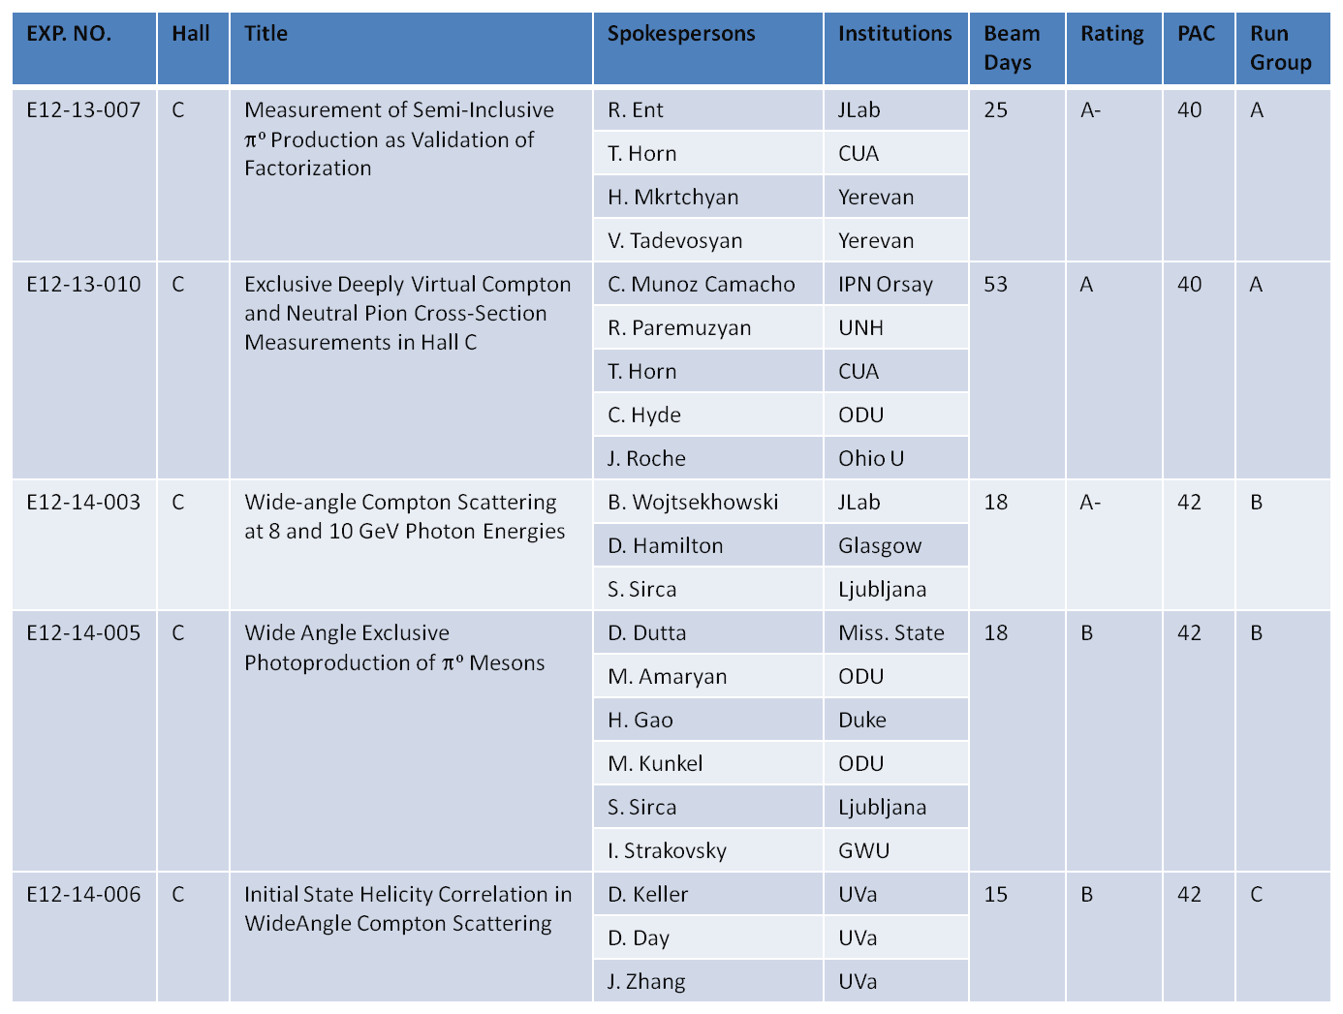

1. **The Neutral-Particle Spectrometer Science Program**

The NPS is envisioned as a facility in Hall C, utilizing the well-understood HMS and the SHMS infrastructure, to allow for precision (coincidence) cross section measurements of neutral particles ( and 0). The NPS will be remotely rotatable off the SHMS platform. Such a facility enables a unique science program at a 12-GeV Jefferson Lab. As shown in Table I above, the Jefferson Lab Program Advisory Committee has positively endorsed this view, and approved at this time already five experiments. Below, we will give a short science synopsis of each of these five.

Exclusive Deeply Virtual Compton and Neutral Pion Cross Section Measurements

Generalized Parton Distributions (GPDs) provide an unprecedented means to describe nucleon structure allowing for a nucleon as a 3-dimensional object. The GPD program is at the heart of the scientific motivation of the 12 GeV upgrade of JLab. Deeply virtual Compton scattering is the cleanest or golden channel to study GPDs. As the DVCS process interferes with the Bethe-Heitler process, one can access the DVCS amplitudes. At leading twist and leading order, one determines Compton form factors, which are integrals of GPDs over Bjorken x with a kernel to describe the hard photon-quark interaction. Present analyses assume dominance of several GPDs, validity of twist-2 dominance, and a leading-order formalism. The GPD program at JLab with 12 GeV has the ambition to go beyond these analyses. The primary goals of the different DVCS experiments at JLab with 12 GeV reflect the complementarity between the different Halls: 1) A measurement of beam spin asymmetries and cross sections in Hall A (E12-06-114) will provide a precision test of scaling for selected kinematical points. 2) A survey over a wide kinematic range of unpolarized and polarized DVCS observables will be performed in Hall B (E12-06-119) to provide an unprecedented DVCS data set. 3) The present NPS experiment (E12-13-010) will be in the unique position, using the spectrometer capability in Hall C, to provide a precision measurement of the cross section measured at different beam energies in order to fully disentangle Compton scattering, Bethe-Heitler contributions, and their interference (after subtracting the known Bethe-Heitler contribution). The analysis of the azimuthal angular distributions will then allow for a determination of the real part of the Compton form factor without any assumptions.

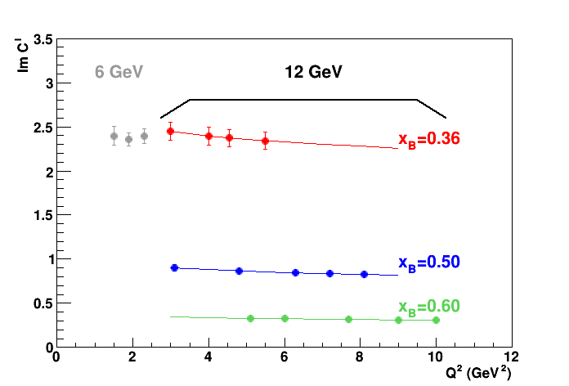

Fig. 1 (left) Kinematics coverage for deep exclusive reactions as accessible with a 12-GeV Jefferson Lab in high-luminosity Halls A and C. The colors indicate accessibility at varying beam energies relevant to separate Compton scattering and Bethe-Heitler contributions; (right) Extraction of the imaginary part of the Compton form factor from a combination of approved Hall A and Hall C/NPS experiments.

Measurement of Semi-inclusive 0 production as Validation of Factorization

This experiment runs in parallel with the one above. The goal of this experiment E12-13-007 is to measure the basic semi-inclusive neutral-pion cross sections in a region where the parton interpretation is thought to be valid. An accurate experimental validation of this interpretation is needed for most of the program related to Transverse Momentum Dependent Parton Distributions. In fact, the PAC stated “the cross sections are such basic tests of the understanding of SIDIS at 11-GeV kinematics, that they will play a critical role in establishing the entire SIDIS program of studying the partonic structure of the nucleon.” Neutral pion production offers multiple experimental advantages, a lack of diffractive  🡪  contributions, no pion-pole contributions, reduced nucleon resonance contributions, and proportionality to an average fragmentation function. These are all points in favor of an accurate semi-inclusive neutral-pion production program to validate the SIDIS science output. In the end, mapping the transverse momentum dependence (at low transverse momentum < 0.5 GeV) will allow to, together with the equivalent charged-pion data, perform a flavor decomposition of the transverse momentum of (un-polarized) up and down quarks. We know by now, based on initial data, based on lattice QCD calculations, and based on nucleon models, that the transverse momentum widths of quarks with different flavor (and polarization) can be different.

Wide-angle Compton Scattering at 8 and 10 GeV Photon Energies

This experiment, E12-14-003, aims to measure the cross section for real Compton scattering from the proton at an incident photon energy of 8 GeV and 10 GeV (corresponding to values of center-of-mass (c.m.) energy squared s = 15.9 and 19.6 (GeV/c)2, respectively) at wide c.m. scattering angles (in the range between 50º and 105º). Previous 6 GeV JLab data have shown a clear indication for a partonic handbag mechanism in the wide-angle Compton Scattering (WACS) process – the process takes place on a single quark, in stark contrast with the perturbative QCD picture which involves three active quarks exchanging two hard gluons. How such a quark is embedded in the nucleon and if a factorization between the partonic sub-process and its embedment in the nucleon can be formulated in a more systematic way are still open questions, motivating these cross section measurements. The present experiment aims to extend the kinematic range of previous JLab WACS experiments by a factor of 2, and can determine the Compton form factor, R(t), up to momentum-transfer squared t values of about 10 GeV2, corresponding to the small distance scales of direct relevance for Jefferson Lab’s nucleon form factor program.

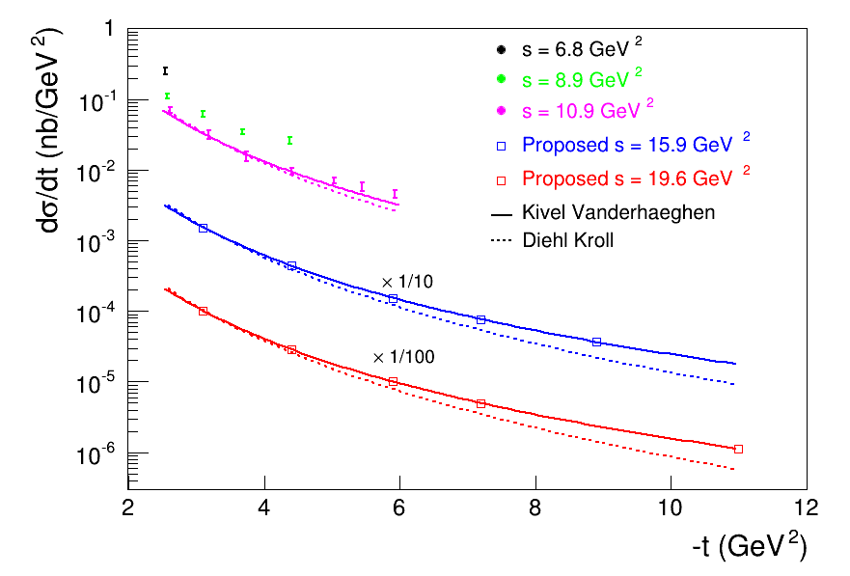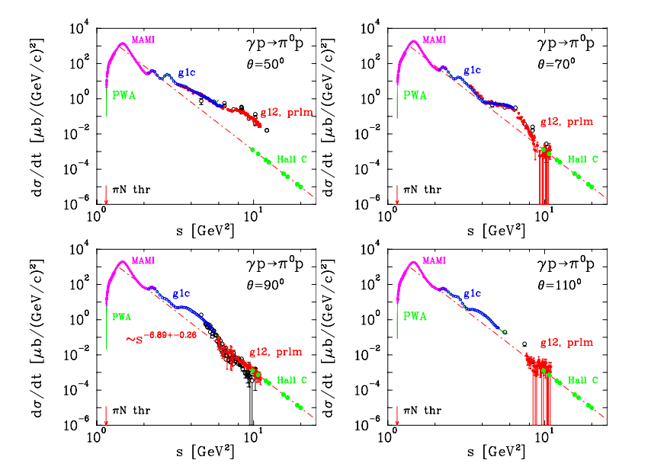Fig. 2 (left) Wide-angle Compton scattering cross section projected measurements from the E12-14-003 experiment constraining the Compton form factor to momentum transfer squared t values of about 10 GeV2; (right) Projected cross section measurements for wide-angle exclusive photo-production of neutral pions at a center-of-mass angle of 90o, extending preliminary CLAS g12 measurements to energy scales s of 20 GeV2.

Wide Angle Exclusive Photoproduction of 0 Mesons

This experiment runs in parallel with the one above. It aims to measure the differential cross-section p 🡪 0p process in the energy range 10 GeV2 < s < 20 GeV2 at large pion center of mass angles between 55° and 105°. The measurement will be carried out using an electron beam impinging on a 6% copper radiator and a liquid hydrogen target. The recoil proton will be detected in the HMS spectrometer and photons from the 0 🡪  decay will be detected in the Neutral Particle Spectrometer. The energy range and the scattering angles are large enough to allow the description of the process in terms of partonic interactions and the exploration of the elementary mechanism at work. The data will extend studies of the scaling behavior of the cross-section and allow for comparisons to handbag calculations — which severely under-predict existing cross sections — at higher energies than previously measured. The expected results could spur further theoretical development and test the limits of the Generalized Parton Distribution formalism for exclusive reactions.

Initial State Helicity Correlation in Wide-Angle Compton Scattering

The aim of this experiment, E12-14-006, is a study of the reaction mechanism of the simple exclusive wide-angle Compton Scattering (WACS) reaction. Previous JLab polarization transfer data have shown a clear indication for a partonic mechanism in the WACS process. The target polarization observable ALL proposed would complement the pioneering measurement of the recoil observable KLL. In the simplest picture where the Compton process takes place on a single massless quark, both observables are equal. The difference between the observables is indicative of the scale at which one approaches the leading order partonic mechanism for WACS. Any difference between the polarization observables KLL and ALL will allow to study the size of power-suppressed corrections to WACS, *e.g*. due to quark mass effects in a constituent quark model framework for such power corrections, or to dressed-quark mass effects in a Dyson-Schwinger Equation approach.

1. **Path to Realization**

We aim to develop and construct a neutral-particle spectrometer required to carry out the Jefferson Lab 12 GeV Hall C neutral particle physics program. Much of the NPS hardware is envisioned to be compatible also with operation in Hall A. The NPS will be a shared instrument for about 150 researchers. Special demands with respect to speed of readout, energy, spatial, and timing resolution, operation in a high-rate environment, geometry, and flexibility are imposed on the design of the instrument. The design of the NPS is based on that of the existing HyCal and DVCS/PbF2 calorimeters, which were built and operated successfully by NCA&T and ODU/OU/Orsay at a 6-GeV Jefferson Lab.

The research instrument is an efficient and economical way to meet the experimental requirements of the approved science program, in that it takes maximum advantage of existing spectrometer infrastructure (*e.g*., to allow for rapid remote rotation) and can take advantage of existing PbWO4 and/or PbF2 crystals, that were used for the PRIMEX and PRIMEX-II experiments in Hall B and the DVCS experiments in Hall A.

The NPS as operated in Hall C will have the following components:

* A detection array of up to 1116 scintillating PbWO4 and up to 208 PbF2 crystals. Both types are fast (PbWO4: 5-14 ns, and PbF2: < 30 ns) and suitable for the proposed experiments in a high-rate environment, which require fast signals with short tails to minimize pile-up at high rates.
* A temperature controlled frame.
* A cantilevered platform of the SHMS carriage to allow precise, remote rotation around the Hall C pivot over an angular range between 6 and 30 degrees (an angle range of 25 to 60 degrees is accessible by positioning the detector on the SHMS carriage itself).
* A horizontal-bend sweeping magnet with integrated field strength of 0.3 Tm for the small-angle operation, and a vertical-bend sweeping magnet with integrated field strength of 0.6 Tm for the large-angle operation. Both are designed to use the same power supply.
* Pipeline digitizing electronics to independently record the pulse amplitudes of each crystal – these mostly exist.
* A set of high-voltage distribution bases with built-in active amplifiers for operation in high-rate environments – these were designed and prototyped by the collaboration over the last two years and provide a factor of 25 improvement in linearity over existing passive bases of HyCal.
* A light monitoring and blue light optical curing system to monitor and restore crystal optical properties – the present emphasis of the collaboration is to develop a novel in-situ monitoring and curing system.

The NPS design allows for neutral particle detection fulfilling all requirements of the approved experiments, *e.g*., detection over a large angular range between 6 and 60 degrees, a range of positions of the crystal calorimeter between 3 meter and 11 meter from the experimental target, with 2-3 mm spatial and 1-2% energy resolution. At a 4 meter distance the spectrometer covers a large solid angle of 25 msr.

The NPS development and construction can be split in two parts: Part-I equates to the NPS infrastructure – this includes all items relevant to develop and construct the NPS facility, but assumes the use of existing PbWO4 and/or PbF2 crystals. The total cost estimate for this part is estimated to be below $1 million, and is the subject of an NSF Major Research Instrumentation grant proposal; Part-II includes improved NPS crystals – to create a new detector of dedicated radiation-hard PbWO4 crystals, and is estimated to add about $1.5 million to the NPS infrastructure costs. The NPS collaboration has joined a world-wide R&D effort to develop reliable production and quality assurance methods of radiation-hard PbWO4 crystals, in close collaboration with the U. Giessen/PANDA efforts and the generic EIC-related detector R&D program.

1. **Resolution**

The Neutral-Particle Spectrometer will be critical to confirm the understanding of the theoretical foundation of the three-dimensional structure of the proton, both in the areas of spatial tomography through the GPD formalism and momentum tomography through the TMD formalism. It allows, through precision measurements of the deeply-virtual Compton scattering cross section at different beam energies, extraction of the real part of the Compton form factor without any assumptions. It allows measurements to push the energy scale of real Compton scattering, the process of choice to explore factorization in a whole class of wide-angle processes, and its extension to neutral pion photo-production. It further makes possible measurements of the basic semi-inclusive neutral-pion cross section in a kinematical region where the QCD factorization scheme is expected to hold. Further ideas to utilize the Neutral-Particle Spectrometer for time-like scattering cross section and polarization measurements are under investigation.

In view of the rich science program enabled by accurate measurements of neutral particles such as photons and neutral-pions, and the cost-effective solution to create a remotely rotatable and movable neutral-particle detection facility in a high-luminosity environment, we *urge timely construction of the NPS*. The equipment funds to construct the NPS are estimated to be below $1 million for the NPS infrastructure alone, and $2.5 million including both the NPS infrastructure and new radiation-hard PbWO4 crystals.

The preparations for the development of the Neutral-Particle Spectrometer have started at various US institutions – Catholic University of America, Ohio University, Old Dominion University, Mississippi State University, University of Virginia, and Jefferson Lab – in collaboration with international institutions – Glasgow University (UK), IPN Orsay (France), University of Ljubljana (Slovenia) and Yerevan Physics Institute (Armenia).