Contents

Monitoring and Controls Screen 2
Front and Back Crystal Zone Temperatures Sensor Monitoring Screens 4
Crystal Zone Cooling Circuit Temperature Sensor Monitoring Screen 5
Electronics Zone Temperature Sensor Monitoring Screen 6
Detector Frame Temperature, Humidity, and Dew Point Monitoring Screen 7
Hall Temperature, Humidity, and Dew Point Monitoring Screen 8
Chiller Coolant Monitoring Screen 9
Crystal Zone Temperature Sensor Controls Screen 10
Crystal Zone Cooling Circuit Controls Screen 11
Electronics Zone Cooling Circuit Controls Screen 12
Detector Frame Temperature, Humidity, and Dew Point Controls Screen 13
Hall Temperature, Humidity, and Dew Point Controls Screen 14
Chiller Coolant Controls Screen 15
Chiller Screen 16
Chiller Expert Screen 17

Monitoring and Controls Screen

The Monitoring and Controls screen provides access to all other screens, indicates a status, a latch, and whether in EPICS control, and allows averaging and interlocks to be reset.
Below is a numbered picture of the screen, with explanations beneath the picture.

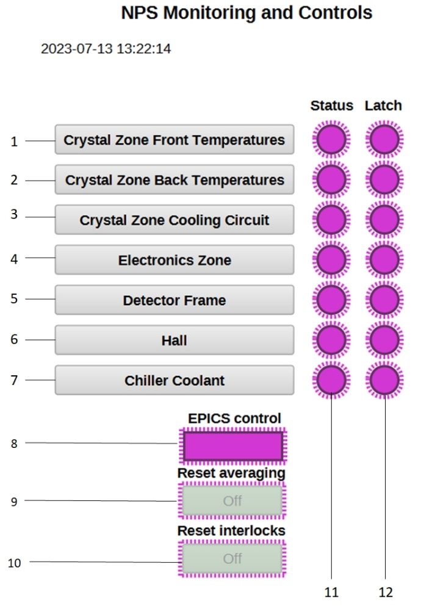

- Clicking the gray area opens the screen to monitor and control the 56 temperature sensors in the front crystal zone. See page 3 for details.
- Clicking the gray area opens the screen to monitor and control the 56 temperature sensors in the back crystal zone. See page 3 for details.
- Clicking the gray area opens the screen to monitor and control the temperatures of the sensors on the two inlet manifolds and two outlet manifolds of the crystal zone cooling circuit. See page 4 for details.
- Clicking the gray area opens the screen to monitor and control the temperatures of the eight sensors in the electronics zone—two on the inlet manifolds, two on the outlet manifolds, two on the heat exchanger top, and two on the heat exchanger bottom. See page 5 for details.
- Clicking the gray area opens the screen to monitor and control the temperatures, humidity, and dew points of the eight sensors in the detector frame. See page 6 for details.
- Clicking the gray area opens the screen to monitor and control the temperatures, humidity, and dew points of the two sensors in the Hall. See page 7 for details.
- Clicking the gray area opens the screen to monitor and control the temperatures, pressure, and flow of the two chillers, one in the crystal zone and one in the electronics zone. See page 8 for details.
- Indicator is on (bright green) when under EPICS control.
- Clicking the green rectangle removes the current temperature averages and restarts averaging.
- Clicking the green rectangle clears all interlock notifications
- The status LED indicators will be green, unless there is a sensor reading over a user-assigned limit, in which case an indicator will turn red. Each screen has its own status indicator, to the right of the gray, screen button.
- The latch LED indicators will be green, unless there is a latched sensor, in which case an indicator will turn red. Each screen has its own latch indicator, to the right of its status LED indicator.
Front and Back Crystal Zone Temperatures Screen

The Front Crystal Zone Temperatures screen and the Back Crystal Zone Temperatures screen are very similar. The screen for the front crystal zone is shown below.

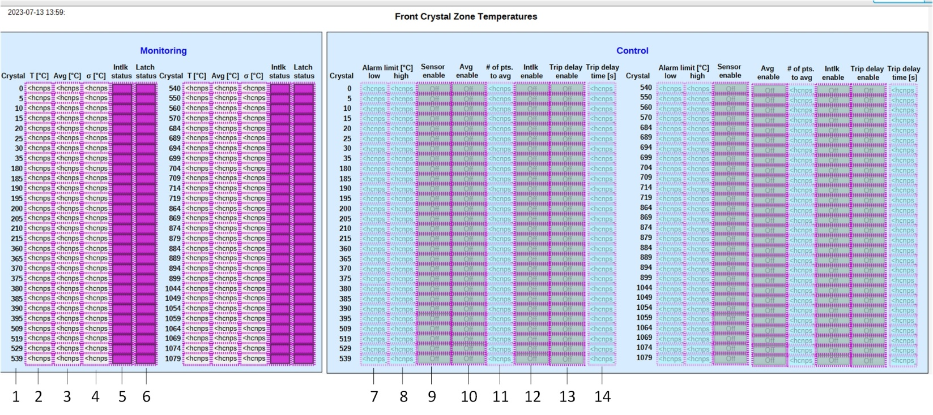

Items 1–6 are for monitoring and 7–14 for control.

- Numbers in the crystal column correspond to the crystal numbers where the sensors are located.
- Column T is the current temperature.
- Column Avg is a running average of the temperature.
- Column σ is the standard deviation of the temperature.
- An LED under Intlk status will turn red if there is an interlock for that sensor.
- An LED under Latch status will turn red if there is a latch for that sensor.
- A value can be input for a low alarm limit. If the temperature equals this value, or goes below, an interlock will occur.
- A value can be input for a high alarm limit. If the temperature equals this value, or goes above, an interlock will occur.
- The Sensor enable button turns the sensor on or off.
- The Avg enable button turns averaging on or off.
- A value can be input into # of pts to avg to set how many values to include in the running average. It is set to a minimum of 300.
- The Intlk enable button turns on or off a potential interlock.
- The Trip delay enable button turns on or off a delay before an interlock occurs.
- The Trip delay time, in seconds, is the length of time between the temperature going out of limit and an interlock, if delay is enabled (#13).

Crystal Zone Cooling Circuit Temperatures Screen

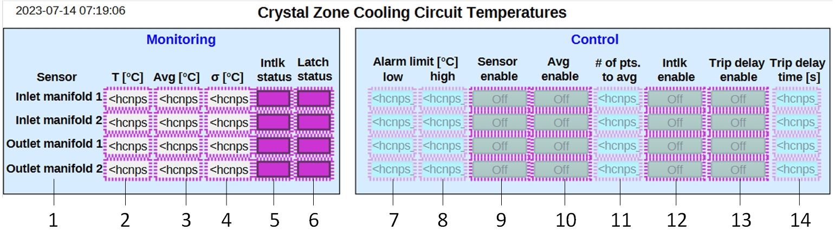
Items 1–6 are for monitoring and 7–14 for control.

- The location of the sensor.
- Column T is the current temperature.
- Column Avg is a running average of the temperature.
- Column σ is the standard deviation of the temperature.
- An LED under Intlk status will turn red if there is an interlock for that sensor.
- An LED under Latch status will turn red if there is a latch for that sensor.
- A value can be input for a low alarm limit. If the temperature equals this value, or goes below, an interlock will occur.
- A value can be input for a high alarm limit. If the temperature equals this value, or goes above, an interlock will occur.
- The Sensor enable button turns the sensor on or off.
- The Avg enable button turns averaging on or off.
- A value can be input into # of pts to avg to set how many values to include in the running average. It is set to a minimum of 300.
- The Intlk enable button turns on or off a potential interlock.
- The Trip delay enable button turns on or off a delay before an interlock occurs.
- The Trip delay time, in seconds, is the length of time between the temperature going out of limit and an interlock, if delay is enabled (#13).

Electronics Zone Temperatures Screen

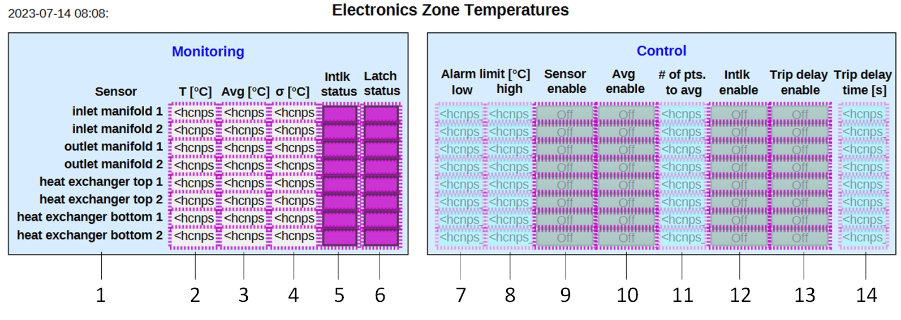
Items 1–6 are for monitoring and 7–14 for control.

- The location of the sensor.
- Column T is the current temperature.
- Column Avg is a running average of the temperature.
- Column σ is the standard deviation of the temperature.
- An LED under Intlk status will turn red if there is an interlock for that sensor.
- An LED under Latch status will turn red if there is a latch for that sensor.
- A value can be input for a low alarm limit. If the temperature equals this value, or goes below, an interlock will occur.
- A value can be input for a high alarm limit. If the temperature equals this value, or goes above, an interlock will occur.
- The Sensor enable button turns the sensor on or off.
- The Avg enable button turns averaging on or off.
- A value can be input into # of pts to avg to set how many values to include in the running average. It is set to a minimum of 300.
- The Intlk enable button turns on or off a potential interlock.
- The Trip delay enable button turns on or off a delay before an interlock occurs.
- The Trip delay time, in seconds, is the length of time between the temperature going out of limit and an interlock, if delay is enabled (#13).

Detector Frame Temperature, Humidity, and Dew Point Screen

The detector frame screen is divided into three sections for monitoring and three sections for control―temperature T, humidity RH, and dew point for each. The temperature section is discussed below.

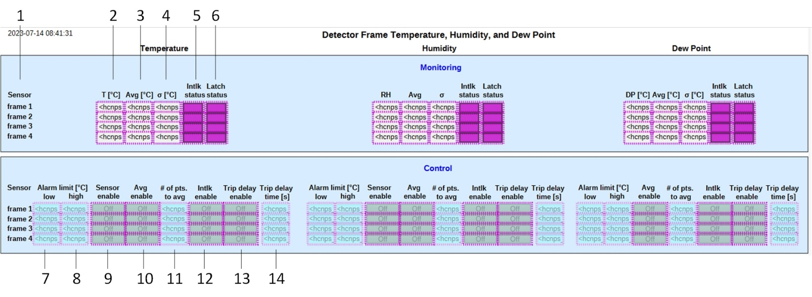

Items 1–6 are for monitoring and 7–14 for control.

- The identity of the sensor.
- Column T is the current temperature.
- Column Avg is a running average of the temperature.
- Column σ is the standard deviation of the temperature.
- An LED under Intlk status will turn red if there is an interlock for that sensor.
- An LED under Latch status will turn red if there is a latch for that sensor.
- A value can be input for a low alarm limit. If the temperature equals this value, or goes below, an interlock will occur.
- A value can be input for a high alarm limit. If the temperature equals this value, or goes above, an interlock will occur.
- The Sensor enable button turns the sensor on or off. Dew point does not have a sensor enable button.
- The Avg enable button turns averaging on or off.
- A value can be input into # of pts to avg to set how many values to include in the running average. It is set to a minimum of 300.
- The Intlk enable button turns on or off a potential interlock.
- The Trip delay enable button turns on or off a delay before an interlock occurs.
- The Trip delay time, in seconds, is the length of time between the temperature going out of limit and an interlock, if delay is enabled (#13).

Hall Temperature, Humidity, and Dew Point Screen

The Hall screen is divided into three sections for monitoring and three sections for control―temperature T, humidity RH, and dew point for each. The temperature section is discussed below.

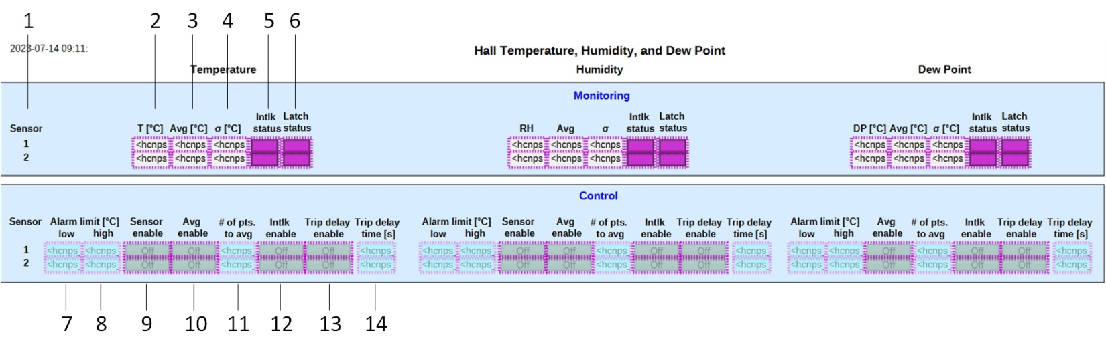
Items 1–6 are for monitoring and 7–14 for control.

- The number of the sensor.
- Column T is the current temperature.
- Column Avg is a running average of the temperature.
- Column σ is the standard deviation of the temperature.
- An LED under Intlk status will turn red if there is an interlock for that sensor.
- An LED under Latch status will turn red if there is a latch for that sensor.
- A value can be input for a low alarm limit. If the temperature equals this value, or goes below, an interlock will occur.
- A value can be input for a high alarm limit. If the temperature equals this value, or goes above, an interlock will occur.
- The Sensor enable button turns the sensor on or off. Dew point does not have a sensor enable button.
- The Avg enable button turns averaging on or off.
- A value can be input into # of pts to avg to set how many values to include in the running average. It is set to a minimum of 300.
- The Intlk enable button turns on or off a potential interlock.
- The Trip delay enable button turns on or off a delay before an interlock occurs.
- The Trip delay time, in seconds, is the length of time between the temperature going out of limit and an interlock, if delay is enabled (#13).

Chiller Coolant Screen

The Chiller Coolant screen is divided into two areas—the crystal zone chiller and the electronics zone chiller. Each chiller area is then divided into monitoring and control. The crystal zone is discussed below.

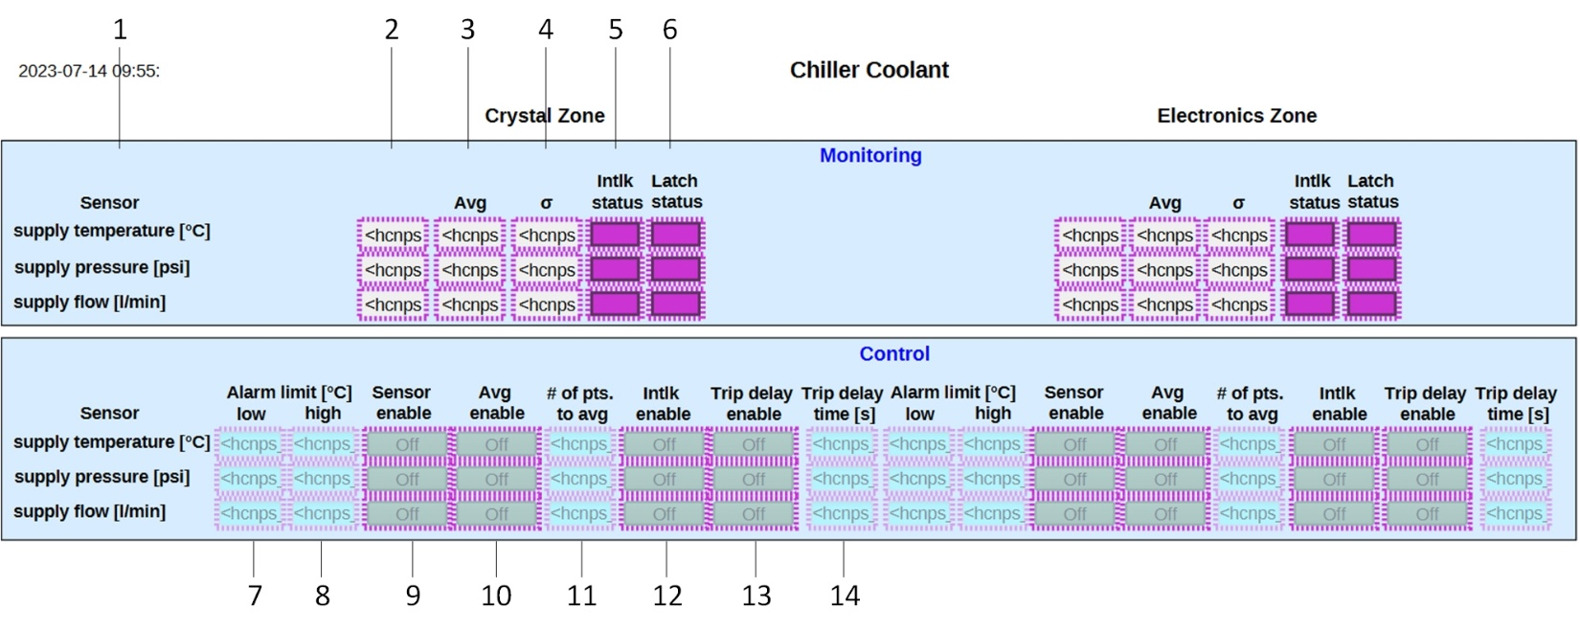
Items 1–6 are for monitoring and 7–14 for control.

- The item being monitored.
- Column T is the current temperature.
- Column Avg is a running average of the temperature.
- Column σ is the standard deviation of the temperature.
- An LED under Intlk status will turn red if there is an interlock for that sensor.
- An LED under Latch status will turn red if there is a latch for that sensor.
- A value can be input for a low alarm limit. If the temperature equals this value, or goes below, an interlock will occur.
- A value can be input for a high alarm limit. If the temperature equals this value, or goes above, an interlock will occur.
- The Sensor enable button turns the sensor on or off.
- The Avg enable button turns averaging on or off.
- A value can be input into # of pts to avg to set how many values to include in the running average. It is set to a minimum of 300.
- The Intlk enable button turns on or off a potential interlock.
- The Trip delay enable button turns on or off a delay before an interlock occurs.
- The Trip delay time, in seconds, is the length of time between the temperature going out of limit and an interlock, if delay is enabled (#13).

Chiller Screen

The Chiller screen is divided into two areas―the crystal zone chiller and the electronics zone chiller. Each area has its own set of controls and indicators.

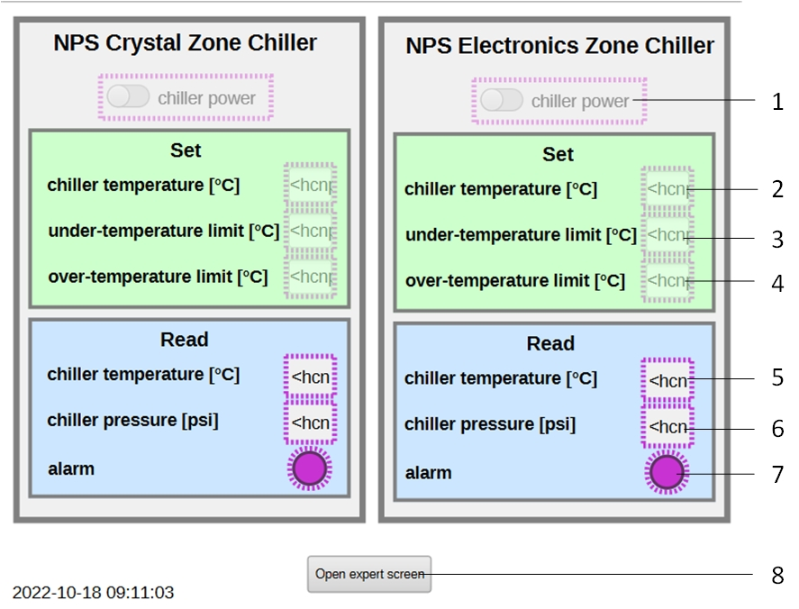

- The slide button turns the chiller power off or on.
- A value can be input to set the temperature for the chiller to maintain.
- A value can be input to set the chiller’s low temperature limit. A read value below or equal to this input will cause an alarm.
- A value can be input to set the chiller’s high temperature limit. A read value above or equal to this input will cause an alarm.
- The current temperature of the chiller.
- The current pressure of the chiller.
- If any item alarms, this will turn red. Alarm details are shown on the expert screen.
- Clicking the gray rectangle opens the chiller expert screen.

Chiller Expert Screen

The Chiller Expert screen is divided into two areas―the crystal zone chiller and the electronics zone chiller. Each area has its own set of indicators.

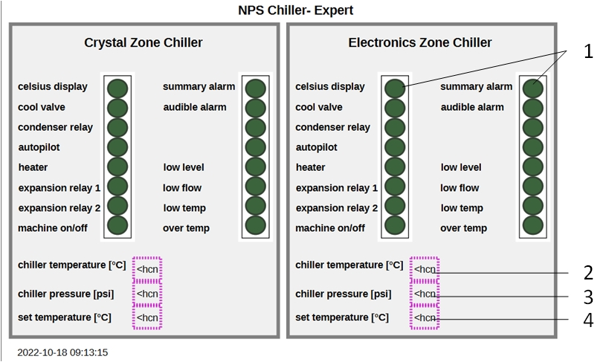

- Two sets of LED indicators. If an indicator turns on, it will turn bright green. The indicators are as follows:
Celsius display—refers to indicators on the chiller showing Celsius values vs Fahrenheit.
cool valve—solenoid valve is open and chiller is cooling the process fluid.
condenser relay—status of the chiller condenser relay.
autopilot—not used
heater—not used
expansion relay 1—not used
expansion relay 2—not used
machine on/off— the chiller is on. Lights the temperature display and pressure indicator on the chiller panel.
summary alarm—an alarm fault condition (low level, low flow, low temperature, over temperature).
audible alarm—a sound will be heard from the chiller when an alarm occurs.
low level—low fluid level in the tank.
low flow—minimum flow requirement of the chiller is not being satisfied.
low temp—water temperature is below or equal to the set under-temperature limit.
over temp—water temperature is above or equal to the set over-temperature limit.
- The current temperature of the chiller.
- The current pressure of the chiller.
- The temperature to which the chiller is set.

