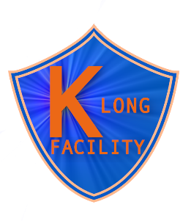
Manpower

Experiment/equipment
- CPS: Sean Dobbs, Gaby Niculescu, Donal Day, Bogdan Wojtsekhowski, Igor Strakovsky, Pavel Degtyarenko, Tim Whitlath
- KPT: Igor Strakovsky, Pavel Degtyarenko, Tim Whitlath
- KFM: Mikhail Bashkanov, Nick Zachariou, Dan Watts
- CryoTarget: Chris Keith
- Cherenkov counter for cryotarget: Paul Euginio

Experiment/accelerator: Todd Satogata

Experiment/MC
- Kaon yield: Ilya Larin
- Kaon monitoring: Mikhail Bashkanov, Sasha Somov
- Neutron & gamma background: Igor Strakovsky, Ilya Larin, Pavel Degtyarenko
- Strange baryons: Simon Tayler, Mikhail Bashkanov, Nick Zachariou, Kijun Park, Maxim Mai, Kevin Luckas
- Strange mesons: Shankar Adhikari, Moskov Amaryan, Marouen Baalouch
- Neutron induced reactions in cryotarget: Mikhail Bashkanov

Experiment/DAC: Sergey Furletov (including open trigger issue), Sasha Somov

Theory/motivations:
- Strange baryons: Dan Riska, David Richards, Jose Goity, Mark Manley, Andrey Sarantsev
- Strange mesons: Bachir Moussallam, Veronique Bernard, Wolfgang Ochs

Theory/PWA:
- Strange baryons: Andrey Sarantsev, Viktor Nikonov, Alfred Svarc, Michael Doering, Mark Manley
- Strange mesons: Shankar Adhikari, Moskov Amaryan, Arkaitz Rodas, Alessandro Pilloni

Alternative projects: Axel Schmidt, Frank Nerling, Jim Ritman, Alexander Austregesilo, Simon Eidelman

