**5. The 208Pb target**

We are proposing using a 208Pb target of 150 mg/cm2 thickness. We would like to point out that the PREX2/CREX collaboration has operated a 208Pb target along with 40Ca and 48Ca targets when they performed their physics measurements during 2019-2020.

Fig. 5.1 shows beam-views of CAD models of the PREX2/CREX target chamber (top) and the main PREX2/CREX target ladder (bottom). The PREX2/CREX target chamber was a custom-made Al chamber of 60 cm diameter, designed to accommodate two independent motion systems, a vacuum pumping station and interfaces with the beam line, both upstream and downstream.

|  |  |
| --- | --- |
|  |  |

Fig 5.1: PREX2/CREX target chamber (top) and the PREX2/CREX cryogenic target ladder (bottom).

The horizontal motion system in Fig. 5.1 positioned the production target ladder in beam. The production target ladder accommodated 16 target positions, 12 for PREX2 (Pb targets), 2 for CREX (Ca targets) and 2 for calibrations (C-foil target) and beam centering (2 mm C-hole target) as can be seen in Fig 5.1, bottom. The horizontally moving target ladder was cryogenically cooled with 15 K helium gas from End Station Refrigerator (ESR). PREX2/CREX used an auxiliary target ladder, which moved at 45o to the production ladder. The auxiliary ladder was water cooled and hosted 4 targets and a water cell for calibrations and optics studies. The production target ladder was specifically designed to accommodate the needs of PREX2/CREX. Both target ladders were made of copper and had a copper tubing brazed on their perimeter for cooling. The 208Pb targets used in PREX2 were 25x25x0.55 mm3 wafers sandwiched between 2 foils of synthetic diamond, each 25x25x0.15 mm3. Two types of synthetic diamond foils were used in PREX2: optical grade (with thermal conductivity coefficient greater than 1500 W/m*K) and thermal grade (with thermal conductivity coefficient greater than 1000 W/m*K).

CFD simulations using ANSYS-Fluent have been done with the target ladder at the bottom of Fig 5.1, loaded with a bare 208Pb foil 0.1 mm thick. The foil was considered in two positions in the ladder, either in one of the PREX2 target positions or in one of the CREX target positions. As the clearance for beam is smaller in the CREX target position, this position proved better for the 208Pb bare foil target, yielding smaller maximum temperatures in the same conditions compared with the one of the PREX target positions. Fig.5.2 shows the CFD predictions for maximum temperature in the 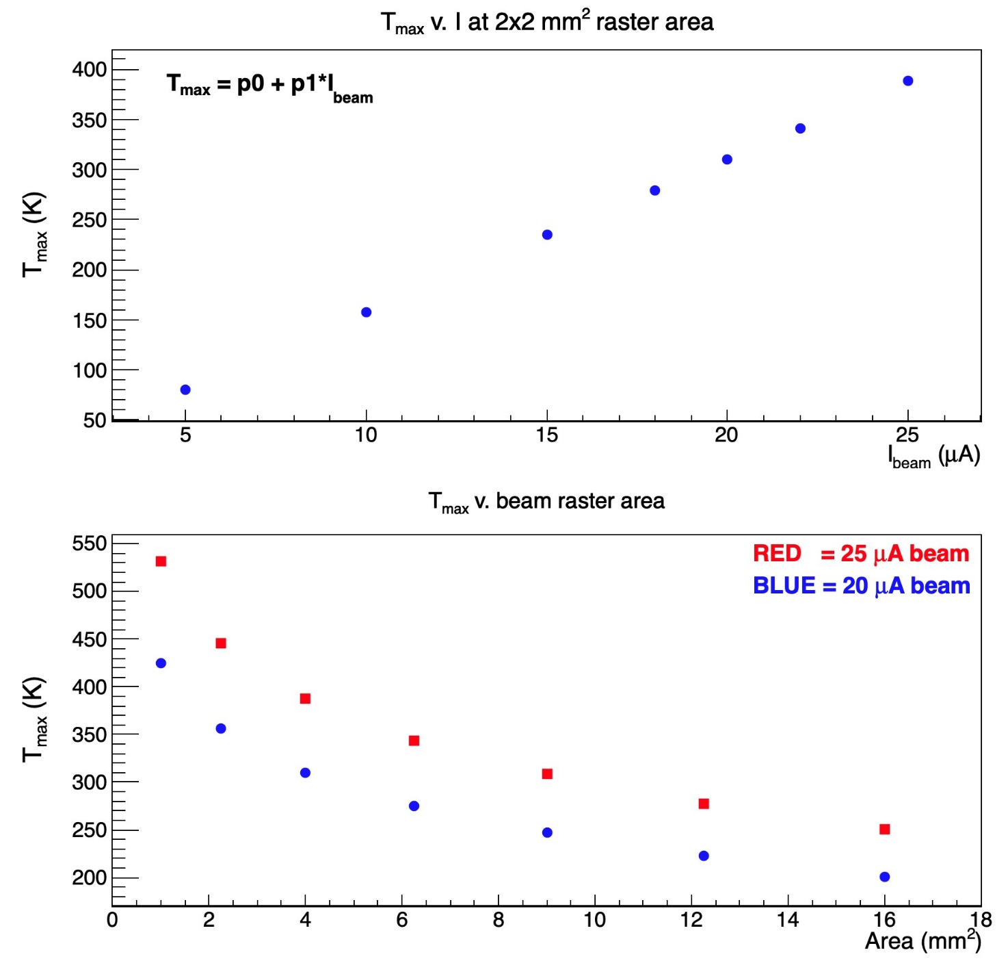

Figure 5.2: CFD predictions for maximum temperature in the PREX2 Pb target vs. Diamond thermal conductivity coefficient*.*

208Pb foil, versus beam current in the top plot and versus beam raster area in the bottom plot. For the top plot the beam raster area was a square of side 2 mm, for the bottom plot the red squares are for a beam current of 25 μA, while the blue disks are for a beam current of 20 $μ$ A. The coolant considered was cold He gas as delivered from the ESR1, at 12 atm and 14 K, with a flow of 20 g/s. In the model only conductive heat transfer was accounted for, to be conservative. The expected beam power into the 208Pb foil is expected to be about 4 W at 20 μA beam current and 5 W at 25 μA. As expected, maximum temperature varies linearly with the beam current and it is non-linear with the beam raster area. In this target ladder the clearance for beam is 12.7 mm horizontally by 19 mm vertically, while the diameter of the beam clearance in the CREX target position is 9.5 mm, which is smaller than both the horizontal and vertical clearance for a PREX2 target position, hence the smaller maximum temperature for the 208Pb foil in this position as the heat path from the center of the foil to the cold mass (the copper frame) is smaller.

We propose as nominal beam conditions for the target: beam raster area a square of side 2 mm and beam current 25 μA. Based on the CFD simulations for the PREX2/CREX target ladder loaded with a 208 Pb bare foil in the CREX position we predict a maximum temperature in the Pb foil of 387 K in nominal conditions which is well below the melting temperature of lead, of 600 K. As this is not a power target, we would need minimal coolant flow, just to keep the target ladder cold. The cold He gas is not used to take away a significant heating power, its purpose is to provide an as large as possible temperature range for the operating the target. If the coolant were liquid nitrogen, for example, then the maximum target temperature would increase by 63 K.

***For this experiment we will use one single bare 150 mg/cm2 thick Pb foil.***

For the reasons outlined above we assume, conservatively, that we can run with 25 μA.

We will setup a system that allows to monitor continuously the target thickness when is exposed to beam.

          For our experiment we plan to monitor the target thickness by performing elastic scattering measurement off  Pb-208. During data taking, we will monitor continuously the thickness of the target by measuring electron scattering rate as a function of two-dimensional positions by using raster information. This method was already used for the CH2 targets in Hall-C hypernuclear programs and cracking or melting of the target were monitored to know right time for target exchange.

The Target Group has pointed out that there are two options being explored for a target system for our measurement: either a system with only solid targets of a system that will accommodate both solid targets and fluid targets. The second option would require more resources for design, fabrication and installation. A PREX2-type target ladder could accommodate many solid targets with cryogenic cooling provided, the actual number to be determined by the collaboration.We will have to calibrate the Ion Chambers (ICs) for the target to set proper setpoints for the Fast Shut-Down (FSD) system. We could also commission the target and beam raster size. The beam raster will have to be commissioned to establish its proper size at the target location entailing a slow beam ramp up to nominal current, assessing the target thickness (by measuring a detector yield) and determining that the target thickness does not change up to the nominal beam current. We will ask the Target Group for installing a temperature sensor (embedded into the target frame) as close as possible to one of the Pb targets. A similar temperature sensor setup was used for the PREX2/CREX target ladder. We could use this sensor to correlate it with target thickness. The target chamber, target ladders, target foils, coolant transfer lines would be new.